|  |  |  |  |  |  |  |  |  |  |  |  |  |  |  |
| --- | --- | --- | --- | --- | --- | --- | --- | --- | --- | --- | --- | --- | --- | --- |
|  |  |  |  |  |  |  |  |  |  |  |  |  |  |  |
|  |  |  |  |  |  |  |  |  |  |  |  |  |  |  |
|  |  |  |  |  |  |  |  |  |  |  |  |  |  |  |
|  |  |  |  |  |  |  |  |  |  |  |  |  |  |  |
|  |  |  |  |  |  |  |  |  |  |  |  |  |  |  |
|  |  |  |  |  |  |  |  |  |  |  |  |  |  |  |
|  |  |  |  |  |  |  |  |  |  |  |  |  |  |  |
|  |  |  |  |  |  |  |  |  |  |  |  |  |  |  |
|  |  |  |  |  |  |  |  |  |  |  |  |  |  |  |
|  |  |  |  |  |  |  |  |  |  |  |  |  |  |  |
|  |  |  |  |  |  |  |  |  |  |  |  |  |  |  |
|  |  |  |  |  |  |  |  |  |  |  |  |  |  |  |
|  |  |  |  |  |  |  |  |  |  |  |  |  |  |  |
|  |  |  |  |  |  |  |  |  |  |  |  |  |  |  |
|  |  |  |  |  |  |  |  |  |  |  |  |  |  |  |

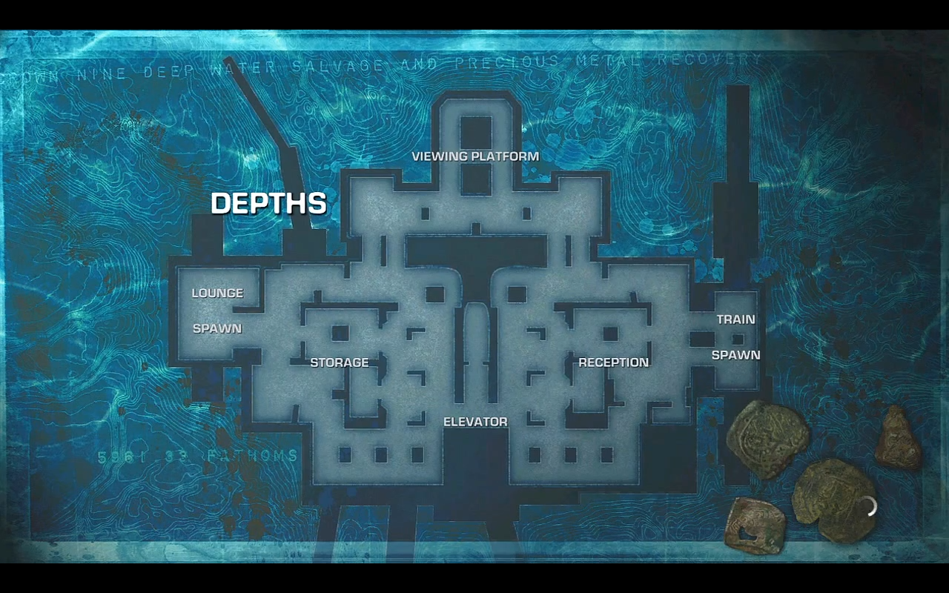

Wall (High)

Wall (Medium)

Wall (Low)

Wall (Mantle height)

Window

Roof

Ramp

\**Weapons*\*

BR (T-Bow)

Pistol (Snub/Boltok)

Plasma Rifle (Retro)

AR (Lancer)

Stickies (Frags)

Splazer (One Shot)

Grenade Launcher (Digger?)

Frags (incens?)