Laue Ensemble

Why does this happen periodically?
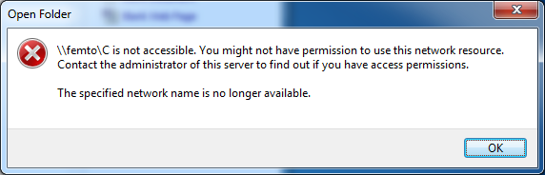

Motion Composer was tied to the S: directory. Had to unmount pslogin (S:) and pslogin-xppopr (T:).

Start -> All Programs -> Win-sshfs -> SSHFS Manager - pslogin.slac.stanford.edu:/reg/ned/home2/schotte - S: -Unmount

