sudo yum -y update

sudo yum remove mysql-libs #移除舊版libs

sudo yum -y install cronie #把mysql-libs dependency cronie 安裝回來

sudo yum -y install httpd

sudo chkconfig httpd on

sudo rpm -Uvh https://mirror.webtatic.com/yum/el6/latest.rpm

sudo yum -y install php56w php56w-opcache php56w-mbstring php56w-gd php56w-devel php56w-pear

sudo pear install DB

wget http://dl.fedoraproject.org/pub/epel/6/x86_64/epel-release-6-8.noarch.rpm

sudo rpm -Uvh epel-release-6*.rpm

wget http://rpms.famillecollet.com/enterprise/remi-release-6.rpm

sudo rpm -Uvh remi-release-6*.rpm

sudo yum -y --enablerepo=remi install php-pear-Mail-Mime

sudo yum -y install php-pear-Mail

sudo pear install Net_SMTP # 用前面的yum替代

sudo pear install Mail_Mime # 用前面的yum替代

sudo pear install Mail # 用前面的yum替代

sudo yum -y install gcc

sudo yum -y install gcc-c++

sudo yum groupinstall "Development tools"

php -m | grep -i mongo

sudo yum -y install gcc php-pear php-devel

php -v

sudo pecl install mongo

sudo pear install --alldeps channel://pear.php.net/HTTP_OAuth-0.3.1

sudo pecl install oauth

sudo vi /etc/php.d/oauth.ini # add "extension=oauth.so" to oauth.ini

#mongo

wget <https://github.com/mongodb/mongo-php-driver-legacy/archive/master.zip>

unzip master.zip

ls -l

cd mongo-php-driver-legacy-master/

phpize

./configure

make all

sudo make install

php -i | grep extension_dir

sudo service httpd restart

////////////////

**more etc/sysconfig/clock**

php –v

///設定時區

Sudo vi /etc/php.in

date.timezone = " America/Los_Angeles"

/////////

php -m |grep -i mongo

sudo service httpd restart

sudo yum -y install mysql55w mysql55w-libs mysql55w-devel mysql55w-server php56w-mysql php56w-soap #先安裝mysql55w-libs再安裝php-mysql

sudo chkconfig mysqld on

sudo service mysqld start

/usr/bin/mysqladmin -u root password '25380280'

sudo chown -R ll5p /var/www/html/

ref: <https://webtatic.com/packages/php56/>

sudo vi /etc/selinux/config

edit => SELINUX=disabled # 若沒設定，會造成PHP無法連外等情形

**Install enterprise edition**

cp ~/download/enterprise/enterprise-1.14.2.0.tar-2015-04-22-03-42-06.gz /var/www/html

sudo tar zxvf enterprise-1.14.2.0.tar-2015-04-22-03-42-06.gz

sudo chown -R apache:apache magento

sudo mv magento enterprise

<http://10.16.133.67/enterprise/>

先進入phpMyAdmin建立enterprise的database

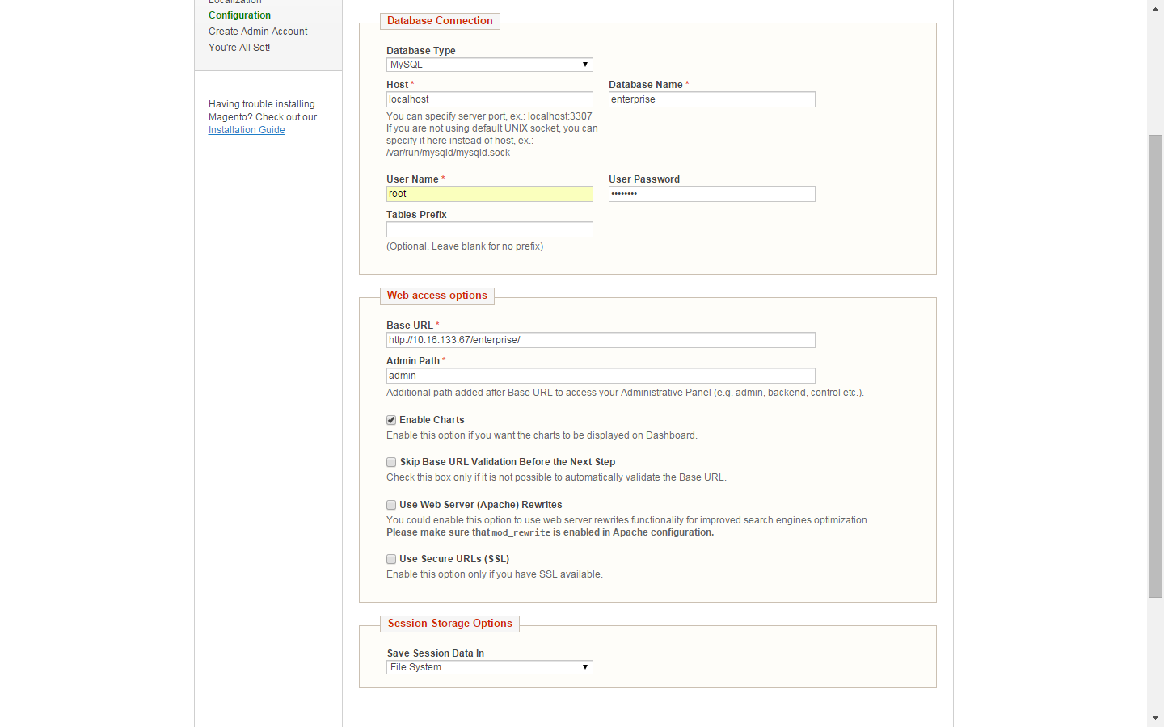

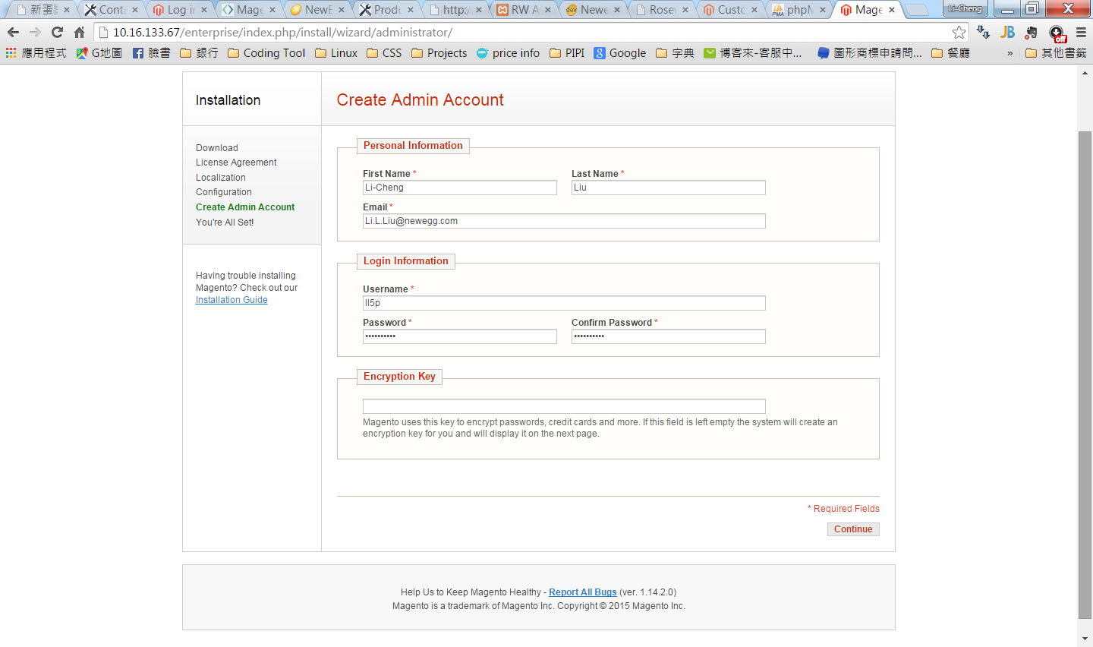

encryption key(10.16.133.67 enterprise): **aca41e2e7312fd8e1a876f11233b9bb6**

sudo cp /var/www/html/enterprise/app/.htaccess /var/www/html/enterprise/app/etc/

**Install community edition**

cp ~/download/ community / magento-1.9.2.0-2015-07-08-02-48-06.zip /var/www/html

sudo unzip enterprise-1.14.2.0.tar-2015-04-22-03-42-06.gz –d /var/www/html/

cd /var/www/html

sudo chown -R apache:apache magento

sudo mv magento enterprise

先進入phpMyAdmin建立community的database

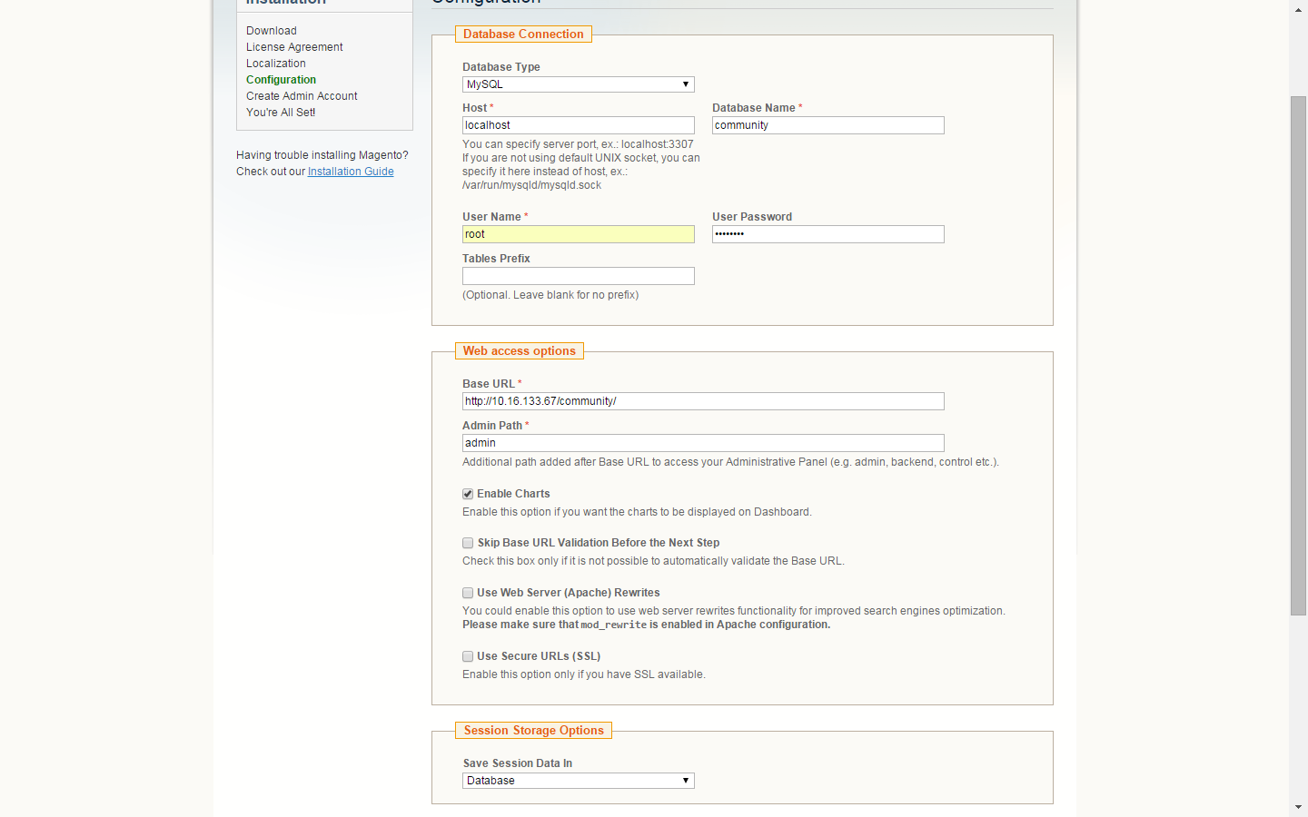



encryption key(10.16.133.67 community): **491edc880584a7d30fa13036c7c527f0**

**sudo yum remove php\***

sudo **rpm -Uvh http://mirror.webtatic.com/yum/el6/latest.rpm**

sudo **yum install \**

sudo **rpm -qa|grep -E '^(php|httpd)'|sort**

sudo yum install -y php56w php56w-opcache php56w-xml php56w-mcrypt php56w-gd php56w-devel php56w-mysql php56w-intl php56w-mbstring php56w-bcmath php56w-pear php56w-ldap

cd /etc/php.d

mongo.ini

"extension=mongo.so" to php.ini

To install Mongo DB on CentOS6 and PHP5.6 add the following:

|  |
| --- |
| **yum** -y **install** php56w-pear  **yum** -y **install** php56w-devel  pecl **install** mongo |

Then add:

|  |
| --- |
| "extension=mongo.so" to php.ini |

sudo yum install gcc-c++ openssl-devel

$ wget http://nodejs.org/dist/v0.10.26/node-v0.10.26-linux-x64.tar.gz

$ tar xzf node-v0.10.26-linux-x64.tar.gz

$ sudo cp -rp node-v0.10.26-linux-x64 /usr/local/

$ sudo ln -s /usr/local/node-v0.10.26-linux-x64 /usr/local/node