**Response to Reviewer #1**

**One of the major difficulties of this sort of work is genuinely showing a significant and demonstrable improvement over existing techniques and knowledge. The analyses undertaken are useful and provide reassurance that the methods are effective but do not provide a huge advance over the pre-existing studies. The authors are clearly already aware of this and state in the discussion that the major gains are likely to be made by the incorporation of epigenetic data. I feel that this should be demonstrated before the paper could be considered for publication in this journal. It is not immediately obvious that simply adding additional independent epigenetic features is sufficient to uncover interesting biology (there maybe complex dependencies between mutational signatures and epigenetic features). An empirical study that demonstrates that this simple model really applies in this context would be desirable to justify the extrapolation.**

While we believe that incorporating epigenetic data, and other types of data, into mutation signatures is an important and exciting direction for future work, we also believe that a proper investigation of this will be a major undertaking and view it as a project in itself that is outside the scope of our current paper. We also believe that, even without this additional work, the combination of novel models, software and visualization tools that are included here already represent a substantive and important advance - one that will be of considerable interest to both methodological, and applied researchers, and perhaps, as reviewer 2 suggests, will dramatically change the way that mutational signatures are identified in practice.

**Response to Reviewer #3**

**If I had one request, I’d ask whether or not the authors have found any examples of mutation signatures that are clear in the full model, but really lose something important in the independence model. Such examples are not hard to find with sequence logos. They write on p.5 that they “likely do exist in practice”, but give no example.**

One very clear example of a previously published signature that cannot be adequately represented as a single signature in the independence model is the Pol epsilon mutation signature (identified as “Signature 10” in the previous literature, Alexandrov et al., Nature, 2013). This signature puts strong probability mass on two patterns (TpCpT > TpApT and TpCpG > TpTpG), and a slightly weaker mass on TpTpT > TpGpT (see the Figure R1 below). Since the features of this signature are not independent (the frequencies of the immediate 3’ base (T and G) are influenced by the substitution pattern (C>A and C>T, respectively)), our model has to use two signatures to represent this signature (Figure R2).

However, whether one considers this as “losing something” is not clear. Indeed, it is possible that representing this signature as two signatures has a biological basis. For example, we discussed in the manuscript that the strand specificity shown in TpCpT > TpApT pattern (see the left panel in Figure R2) is somewhat consistent with previous research (Shinbrot et al., Genome Research, 2014); whereas, in contrast, the TpCpG > TpTpG does not appear to show such strand specificity (see the right panel in Figure R2). This biological difference supports the notion that the previously published “Signature 10” may in fact consist of two distinct signatures. However, we do not feel we have enough evidence to argue strongly for this at present, and we plan to explore this using more data in the future.

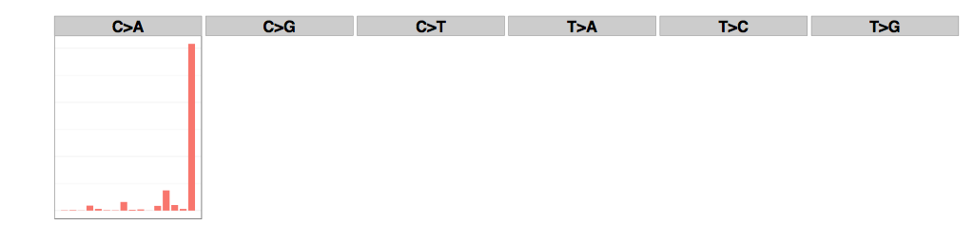

**Figure R1.** The pol epsilon signature (Signature 10) derived in the Alexandrov et al., Nature, 2013. The barplots are divided by 6 substitution pattern. In each division, 16 bars show joint probabilities of substitution pattern and 5' and 3' bases (ApNpA, ApNpC,

ApNpG, ApNpT, …, TpNpT).

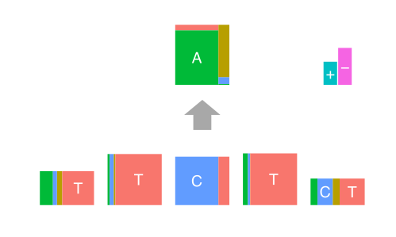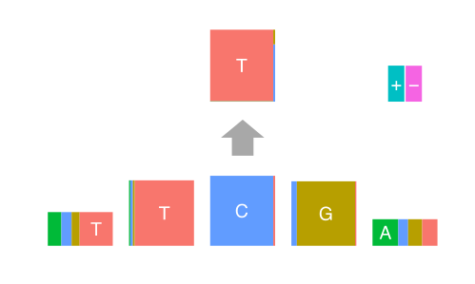

**Figure R2.** The signatures corresponding to Pol epsilon obtained from the Colon-Rectum cancer data using our approach.