Global Illumination for Fun and Profit

Josiah S. Carberry , Ed Grimley, and Martha Stewart
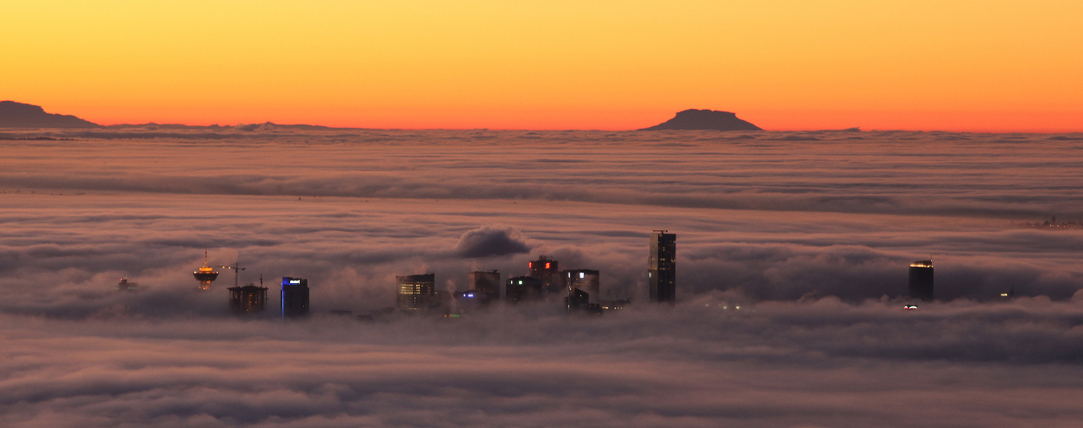

Fig. 1. In the Clouds: Vancouver from Cypress Mountain. Note that the teaser may not be wider than the abstract block.

Abstract—Lorem ipsum dolor sit amet, consectetuer adipiscing elit. Ut purus elit, vestibulum ut, placerat ac, adipiscing vitae, felis.Curabitur dictum gravida mauris. Nam arcu libero, nonummy eget, consectetuer id, vulputate a, magna. Donec vehicula augue eu neque. Pellentesque habitant morbi tristique senectus et netus et malesuada fames ac turpis egestas. Mauris ut leo. Cras viverra metus rhoncus sem. Nulla et lectus vestibulum urna fringilla ultrices. Phasellus eu tellus sit amet tortor gravida placerat. Integer sapien est, iaculis in, pretium quis, viverra ac, nunc. Praesent eget sem vel leo ultrices bibendum. Aenean faucibus. Morbi dolor nulla,malesuada eu, pulvinar at, mollis ac, nulla. Curabitur auctor semper nulla. Donec varius orci eget risus. Duis nibh mi, congue eu, accumsan eleifend, sagittis quis, diam. Duis eget orci sit amet orci dignissim rutrum. A free copy of this paper and all supplemental materials are available at https://OSF.IO/2NBSG.
Index Terms—Radiosity, global illumination, constant time.

Introduction

This template is for papers of VGTC-sponsored conferences such as IEEE VIS, IEEE VR, and ISMAR which are published as special issues of TVCG. The template does not contain the respective dates of the conference/journal issue, these will be entered by IEEE as part of the publication production process. Therefore, please leave the copyright statement at the bottom-left of this first page untouched.

Author Details
Authors should specify ORCID IDs (see https://orcid.org/ to register) for author disambiguation and long-term contact preservation.
Each author’s affiliations have to be provided in the author footer onthe bottom-left corner of the first page. It is permitted to merge two or more people from the same institution as long as they are shown in the same order as in the overall author sequence on the top of the first page.For example, if authors A, B, C, and D are from institutions 1, 2, 1, and 2, respectively, then it is ok to use 2 bullets as follows:

- Josiah Carberry is with Brown University. E-mail: jcarberry@example.com
- Ed Grimley is with Grimley Widgets, Inc.. E-mail: ed.grimley@aol.com.
- Martha Stewart is with Martha Stewart Enterprises at Microsoft Research. E-mail: Martha.stewart@marthastewart.com.
Manuscript received xx xxx. 201x; accepted xx xxx. 201x. Date of
Publication xx xxx. 201x; date of current version xx xxx. 201x.
For information on obtaining reprints of this article, please send
e-mail to: reprints@ieee.org.
Digital Object Identifier: xx.xxxx/TVCG.201x.xxxxxxx/.
- A and C are with Institution 1. E-mail: {a | c}@i1.com .
- B and D are with Institution 2. E-mail: {b | d}@i2.org

Hyperlinks and Cross References
Here are examples for use within a sentence: Fig. 3, Tab. 1, Secs. 6 and 7, Eq. (1). The following sentences all start with a reference: Figure 3 is a figure environment. Table 1 is a table environment. Sections 6 and 7 are section environments. Equation (1) is an equation environment.

Figures

Figures on the first page
The teaser figure should only have the width of the abstract as the template enforces it. The use of figures other than the optional teaser is not permitted on the first page. Other figures should begin on the second page. Papers submitted with figures other than the optional teaser on the first page will be refused.
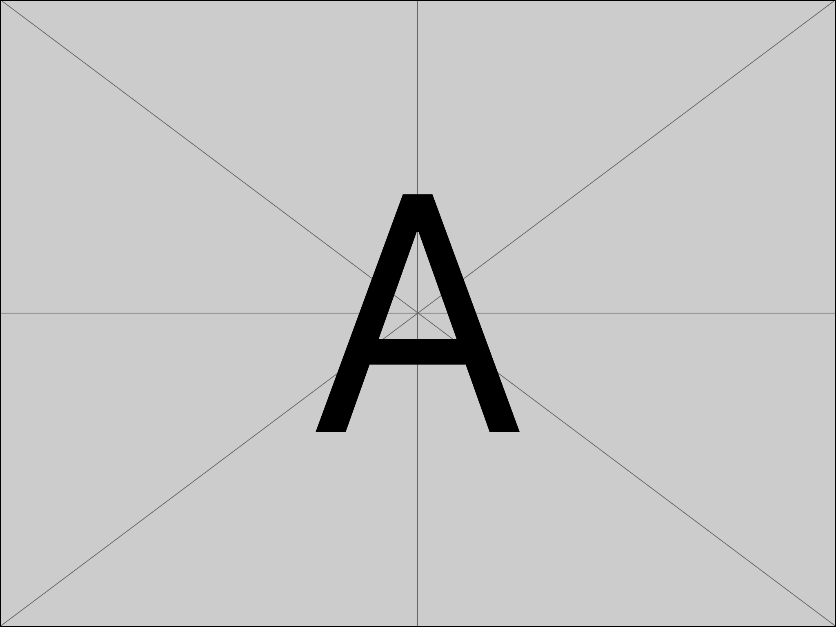 | 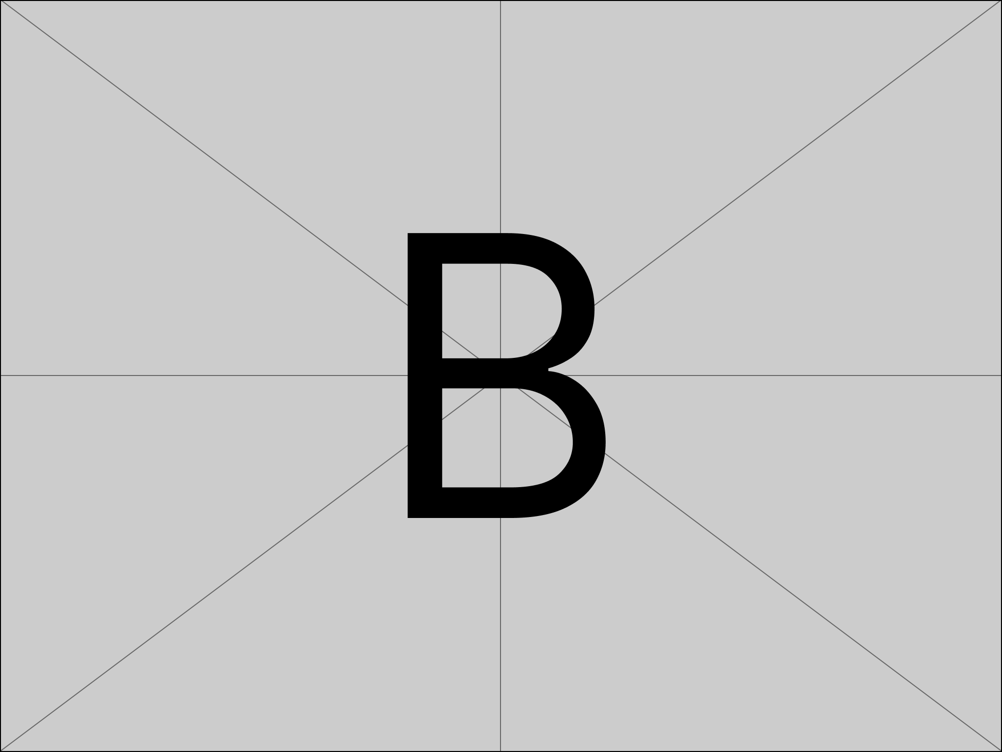
(a) The letter A. | (b) The letter B.

(c) The letter C.
Fig. 2. Example of adding subfigures.

Subfigures
See Fig. 2 for an example.

Equations and Tables
(1)
Equations can be added like so:
Tables, such as Tab. 1 can also be included.

Table 1. Vis Paper Acceptance Rate
Year | Submitted | Accepted | Accepted (%)
1994 | 91 | 41 | 45.1
1995 | 102 | 41 | 40.2
1996 | 101 | 43 | 42.6
1997 | 117 | 44 | 37.6
1998 | 118 | 50 | 42.4
1999 | 129 | 47 | 36.4
2000 | 151 | 52 | 34.4
2001 | 152 | 51 | 33.6
2002 | 172 | 58 | 33.7
2003 | 192 | 63 | 32.8
2004 | 167 | 46 | 27.6
2005 | 268 | 88 | 32.8
2006 | 228 | 63 | 27.6
2007 | 216 | 56 | 25.9
2008 | 197 | 50 | 25.4

Supplemental Material Instructions

Long-term Open Science Goals
Research should be accessible to everyone. Financial means and privileged access should not limit anyone’s ability to participate in and learn from research. As such, research articles and their accompanying supplemental materials should be freely accessible to researchers from all backgrounds, discoverable, and uniquely and persistently identifiable in perpetuity.
Research should be transparent, reproducible, and trustworthy. Authors should be as transparent as possible about their research process. Increased transparency can help reviewers and readers judge for themselves whether the research conducted was plausible and whether the results are reliable. In particular, research should be:
- Transparent—enough description and supplemental material should be provided so that reviewers and readers can follow all important details of any processes or analyses.
- Reproducible—a reviewer or reader should, to the extent possible, be able to use the process, software, data, and operating conditions provided by the authors to obtain the same result.
- Trustworthy—This combination of transparency and reproducibility will help readers to gain trust in the research process and results.
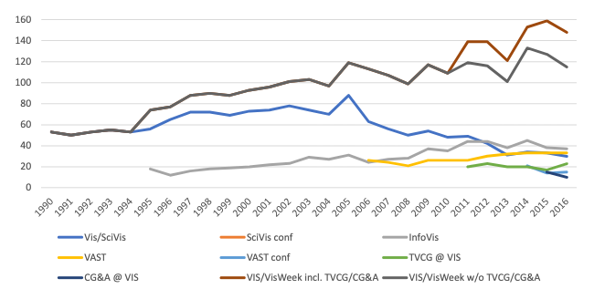
Research should be replicable and transferable. We believe that our community should support knowledge transfer between teams and that research results should stand up to scrutiny by future researchers. An independent team should be able to replicate or transfer the research results in other contexts, locations, domains, and in multiple trials. By making research more transparent and reproducible, we make it easier for future researchers to adopt and adapt the research methodologies to new situations as well as larger or otherwise more convincing studies.
Fig. 3. visualization of the 1990–2016 vis paper acceptance data, recreated based on Fig. 1 from [1].

Where to upload supplemental material
We recommend using https://osf.io as the primary repository for supplemental materials and that authors justify using an alternative repository. In some cases, https://databrary.org or https://dataverse.org may be more appropriate. We caution authors against using solely IEEE Xplore and IEEE Dataport, GitHub & GitLab, or institutional repositories / homepages / lab pages, but do encourage hosting multiple mirrors of material.

What to include in the Supplemental Material section
In the Supplemental Material section at the end of the paper, authors should try to be as descriptive and complete as possible about (1) what supplemental materials are available, (2) where they are hosted, and (3) justifications for why materials were omitted (if any). This section does not count against the page limit, instead being included in the 2-page allotment for References, Figure Credits, and Acknowledgments. An example is provided below.

References

Include DOIs
All references which have a DOI. The DOI can be entered with or without the https://doi.org/ prefix.

Guidelines for references
- All bibliographic entries should be sorted alphabetically by the last name of the first author.
- Merge multiple references into one; e. g., use [2, 4] (not [2] [4]). Within each set of multiple references, the references should be sorted in ascending order.
- Verify all data obtained from digital libraries, even ACM’s DL and IEEE Xplore etc. are sometimes wrong or incomplete.
- Do not trust bibliographic data from other services such as Mendeley.com, Google Scholar, or similar; these are even more likely to be incorrect or incomplete.
- Articles in journal—items to include:
  - author names
  - title
  - journal name
  - year
  - volume
  - number
  - month of publication as variable name (i.e., Jan for January, etc.; month ranges using Jan / Feb or Jan – Feb)
- Use journal names in proper style: correct: “IEEE Transactions on Visualization and Computer Graphics”, incorrect: “Visualization and Computer Graphics, IEEE Transactions on”.
- Papers in proceedings—items to include:
  - Author names
  - Title
  - abbreviated proceedings name: e.g., “Proc.\CONF_ACRONYNM” without the year; example: “Proc. CHI”, “Proc. 3DUI”, “Proc. Eurographics”, “Proc.\EuroVis”
  - year
  - publisher
  - town with country of publisher (the town can be abbreviated for well-known towns such as New York or Berlin)
- Article/paper title convention: refrain from using curly brackets, except for acronyms/proper names/words following dashes/question marks etc.; example:

The paper “Marching Cubes: A High Resolution 3D Surface Construction Algorithm” should be entered as “Marching Cubes: A high resolution 3D surface construction algorithm”.
- For all entries:
  - DOI can be entered in the DOI field as plain DOI number or as DOI url.
  - Provide full page ranges AA—BB
- When citing references, do not use the reference as a sentence object; e.g., wrong: “In [3] the authors describe …”, correct: “Lorensen and Cline [3] describe … ”

Filler Text to Flush Out the Paper
Lorem ipsum dolor sit amet, consectetuer adipiscing elit. Ut purus elit, vestibulum ut, placerat ac, adipiscing vitae, felis. Curabitur dictum gravida mauris. Nam arcu libero, nonummy eget, consectetuer id, vulputate a, magna. Donec vehicula augue eu neque. Pellentesque habitant morbi tristique senectus et netus et malesuada fames ac turpis egestas. Mauris ut leo. Cras viverra metus rhoncus sem. Nulla et.

Supplemental Materials
All supplemental materials are available on OSF at https://doi.org/10.17605/OSF.IO/2NBSG, released under a CC BY 4.0 license. In particular, they include (1) Excel files containing the data for and analyses for creating Tab. 1 and Fig. 3, (2) figure images in multiple formats, and (3) a full version of this paper with all appendices. Our other code is intellectual property of a corporation—Starbucks Research—and there is no feasible way to share it publicly.

Figure Credits
Figure 1 image credit: Scott Miller / Special to the Vancouver Sun, January 22, 2009, page A6.
Figure 3 is a partial recreation of Fig. 1 from [1], which is in the public domain.

Acknowledgments
The authors wish to thank A, B, C. This work was supported in part by a grant from XYZ (# 12345-67890).

References
- P. Isenberg, F. Heimerl, S. Koch, T. Isenberg, P. Xu, C. Stolper, M. Sedlmair, J. Chen, T. Möller, and J. Stasko. vispubdata.org: A Metadata Collection about IEEE Visualization (VIS) Publications. IEEE Transactions on Visualization and Computer Graphics, 23, 2017. doi: 10.1109/TVCG.2016.2615308
- Kitware, Inc. The Visualization Toolkit User’s Guide, January 2003.
- W. E. Lorensen and H. E. Cline. Marching cubes: A high resolution 3D surface construction algorithm. SIGGRAPH Computer Graphics, 21(4):163–169, Aug. 1987. doi: 10.1145/37402.37422
- N. Max. Optical models for direct volume rendering. IEEE Transactions on Visualization and Computer Graphics, 1(2):99–108, June 1995. doi: 10.1109/2945.468400

Appendices
Note that appendices do count against the page limit and that reviewers are not required to review appendices in the supplemental material. Regardless, we suggest creating a complete version of the paper with all appendices that you then upload in your supplemental material and to arXiv, OSF, or another preprint server.

