**PSYC6135 Assignment 1: Good Versus Evil in the Battle of Data Visualization**

Visualizing data is an aspect of research that I had never put much thought into. I knew how to tell an outlandishly bad data display from an average one but did not think to extend my knowledge beyond that. After reading in-depth about good and bad data displays, it is difficult not to see glaring issues in displays that I previously considered acceptable. For instance, the infographic in figure 1 (Zandt, 2025) is meant to display key statistical comparisons of California’s wildfires between 2024 and a 5-year average (2020-2024). Visually, the graphic is clean, eye-catching, and an example of what I would have previously thought was a good data display. However, there are several issues regarding this graphic. Firstly, the story it conveys is difficult to comprehend. Prior to reading the legend, I assumed that two separate years were

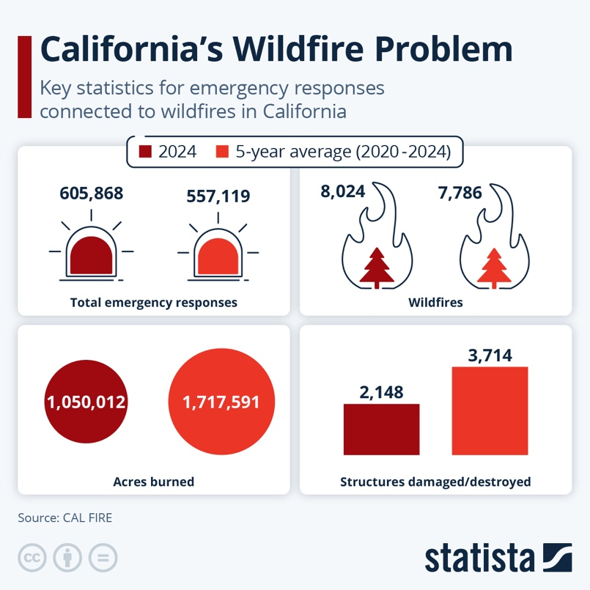

Figure 1. This infographic displays important statistics surrounding California’s wildifres. It is meant to act as a comparison between 2024 and a 5-year average period (2020-2024).

being compared. Although data from a 5-year average offers interesting insights, using it to compare to data from a single year makes it difficult to truly see patterns. Furthermore, the 5-year average period includes the very year it is being compared to (i.e., 2024), which confuses the patterns even more. We cannot accurately interpret how much better or worse California’s wildfire problem is getting when the data is presented this way. We also cannot tell if data from one specific year is inflating or deflating the 5-year average we see. Comparing two separate years (e.g., 2024 and 2023), or comparing all five years separately, would make interpreting the data much easier.

In terms of visual clarity, the graphic attempts to use interesting visuals to catch the attention of viewers (i.e., the ambulance light and fire engulfing a tree). I had initially thought that the visuals themselves were part of the data display and were shaded in depending on their amounts. However, these visuals do not offer anything besides being nice to look at, and do not relate to the data at all. This confuses the viewer – the eye is drawn towards the visuals, but the actual statistic is simply displayed on top, making the visual useless.

An example of a good data display that communicates trends and patterns while still being pleasant to look at aesthetically is the Baby Name Wizard in figure 2, originally included in the Gelman and Unwin (2013) reading. This data display is a good example of comparing trends across a specific timespan. By including data from each time period, viewers can easily compare the popularity of a baby name between specific years while also easily seeing how much more or less popular that name is becoming as a whole. Aesthetically, the display uses eye-catching colours that attract attention without having to include graphics without a purpose. Overall, this data display does a much better job at communicating a visually appealing and informative story than California wildfire graphic.

Figure 2. Screenshot of the Baby Name Wizard, taken from Gelman and Unwin (2013).

**References**

Gelman, A., & Unwin, A. (2013). Infovis and statistical graphics: Different goals, different looks.

*Journal of Computational and Graphical Statistics, 22*(1), 2-28. https://doi.org/10.1080/10618600.2012.761137

Zandt, F. (2025, January 8). *How Wildfires Are Impacting California.* Statista.

https://www.statista.com/chart/33727/key-statistics-for-emergency-responses-connected-to-wildfires-in-california/