Courtney Chan

PSYC 6135 Data Visualization

This graph is linked from the lecture and shows the number of fatal police shootings in the United States from January 2015 – August 2020. The graph is referred to as a spike graph and combines a bar chart and a map. It is impactful because it shows geographic densities of police shooting deaths and clearly. This allows the viewer to see where the highest numbers of police shooting deaths happen.

Zhou, H., & Fishbach, A. (2016). The pitfall of experimenting on the web: How unattended selective attrition leads to surprising (yet false) research conclusions. *Journal of Personality and Social Psychology, 111*(4), 493–504. [https://doi.org/10.1037/pspa0000056](https://psycnet.apa.org/doi/10.1037/pspa0000056)

This is a graph from a paper examining whether online studies violate the assumption of random assignment due to participant attrition. This is a good graph because it clearly depicts the trend over time using a line graph, it includes clear labels for the axes that make it easy to follow. The legend is distinct, representing each journal with a unique shape, making it easy to distinguish between the two journals.

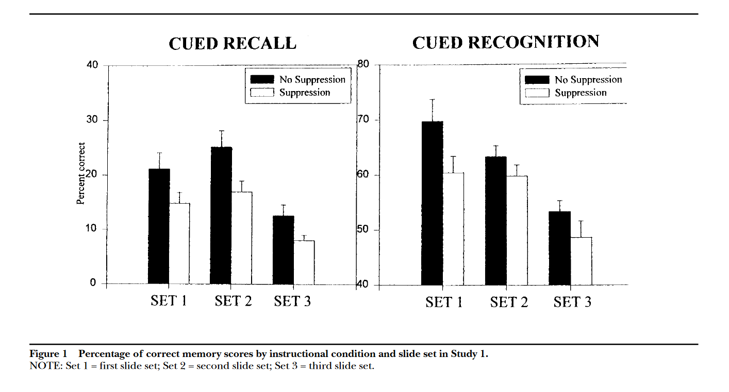

Richards, J. M., & Gross, J. J. (1999). Composure at any cost? The cognitive consequences of emotion suppression. *Personality and Social Psychology Bulletin, 25*(8), 1033–1044. [https://doi.org/10.1177/01461672992511010](https://psycnet.apa.org/doi/10.1177/01461672992511010)

This graph is less effective because it uses inconsistent Y-axis scales across the two panels, making it difficult to compare Cued Recall and Cued Recognition. The bar format is suboptimal for showing trends across sets, and the error bars are not clearly explained. Additionally, the lack of context for "SET 1," "SET 2," and "SET 3" leaves the data ambiguous. The visual design is cluttered, with legends taking up a large amount of space and insufficient differentiation between conditions. Overall, the presentation fails to communicate the data clearly and comparably.