**Mini-Assignment #2**

The visualization I selected is Lindsay Betzandahl’s *The Cycle of Influenza* (See Figure 1). I think that the graphic succeeds well in telling a clear and compelling story of how the prevalence of influenza changes over several months across several years. For example, by using the size of the spheres as indicating prevalence rates, it is clear that flu season creeps up in the fall, erupts in the winter, calms down in the spring, and is largely absent in the summer (which makes complete sense, given that colder temperatures result in longer hang time for viruses and more time spent indoors (without outside circulation), resulting in easier spread). Additionally, upon exploring the plot a bit in its interactive form, the plot also reveals the years with particularly worse flu seasons: the innermost circles are most distant time-wise, whereas the peripheral spheres represent are most recent. I enjoy that the designer also explains particular patterns in the data so that the viewer is not left wondering why particular “blips” occur (e.g., spring 2009 having the worst flu season). Overall, the visualization is far more compelling and less busy than an equivalent time-series line plot would have been, so it succeeds in telling a simple, clear, and compelling story.

The only small improvements I would make for the plot is adding in an annotation showing that the innermost circles are the older years and outermost circles are newest years. (It works as an interactive plot since you could just touch the screen to see that, but it was initially unclear from viewing it as a static plot). It might also have been nice to more specifically visualize particular days and weeks to see more fine deviations over time (though it would only likely work if the viewer could filter across different years).

**Figure 1**

*Lindsay Betzandahl’s* *The Cycle of Influenza*

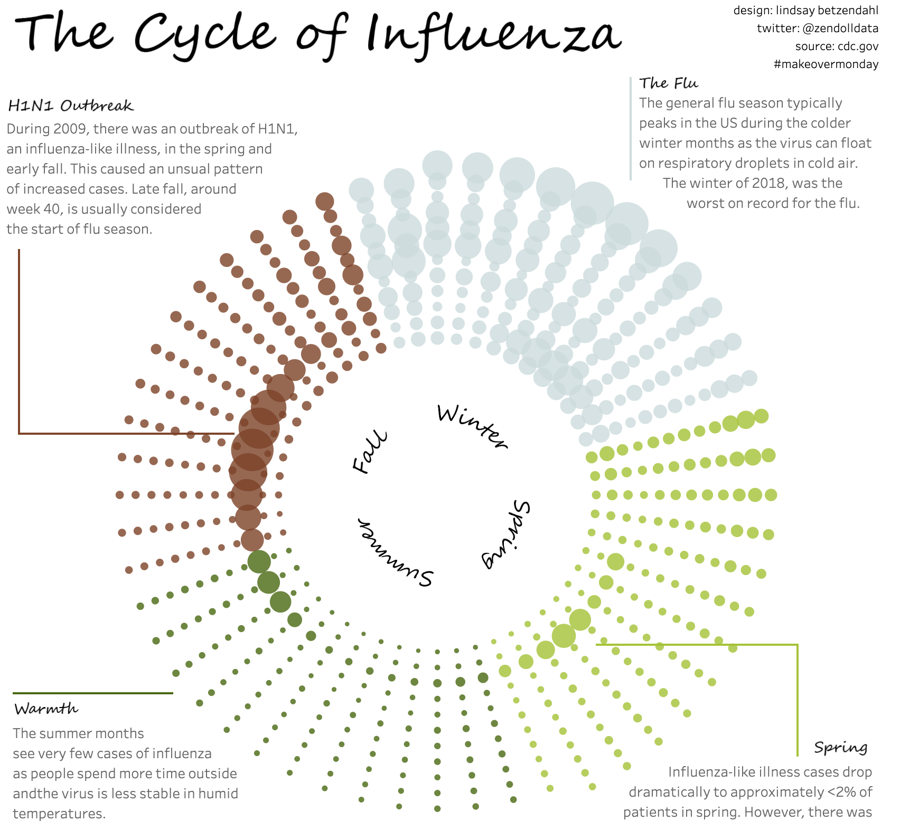

Original source: <https://public.tableau.com/app/profile/lindsay.betzendahl/viz/InfluenzaSeason-MakeoverMonday/Influenza>