Camille Proszanski

214927891

Storytelling in graphs: The change of generations

A few days after class, I came across a blog that discussed the current proportional spread of the population in terms of generation in 2025 and expected in 2035 (See Figure 1). The graph consists of two core pseudo-proportional stacked bars that give the percentage that each generation accounts for of our population. However, the graph is also a time series graph, which tracks expected changes over the next ten years by attaching the stacked bar with a line to make a time series line graph. These connection lines highlight the story of the changing distribution of the generations by easily allowing the observer to see the change in slope. The graph would not have been as effective in conveying this message if the graph only depicted the stacked bars. Also, because the article's audience is the general public rather than academia, the graph is more of an infographic and includes images to represent each generation. The images for each generation help to visually show the difference in age between them and adds to the story that as time passes, the generational spread changes as the older generations die off.

One issue is that on the graph in the middle of the ten-year transition section, the current age range of each generation is given, which could be confusing as it might be misinterpreted as the change in age over this period due to its placement. Overall, the graph does a very good job of expressing the story it is trying to tell in a very visually appealing way.

Referance

Venditti, B. & Diederichs, A. (2025, January, 17). *Visualizing the global population in 2035, by generation*. Visual Capitalist. https://www.visualcapitalist.com/visualizing-the-global-population-in-2035-by-generation/

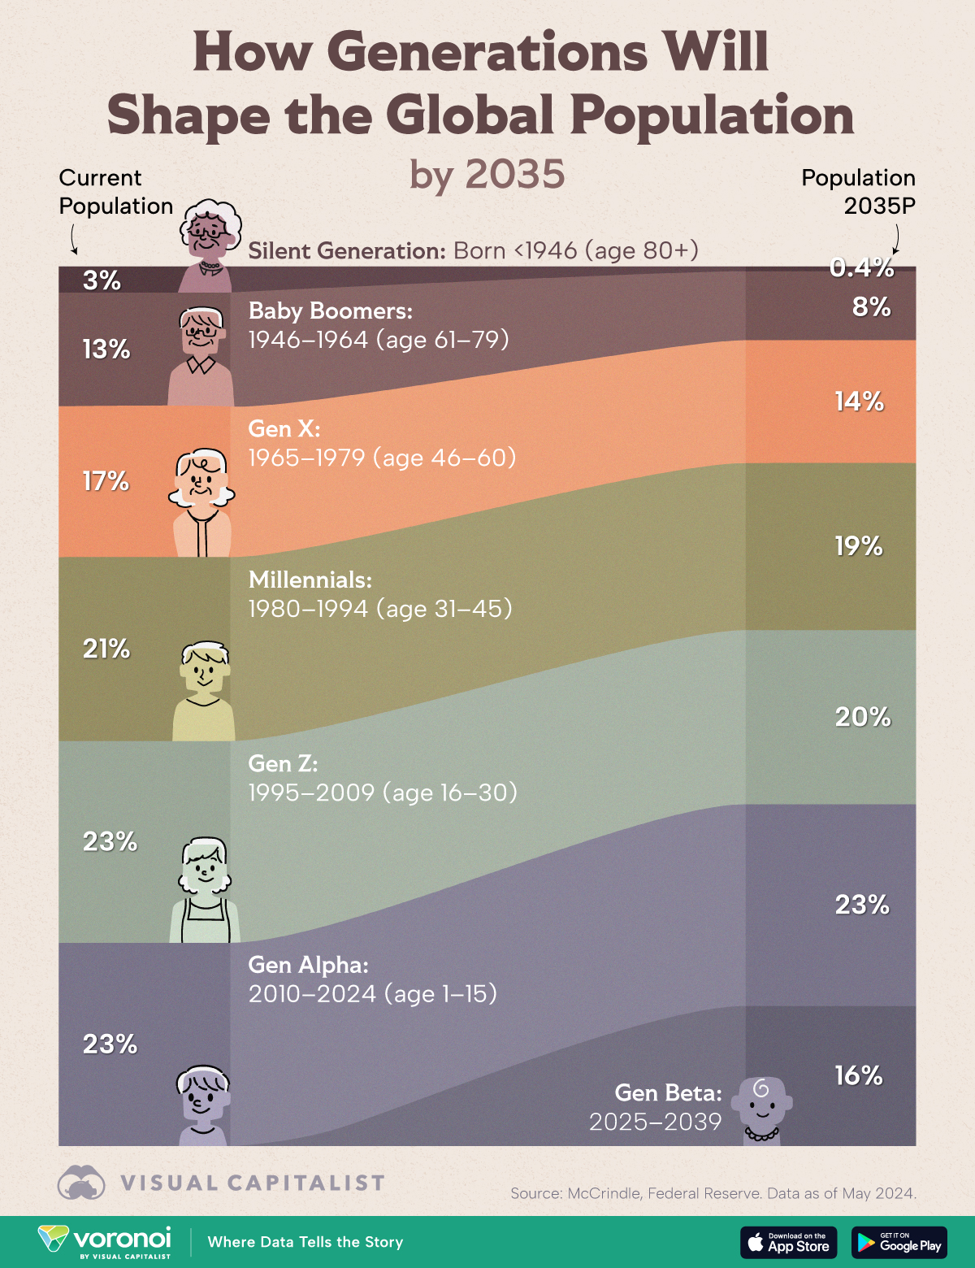

Figure 1. Global population represented by generation in 2025 and 2035