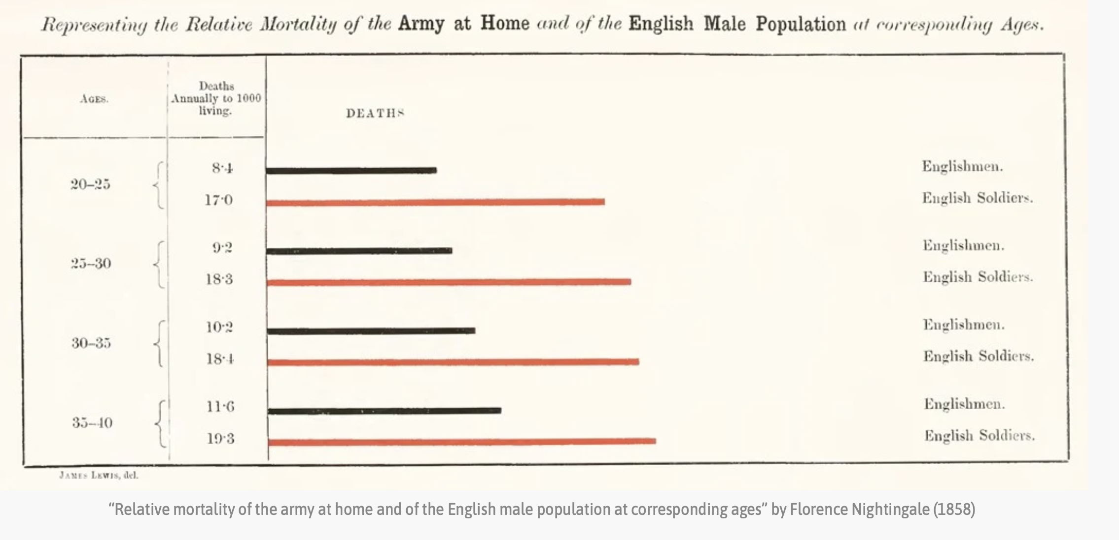

The success of this graph pertains to how the number of deaths between civilians and soldiers can be compared per age category, and they provide the magnitudes of deaths for reference. However, this graph can be improved by: adding a horizontal axis with values and labels to improve the ease of comparison; clarifying whether 'deaths annually to 1000 living' refers to 1000 persons in the general population or 1000 persons within the solider or civilian group, respectively; maintaining the graph in black-and-white exclusively (removing red colour and replacing with a black-and-white pattern) for accessibility reasons; adding a legend for the bars instead of labeling the bars redundant as civilian or solider;  clarifying whether the in-between-points of age (25, 30 etc.) are including in one age category or another; and perhaps adding an indication of variability such as variation, SD, or error.