README: Figure Notes

This folder contains the image files for our book, taking account of figures that have been deleted in this version. It also reflects the comments of the TNT consultant and our subsequent work to try to resolve some of these problems.

To do this, I

* re-ran nearly all of the R code files for “author graphic”s to give 300 dpi PNG files as well as vector graphic SVG files that were requested.
* found higher resolution images of some historical images, at the expense of larger file size.
* included the subfigures used to compose a given figure as separate files within this folder.

This is not an ideal situation. In all previous books, I’ve delivered a complete set of text files together with all associated image files in a **single** format that works for production, given that all images would derive from one LaTeX source. As a result of the requirements from TNT/HUP, there are now several versions of a given source image.

In passing, I note that the TNT consultant often commented on the quality of historical images: "Need higher quality image. All text, lines and shapes pixilated. Could be redrawn." In a few cases we were able to find higher resolution images, but for the most part images from this history are what they are. It might be possible that a few of these could be enhanced from our digital files, but re-drawing is a last option because we want readers to appreciate these graphs & charts in historical context. We will resist requests to delete some important historical images simply because the available images “are not in the resolution”. Going forward, let’s work on this together.

# Submission

This submission is designed to allow HUP to assess the images and assist in obtaining permissions. It consists of:

* A ZIP file, **TOGS-figs-all.zip**, containing 186 figure versions for the 126 numbered figures.
* A spreadsheet, **art_log2.xlsx**, giving the details of those figure versions

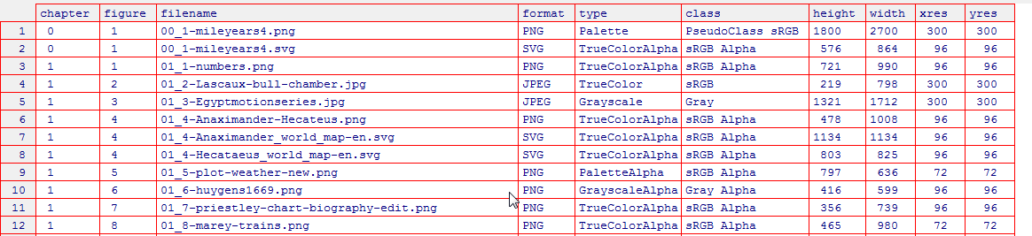

* An updated version of our **art_log.xlsx** file, giving details of the 126 numbered figures in the book. Because some figures use LaTeX \includegraphics{} to compose two or more separate images side-by-side, there are 135 images listed here on the **figinfo** tab.
* In the same **art_log.xlsx** file, the **sources** tab gives the \source{} information extracted from our text, to be used for determining permissions.

# General notes

All figures in this **figs/** folder have been renamed to reflect the figure numbers in the current ms. as well as content, in the form ch_fig-file.ext, e.g., **00_1-mileyears4.png**

In quite a few cases we have included several versions of the same image. One common case is where we created these in R software and saved these in high-res (300 dpi) PNG bitmap files and also in vector SVG files. In our LaTeX files, itis not easy to use SVG files directly, so we use the PNG files in what becomes the PDF file for the book.



A different simple case is where we had a high-resolution version of an image of large file size, but chose a smaller version of the same figure to include in the ms. In most cases, it is hard for us to see any difference between these versions on screen, but publishing considerations may want to use the larger version.





Another situation arises where we have two or more separate images and want to compose these into a single figure for the book. This could be done directly in LaTeX with two or more \includegraphics{}, or else composed in a combined figure, e.g., with PPT and used in this PNG form.



One more example of this is in Fig 4.8, where we wished to show a facsimile of John Snow’s cholera map together with a zoomed-in portion. The **–combined** version is used in the text and we think this is sufficient.



# Remaining problems

**02_3-timeline.png** – this figure was first drawn as a simple timeline using R, then annotated in PPT and finallly screen-captured to an image. The resolution still isn’t great, but maybe it is sufficient. I now provide the basic version of the timeline as **02_3-timeline-basic.{png,svg}.**

**02_4-langren\*** - these are two tables, but I wanted to put them side-by-side for direct comparison~~. In this version, I have prepared higher-res versions of these as images and also formatted them as tables: Table 2.1. Image size can be easily controlled; table size is more difficult. Deleting Figure 2.4 in favor of Table 2.1 would require re-numbering all remaining figures in this chapter. This is your call.~~ These are now two LaTeX tabulars, produced as one table. Figures here need to be re-numbered/

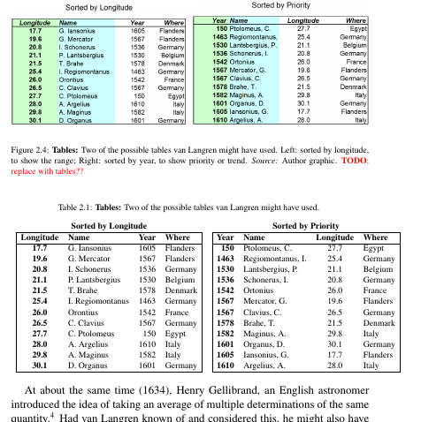

**05_12** and **06_5** are the same figure. In the interest of reducing figure count, the latter could be deleted; this would entail re-numbering all remaining figs in ch 6.

**06_22-nobel-prizes.png** is a screen-capture from the Maurage et al. 2013 article. We could try this again with a higher resolution (300dpi), or else include only two of the subfigures.