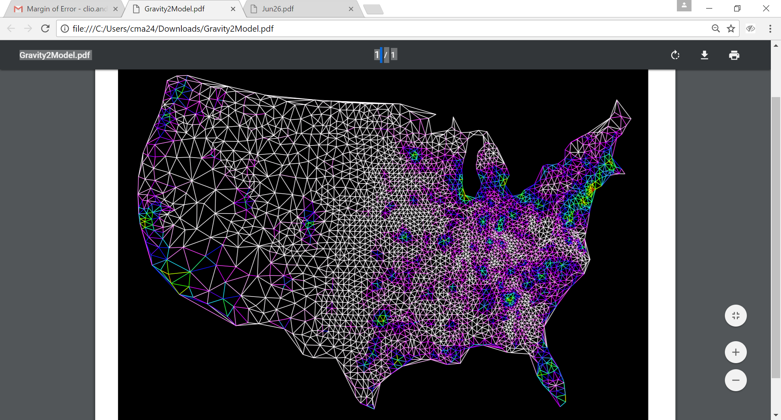

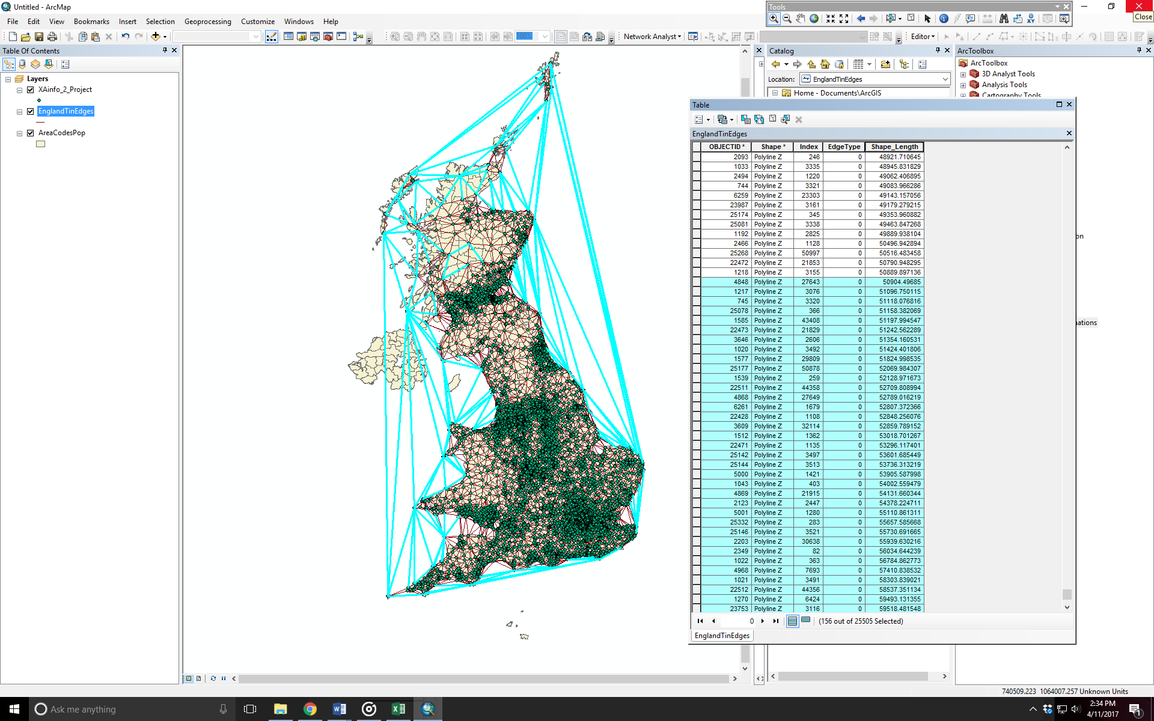**Lattices**

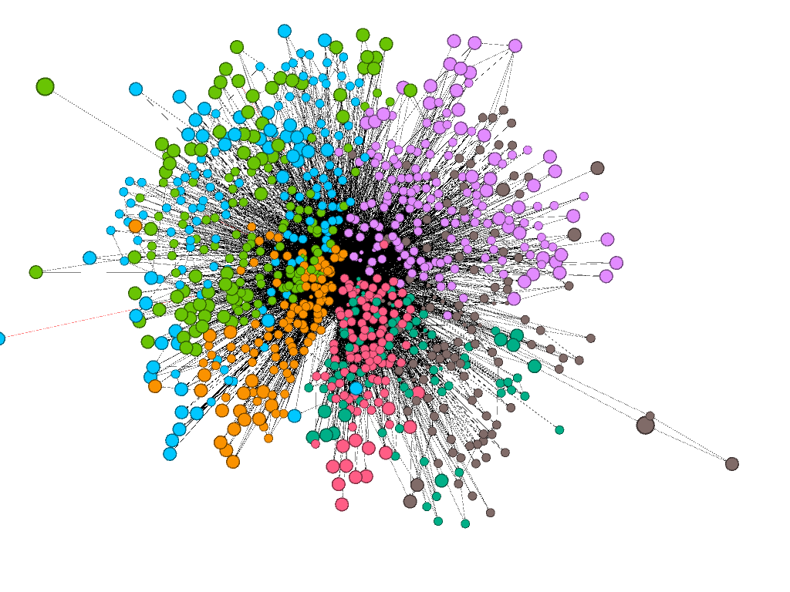

NAME______________________

DUE _______________________

**Objective:** Examine a region in terms of pairs of places that are well-connected via migrants and commuters. Build a lattice that defines these values. Which areas do you think information or disease will diffuse quickly though? What boundaries tend to preclude connectivity?

**Part 1: Preparation**

**Step 1:** Bring in data: Open the points called **classLab_MSOAs** points. MSOA stands for Middle Super Output Area. This is United Kingdom census data that can be found at the U.K. Office of National Statistics.

1. These data are populated with the following fields:

______________________________________________________________________________________

**Step 2:** Open the file called **MSOA_connections**

1. What kinds of data signify **potential** and **actual** interaction between two **MSOAs**?

**Potential interaction ___________________________________________________________________________**

**Actual Interaction _____________________________________________________________________________**

**Part 2: Creating a Lattice**

**Step 1**: Go to **3D Analyst 🡪 Data Management 🡪 Create TIN.** The coordinate system will be British National Grid. The input feature class should be the MSOAs and the Z factor should be population. (You could actually do any Z factor that you want as long as the variable is numeric.)

**Step 2:** Then go to **3D Analyst 🡪 Conversion 🡪 From TIN 🡪 TIN Edge**. Now we will just extract the lines out of the TIN. Take the defaults but make sure to save it in a place where you will remember it, and call the file **UK_Lattice**. You’ll no longer need your original TIN.

1. Tin Cleaning: Our next step is to remove some of the connections created by the tin that we no longer want. What is the min edge length in the lattice? _________________________
2. What is the approximate length of the LONGEST edge that we should probably keep because it connects nearest neighbors? ________________________________

**Step 3:** Open an Edit session by going to editor, start editing. Remove the extra lines per the directions below. (Before editing you may want to export a copy of the original).

Tip: With irregular polygons (polygons that are not squares, circles, etc.), the TIN will try to connect places that you don’t consider part of a functional ‘lattice’ (connections that signify nearest neighbors). Cleaning TINS can take some subjective decisions. One first-pass way of cleaning the TIN is to remove the longest edges. However, this is something you have to be careful about doing, because long edges can be found in the mainland as well—and we don’t want to necessarily remove these! After this step, a second-pass method is to isolate and remove edges that don’t intersect the land (sufficiently). With this method, however, you have to decide which water-forging ties to keep (i.e. how far over the water—or other country!—you can consider two places to still be functionally-connected). You don’t necessarily want to get rid of ties that cross a river, if the points on either side of the river are a clear nearest neighbor.



**Part 3: Attaching Data**

**Step 1:** Ensure that your **Lattice** has a spatial projection. If not, go to *Data Management 🡪 Projections and Transformations 🡪 Define Projection.* Define it as British National Grid.

1. It’s hard to spatially-join points to lines. What is one potential work around for this?

________________________________________________________________________________

1. Create a buffer for the MSOAs and call this file **MSOA_buffer**.
   1. Think: What is the largest buffer you can “get away” with? ________________________________________________
   2. 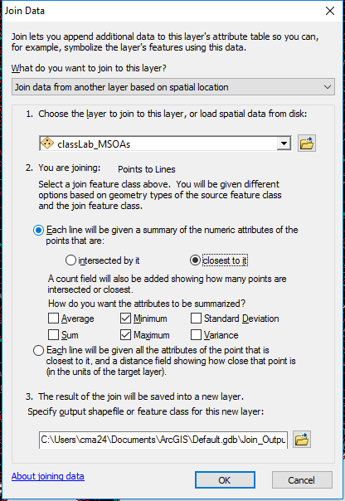And what do we mean “get away with”? ________________________________________________

**Step 2:** Click on your lattice and select join 🡪 spatialjoin. You’ll join your lattice to the MSOA nodes, so that the edge picks up the MSOA ID on either side. Choose MSOAs as the layer to join to the lattice. Then select that lines will be given a summary of the points closest to it. Choose both minimum and maximum summary attributes. Since one MSOA id has to be bigger than the other (on each edge), you should come up with both! Call this **Lattice_MSOAs**. (see image)

1. What does the count field mean in **Lattice_MSOAs**? _________________________________

**Step 3:** Delete fields off of Lattice_MSOAs, such as Min and Max Shape Length and Area, as these are just artifacts of the buffer. Shape Length, FIDs and OIDs can be deleted as well.

**Step 4:** In Lattice_MSOAs, create a new field called Concat. This is short for concatenate, which is a stringing together of different strings. We’re going to make a string of ‘node1’_’node2’, so we can identify each edge and join it to flow data. Since the network is NOT directed, we don’t have to do the opposite this time. Another time, you’ll need to do another concatenated field that looks like ‘node2’_’node1’. In the Field Calculator for field Concat, type: [Min_PXA] & "a" & [Max_PXA]. Here, a is the delimiter. In another exercise, you could also use an underscore, or other character (no numbers).

Now, join the connectivity data **MSOA_connections** to the **Lattice_MSOAs** on the concat field. Now you have data on the number of migrants and commuters on this lattice.

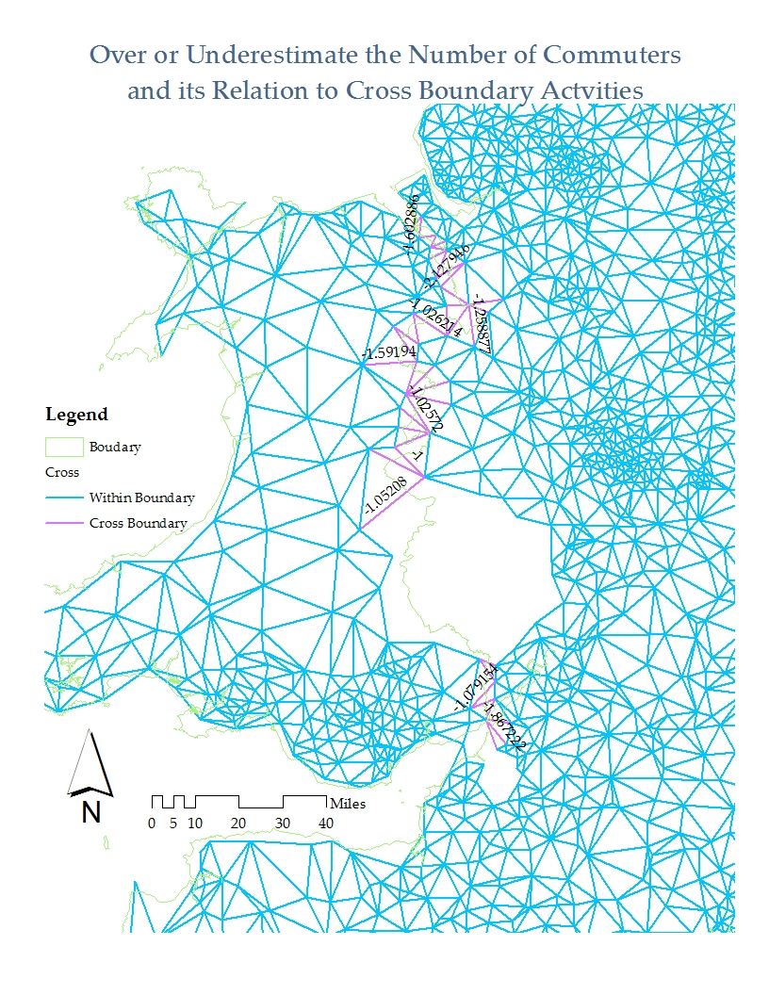

**Part 4: Quantifying the “Pull” of the City**

The goal now is to explain the extent to which urban area boundaries (called FUAs or Functional Urban Areas) under the shapefile *UK_FUAs.shp* hinder network connectivity. There are also URAUs to look at too, for context (called *UK_URAU.shp*) You have a number of tools from this class to work on this problem. For example, you can create a gravity model, and you can use spatial joins to join spatial features to the edges. Be creative. Your final report should have good figures, scatterplots, a T test, etc.

Functional Urban Areas and URAUs come from: <http://ec.europa.eu/eurostat/web/gisco/geodata/reference-data/administrative-units-statistical-units> ).