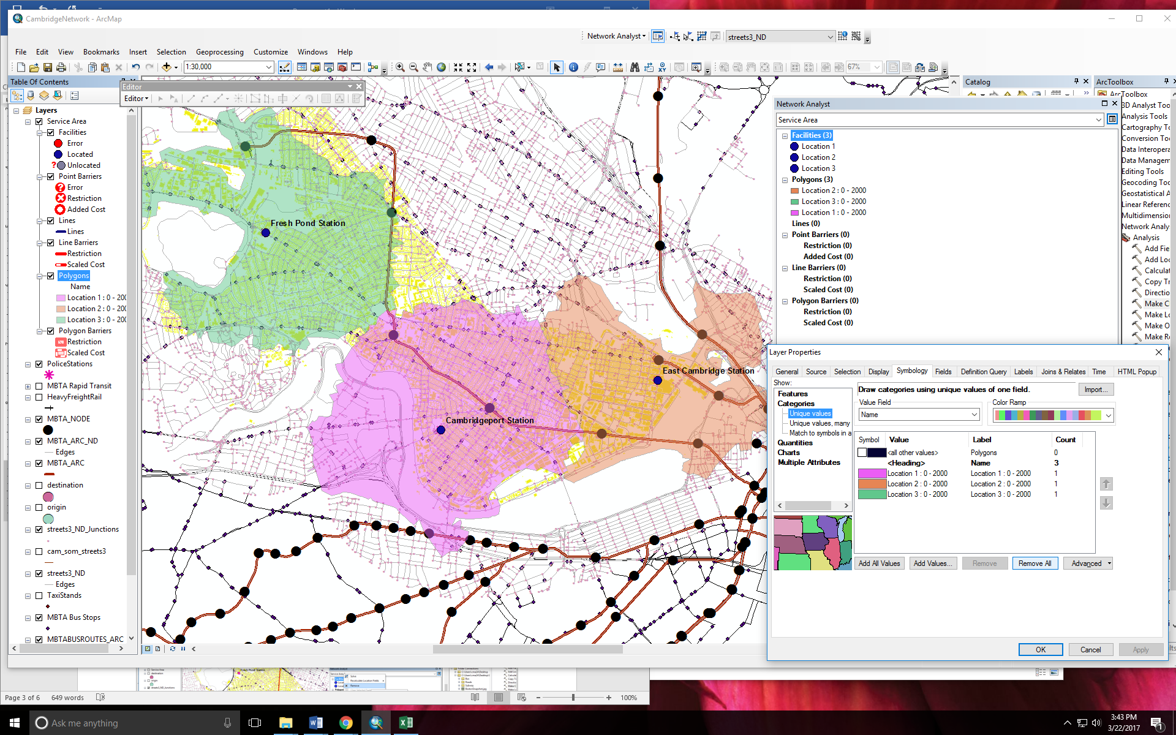

**Urban Road Networks & Facilities**

NAME______________________

DUE _______________________

This lab will examine our first set of planar networks in GIS. These networks represent how traditional “spatial networks” are used in GIS, and therefore, there are built-in tools in ArcMap for their analysis. We will be modeling network cost, i.e. travel cost, delineating service areas, creating routes and finding new facilities. The lab takes place in Cambridge, MA., as the state publishes great data for that area.

**SECTION 1**

**Part 1: Set Up**

**Step 1:** Bring in the files from Canvas into ArcMap.

**Step 2:** Turn on the Network Analyst extension is turned on by going to **Customize 🡪 Extensions.**

**Step 3**: Load the Network Analyst toolbar by going to **Customize 🡪 Toolbars 🡪 Network Analyst.**

**Notes:** You can read a lot about the Network Analyst tools online if you are interested in using these tools in the future. http://help.arcgis.com/en/arcgisdesktop/10.0/pdf/network-analyst-tutorial.pdf These tools can be really helpful, and can provide new insight into a project. A network dataset is required for network analyst. You can make a network dataset from any line file where there are intersecting lines. In this lab, the network has already been made for you.

**Part 2: Service Areas (Police Turf)**

In Cambridge, perhaps there are three police stations, called PoliceStations.shp. These three stations are battling for coverage of different turf in the area.

**Step 1:** Open the Network Analyst Analysis window (watch the demonstration—it looks like a second table of contents) (there’s an image at the bottom of this document).

**Step 2:** Ensure that the Streets3_ND (ND stands for _______________) is used as a baseline—you’ll know this because it is selected and visible on the toolbar.

**Step 3:** In the toolbar, click **Network Analyst,** then choose **New Service Area**.

**Step 4:** Drag the police stations layer onto the **Facilities**heading of the analysis window.

1. Note the search tolerance of 5000 meters. What is the search tolerance? ___________________________________________________________

**Step 5:** The Operation Properties is a tiny button in the top right hand corner of your Network Analyst **WIDOW**. Use the operation properties to set up your analysis parameters.

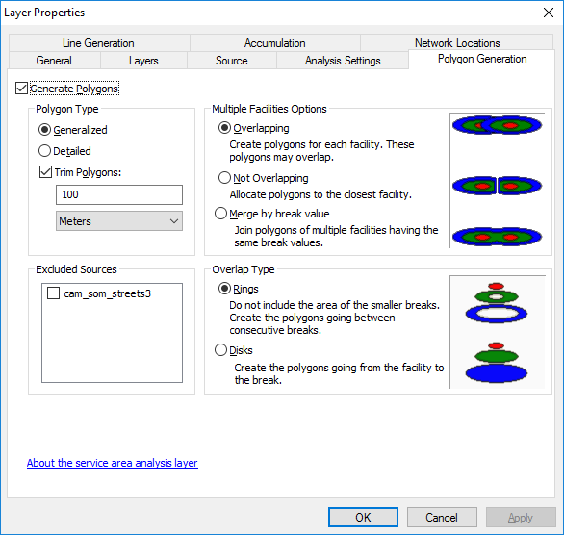 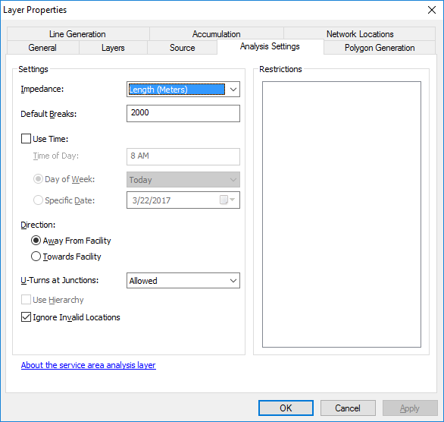

1. Note the impedance factor of 1000 meters. What is the impedance factor? ___________________________________________________________

Is 1000 meters generous or a little bit conservative? ___________________________________________________________

**Step 6:** Click **Solve**—it’s a button on the toolbar that looks like a grid with a route going through it. After you click **solve**, there will be polygons that pop up under your Service Area results in the Table of Contents.

**Step 7:** Open the attribute table for the service area polygons. Choose a numerical field that already exists. Overwrite that field’s value by right clicking on the field heading and choosing **Calculate Geometry**.

**Calculate the area in kilometers. Use State Plane—the default.**

**On Your Own; Step 8:** The police tell us that we are underestimating their amazing reach. Create a new Service Area the same way you did in Step 3. This will be called Service Area 2, automatically. Rename this to Wide Service Area in the Table of Contents.Repeat this process for 2000-meter impedance factor.

1. What are the sizes of these service areas of the three police stations for 1000 meters and for 2000-meter service areas? List them by station.

_______________________________________________________________________  
_______________________________________________________________________

_______________________________________________________________________

Figure 1: Make a map of the service areas for both service area lengths and label the police station **and the station size (you can do this under label – expression)—I will demo**. In your description, point out a few places that the geometry of these polygons differs from what a Euclidean distance buffer (I.e. a circle) *would* have created.

1. Extra Credit (up to 5 pts) Where is the contested turf? Make a shapefile of it, a brief map and find the amount of area (number of km^2) that is contested.

**Part 3: Closest Facilities (“Routes”)**

The police are now bragging about who has to travel the farthest to respond to an incident. We will now find the longest route that each has to travel.

**Step 1:** *First, we have to delineate who will reach each node.* In the toolbar, under Network Analyst, where you found the **Service Area**, now click **Closest Facility**. Your Facilities are still the police stations, so drag and drop those into facilities. Your Incidents will be each node intersection that exists: Drag and drop **Streets3_ND_Junctions into Incidents.**

How many Streets3_ND_Junctionsare there? ________________

**Step 2:** It will take a little while to load. Click Solve.

1. How many routes were there? _________________ .
2. Could the police stations reach every node? How many nodes did it miss? _______________________.

**Step 3:** Since you are a curious student, you want to know which nodes couldn’t be reached. To do this, open up your attribute table of the **Routes,** which lives under the heading **Closest Facility.**

1. Can you recognize an ID that might relate back to Streets3_ND_Junctions: what is it called _______________________?

**Step 4:** Now join this data back to your streets3_ND_Junctions to see where those missing destinations were. Sort the data by your “null” values, and highlight the nulls.

1. What do you make of this problem? Is it a periphery issue? A software issue? Are the nodes off the road?

__________________________________________________________________________________________________________________________________________________________________________________________________________________________________________________________________

*Now we will find the longest route.*

You can drop your table join.

**Step 5**: In **Routes**, symbolize each route segment by the **Facility ID**. Make them three different colors, like you did with the service areas above.

Importantly, are lines on top of lines here? _________________________________________

**Step 6:** Right click on routes (not in the attribute table). Export your routes as a shapefile called *ThreeStationRoutes*.shp.

**Step 7:** Open ArcScene.

**Step 8:** Add *ThreeStationRoutes*.shp. Open the properties. In the symbology, make them three different colors. Go to the tab called *Base Heights*. Go to “Elevation from Features” and “Use a constant value or expression:”. Choose [IncidentID]. Press OK.

1. What do these lines represent? ____________________________________________________________________________________________________________________________________________________________________________

Now, find the longest routes for each station.

1. What is the longest route for each station? (make sure to use units). __________________________________________________________________________________________________________________________________________________________________________________________________________________________________________________________________

Figure 2: Make a map or a cropped screen cap of your ArcScene routes. Make the longest routes in Bold Red. *(hint: select these three routes, to go create layer from selected feature, add the same base height).*

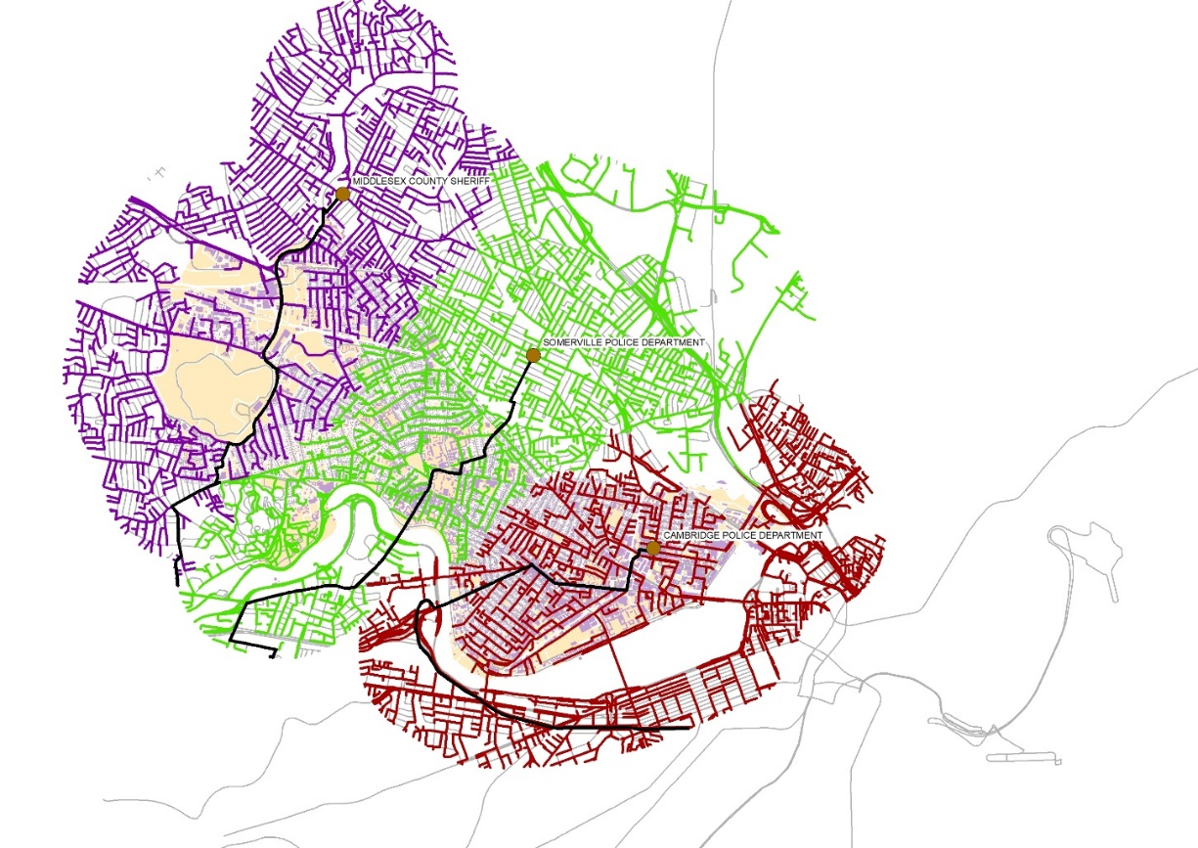

**Figure: The longest possible routes from a police station to an intersection for the three police stations, visualized in 2D.**

**SECTION 2**

**Part 1: Responding to an Incident**

An incident has occurred! There is a very loud pizza party in Massachusetts! The police really like pizza and they are all trying to get to the party first to collect delicious evidence. It’s unclear which station will be the first to respond to the incident (i.e. the fastest drive time, and here, the shortest distance).

**Step 1:** In the network analyst toolbar, click **New Closest Facility**. In your **Operation Properties (that little icon in the corner)**, go to the **Analysis Settings** tab and change **Facilities to Find** **from 1 to 3**. This makes sure that all police stations will be counted, not just the closest one.

**Step 2:** Drag the *PoliceStations.shp* into the **Facilities** folder, as you’ve done.

**Step 3:** Find out where you want your party to be at. Load some of the historical buildings and label them. Highlight a node at *streets2_ND_Junctions* (using your selection tool), where that party will be! Now load *streets2_ND_Junctions* as your **Incidents**. Only the selected one should pop up.

**Step 4:** Press solve. The result will be a route, i.e. a set of lines. When you look in the attribute table for this route, you’ll see the distances associated with each line segment.

1. What police station could get to the incident first? (Hint: highlight the route in the attribute table, and the highlighted line will lead you to that police station). ____________________________________________________________________________________________________________________________________________________________________________
2. What is the distance each travels to get to the incident?

____________________________________________________________________________________________________________________________________________________________________________

1. If each car travels one meter per second, how much after the first station’s car arrives, will the second station’s car arrive?  
   ____________________________________________________________________________________________________________________________________________________________________________

Figure 3: Make a map of the three routes. Include nice labels (station name, distance to travel) instead of a legend. Include a figure caption!!

1. If are 500 slices of pizza left when the **second station** gets to the incident, and each station **eats 10 slices of pizza a minute**, how many slices will be left when the **third** (finally) shows up. **Show your work.**

______________________________________________

**Bonus, 3 pts:** How many slices did the FIRST station get to eat before the second station showed up? _____________________________________________ **Show your work.**

**Part 2: A New Facility**

Since the police ate all the pizza and did not put it into evidence like protocol, they are now being punished by having to consolidate into one single station.

**Step 1:** In the Network Analyst window, select Location-Allocation. Your facilities will be the network nodes *streets3_ND_Junctions*. Your demand points will also be *streets3_ND_Junctions*.

**Step 2:** Press solve.

1. I will now demo 3 facilities. When we had three facilities to find, where were the target placements? Was this the best thing for the city, or did it depend on the connectivity of the network? ____________________________________________________________________________________________________________________________________________________________________________________________________________________________________

**Step 3:** Now we will see what kinds of coverage is lost or gained by this new decision. For the “before” you created these when you did “Closest Facility” last week. The routes had a distance associated with them. Now you will do this again. With this one new station.

Use the selection tool to select the green square that is the new facility. Right click in the attribute table and make it its own layer. Call this **NewFacility**.

Perform “Closest Facility” again (It will be called Closest Facility 2, but rename it to ClosestNewStation) with **NewFacility** as your Facilities. Your incidents be *streets3_ND_Junctions*.

**Step 4:** Open both attribute tables for both **Routes**, the Closest Facility and ClosestNewStation. Sort by length and see that they have different max values. Open your graph in one of the attribute tables and make a box and whisker plot based on length. How can you add two box and whisker plots on the same chart? At the bottom of the window, it says Add, click that and click New Series. Add both **Total_Lengths** one by one so you have two box plots.

Figure 4: Put your two box plots in here. Add nice labels and a caption.

How long does it take to get to the nodes?

|  |  |  |
| --- | --- | --- |
| Percentage of nodes | Before | After |
| 50% of the nodes |  |  |
| 75% of the nodes |  |  |
| ~100% of the nodes |  |  |

1. Instead of percentage of the nodes reached, what other statistic could we calculate? (hint: flip the unit of measurement) **__________________________________________________________________________**
2. Would you tell a policy person to move the station? Why or why not?

**____________________________________________________________________________________________________________________________________________________________________________**

**Part 3: Creating OD Matrices**

Now we will create OD Matrices to show the cost of getting from a set of locations to another set of locations.

**Step 1: Go to** <https://www.cambridgema.gov/GIS/gisdatadictionary/Landmark> and download a point shapefile that interests you.

**Step 2:** Under Network Analyst,go to New OD Cost Matrix.

1. **What does OD stand for? ________________________________________**

In your Operation Properties, under the Accumulation tab, click on Junction Count (JunctCount), and Turn Count (TurnCount) and length.

Put in the shapefile into both **Origins** and **Destinations**.

**Step 3:** Press solve. Open up the **Lines** table. Note that the lines don’t reflect the actual routes, but are just there to guide you.

1. Describe your results in a short paragraph. Use numbers and specific names of places**. ________________________________________________________________________________________________________________________________________________________________________________________________________________________________________________________________________________________________________________________________________________________**

**SECTION 3**

**Part 1: Solving the TSP Problem (What does TSP stand for?)**

Step 1: In the toolbar, click Network Analyst, then choose **New** **Route**.

Step 2: Drag the *PoliceStations.shp* into the **Stops** heading of the analysis window.

Step 3: Keep the node of *streets2_ND_Junctions* (using your selection tool), highlighted to show where that party was!!!

Load *streets2_ND_Junctions* into **Stops. It should immediately become the last stop.** Ensure that it is both the first stop and the last stop. (You may have to copy and paste it to get it to do this.)

Step 4: Use the Operation Properties **WIDOW** not TOOLBAR. (That tiny icon). Check   
“REORDER STOPS TO FIND OPTIMAL ROUTE”, and “PRESERVE FIRST STOP” ALSO CHECK **“PRESERVE LAST STOP”. (it is not checked in the screen cap, but check it).** Select OK.

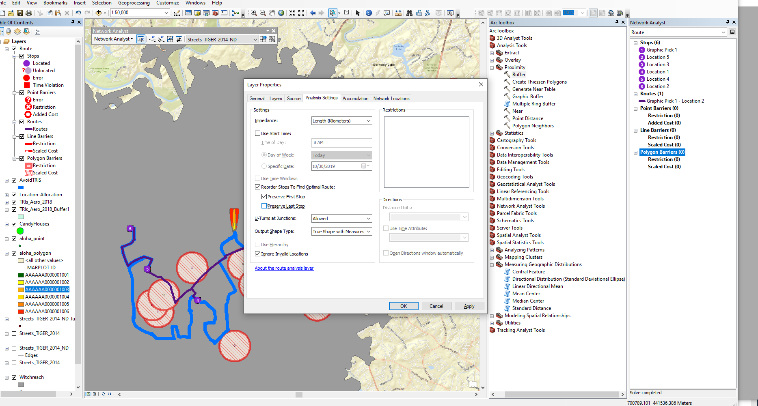

Step 5: Click “run”.

Open the Route attribute table.

Figure 5: Screen cap your TSP results.

1. Is this a Hamiltonian path? Is it a Eulerian path?

____________________________________________________________________________________________________________________________________________________________________________

1. What is the total distance of your path? Did it take the route you expected? Could it have taken other routes?

____________________________________________________________________________________________________________________________________________________________________________

Step 6: Re-run the process **without** checking “REORDER STOPS TO FIND OPTIMAL ROUTE”.

1. Did you get a different answer? What is the new distance of this route? (Is it longer or shorter than your optimized route?)

____________________________________________________________________________________________________________________________________________________________________________