April 2011
Newsletter 39
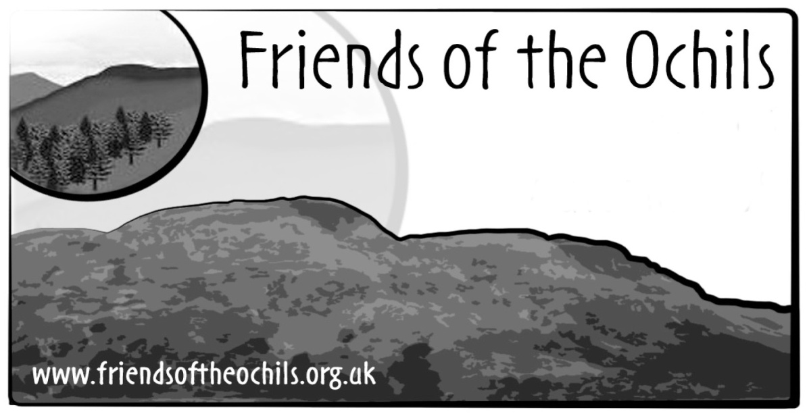
Chair’s report – Stuart Dean

Once again I have to report on a number of significant Ochils developments. Some are very positive and give hope that the Ochils landscape will be enhanced, whilst others could result in further significant damage.

The complex and convoluted processes that will determine the mitigation measures for the Beauly to Denny power line continue, and these are detailed in Nicki Baker’s piece. However, with elections to the Scottish Parliament looming, it will obviously be some time before we know the outcome of the discussions and negotiations that will determine the future of the line around Stirling, and through the Ochils landscape in particular.

The Ochils Landscape Partnership stalled somewhat earlier this year, due mainly to the need for Clackmannanshire Council to review, along with other councils, its future budgets. However it is good to be able to report that the partnership is now back on track and we look forward to working with our partners in developing the many projects that will help to enhance the Ochils and their accessibility. The Hillfoots Way, which FotO proposed, continues to receive widespread support and we look forward to the establishment of this route between Muckhart and Logie Kirk.

In preparation for the next Local Development Plans, the three councils covering the Ochils – Perth & Kinross, Stirling and Clackmannanshire – have all consulted on their Main Issues Reports (MIR). We have responded to all three and our comments are available on the FotO website. As well as dealing with specific issues raised in the MIRs, we have tried to get across to each of the three councils the importance of them working together to ensure a single approach to the Ochils landscape. We have stressed the importance of moving away from the patchwork of designations, such as AGLVs, which exist at present and agreeing on a single landscape designation for the whole range. We have also raised the idea of designating a park status to the Ochils. It is a small beginning but one which we can build on in future discussions with relevant individuals and bodies.

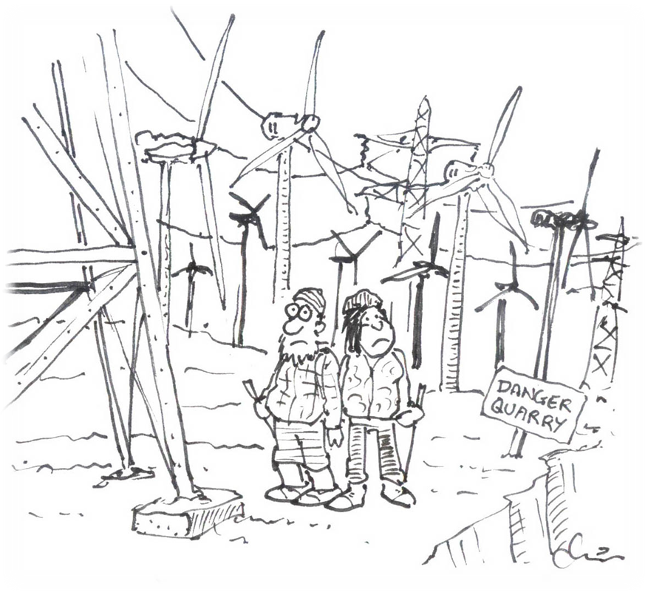
On a less positive note we are continuing to deal with planning applications for wind turbines in and around the Ochils to be established under the Feed in Tariff Scheme, and we have submitted objections where appropriate. The lack of a coherent planning policy within the Councils on such applications does not help, but we have tried to point out in our responses that a scattering of individual turbines, each of which could be well over 45 metres in height, would have a negative impact on the landscape not dissimilar to a single wind farm.

We have also objected to the proposed 125 metre high turbines at Forthbank, just outside Alloa. It was gratifying to read in many of the objection letters sent to Clackmannanshire Council just how damaging many felt the turbines would be on views of the Ochils from further afield. We reflected those concerns in our letter of objection, as well as expressing concern about the cumulative impact of the turbines with the many other wind farms visible in and from the Ochils.

Finally, let me update you on the application for a quarry in Glen Quey, near Glendevon, about which I wrote to you earlier in the year. First of all may I thank the many members who responded with their own letters of objection. Over 100 such letters have been received by Perth & Kinross Council and these will have helped enormously to raise concerns, as will the communications that many people had with local MPs and MSPs.

A very effective campaign has been superbly led by FotO member Malcolm Best, with huge support from local Glendevon resident Paul Evans, who has been very generous with his professional expertise in planning matters. His advice and in-depth analysis has enabled many aspects of the application to be challenged; many of his concerns were reflected in the vigorous and strongly-worded objection submitted by Clackmannanshire Council.
The Friends must be very grateful to them both for all their efforts. The ‘Stop the Quarry’ campaign has also been supported by local community councils and members of both the Scottish and Westminster Parliaments. Scottish Natural Heritage has also objected. The campaign, which commenced with a public meeting in the Muckhart Village Hall attended by over 70 people, has been accompanied by press releases that have ensured continued and effective publicity.

It is now incumbent on Perth & Kinross Council to decide how to proceed, but it is quite clear that the overwhelming view is that such a quarry would be extremely damaging from many aspects, not least its impact on the landscape of a beautiful and much visited area. We trust that not only do the Council turn down this application, but also remove all references to Glenquey Moss once and for all from future development plans as a site for mineral working... something we and others have asked that they do in our responses to the Perth & Kinross MIR.

At the time of writing we do not know when the PKC Development Control Committee will consider the application. However, it would be good if as many as possible attend the meeting when it does take place. The Council will be able to provide that information and we will do as much as possible to let you know the date.

Meanwhile enjoy the hills in the coming months!

Ochils Landscape Partnership – an update
In our last newsletter, we reported the welcome news that Clackmannanshire Council had succeeded in its bid for substantial funding from the Heritage Lottery Fund for the Ochils Landscape Partnership, in which our proposals for the Hillfoots Way – a signed footpath along the bottom of the Ochils, from Logie in the west to Muckhart in the east – play a prominent part. We expected then that things would proceed apace, with key staff being appointed quickly and the works starting to gain shape, but that was not to be.

There was a long period when nothing happened, and we didn’t know why. But it turned out that this was because Clackmannanshire Council had put a massive clamp-down on recruitment, while they considered just how they were going to deal with the huge spending cuts imposed over the next three years by central government.

Eventually, however, in February the Council made the necessary painful decisions, and these allowed the Ochils Landscape Partnership to continue as planned, albeit with a delay of some five to six months. The Council’s Julie Hamilton, who has line management for the project, confirmed that the Heritage Lottery Fund understands and is sympathetic to the reasons for the delay in starting, and will accept some time slippage. The latest news we have had, at a meeting in March, is that the advertisement for the Project Manager will be published very soon. Other posts will, however, be filled where possible from existing Clackmannanshire Council staff. Once again – we’ll keep you posted!
Beauly to Denny: and still it goes on…

The election is looming – challenge the candidates to offer their and their party’s clear support!

As you may recall, at the time of our last newsletter, in October 2010, Scottish Power had recently published its woefully inadequate draft proposals for visual mitigation for the proposed Beauly – Denny power line in the Stirling area. Company representatives went
on to hold a number of open meetings (several with a security guard sitting in, presumably
in case we all turned nasty!) and were roundly lambasted for the inadequacies of their imagination, and the paucity of the draft proposals, by just about all who attended or responded, as well as Stirling Council and some MSPs. Sadly, but unsurprisingly – given
all the history of this sorry saga – that didn’t really open Scottish Power’s eyes, or change
its mind.

The next move in this tortuous and apparently never-ending game was for Scottish Power
to bring forward formal proposals for visual mitigation, hopefully modified to take account of all the ferociously negative comments it had received. These proposals would be considered by Stirling Council, which would give its response after six weeks, and then finally it would
be for the Minister for Energy etc to make a decision as to whether to accept Scottish Power’s proposals.

All went very quiet for a number of months and, with an election looming, we knew that time was running out – no political decision can be made in the six weeks before an election (the so-called ‘purdah period’). Deadlines came and went; then all of a sudden, a few days before purdah came into effect, there was an announcement via the press that Scottish Power had in fact submitted its formal proposals to the Scottish Government several weeks previously and, as these showed little improvement on the draft proposals, Minister Jim Mather had rejected them unilaterally and was calling on Scottish Power to work with Stirling Council on revised proposals, including “consideration of partial undergrounding”!
Of course, this was a very exciting development, even though it actually promises nothing definite. Indeed, even though we know that SNP constituency MSPs Bruce Crawford and Keith Brown put in a lot of effort to get this statement from Jim Mather, the press tended to accuse them of blatant electioneering.

Scottish Power rejected Jim Mather’s response out of hand, on the grounds that in January 2010 he gave approval for an all-overhead line, and it is currently refusing to co-operate at all. Our QC suggests Scottish Power may put up a legal challenge to the situation. The Labour Party accuses the SNP of misleading the public, saying the line can’t now be put underground – even though local Labour MSP Dr Richard Simpson went on public record just a few months ago, calling for undergrounding. Stirling Council is considering its response – and we will have to once more wade through two large tomes of documentation, and write in with our comments to the Council.

So where do things stand right now? Heaven knows! But there’s an election coming up, so why don’t you go along to one or more of the public meetings that will be held by those who want to woo your vote, and ask them two straightforward questions:

- What is each candidate’s personal position on the still-outstanding question of the Beauly – Denny power line in the Stirling area and, most of all, on the section that goes through the Ochil Hills?

- What will be their party’s line on the Beauly – Denny question, should they get into power or into a coalition?

For many years now, we’ve had all-party support locally for our objections to the power line from individual politicians, and it is likely that this will continue (although Labour’s Richard Simpson has been elusive recently), but the recent statement by outgoing Minister Jim Mather (who is to retire at this election) is the first time there’s been any indication of support from anyone actually in a position of power. But what will happen after the election? Will we be back to square one, or will the new masters of power take a stand to force Scottish Power into responsible action to provide decent mitigation, undergrounding key sections, or – at the very least – doing as much as it conceivably can to provide mitigation for its immensely ugly and intrusive giant power line?

Watch this space… and challenge those politicians!

Minimal marks on Scotland’s mountains

FotO’s David Scott introduces new advice from the MCoS.

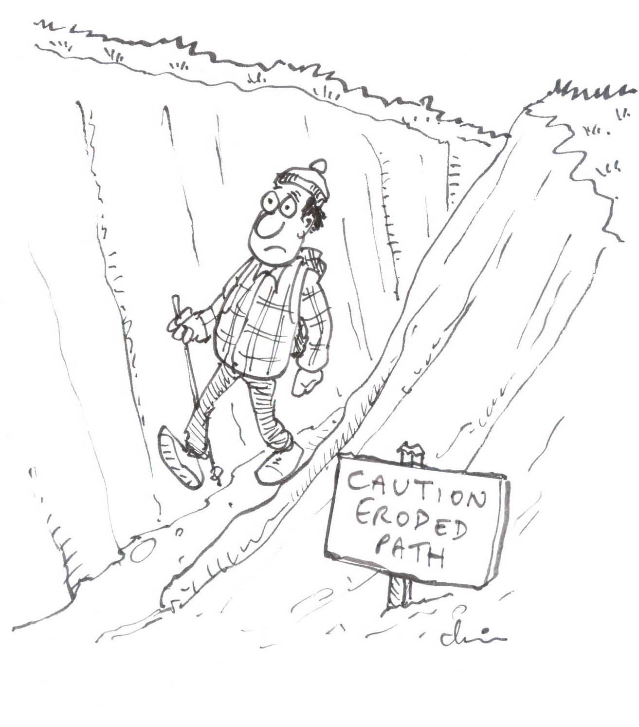
The Mountaineering Council of Scotland (MCoS) has recently published a guide to good environmental practice known as Minimal Impact Mountaineering Advice (MIMA). Access rights in Scotland are a balance of having statutory rights of access whilst exercising such rights responsibly, and MIMA aims to provide practical advice in this respect to outdoor users, in particular hill walkers and climbers.

MIMA includes sections on erosion, litter, sanitation, nesting birds, dogs, and camping; all of which are potential issues in the Ochils. The advice given is very much based on common sense and it seems that those most in need of it may be the least likely to read or heed it! Nevertheless, any attempt to pull together guidance on impact avoidance is to be welcomed and will hopefully lead to higher standards.

Erosion of paths can be a problem on the more popular routes in the Ochils, for example the main path up Dumyat. MIMA suggestions include trying less popular routes and either walking within or well away from erosion scars to avoid spreading the damage. Given that the advice is aimed mainly at walkers, there is no reference to erosion from mountain bikers, horse riders or other users, which again can be a problem in certain areas of the Ochils.

With regard to litter, the advice is to ‘take out’ what you ‘take in’. Food scraps, cans and bottles can all have impacts on wildlife. In terms of where to ‘go’, best practice is also to
‘take it out’ (!), failing which one should keep away from water courses, paths etc. Control
of dogs is of particular concern in the Ochils, given the presence of livestock, and the possible impact on nesting birds in the spring and summer – a damaged or disturbed nest may be abandoned.

The placement of memorials to departed loved ones on hill tops is a growing trend, and has also been seen in the Ochils. Feedback from mountaineers suggests that such artefacts should not be a permanent feature of the landscape, and advice is given on how this issue might be tackled.

Wild camping is a great way to experience the outdoors, especially if done in the true sense; that is, well away from roads and habitation, typically with light weight gear, spending no more than one or two nights in any one location, and leaving no trace behind of one’s stay. Sadly, irresponsible wild camping has become an issue in the Ochils in recent years, and has come to a head in Dunning Glen, with litter, disturbance and damage to property from large numbers of impromptu campers. The problem is receiving continued attention from the police and other parties, but a solution has yet to be found.

In summary, as the title suggests, Minimal Impact Mountaineering Advice is aimed primarily at those accessing the higher hills and crags on foot. Nevertheless, most of the potential impacts covered are of direct relevance to those getting out and about in the Ochils, whatever their particular pursuit.

Whilst the advice given is common sense to responsible access takers, the challenge as always is to get the message across to those who, for whatever reason, are unaware of the issues and do nothing about them.

Details are available at www.mcofs.org.uk/advice-and-policies.asp.

Do you have a story or a photo to share?
We’d love to hear from you!

Chair: Stuart Dean, Viewfield, Muckhart, Clackmannanshire, FK14 7JN. Tel: 01259 781551 begin_of_the_skype_highlighting, end_of_the_skype_highlightingEmail: spdean@lineone.net

Vice-Chair, Treasurer and Membership Secretary: Nicki Baker, Parkhead, Logie, Stirling, FK9 4LS. Tel: 01786 833399, begin_of_the_skype_highlighting Email: end_of_the_skype_highlighnicki@baker-pearson.net

