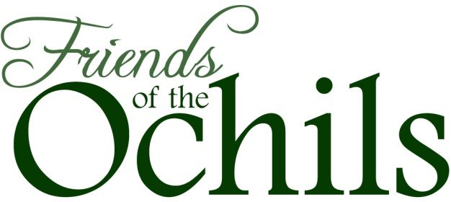 Membership form

How to become a ‘Friend’ of the Ochils

Please print off this form below, then fill in your details, sign the form and send it to us, along with either a cheque or the details to set up a Standing Order (including a second signature).

Your details

Title
Forename(s)
Surname
Address
Postcode
Tel
Email
Type of membership | Annual fee | Please indicate
Individual | £5
Family | £7.50
Concession (unwaged) | £3
Life membership (one-off cost) | £100
Corporate supporter (voluntary, community council) | £15
Corporate supporter (commercial organisation) | £50
Donation

Methods of payment

A) I enclose a cheque for: ________________________
(Please make cheques payable to Friends of the Ochils.)

B) Banker's Order
(Payments by standing order are a great help in reducing administration. To pay by this method, please complete this mandate.)

Name of bank
Bank address
Account number
Sort code

1 of 2
Please pay now and thereafter annually on the 1st November, to the Bank of Scotland, Dunblane (80-06-47) for the credit of Friends of the Ochils (a/c no.00423841) the sum of:

_________ pounds & _________ pence

Signed
Date

Gift Aid

If you pay UK income or capital gains tax, Gift Aid lets us reclaim tax on your subscription at no extra cost to yourself. One declaration covers all payments to Friends of the Ochils and remains in force until cancelled. You can write to us at any time to cancel it.

Signed
Date

Where to send it

Please post or email your completed membership form to our Vice Chair, Treasurer and Membership Secretary:

Dr Nicki Baker
Parkhead
Logie
Stirling
FK9 4LS
ochils@baker-pearson.net

Do you have any skills that could benefit the Ochils?

We are always looking for people to volunteer for our committee, or help with campaigns and events. If you would like to find out more, please send us an email with your skills and interests:

FotO Chair, Stuart Dean: spdean@lineone.net
FotO Vice Chair, Treasurer and Membership Secretary, Dr Nicki Baker: ochils@baker-pearson.net

Friends of the Ochils
Scottish Charity: SC022034

2 of 2

