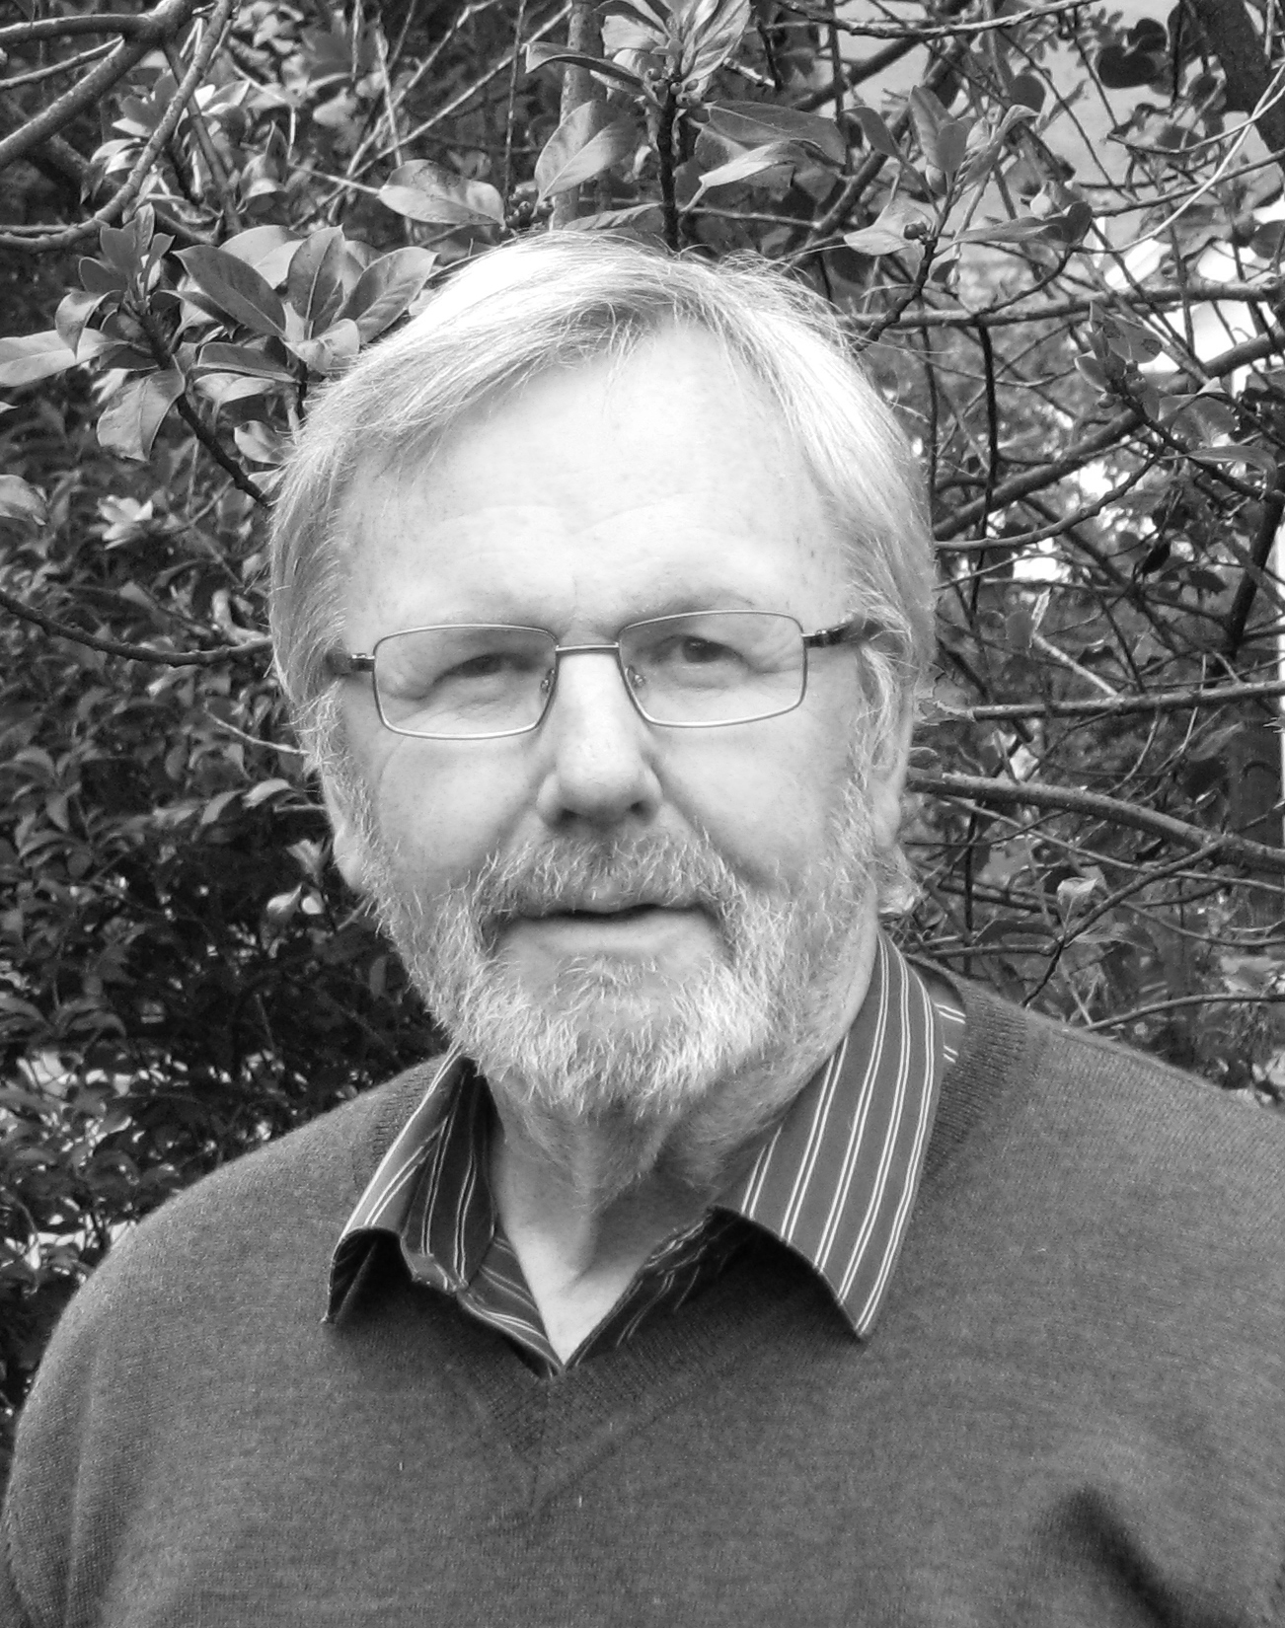
Chair’s
Report

Welcome to the Friends of the Ochils newsletter. We continue to be involved in many different developments in the Ochils and this report summarises those key areas on which we are focussed.

The Beauly to Denny power line will not be placed underground around Stirling, in spite of the huge effort put in by Peter Pearson, Nicki Baker and many others over many years. As Nicki’s piece makes clear, whilst mitigation measures will be put in place, they will offer little comfort for those who have campaigned for so long to avoid giant pylons marching across the western Ochils and down the scarp face to the west of Blairlogie. Nevertheless, there may be some significant gains to be made for the landscape if suitable landscape mitigation measures can be won from the Stirling Visual Impact Mitigation Scheme.

Decisions on other key developments have still to be made. As my piece on windfarm and wind turbine development details, there are something like 10 applications for the Ochils which, at the time of writing – mid October 2012 – are at various planning stages, but many are, as yet, undetermined. They range from the three applications to extend the Burnfoot Hill windfarm, through to three proposals at the scoping stage and three applications for individual large turbines or clusters of turbines. Each application on its own raises serious landscape and visual impact issues, but collectively the potential cumulative impacts become horrendous. Also the cumulative impact issues are extremely complex; with so many undetermined applications in the pipeline, there are many possible combinations of turbines and windfarms.

However, the key concern for FotO is to stop the Ochils becoming a windfarm landscape, with all the consequential damage to that landscape and our enjoyment of it. If the gaps between the existing windfarms start to be filled with windfarm extensions and individual large turbines, the fate of the Ochils will be decided. The fundamental question to be asked at this stage is whether or not the local authorities that have the responsibility for determining these applications have in place planning procedures for handling such complex cumulative impact issues. I suspect not!

Malcolm Best’s piece on the Glen Quey Quarry shows just how much is being done to persuade Perth and Kinross Council to refuse the quarry applications. Are we winning? When the applications were deferred by the Council’s Development Management Committee (DMC) in March they asked for additional information on a number of areas and we hope that such additional information will develop a strong case for refusal. Information on bio and geo diversity is being prepared for submission to the Council, and further information on the impact of the quarry on the landscape and recreational amenity, along with an improved traffic analysis will hopefully build up such a case. The pressure is being kept up on all those in a position to influence the outcome and I want to express our gratitude to Malcolm for all that he is doing to ensure the applications are refused when they next come before the DMC.

Earlier this year we had a difficult decision to make in relation to our continued membership of the Ochils Landscape Partnership and I want to thank those members who contacted me to express their support for our decision to resign as a partner. We did so primarily because of the growing involvement of Wind Prospect and EDF Energy in the Partnership and we did not want to be further compromised by that involvement. We continue to wish the Partnership well in developing its 22 projects, but continue to regret its inability to see beyond those projects and take a stance on the protection of the wider Ochils landscape.

Recently the issue of deer fencing in the Glen Devon area has surfaced once again. To the credit of two of our members who were walking in the area a couple of weeks ago, they spotted deer fencing materials on the ground all ready to be erected along the line of the existing stock fence between the Woodland Trust Scotland woodland in Glen Sherup and that in Glen Quey. The fence would have taken a line across the high plateau between Whitewisp and Tarmangie and would have had a serious impact on the landscape and access etc. Their concerns were raised with both FotO and Ramblers Scotland and as a result, the Forestry Commission Scotland is now entering into discussions with interested parties, including FotO, Ramblers Scotland, Woodland Trust Scotland, Dollar and Auchterarder Community Councils and the Access Officers of both Clackmannanshire Council and Perth and Kinross Council to find a solution to the fencing issue that will hopefully not only result in the selection of a more acceptable line for the fencing but, longer term, reduce the amount of deer fencing in the area.
“Earlier this year we had a difficult decision in relation to our membership of the Ochils Landscape Partnership…”

Finally, we are starting to become involved with a proposal to plant extensive private commercial forestry across a wide tract of the Ochils to the east of the Menstrie Burn around Jerah, stretching from above Menstrie almost to the Wharry Burn. Its early days, as the proposal has only just gone to the Forestry Commission and it is now at the screening/scoping stage. However, it would have huge implications for the setting of the historically important Menstrie Glen, recorded in the publication ‘Well Sheltered and Watered’ – Menstrie Glen, a farming landscape near Stirling’, published by the Royal Commission on the Ancient and Historical Monuments of Scotland in 2001 and the subject of our 2009 AGM presentation by John Harrison. It would also have very significant impacts on the character and appearance of the wider Ochils, as well as on access issues etc. Looking further ahead, could this be the shape of things to come in the western Ochils, where landowners see commercial forestry as the way forward with large areas becoming more like the eastern Ochils around Dunning Glen? These are huge issues for the Friends of the Ochils and we will need to work hard to respond effectively to the approval process undertaken by the Forestry Commission. Please get in touch with any member of the committee if you feel that you can help deal with this and other forestry issues in the Ochils.
As you will be aware, our Annual General Meeting is on Tuesday 6th November at 7.00pm in Alloa Town Hall, when we will have a presentation on the Central Scotland Green Network. No doubt the issue of commercial forestry in the Ochils will arise in the course of the presentation and it would be good if as many of you as possible are able to attend.
“As you will be aware, our Annual General Meeting is on Tuesday 6th November at 7.00pm in Alloa Town Hall…”

This newsletter also announces the launch of our new website and we trust that you like what has been developed by Catherine Kilgour. I must extend my sincere thanks to Catherine for all the hard work she has put in over the last year to develop the website. We trust that you will find it helpful in keeping up to date with what is happening in the Ochils and that it will enable you to better communicate your thoughts and ideas on all the many developments that are changing the Ochils landscape, for better or worse, and our enjoyment of it.

Stuart Dean, FotO Chair
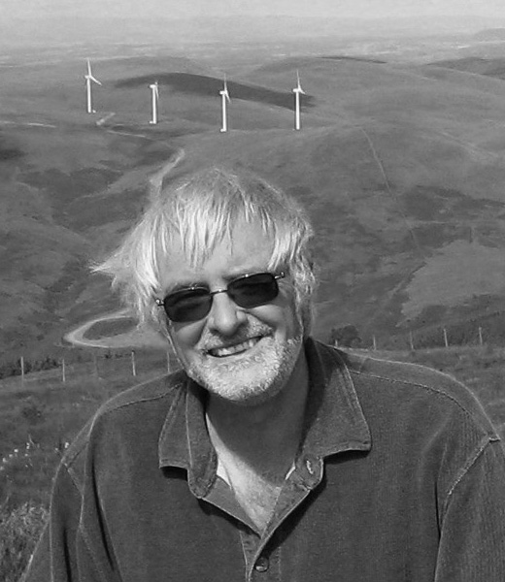
Stop the Quarry: Save Glenquey!

Malcolm Best reports on quarry developments

Back in March I reported that the Perth and Kinross Council (PKC) Development Management Committee had deferred a decision on the quarry planning applications for Glenquey. The Committee deferred their decision because they required further information on the impact the quarry will have on bio and geo diversity, the landscape (including cumulative impact of wind farms) recreational amenity, tourism, road safety and the history of the site.

At the time of writing (mid-October 2012) we do not know what information the Council Planners or the applicant have decided is required in order to satisfy the Development Management Committee, but we do know that the Council’s Biodiversity Officer has issued a scoping opinion – we are waiting for a copy.

For those of you that receive a copy of the regular quarry update email I send out, you will have noticed the heading of this article is different in that it includes “Save Glenquey”. In reality this is not new as it has always been our desire to save Glenquey from the quarry but I totally agree with a recent request to expand the message beyond the simple “Stop the Quarry”.

Glenquey is a very beautiful and unique part of the Ochils and also a fascinating area from a bio and geo diversity perspective. In recent months, much effort has been put into researching and documenting both these aspects and the results expose the serious shortcomings of the applicant’s Environment Statement.
The habitat on the site is clearly very rare and a number of uncommon and some rare species are being found. Glen Quey Moss is extremely interesting from a biodiversity perspective, as demonstrated in the box overleaf.

The geological feature supporting the bog was the basis of a paper by Professor Andrew Russell, and geomorphologists having read the paper and visited the site agree it is central and fundamental to the understanding of the processes of de-glaciation that were at work in the Ochils at the end of the last Ice Age and important within the Scottish context.

We are hopeful the site will be given a Regionally Important Geological Site (RIGS) designation and although this is only advisory in nature it is none the less quite powerful.

We have been told the Council Committee that it will not be considering the quarry planning applications at its October meeting and the next scheduled meeting is 28 November – if you would like me to include you in my regular email update so I can keep you informed or if you have any questions or suggestions please let me know. malcolmglenquey@yahoo.com
Moss facts

- an extremely interesting range of plant communities has been identified and documented;
- it’s the only site with remains of a type of vegetation that was once extensive here;
- it’s the only active bog of any kind in the Ochil Hills;
- two unusual insects for the area have been found, as have important bird species that were not included in the Environment Statement;
- a delphacid plant hopper called Paraliburnia clypealis, which is rare in Britain and a Red Data Book species has also been found;
- a recent sampling of the site has also revealed one rare and a few uncommon spiders;
- badgers have been found at the site, and;
- recent consultation by the Woodland Trust revealed Black Grouse have been recorded nearby.

Windfarm Report

FotO Chair Stuart Dean’s update on on-going windfarm struggles

The never ending saga of windfarm and wind turbine developments in the Ochils continues. The Friends of the Ochils have tried to keep on top of an ever-changing planning situation, but applications are being regularly submitted and keeping track of what is happening is a full-time job! It is particularly significant that so many of the applications are as yet undetermined. This is creating a complex situation, which we trust will be resolved by the two key local authorities, Clackmannanshire Council and Perth and Kinross Council, deciding that enough is enough and that any more turbines in the hills would be contrary to good planning. Or we could be on the road to the creation of a windfarm landscape in the Ochils that would result in turbines being the dominant feature in the landscape.

Let me give you a brief overview of where we are at.The three applications for a further 18 turbines around the existing Burnfoot Hill development have still to be determined. However, from information available on the Perth and Kinross Council website, it looks as if the Council has a November target date for a Development Management Committee hearing for Frandy Hill and the BFH Extension applications. However, only very recently a great deal of additional material was made available by Wind Prospect to the two Councils, although only Clackmannanshire Council has seen fit to publish it on their website. It contains further landscape analysis, including cumulative impact analysis, and the question will now be asked by FotO as to whether or not it is the intention of the Councils to open this additional information for further public comment. Given the poor landscape and cumulative impact analysis in the Environmental Statements for Rhodders, the Burnfoot Hill Extension and Frandy Hill – something we pointed out in our objection letter – it would only seem right that this additional analysis is also open to further representations. If it is not, how can we hold the two Councils to account if we find that the new information is also flawed? Will it, for example, deal adequately with cumulative impact not only of windfarms and individual turbines but also the Beauly to Denny powerline and the quarry proposal in Glen Quey?

The eastern Ochils are being hit by proposed developments above Dunning and nearer Milnathort. Even a proposal to erect turbines at Tillyrie has resurfaced, in spite of an earlier application being turned down at a Local Public Inquiry. However there are strong local groups in both areas fighting these applications and FotO does what it can to support these more local campaigns. Of interest is an excellent new website – www.kinrosswindfarms.co.uk – that has been created to make the wider public aware of what is happening in the eastern area of the Ochils, particularly within Kinrossshire. The authors of the website asked FotO for comment on the content before its launch, something we were pleased to do.
However, it is not all doom and gloom! Applications are being refused, particularly by Perth and Kinross Council, such as those for turbines at Newhill and Temple Hill near Glenfarg and at Pairney Farm near Auchterarder. In the case of Pairney Farm and Newhill, the refusal was supported by the Perth and Kinross Council Local Review Body after an appeal. Meanwhile, applications for smaller turbines are however being approved but that is in line with our own policy of only objecting when the turbines would become highly visible in the landscape and contribute to the creation of a windfarm landscape in the Ochils.
“However, it is not all doom and gloom!”

May I finally thank all members who have made comment on windfarm/turbines applications. It is important to continue doing so, as the next stage in this long-running attempt to erect more and more large turbines in the Ochils will be critical to the future of the Ochils landscape.
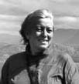
The end of the line
By Nicki Baker
As I expect you’ll know by now, we have finally lost the war. Scottish Ministers decided in December 2011 to give Scottish Power the go-ahead to build the wretched extra-high voltage power line overhead, on giant pylons, with all sorts of accompanying environmental damage, right through the Stirling area – despite all the years of campaigning, all the widespread support, and the obvious common sense of needing to find an alternative option, such as putting the line underground through this most sensitive of areas. Nothing has happened on the ground as yet, but Scottish Power is currently in the process of placing a contract to construct the overhead line and access tracks (the latter still, hopefully, temporary – but watch out for landowner bids to make the new tracks permanent – make sure you put in an objection, if that happens!).
To say this outcome is a profound disappointment would be rather an under-statement. We got all-party support for our campaign to, at least, put the thing underground, from Stirling Council and local MSPs, for many years. Two MSPs gave evidence on our behalf to the Public Inquiry in 2007, and a third was prepared to but couldn’t once he became a Minister. But somehow, even though both constituency MSPs were promoted to ministerial level in the Scottish Government, they claimed to have no influence on the decision-making ministers – who listened only to Scottish Power and SSE, and gave the line the go-ahead.
Very ironically, England and Wales will benefit hugely from all the campaigning up and down the line. National Grid, the power transmission company for England and Wales, announced some months ago that it would expect to give serious consideration to putting underground any stretch of new high-voltage power line, where it crossed an area of particularly sensitive landscape, or too close to houses. And, true to its word, the plans published for new power lines in both England and Wales have significant lengths of undergrounding built in.
It doesn’t help to know that we in Scotland will share the costs of those stretches of underground power line, through our electricity bills – just as the cost of putting some of the Beauly-Denny line underground would have been largely borne by English and Welsh consumers.
In reaching its decision, the Scottish Government has offered us a few crumbs, and has forced Scottish Power to put up between £3 and £5 million, for “visual mitigation” measures, with the stipulation that most of the money should go to the Ochils and Plean areas, as these will get the worst visual impacts from the new line. However, the money is to be distributed by Stirling Council – and we know there will be any number of proposals for spending it, but most won’t be in the immediate vicinity of the power line. As one councillor has already said to me – “There aren’t many votes in the Ochils” – meaning, the inclination may be to divert the funding to other areas. But rest assured, we’ll do our best to continue fighting for the least worst possible outcome for the Ochils.
At the time of writing, we are waiting to hear how Stirling Council will handle the distribution of the visual impact mitigation moneys, and we’ll let you know what transpires. Our position is that, to best use the funding, priority should be given to projects which actively enhance the landscape of the Ochils area, where it is immediately affected by the power line; and/or to improve the experience of those who actively use the most affected part of the area. So our bid, assuming we get invited to make one, will be to re-build the dry stone walls all along the Sheriffmuir road, and otherwise tidy up and restore the immediate landscape; to give the paths up Dumyat and round the Cocksburn Reservoir a more solid basis, to make them better able to accommodate mountain bikers and horse riders; and to use sensitive planting to give people in years to come a more varied and slightly softer landscape to enjoy. None of which, of course, will in any way hide the monstrous new pylons and line, but they might just provide a bit of a balance.
We understand that the idea of planting has taken hold, and the Central Scotland Green Network (CSGN) are in the process of developing proposals. The Chief Executive of CSGN, Simon Rennie, and Chair, Keith Geddes, have kindly agreed to give the talk after our AGM on 6th November. It’s going to be really important for us to offer our detailed local knowledge and insights, to influence their future plans as much as possible, at this key stage of the developments.

