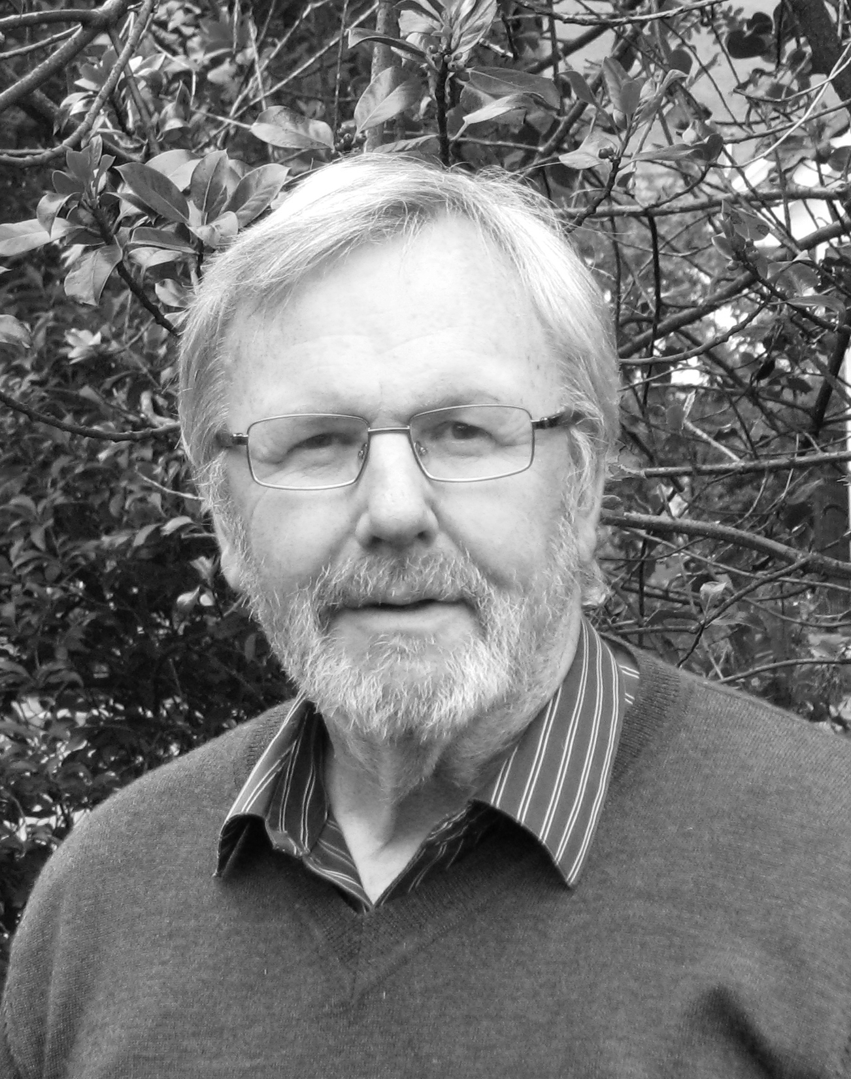
Chair’s
Report

A number of key decisions are likely to be made over the coming weeks and months which will determine whether or not the Ochils landscape will be further damaged. As Malcolm’s piece shows, we anticipate a decision on the Glenquey Quarry applications at some point, despite long delays over their determination. Furthermore, there are several wind farm applications the outcome of which will indicate whether or not we have turned a corner and a line has been drawn under the attempts to create a wind farm landscape in the Ochils. As my wind farm report indicates, the decisions on Frandy, Rhodders and Tillyrie are most significant in this respect. Refusal of these applications on landscape and visual amenity grounds will send a message to other developers that there are limits to wind farm development in the Ochils.

However, applications for large individual turbines in and around the Ochils continue to be made and we do our best to prevent them adding to a wind farm landscape. Some have been refused, particularly within the PKC area, and we continue to put forward the essential arguments about their negative impact.

As Nicki’s piece shows, the aftermath of the decision to approve the Beauly-Denny power line continues with the totally unsatisfactory manner in which mitigation measures are being determined. It was bad enough that the line was approved across the Ochils, but insult is being added to injury when mitigation measures are dealt with so unsatisfactorily by the key players.

Meanwhile, proposals to plant extensive areas of commercial forestry in the hills are coming to the fore. The Friends of the Ochils have already been involved in the scoping issues in relation to proposals to plant extensively on the east side of Menstrie Glen and will respond appropriately to Environmental Impact Assessments in due course. However, it will be necessary to assess the views on FotO members on this issue so that we can reflect those views in our representations.

We also continue to respond to the consultations on the new Local Development Plans (LDPs) and relevant Supplementary Planning Guidance documents which are at various stages of preparation in the three key Ochils local authorities. Clackmannanshire’s LDP will be the last of the three to go out for consultation; it is anticipated that the
finalised draft will be ready by August.
Whilst it is difficult at times to maintain the required level of response to the many planning issues relating to the Ochils, we do have to look beyond the present period of intensive campaigning and take a more holistic and strategic approach to the future of the Ochils.
The hills require long-term stewardship so that their many wonderful characteristics can be protected and enhanced and I’m delighted to report that one of our members, Drew Jamieson, has undertaken some sterling work on the future of the Ochils following the presentation on the Central Scotland Green Network (CSGN) at our AGM.
Drew, who has a background in planning and was involved in the Pentlands Regional Park Development, has written documents that have been submitted to the CSGN for their response.

The FotO Committee has seen the drafts prepared by Drew and fully support the initiative. As his ideas evolve, particularly if they receive a positive response from key organisations such as the CSGN and Scottish Natural Heritage, we will further involve FotO members to ensure that the initiative proceeds with the involvement and endorsement of you, our members.

Finally, work is being carried out on the new website to ensure that it contains much more up-to-date information for members such as the documents prepared by Drew on the vision for the Ochils and the numerous representations submitted to the local authorities and the DPEA on planning applications etc. We aim to make the website a key tool for keeping members informed of FotO activities and for receiving your feedback on key issues. However, for those of you who do not have internet access we will continue to maintain contact through tried and tested methods such as the Newsletter. Stuart Dean, FotO Chair
“The hills require long-term stewardship so that their many wonderful characteristics can be protected and enhanced…”

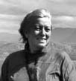
Beauly-Denny power line mitigation: latest developments

Sorry, folks – I’m afraid the heading of this piece is rather misleading. Sadly, there are no significant developments in the sorry saga of the £4-5 million supposedly allocated to providing ‘visual mitigation’ for the Beauly-Denny power line. Things remain much as they were at the last time of reporting, six months ago.

Stirling Council re-convened its Beauly-Denny Legacy Group in January. This comprises four Councillors and three members of the public (including Friends of the Ochils’ member Peter Pearson – the veteran campaigner on the power line). It’s chaired by Cllr Callum Campbell, of Bridge of Allan & Dunblane Ward, and its meetings are attended by very senior Council officers on the legal and planning sides. But it doesn’t appear to have made any progress in the last 12 months, and the proposals that we have put forward have received little more than a lukewarm acknowledgement.

In the meantime, it appears Scottish Power seem to be controlling the process and appear to plan to use the funds in ways they think best (which we can predict will be astonishingly small-minded and mundane, and/or will be for works that they should anyway be carrying out as part of the restoration for their construction works). And the Scottish Minister has apparently commissioned consultants to put forward proposals for using the funds, which they have done with little reference at all to the Council, and none to local community groups, or to previous suggestions. They don’t even appear to be aware that the same Scottish Minister, in setting out his proposals for these funds in the first place, identified the Ochils and the Plean area as being the places where the bulk of the funding should be spent. So it’s all a bit of a guddle and rather disappointing, and there really isn’t much to tell you!

In the meantime, Scottish Power have apparently said they won’t be in any hurry to start the construction works in the Ochils area – maybe the Scottish Ministers think that having major construction works taking place on the newly-Listed Sheriffmuir Battlefield might not be quite what they want people to be noticing when it comes to the Independence Referendum in September 2014. So it may be Spring 2015 before anything significant happens on the ground, and probably a significant time too before Scottish Power bother to hold any public exhibitions or meetings about their proposals.

If you are able to access the Friends of the Ochils website, keep an eye on it for further developments as we’re going to start posting blogs about key developments in the fairly near future. And you can also look at the relevant page on Stirling Council’s website:

http://www.stirling.gov.uk/services/business-and-trade/planning-and-building-standards/planning-consultations/beauly-denny-power-line-meetings.

Nicki Baker, FotO Vice Chair

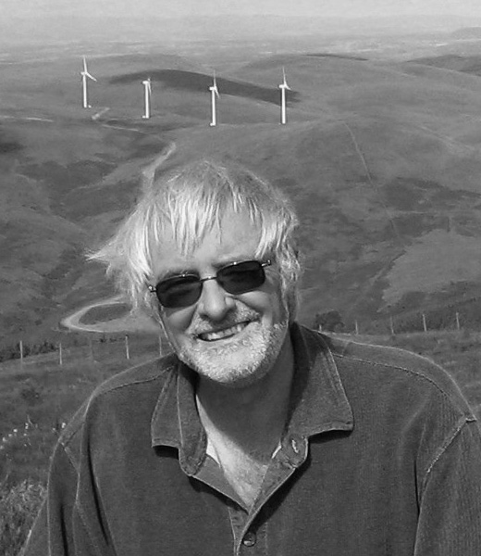
Message from the Treasurer and Quarry report

As I am sure you are well aware Nicki Baker has long been Treasurer of the Friends of the Ochils and on behalf of everybody I would like to say a huge thank you to Nicki – Thank You!

Following a Committee meeting earlier this year I agreed to take on the role of Treasurer, thereby allowing Nicki to focus her energies on the role of Vice Chair. In March 2013, Nicki handed over all her files and papers, cheque books, paying in slips and copies of previous annual accounts, leaving me with a grimace and her with a big happy smile!
I will try to do the job of Treasurer as efficiently and effectively as Nicki has!

Now onto other matters, namely a quarry update…

I cannot believe it is already June 2013 and the quarry planning applications have still not come back before the Perth & Kinross Council (PKC) Development Management Committee (DMC) following their decision to defer in March 2012!
In October of last year I noted “As of today (mid-October 2012) we do not know what information the PKC planners or the applicant have decided is required in order to satisfy the DMC but we do know the PKC Biodiversity Officer has issued a scoping opinion – we are waiting for a copy.” Well, we still do not have a copy of the scoping opinion and we do not have a definitive list of the specific information that the applicant is required to provide! And despite a letter from PKC in August 2012 advising that additional information submitted by the applicant would be subject to further public consultation, we were astonished when in December 2012 the Planning Department wrote to the various interested Community Councils seeking their views on the road safety and traffic information that was submitted to PKC in December 2010. Ridiculous! And we were even more amazed when that Officer orally advised he was targeting putting the applications back before the DMC at the end of January 2013!

Needless to say this caused a flurry of activity and eventually confirmation from a senior officer in Planning that the August 2012 letter is correct and there will be further public consultation on all new information received and until this has happened the applications will not be put back before the DMC. Incredible!

Our determination to resist these planning applications has not changed! A sand and gravel quarry in the heart of the Ochils is completely inappropriate and we will continue to do everything we can to ensure the license is not renewed.
“Our determination to resist these planning applications has not changed!”
We will continue to monitor these planning applications and keep members advised - if you would like me to include you in my regular email update so I can keep you informed or if you have any questions or suggestions please let me know by contacting me at the following email address: malcolmglenquey@yahoo.com

Malcolm Best, FotO Treasurer

Wind farm report

We are now entering a key period for the Ochils when we could see a considerable number of turbines added to those already in existence. As I write, the applications for additional turbines around the existing Burnfoot Hill (BFH) wind farm are going through increasingly complex determination procedures. Already Perth and Kinross Council has approved the application for two turbines to the north of the existing BFH wind farm but the application for the Frandy Hill extension, consisting of seven turbines has been appealed on the grounds of non-determination. Furthermore, the application for the nine Rhodders turbines has been revised to six turbines. Meanwhile, the application for a cluster of turbines at Tillyrie remains to be determined by PKC whilst applications for large individual turbines in and around the Ochils continue to be submitted.
Particularly worrying is the application for a wind monitoring mast above Dunning, which could well signal another application for more turbines on the hills behind the village.

The BFH applications have been particularly difficult to deal with. Not only has the determination process been complicated by two councils having to make decisions on what are closely related developments, but the all-important cumulative impact issues are in danger of not receiving the attention that they require. However, on a recent site visit with the Reporter dealing with the Frandy application we were able not only to point out the key viewpoints from which we believe the cumulative impact would be particularly serious but also to point out the proposed site on Common Hill for two turbines which have been ignored by Wind Prospect in the various Environmental Impact Assessments for the BFH extensions.

However, it was gratifying that the PKC Development Management Committee recommended at a recent meeting that the Reporter should refuse the appealed Frandy application as being contrary to the Development Plan due to the unacceptable impact on landscape quality and visual amenity. If, however, the Reporter approves the application, the future for the Ochils will look very bleak indeed as it will be seen as acceptable to fill the gaps between existing wind farms with turbines.

The Rhodders application is the next key test of a council’s willingness to draw a line under more wind farm development in the Ochils. Although the application could be determined by an officer under the new rules for determining planning applications, the Chair of the Clackmannanshire Planning Committee proposed at a recent Council meeting that the application be determined by the Committee and not the Officer. This they are entitled to do and the proposal received full support from the Council. Therefore, even if the Officer recommends approval there is an opportunity to persuade the Planning Committee that they should refuse the application. Those of you who have made representation to the Council should receive notification of the Committee determination date and I would encourage as many of you as possible attend the meeting of the Planning Committee.
(PS After writing my wind farm report we heard that the Rhodders application will be determined by the Clackmannanshire Planning Committee on Thursday 13th June. The meeting starts at 9.30am at Greenfield House, Alloa. The Officer's Report recommends approval. Please attend if at all possible in the hope that we can persuade the Committee to refuse the application!)

So what of the future? My fear is that until the Government draws a line under further wind farm developments in our beautiful landscapes we can only exercise continued vigilance and do what we can to ensure, through both the development planning process, and through continued opposition to planning applications, that the case is always put in favour of the Ochils landscape. We ask for your continued support in our efforts to protect the Ochils. Stuart Dean, FotO Chair

