**FORMS**

**Book Master Form**

1. Form Layout

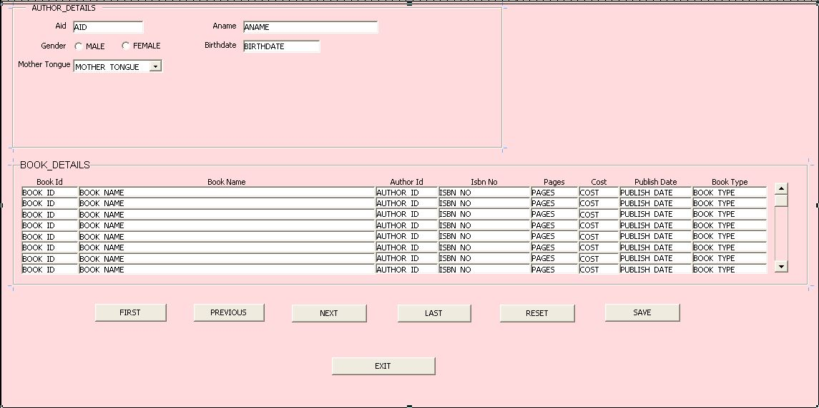

2. Form register

3. Function creation

Description

Property

Form

4. menu creation

5. Responsibility creation

6. Adding responsibility to user

7. Form output

**Author form**

1. Form layout

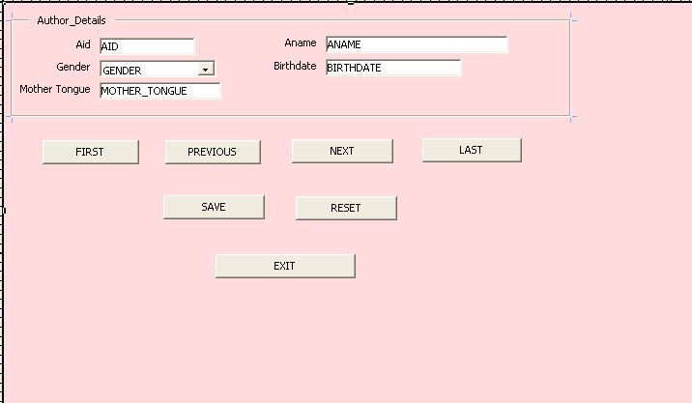

2. Form register

3. Function creation

Description

Property

Form

4. menu creation

5. Responsibility creation

6. Adding responsibility to user

7. Form output

**Query for buttons:**

* FIRST

BEGIN

Go_Block('AUTHOR_IMT');

FIRST_RECORD;

END;

* NEXT

BEGIN

Go_Block('AUTHOR_IMT');

NEXT_RECORD;

END;

* PREVIOUS

BEGIN

Go_Block('AUTHOR_IMT');

PREVIOUS_RECORD;

END;

* LAST

BEGIN

Go_Block('AUTHOR_IMT');

LAST_RECORD;

END;

* SAVE

BEGIN

DO_KEY('CREATE_QUERY');

EXECUTE_QUERY;

END;

* EXIT

BEGIN

Go_Block('AUTHOR_IMT');

EXIT_FORM;

END;

* RESET

BEGIN

Go_Block('AUTHOR_IMT');

CLEAR_FORM;

END;

* ADD BOOKS

BEGIN

FND_FUNCTION.EXECUTE(FUNCTION_NAME => 'AUTBOO_IMT_FUN',OPEN_FLAG => 'T');

END;

* ADD AUTHOR

BEGIN

FND_FUNCTION.EXECUTE(FUNCTION_NAME => 'AUTHOR_IMT_FUN',OPEN_FLAG => 'T');

END;

**Validation Trigger for ISBN NO**

* INVALID_ISBN

declare

ctr number;

v_alertvarchar2(20);

BEGIN

select count(*) into ctr from book_master_imt where isbn_no = :isbn_no;

if(ctr = 1) then

v_alert := show_alert('INVALID_ISBN');

raise FORM_TRIGGER_FAILURE;

end if;

end;

* INVALID_PAGES

declare

v_alertvarchar2(20);

BEGIN

if(:pages < 0) then

v_alert := show_alert('INVALID_PAGES');

raise FORM_TRIGGER_FAILURE;

end if;

end;

* INVALID_COST

declare

v_alertvarchar2(20);

BEGIN

if(:cost < 0) then

v_alert := show_alert('INVALID_COST');

raise FORM_TRIGGER_FAILURE;

end if;

end;

* INVALID_PUBDATE

declare

v_alertvarchar2(20);

BEGIN

if(:publish_date>sysdate ) then

:publish_date := sysdate;

v_alert := show_alert('INVALID_PUBDATE');

raise FORM_TRIGGER_FAILURE;

end if;

end;

* INVALID_BOOK

DECLARE

V_ALERT VARCHAR2(20);

BEGIN

if( :BOOK_TYPE != 'fiction' and :BOOK_TYPE !='non-fiction' and :BOOK_TYPE != 'business' and :BOOK_TYPE != 'audio') then

V_ALERT := SHOW_ALERT('INVALID_BOOK');

raise FORM_TRIGGER_FAILURE;

end if;

END;