Friends of Burma, Inc. Newsletter
Spring 2021

“A generous person will prosper; whoever refreshes others will be refreshed.” Proverbs 11:25

We can’t thank you enough for all you have supported in this time of need in Myanmar. Because of your kindness and concern, lives are being transformed daily through the power of Jesus Christ. These are a paraphrase of words from our friend, Rev. Donovan Coley who is the leader of the Rescue Mission here in Ft. Wayne. He is much more eloquent than we are.

Military Coup and Ongoing Protests

On February 1, 2021, Myanmar’s military overthrew the democratically elected parliament and took over running the government. Perhaps they were surprised by the landslide victory of the National League for Democracy (NLD). Perhaps they have also been surprised at the overwhelming resistance to this action. Since then, the citizens have taken to the streets and the airwaves to defy the military. There have been shootings and all of it is documented by the younger generation in spite of obstacles put in the way of open internet.

Many NGOs have suspended their operations in Burma, in some cases, due to logistics. Friends of Burma continues to cooperate with our mission colleagues in Burma despite challenges to make sure that donations are disbursed to meet the needs.

The following picture on the left sent to us by one of our colleagues is a photo of soldiers in front of the seminary in Insein, Yangon. The one on the right is of a candlelight vigil for the people who were shot dead by the military during the protests. According to the Assistance Association for the Political Prisoners in Burma, more than 500 people have been killed since February 1.
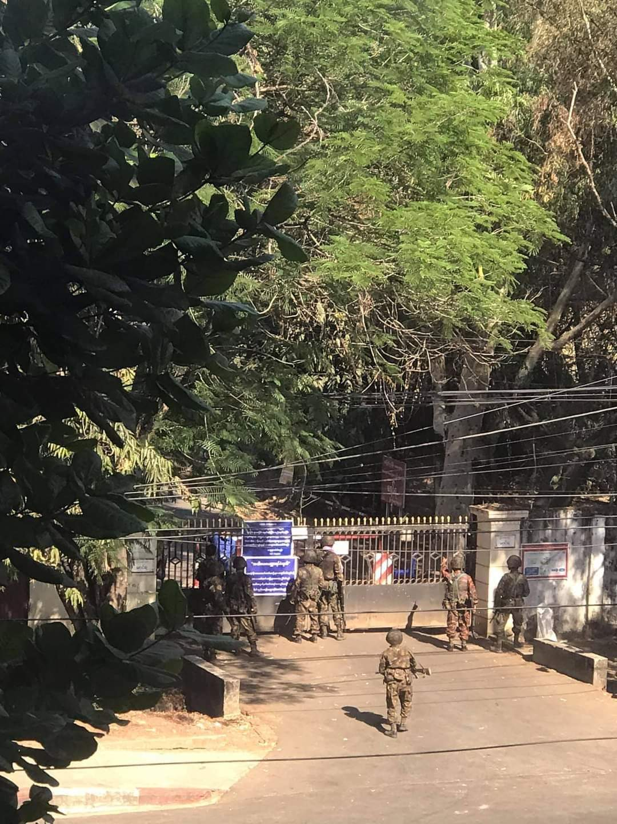
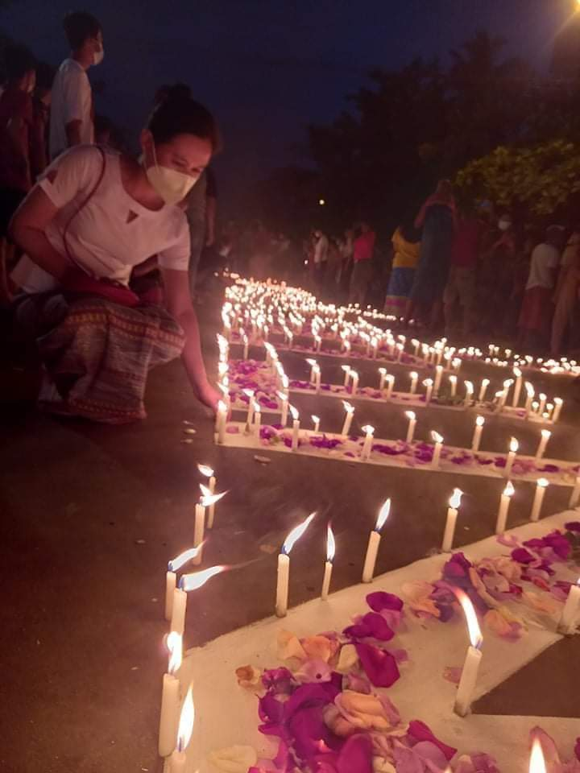

Health Care During the Military Coup

During this time, government hospitals have been closed due to mass strikes and civil disobedience movement, known as CDM. The winning party, NLD, has set up an alternative government and has been appointing people to represent it. One of the appointees, Dr. Sa Sa, visited us two years ago to speak about his projects in Chin State and to thank Friends of Burma for facilitating donations to his projects. He has been appointed special envoy to the UN to represent the NLD. He is now outside Burma, travelling the world to encourage countries to sanction the military actions.

Friends of Burma, with the help of board members and social media, have been raising funds for the KBC hospital and for Internally Displaced Persons (IDP’s) whose villages have been shelled by the military. With these funds, needed supplies such as blankets, mosquito nets, tarps, food, medicines have been bought for the IDP’s (8000 of them) who are sheltering in the jungle.

Since government hospitals are closed, the KBC hospital has been accepting increased numbers of patients seeking help. Pastors are writing letters, asking the KBC hospital to accept out of town patients for treatment. FOB is helping in this situation by sending funds to help the staff, and for protective equipment. Up to 50% of the patients are non-paying charity cases. Thank you all for your participation in our fundraising.

As written on March 14 by an anonymous citizen in Yangon:
“It has been 42 days since the military coup in Myanmar. 327 hospitals were closed since February 5th, 2021. Till 14th March 2021 morning, 104 people had given their lives in the Spring Revolution of Myanmar. For the health needs in the country, private hospitals and social health teams tried their best providing health care for the community.”

The following are some of the stories (in their own unedited words) of people who KBC Hospital helped recently.
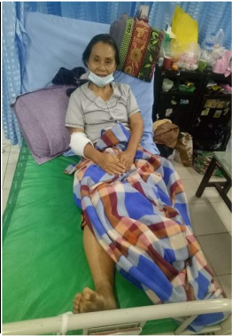
Three weeks ago, I was cleaning the mission field church, and accidentally fell from the chair and, got a fractured neck of femur. At the end of the day, the villager sent me to Pathein. As the situation in Myanmar become worse and worse, I had to stay in Pathein for 3 days without treatment. After that, Pathein Myaung Mya Association leaders called KBC hospital for further treatment. Then the hospital accepted and arranged so I could come to the hospital. As soon as I reached KBC hospital, all the hospital management team arranged things so that I could get the best treatment. Within one day, I was able to get an operation, and now can sit. So, I thank all of the well-wishers for providing me the treatment cost. As I am only a field mission worker, I could not afford the operation cost. Besides, due to our current situation, the villagers from my village told me that if I did not get an operation on time, I have to live lying on the bed the whole of my life. But now, due to all of your support, I can walk again. Thanks abundantly. May God bless you all.

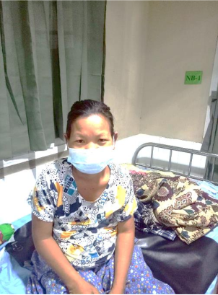
My name is Aye Aye Thit. I come from Tharyarwaddy to give birth at the KBC Hospital. May I share my biography? I am working as a clerk in the government department. At first, for my pregnancy antenatal care, I consulted with basic health staff (BHS) in my hometown. But being a high-risk pregnancy and all health care workers participating in CDM, there were no specialists to see me in town. Our villagers together with our pastor, decided to request support from KBC Hospital Medical Superintendent. The pastor sent a letter to KBC Hospital requesting support. After discussing it with the KBC Hospital Medical Superintendent, the pastor sent me to KBC hospital to be operated on. As the political situation in Myanmar is unstable, it’s also hard to travel from one region to another. So, the villagers together with the KBC Hospital, hired a car for me to reach the hospital. As soon as I reached the hospital, the staff and the OG specialist warmly welcomed me and did the best for me. The OG specialist told me that she thanks God as she could save both the mother and child's life. She also mentioned that, if I could not reach on time to KBCH, both of us (Mum and Child) will lose our lives. After reaching the KBC Hospital, the management team told me that, all the treatment and medicine support for me was provided by FOB. Thus, I thank all of the well-wishers for saving both of our lives. But now we are safe and sound. May I say a few words to all of the well-wishers as, “All of you are my lifesaver and May God bless you throughout your lives. Without all of your support, I may not see my child and lose my life too.
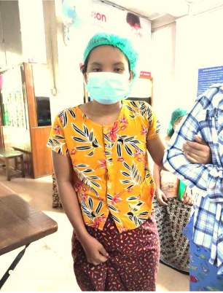
My Name is Ma Mya Myint Zu, and I live in Shwe Pyay Thar Township. I reached KBC Hospital with the diagnosis of atopic pregnancy with shock. My blood pressure was 70/0 mmHg. A thorough examination and fluid resuscitation were done immediately. An urgent operation was done and 3 units of blood were given to me. For my hospitalization I had only 90,000 kyats and, my family and I could not afford to pay. Then, the OG specialist together with the hospital told my family members not to worry and will support it as much as they could. After my operation process, the hospital staff told me who my supporter was for my operation. Thus, I want to say to all of you, “Thanks a lot for supporting me for my operation. Without your support, I cannot see the world again. Thanks profoundly for saving my life. I promise that I will pray for all of you to be healthy and well.”

Students

In past years, because of a lack of middle and high schools in delta village areas, students would come to Pathein city to stay and take their secondary studies in Pathein, aided by families in the community.

A donor had donated money for a hostel to accommodate students who had taken qualifying tests and made high scores. This is called the Gillen Hostel. Out of 30 students, 24 passed the difficult matriculation tests. For the whole country, only 35% passed in 2020. Here are a few that Rev. Mooler Gay mentioned.

Saw David Htoo made a score of 488 (out of 500), qualifying him to join the Medical college, which is a seven year course. One of our supporters has said she will support this student once the medical college reopens. But at this time it is highly uncertain when the medical college will reopen with the political unrest going on.

Naw Paw Wah Htoo, score 437, qualifies her to join the Education college.

Naw Emerald, score 366, is qualified to join the Nursing College, which is a three year course, at a cost of $100 per month. She has 5 siblings and she is the second. Her parents are farmers. She studied at the Gillen Hostel.

Naw Moe Eh is already a 1st year student at the Technological University. Her mother works at the Gillen hostel as a cook.

Naw Eain Chit plans to go to Pathein University. She is from the mission field, which is usually a remote area. She finished high school in 2020.

All these students study 10 months in a year and we are looking for a multiyear commitment for their support.

A music grad student, Ms. Thandar Aung Kyaw Soe, who we are supporting, has been studying all year online with a university in Singapore while staying in Yangon due to the Covid-19 restrictions. She is a teacher at Karen Baptist Theological Seminary Music School. At the request of the school, FOB bought a saxophone for the music program. It is sitting in Washington, D.C. waiting for shipment to Burma because of Covid-19 restrictions.

Internally Displaced People

If the fight against Covid-19 and the civil disobedience movement (CDM) against the military who declared martial law wasn’t enough for the people of Myanmar, there has been increased Myanmar army aggression in some ethnic areas. Although this is not one of FOB’s founding goals, we do send humanitarian support when we have funds available. According to Irrawaddy News (now being sued by the military), “Shelling and attacks on civilians have driven more than 8,000 Karen internally displaced people to flee since mid-December.” Accordingly, FOB has sent humanitarian relief to supply basic needs to the people who are literally in the jungle with no shelter. Since our fundraiser for the KBC hospital has been so successful, we are now seeking funds to the great needs of the IDP’s.

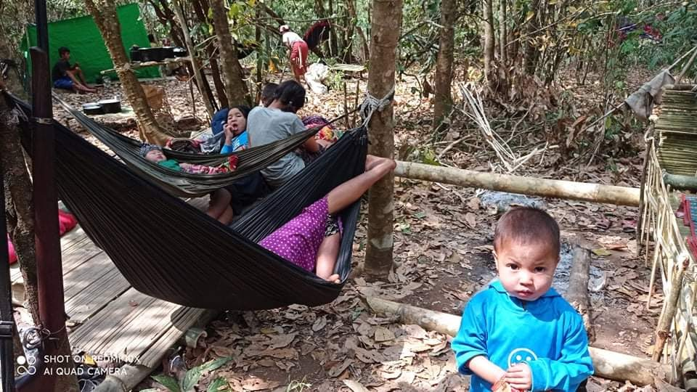
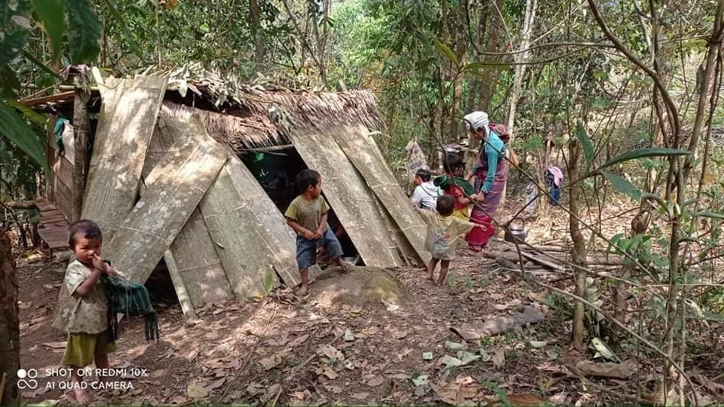
A report from Naw Nita, who is the head of the Karen Baptist Convention (KBC) Department of Care and Counseling, which is in charge of the orphanages run by the KBC, reports that two orphanages, Myit Tar Yeik Mon and Chit Myit Tar, are in special need to help them with their water systems. We just learned that the artesian wells at those two orphanages are no longer providing adequate water for the needs of the children. Please consider donating to this special need.

Karen Devotional Book: All 1,000 of Book One of Karen Stories for God’s Glory were sold out. Book Two, in English and Karen, is filled with stories of what Karens have experienced and how God has affected their lives. Price $15.00. It is also available for your spiritual enrichment at http://kbcusedd.org This is a book easily useful to both Karen and American readers and has stories from all different parts of the US, Thailand and Burma.

Donation

FOB was very grateful to receive a bequest of a donor upon her death, of stock, which is being liquidated to provide approximately $14,000 to help us meet needs in Burma.

Wish List.
- KBC Hospital—ongoing needs
- Internally Displaced People fleeing from civil war
- Naw Paw Wah Htoo, major Education, 4 years at $1,000 per year.
- Naw Emerald, major Nursing, 3 years at $1,000 per year.
- Naw Moe Eh, Technological University, 5 years at $1,000 per year.
- Support for the various orphanages which are doing the best they can for the children during this difficult time.

Your support of full amount or any portion would be a blessing. Please write a check payable to Friends of Burma. Please consider including FOB in your will. FOB, tax ID 20-5572384, is a 501(c)(3) non-profit organization, and all donations are tax-deductible.

All the work of FOB is done by volunteers in the U. S. FOB has one paid staff member in Myanmar. Less than 2% of our income goes for overhead—most of which is for our one staff member in Myanmar and printing and distribution of our 3 annual newsletters.

This newsletter was written and compiled by Neil & Diana Sowards, and Lwin Moe. Please notify us if you wish to be on the email list instead of hard, mailed copy as this saves us money.

Donate: http://friendsofburma.org/donate

Friends of Burma, Inc. 548 Home Ave. Ft. Wayne, IN 46807
Tel. 260-745-3658, Website: http://friendsofburma.org, Email: neildianasowards@juno.com
E-Newsletter: http://news.friendsofburma.org

Photos of the women entrepreneurs from the Women Empowerment Program supported by Friends of Burma.
