FRIENDS OF BURMA, INC.
Fall, 2011 Newsletter, a non profit 501(c)(3) organization. Neil Sowards, President
548 Home Ave., Fort Wayne, IN 46807. (260)745-3658.
A COMMITTEE OF AMERICAN CHRISTIANS FOR AIDING THE PEOPLE OF BURMA
Website: friendsofburma.org E-mail: neildianasowards@juno.com

The year continues with the Lord’s guidance and Friends of Burma is moving forward to help meet the needs of brothers and sisters in Christ in Burma (Myanmar) with the generous support of friends from the U.S.A.
Theological Education
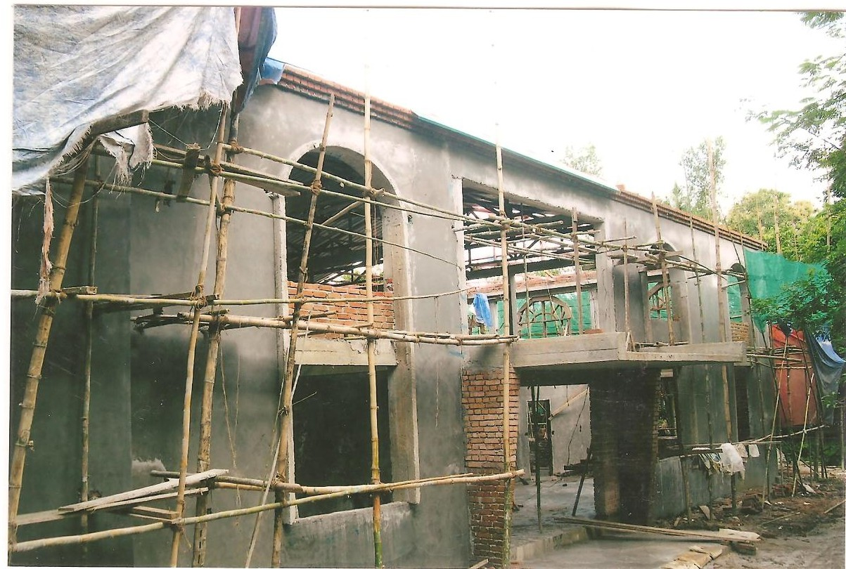
Burmese Christians will soon be celebrating 200 years of sharing the good news of Jesus Christ and honoring Adoniram Judson. Over these many years American Baptists sent over 800 missionaries to carry out the great commission. Over thirty two Bible Schools and seminaries have been established to train leaders to develop churches and education facilities so that today we can praise the Lord for His blessings. In recent months the Myanmar Institute of Theology (MIT) has been constructing a new classroom building, the Jubilee Annex, in Insein, and on the same hill, the Karen Baptist Theological Seminary has nearly completed another new facility. With the growing student body there is also a need for increased faculty and offices. We join the leaders and faculty in praising God for these accomplishments. Scholarships are desperate-ly needed in these economic tough times. MIT has exhausted its funds and needs donations to complete their building. A Memorial Room can be named for $5,000. Any donation will be deeply appreciated.
Hpu Mya San Bible School New Building under Construction.

Sakhan Tha Village Health Workers.
Many villages in rural areas of the country have no medical facility whatsoever. Therefore the Karens founded Sakhan Tha Village Health Workers School to give six months training to health workers. Graduates are given the book, “Where There is No Doctor”, in Burmese translation which is published by The Hesperian Society. Recently the book, “Where There Is No Dentist” was translated into Burmese and we hope to give this book also to the 62 graduates. These workers are trained to treat minor medical problems and to recognize more serious sickness so the patients can be taken to urban medical centers. These village workers make a huge difference in the care of sick people. An additional two thousand copies of the “Dentist” books are being printed and a new class is scheduled for 2012. A similar training school in Pathein has also requested these two books.
Please go to friendsofburma.org to learn more.

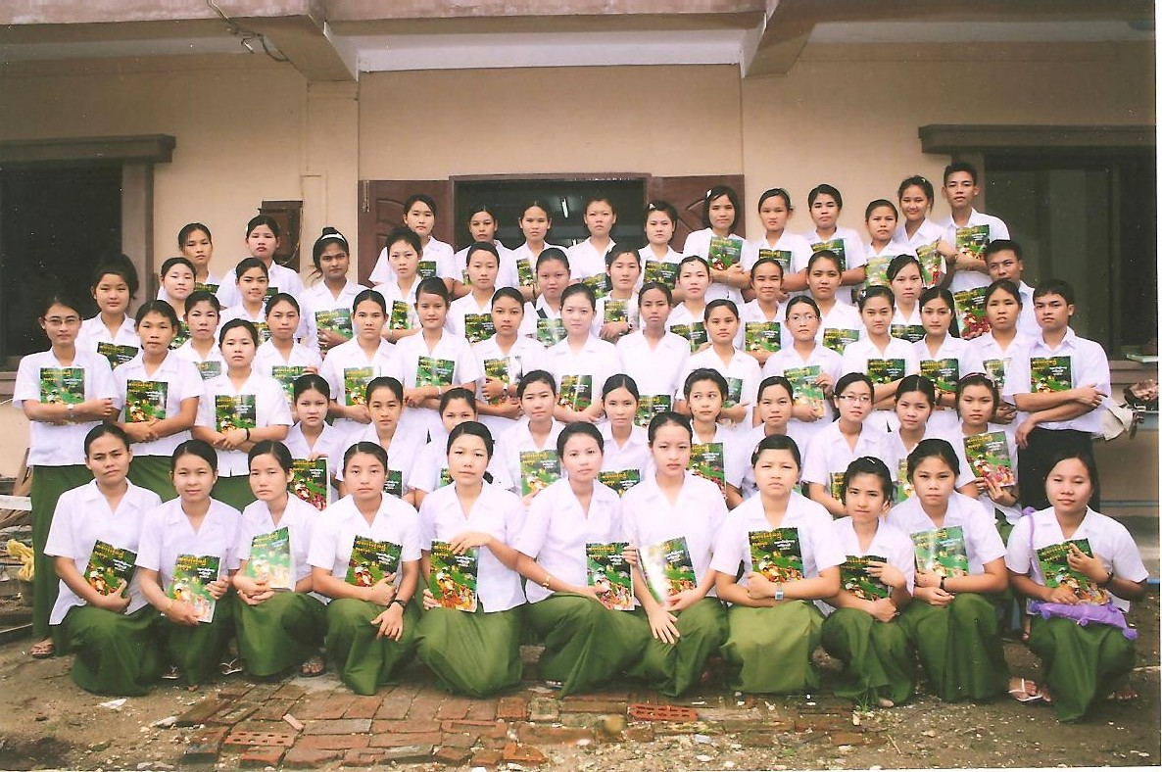
Sakhan Tha Health Training Center trainees holding “Where There Is No Doctor” book.

Introducing Htoo Khu Kalu Paw, Care & Counseling Department of the Karen Baptist Convention
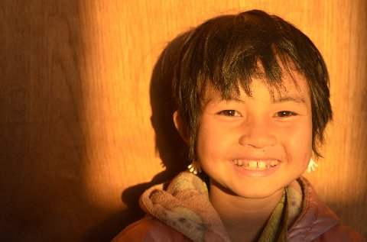
Naw Magnolia served faithfully as director for many years. We have just learned of Htoo Khu Kalu Paw, the new director. She tells us that two enrichment centers have been added and a couple of the centers have taken on new names. With all of the tragic events, the movement of children in and out of the facilities has been tremendous. One of the children we (Dave Horton) have supported over the past ten years is ready to complete her basic education. We hope to find out what her plans are for the future. Will she pursue more education and training? Where will she live if she moves out of the facility? Such information is not always available but prayer will continue as she seeks God’s will.
Child Enrichment Centers
Many children are made orphans by various circumstances. War, diseases, and natural
disasters are some of the leading causes that made these children parentless. The Bible tells us to look after the widows and
orphans. ( James 1:27) These children need
An orphan child from Burma
our prayers and support. Will you consider supporting one of them for $240 per year?

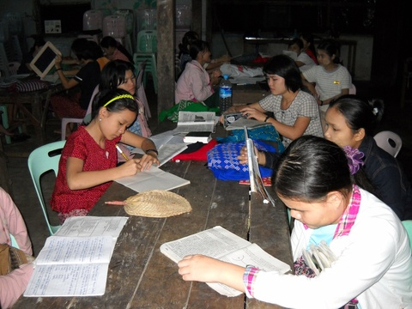
Outstanding students program
The Baptist leaders in the delta area have developed two programs. One is where they choose the very brightest and motivated students who scored high on the annual government tests from each of the sixty five villages in the Pathein-Myaungmya area and bring them to Pathein where they live in a hostel so they can attend Middle School (6th, 7th,& 8th Grade) and later, High School(9th, 10th, &11th Grade).
The other program is where they take the brightest and best from each of their thirty five mission fields--one from each field. Both groups are under the watch care of the Pathein Myaungmya Sgaw
Karen Baptist Association. Members of the churches tutor these youth to help them overcome their weak Primary School education. Students studying their lessons together

The Baptist leaders would like to expand this program when money and space become available. Also many want to go on to university if scholarships can be found for them.
Here is one of the candidates, Saw Kyaw Zin Aung.
Saw Kyaw Zin Aung. Born 6/5/93. Attending Technological University. His parents are farmers but after Cyclone Nargis, both become weak and unhealthy and cannot work anymore. So he needs help. His recommendation reads, “Saw Kyaw Zin Aung is ambitious and he is hard working. In 2011 he passed the Matriculation Exam with 2 distinction--Biology and Math.

Pathein University Christian Fellowship (UCF) is going well. Rev. Erville Porwy reports that their new pastor is Thramu Thant Zin Oo. The university is now open and there are 30 students (15 male and 15 female) staying at the UCF Center. Worship services are held each Sunday at 8:30 a.m. The students visit various mission fields and participate in work camps. The center is in need of a women’s latrine with shower. Please pray for this student work.

Matthew 25 Love Hospital in Pathein is going well and appreciates two new autoclaves recently purchased by an FOB board member. The hospital treated over 23,000 outpatients last year and their surgeons performed 907 operations. A new doctor’s house was constructed along with 5 staff houses. Dr. Say Paw Wah is the new director of the hospital. Thanks for your prayers and financial support for this growing medical facility.
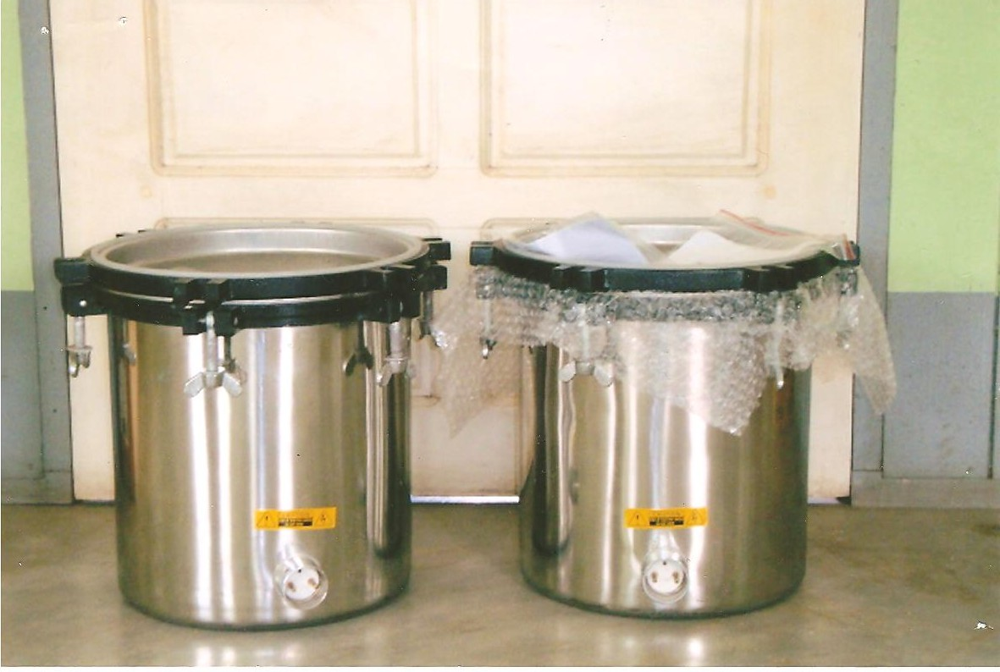
Two autoclaves donated to Pathein Matthew 25 Love Clinic by Tansy Kadoe

MIT Professors to teach at Central Seminary.
Prof. Cung Lian Hup, Dr. Samuel Ngun Ling, and Dr. Maung Maung Yin will be teaching in the doctor of ministry program at Central Seminary [6601 Monticello Rd., Shawnee, KS 66226] in the fall semester. These dynamic and devoted men have blessed many pastors and churches in the US. You can contact them for special assignments in your church through the seminary.

FOB Publicity. Two FOB supporters recently set up an exhibit at the annual meeting of the American Baptist Women of the Pacific Northwest Conference. They had photos of hill people and sold hill tribe clothing and craft items. They gave out FOB newsletters and answered many questions. We deeply appreciate their spreading the word about FOB and its work.

Mission Tour to Myanmar, 2013.
Stan Murray, Area Director of Southeast Asia for International Ministries is hosting a trip to Myanmar in December 2013 for up to 50 members. Exact dates and costs will be announced later. Neil and Diana Sowards hope to go also. If you have interest in a trip for a week to two weeks let us know so we can put your name on a list. Such a trip is a tremendous blessing and inspiration as well as encouraging the leaders in the work they are doing. The Christians of Burma really know how to celebrate!

Eye Glasses Program
Years ago Neil Sowards was visiting the Shan State Bible School and the students sang for him. He noticed a number of them were squinting as they read their music. Then he realized that not one of them was wearing eye glasses. It seemed unusual for there to be forty students and none needed glasses. Later he learned that a good number needed glasses but they cost $17 for an examination and prescription eyeglasses. That was about what a student could earn in one month. They simply could not afford them.
So he started a program to pay for examinations and eyeglasses for those students and faculty that needed them. Many students suspected they needed glasses but never had their eyes tested because they could not afford glasses if the testing indicated they needed them.
These young people are eager to get their glasses. For many it is the first glasses they have owned.

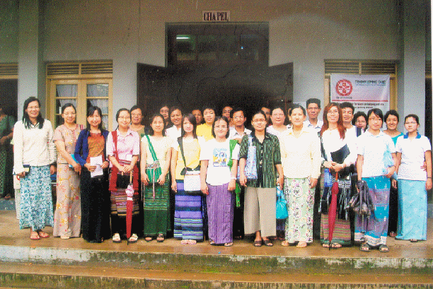
25 Students at Myanmar Institute of Theology who received glasses in 2009.

We are still attempting to send some of our newsletters by e-mail. If you would like to receive it in color by e-mail, please e-mail Neil at neildianasowards@juno.com We will also gladly send an e-mail copy if you wish to pass on an electronic copy to your friends.

We have been working on our website friendsofburma.org listing in more detail some of our fifty ministries. Please take a look and tell us what you think.

Friends of Burma, Inc. is a 501(c)(3) nonprofit organizations so all donations are tax deductible. The economic situation here in the U. S. has lowered donations coupled with the rise in value of the Burmese kyat against the dollar. So, all donations are really appreciated here by us and the people in Burma.

Update on Neil Sowards.
Neil has received 39 radiation treatments over the past 8 weeks for prostate cancer. The discomfort has been minimal and he has been able to have a pretty normal time. The doctors will continue to keep close watch over the next months to be sure it hasn’t returned. We are thankful for your prayers and concern during this time! Neil and Diana have been taking steps in the past few years to include the FOB board in much of the activities and the day-to-day operation. There is so very much involved in this “little” operation that the Sowards do behind the scenes. If you have talents or ideas to help our mission move forward don’t hesitate to call or send them along.

Moh Hin Gha (National Dish of Burma).
This rice vermicelli with fish soup is a popular dish throughout the country and can be enjoyed with your Burmese friends in the US. Bowls of Moh Hin Gha are a popular snack sold at roadside stalls or sold by vendors house to house. The one-course meal is often used to entertain large numbers of people. Moh Hin Gha is made from 20 different ingredients and is quite an involved process. You might want to plan a special (unique) Christmas celebration with some of your Burmese friends. Some FOB board members are suggesting we serve it at our February board meeting in Arizona.

Wish List.

- Useful books” Where There is No Doctor/Dentist”) to village health workers $6 for the pair or $372 for the entire graduating class.
- Small generator for domestic skills school in Pathein, which cost $225.
- Eye examination and glasses for eyeglass program cost $17.
- Orphan support for one child ($20 per month) for one year. $240.
- “Brightest student program” in Pathein at $50 scholarship per student.
- Seminary scholarship program (tuition, books, room & board)-$300.
- University Christian Fellowship women’s dorm-in Pathein--$45,000.
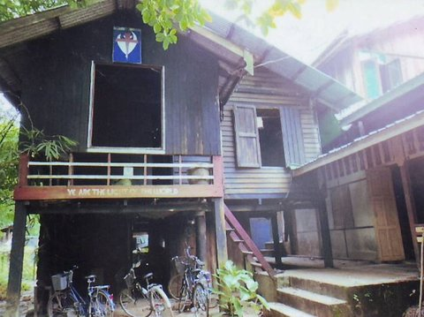
Pathein University Christian Fellowship Women’s Dormitory
- Many church members help tutor the orphans and so, some score high enough they could attend university if there were scholarships for them. Cost varies from $300 to $600 per year.

This news letter was compiled by Dr. David Horton and Dr. May Pearl.

