**Christmas 2022 Alternative Gifts.**

I am writing to express my gratitude for your “Christmas Gift.” We have received your gift of 140,000 MMK (One hundred and forty thousand Myanmar kyats) from Dr. Fom Men and the gift has been donated for Ms. Paw Win for eye operation. First of all, we would like to thank you for your generous donation for the needy. And we are also thankful to Dr Fom Men and family for their commitment to serving and helping the needy in this difficult time. Out of many needy people around us, we have chosen Ms. Paw Win to be a recipient of your “Christmas Gift” because her need and her desire for sight was very touching. She is a widow of 70 years of age and it has been five years that she lost her sight. Due to financial hardship, she was not able to take medical care and proper treatment. She is from a rural village in Paletwa township, Chin State and the pastor of the village brought her to Yangon for medical treatment. Even though the roads are blocked and travel is restricted, the pastor brought her throughout the jungle searching ways to fulfil her wishful prayer to get her sight again. She brought no money with her but faith alone. When they arrived Yangon, the pastor requested our team to help and our team tried to help her as much as we can including arranging the place to stay.

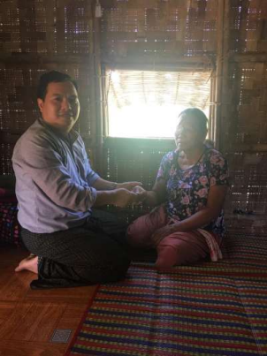The reason she wants to see again is none but to read the Bible. She belongs to a small minority group of people who do not have the Bible in their language. They are working on Bible translation and plan to get Four Gospel in printed form this December. She is the one who prayed that “I do not want to die before I can read the Bible in our language” when the Bible translation started. When she heard the Gospels will be available in her own language in coming December, she went to the pastor every evening with the prayer request for her sight. The pastor expressed, “We knelt down in tears every evening with her before God. She always says he wants to see again to be able to read the Bible. After long months of prayer, we decided to come to Yangon by faith.”

With the help of individuals like you, she was able to undergo operation for her right eye and will continue to undergo operation on the other side next week. When I put your gift on her hand, she asked who gave it to her. When I told her that it was from FOB from abroad who loved her and prayed for her, she asked again how they knew her. And I explained that God knew her and saw her, she cried. And she said, “I do not know who give me this gift. Tell them that I really thank them. I want to see to read the Word of God. I could not read the Bible in other language because I did not go to school. I hear that the Bible will be available in our language soon. So, I want to see.” Helping the needy always brings joy and compassion. I was deeply touched to see how much she longed for sight in order to read the Bible and how much she was filled with joy when she received your gift. The experience gained from sharing pain and joy with the needy in the name of the Lord is priceless and precious to me, especially for ministry. When I gave your gift to the window, I asked myself how I can serve God better by serving those in need better. We pray and believe that within a few weeks, the widow will be able to see again. I can’t imagine how she will feel at that time. Because of your donation, the Christmas season this year will be more meaningful than ever as she will be able read the Bible by herself for the first time. Your donation truly helps her gain not only her physical sight but also spiritual sight.

Thank you very much for your gift and please continue to help us serve the needy and show Christ’s love to them, especially in times as such in Myanmar.

Christ’s service,

Rev. Swe Maung

Love Your Neighbor Ministry Team

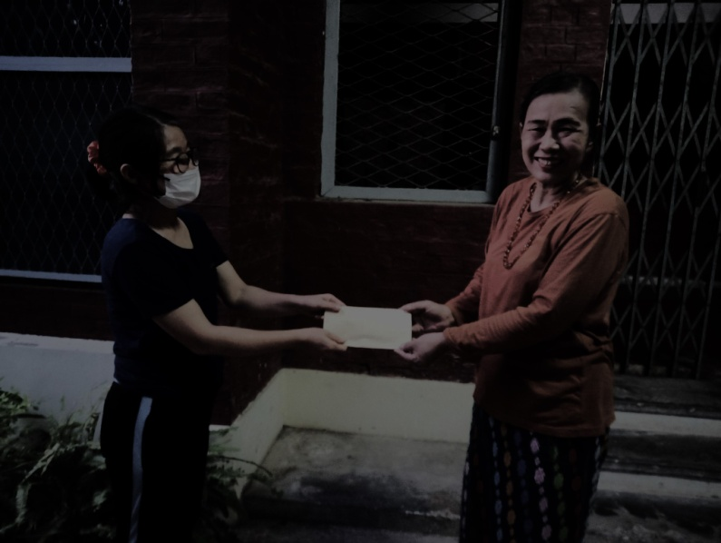Christmas Gift #2

Dear FOB Donors,  
  
This is Seng Tawng from Myanmar Institute of Theology (MIT). I have been teaching the Old Testament subjects and Biblical Hebrew since 2010 at MIT.  
  
I have been blessed to participate in distributing FOB's Christmas Gifts to the needy of our community for three years. Today again I received FOB's Christmas gift (USD 50 or 145,000 Kyats) from Dr. Fom Men and distributed it to our needy sister Ms. Maran Seng Awng. She has been having a troubling mental health problem for more than ten years after she had worked seventeen years as an office staff both at Kachin Baptist Convention (KBC) and Myanmar Institute of Theology (MIT). She regularly meets her psychiatrist twice a month. In the past when she had income, she helped needy people around as much as she could. But at this time, she is the one in need. Today when she unexpectedly received FOB's Christmas Gift, she gave thanks to our Almighty God and prayed for FOB donors so that God would bless you/them richly and wonderfully for His glory.  
  
Thank you so much for your kindness and concern for the needy. May God continue to bless you and use you richly!  
  
Sincerely,  
  
Seng Tawng, Lecturer, Biblical Studies Department, Myanmar Institute of Theology

Christmas Gift #3

A report from U Shee Sho, a security guard at MIT.

U Shee Sho asked his daughter, an LAP student, to write this report for him and sent it to me via messenger today:

**Words of thanks from Ngwe Tun Ngaing' family**

The reason they were chosen was because of the baby's injury and financial difficulties. When they received the donation, they said, "We are very thankful and grateful and we'll never forget your support and kindness."

U Shee Sho told me that the baby's parents are not Christians, and he told them about Christmas and the Christmas gift. He was happy that he could share the message of Christmas with this Christmas gift which was very helpful for the baby's treatment.

Sincerely,  
  
Fom The baby fell into an open fire.

Christmas Gift #4

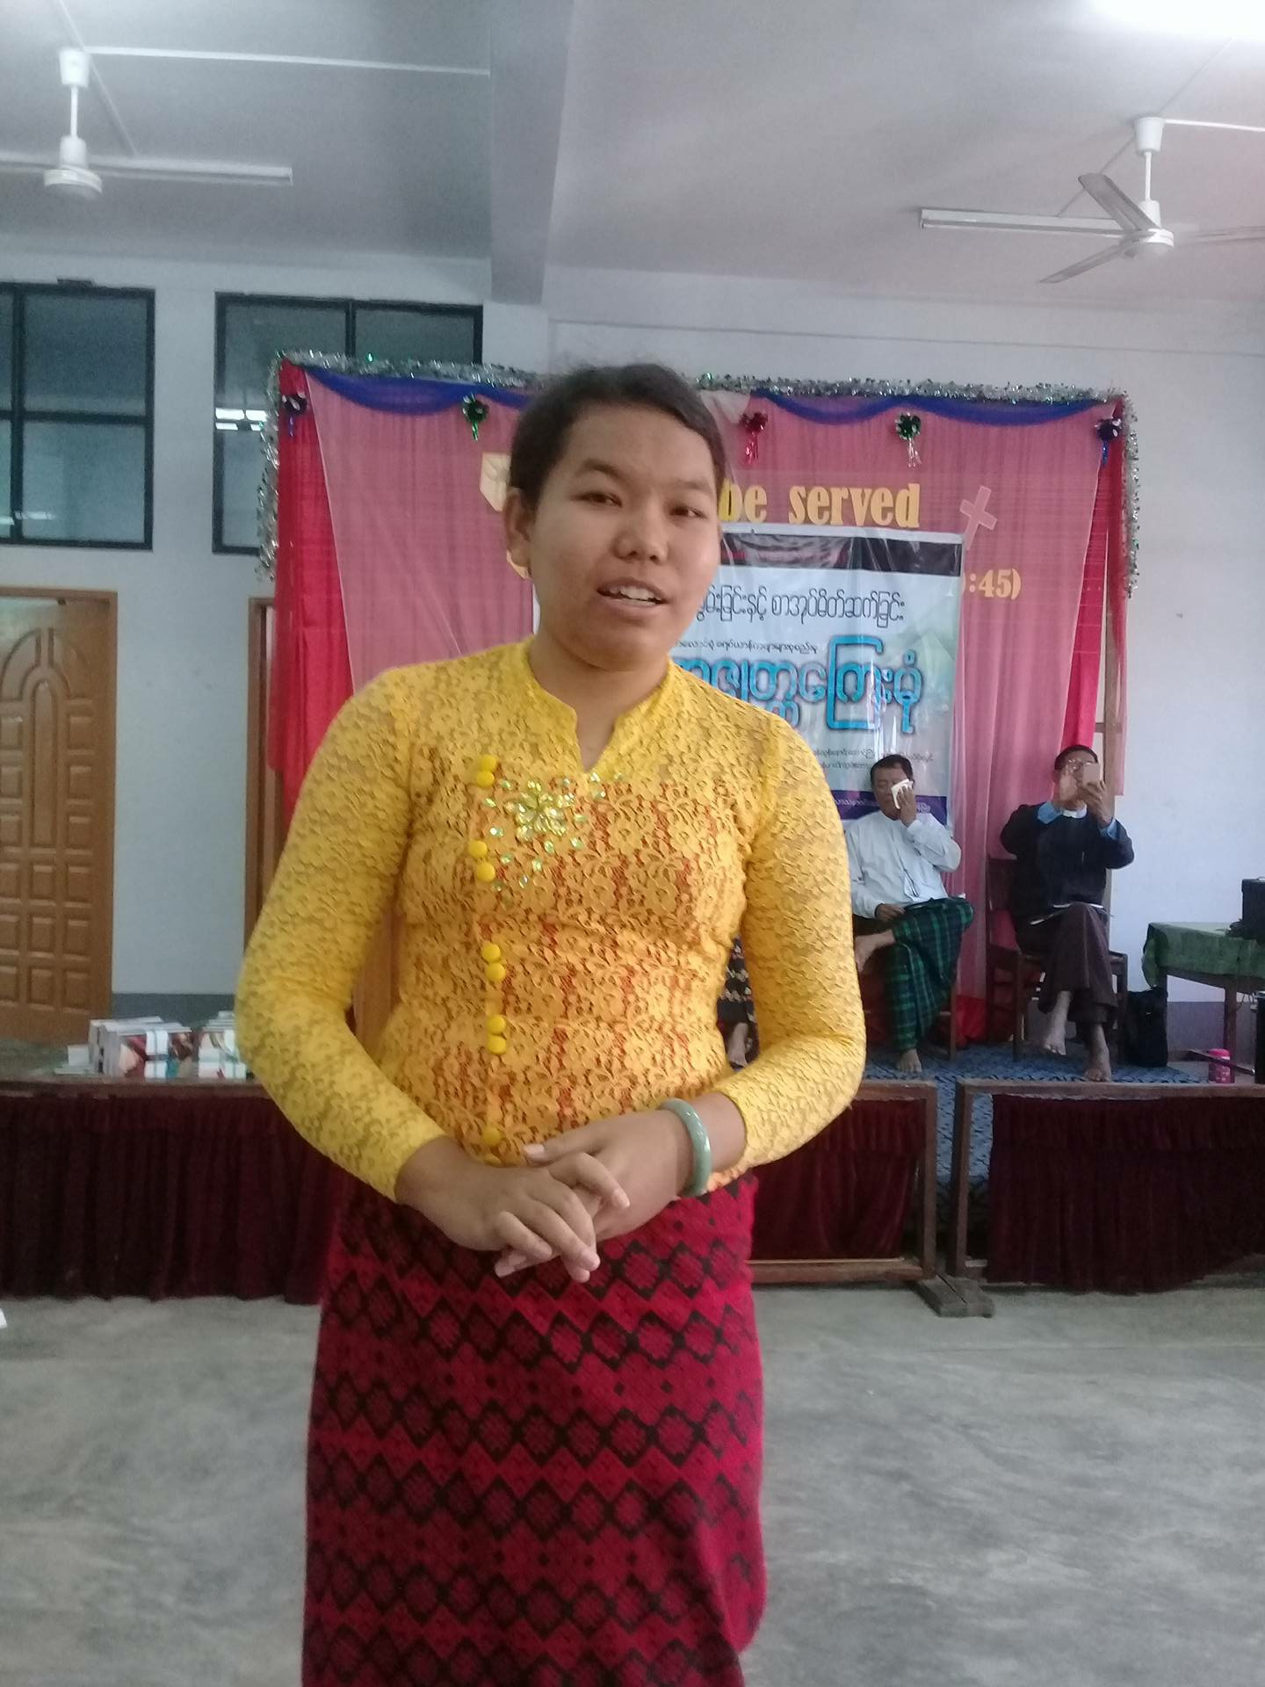

Dear FOB Donors,   
  
Warmest Greetings to you all!  
  
This is Rev. Dr. La Rip Marip, a faculty of Myanmar Institute of Theology MIT.  
  
Last week, Dr. Thomas Cung Bik and Dr. Fom Men asked me to choose a needy person around me and to give the FOB’s “Christmas Gift” to him/her. I am very happy to be a part of your “Christmas Gift” distribution program. I chose a young Bamar pastor who is working among poor Bamar in Hlaing Thar Yar, near Yangon. She had finished her Bachelor of Theology BTh program from Myanmar Institute of Christian Theology MICT. She is poor. Her mother recently passed away. Her father earned very little. I personally know her since she was a theological student at MICT. Since she obtained her BTh degree, she has been working among Bamar Christians who are a minority among their fellow Bamar Buddhists. She teaches Sunday school classes, dances, songs, and performance.  
  
When I informed her about the Christmas Gift, she was very happy and she wrote a thank you letter (in Burmese) to Friends of Burma. In the letter she expressed her gratitude to you all. She also described her financial difficulty that her father worked only ten days in a month and earned very little money. She also told you that she was applying for the MDiv program at MIT. She said she received 145,000 Kyats. She prayed for you and she vowed that she would serve the Lord more and more.  
  
As she described in her acknowledgement letter, she is applying for MIT’s MDiv this year. In our telephone conversation, she had not had a sponsor yet. So, I would like to request you to grant her a full scholarship. I strongly recommend her to you because her service will benefit all Bamar Christian and non-Christian of her area. May God bless you all!  
  
Warm regards,  
  
La Rip  
  
Rev. La Rip Marip, PhD  
Associate Professor of Old Testament and Dean of Students  
Myanmar Institute of Theology, Seminary Hill, Insein, Yangon 11011, Myanmar

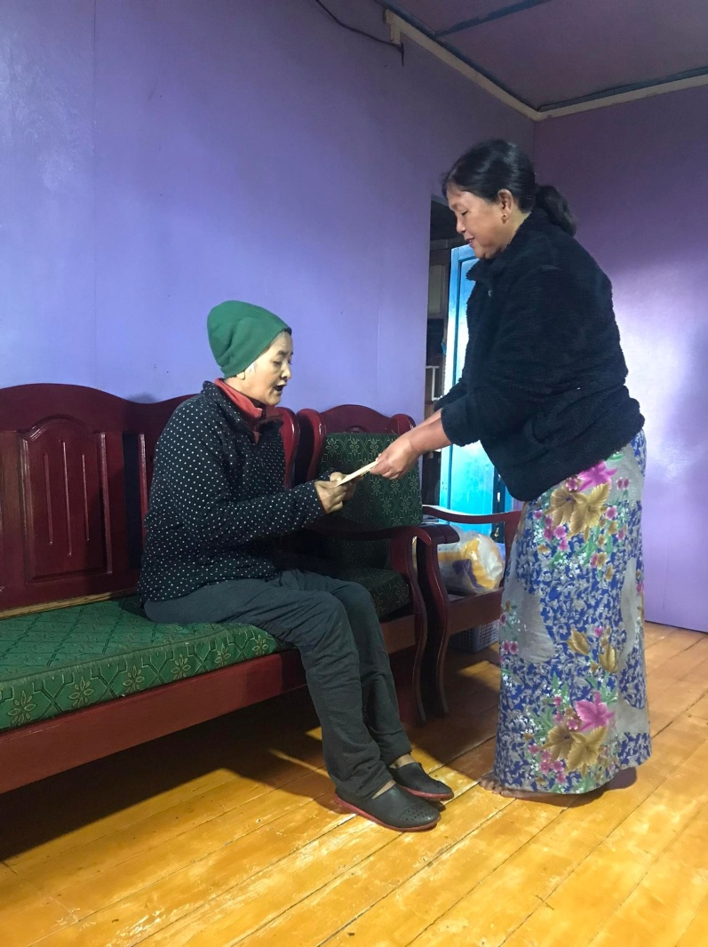Christmas Gift #5

Date: Tue, Nov 22, 2022 at 1:55 PM   
Subject: Thank You for Your Christmas Gift

Dear FOB Donors,

Greetings from Myanmar! I would like to give a report on the distribution of the Christmas gift of **145,000 kyats ($50)** from you.

I chose Pi Siang Zi who has been paralyzed for three years. Her husband cannot use his left hand since it was broken a few years ago and has to work only with his right hand. He is a manual worker, and at this time it is extremely difficult for him to find a job. They have three children. One oldest son is married and lives with his family in a village near the India border. This son has a mental problem and cannot even look after his family, and his wife's parents are taking care of his family. Their second son worked before the pandemic and helped his parents, but at this time he could not find any job. Their daughter has a mental problem. I heard from my aunt that this family is in desperate need. Their neighbors tried to help them as much as they could, but their neighbors are also trying to survive in this trying time. Thus, I chose Pi Siang Zi and family for the Christmas gift. I sent the money to my aunt who gave it to her on my behalf.

Yesterday, I spoke with her and explained to her that this Christmas gift is from you. She praised God and thanked you. I prayed for her on the phone. She asked me to express her heartfelt thanks to you for your Christmas gift.

From her voice I could tell how grateful she was. I am also happy that this Christmas gift reached one of the poorest among the poor in this country.

I would like to thank you for your Christmas gift to show God's love in tangible ways to the needy in Myanmar.

May God continue to bless you and use you more in the days to come!

Shalom,

Thomas

Rev. Thomas Cung Bik, PhD

Christmas Gift #6 Given by Naw Paw Gaw

The story of heartwarming Christmas gifts for 2022

This year I receive 2 Christmas gifts for 2 people.

1. **NawMyintNwe**

She lives in ByinNyar village, Hinthada Township. She is 39 years old and has 5 boys, the eldest one is 17 years old and the youngest boy is 1 year old. Her husband was suicide last year because of a depression issue. She was 7 months pregnant and has 4 boys when her husband left her. Now her eldest son goes to the Yangon and works as a waiter in a small restaurant. The second son is dropping out of school and working as a daily wage worker in his village. The rest 2 boys are attending primary school in the village and the youngest one is still an infant age. So NawMyintNwe could not work fora family income.

Her 2 sons can support the family with only 100000 kyats per month but for some months only 80000ks because his salary is only 150000Ks per month. The second son, 14 years old can support his family as much as he can. So when we went to her house with her pastor her youngest son was sick and nothing cash in her hands. People in her surrounding also help her family as much as they can. So when I gave the Christmas gift (150000 Ks) from Neil and Diana (FOB) to her family, I explained about the gift. She was so happy about the unexpected gift and said words of thanks to Neil and Diana (FOB). After that, I prayed for her family and came back to the pastor’s house. NawMyint New received the Christmas gift on 20thNovember 29, 2022.

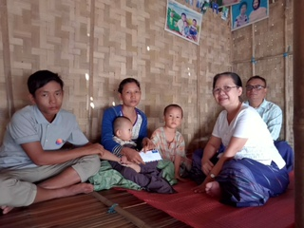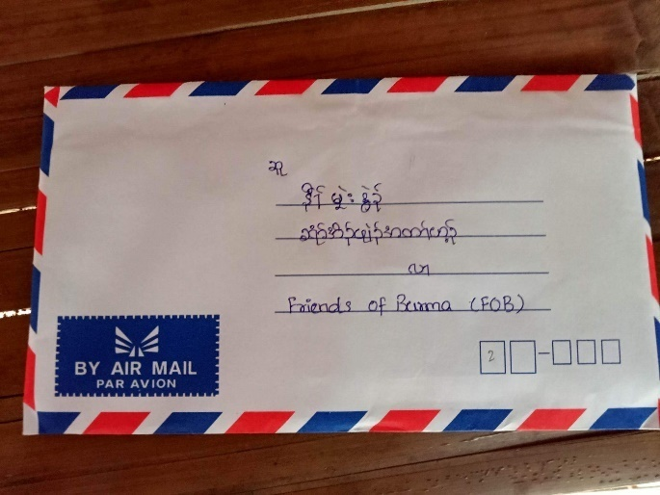

Christmas Gift #7. Given by Naw Paw Gaw

1. **Thara Saw Jonny**

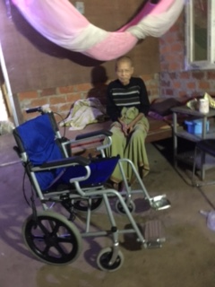He is a man of godly and has 78 years old. After he retired asa middle school teacher, he worked as a mission field worker for 6 years at Ywa Theit Gone Village, Hle Gu Township. When he was a mission field worker he worked so hard even he neglected his personal health care. After 6 years of his service, he got sick and gradually paralyzed in the lower part of his body. He got a little hard of hearing and got weak in eyesight but he can talk and hear. He suffers it for 8 years.

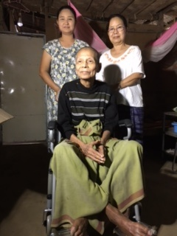During this year his son-in-law was arrested for unwitting participation in illegal activities because he was a taxi driver. Last 2 months her daughter who take care of him got a serious disease and there was a big financial problem in the family. Now his son-in-law is in Jail and her daughter is weak in health. There is another daughter who supports him but she also could not support her father much. Thara Jonny is longing for a wheelchair for a year because he wants to go to church but his family could not afford to buy it. The cost of a wheelchair is 240000Ks and FOB has 150000Ks.So I added 90000Ks in the FOB Christmas gift. I don’t have much money but I know Thara Jonny is longing for it for a year. He really wants to go to Church. When I gave him the wheelchair he thanked us with long words and was excitedabout receiving the wheelchair. He received a wheelchair on November 27, 2022. As I receive the warming atmosphere of Christmas Joy through Thara Jonny, I’m sure that you also will feel the touching of joyful Christmas in your hearts.

Christmas Gift #8

A report from Dr. Paw Lar Say, Associate Professor and Head of the Department of Social Studies at MIT.  
  
 From: PawLar Say <[pawlarsay@gmail.com](mailto:pawlarsay@gmail.com)>  
Date: Thu, Dec 1, 2022 at 12:53 PM  
Subject: Report: FOB Christmas Gift  
To: <[fommen@gmail.com](mailto:fommen@gmail.com)>  
  
To,  
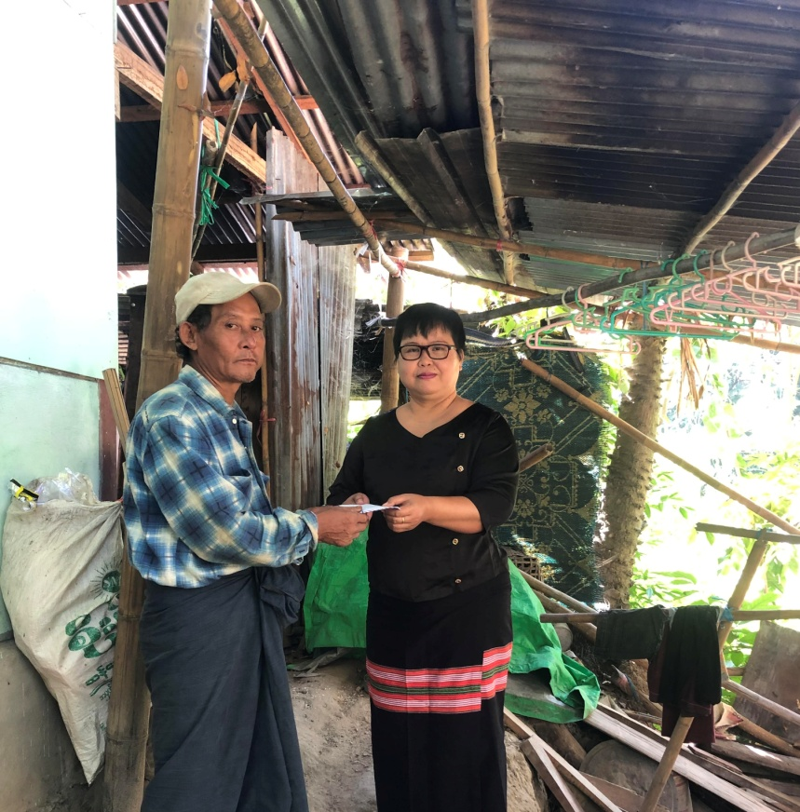 FOB Donors, Merry Christmas!  
  
It is my greatest pleasure to send you a report of FOB Christmas Gift.  
  
Early one morning, I had a special surprise for a father named Saw Tha Taw who lives at a village in Toungoo, Myanmar. He is from my neighborhood.  
  
He is a daily random worker earning 2000 - 5000 Kyats ($1 - $2.) per day. He has a duty and responsibilities to look after his wife who is suffering from a Chronic disease and two children.  
  
He was surprised by seeing me early in the morning with an envelope. I talked to him about the FOB Christmas Gift in this year of 2022 and told him that I would like to give this Christmas gift to him. He was laughing, head scratching and said, "Oh really? I’m so happy to hear this good news early this morning as I have never received any Christmas gifts (cash) in my life." And, he continued saying that he thought I would be asking him to give donations for Christmas and if I really asked him for that then he would say sorry for this time. (We were laughing at that moment).  
  
My few minutes experienced with this father taught me to ask a question that currently how many people in Myanmar would be afraid of someone coming and asking for donations in this moment of uncertainty living life situations. In fact, Christmas is a time of giving love isn’t it?  
  
Thanks for giving me this opportunity to share the Christmas Gift to the needy that is to show the meaningful Christmas indeed.  
  
May God continue to be with you & may the name of our Lord Almighty God be praised and glorified by FOB forever.  
  
All the best,  
PawLar