548 Home Ave, Ft Wayne, IN 46807  (260) 745-3658  friendsofburma.org  Neildianasowards@juno.com 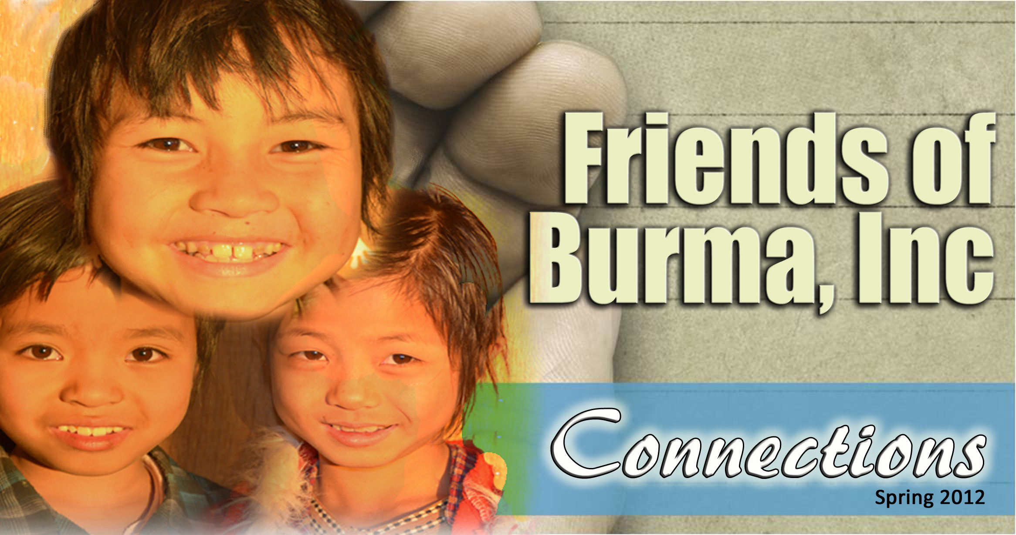

# Neil and Diana 1985.jpgAre you an MK from Burma?

Friends of Burma Inc was founded when Neil Sowards visited the country where his parents served as missionaries. In 1985, Neil and his wife, Diana, accompanied by Rev. Dr. William and Marion Hackett (IM missionaries in Burma, 1941-66) on a trip to take supplies to the Burmese. Neil and Diana were moved by the needs of the Burmese Christians, and established Friends of Burma, Inc. which now has more than 50 ministries that address the institutional, evangelical, health and educational needs in Burma.

Neil and Diana are now attempting to contact other Missionary Kids whose parents served in Burma. If you know of any former MK’s, contact Neil and Diana so that we can expand the reach of Friends of Burma.

# Pressing Need - Pegu Yoma Famine

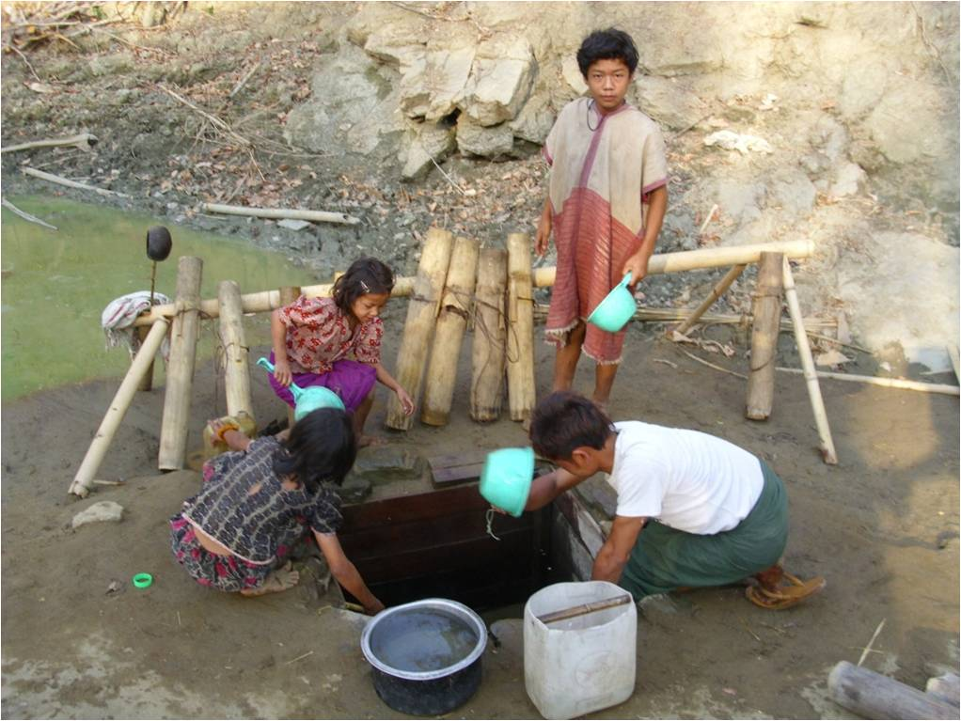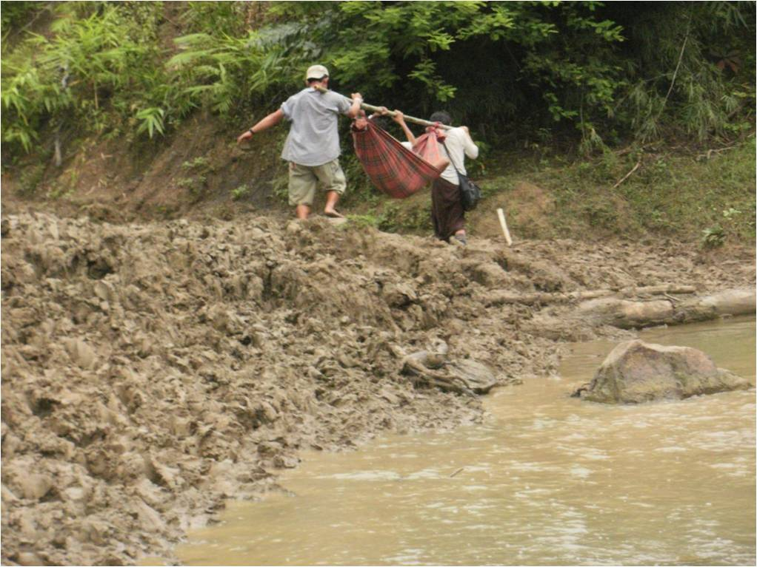Saw Russ Kadoe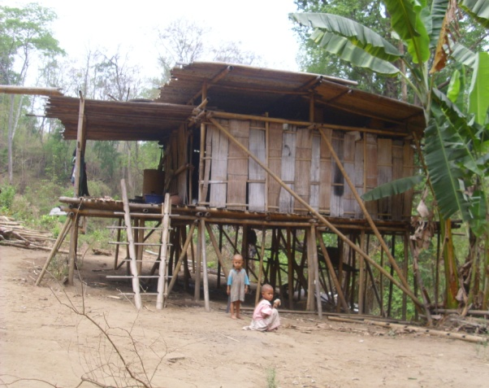 reports a pressing need from the famine stricken Pegu Yoma area north of Yangon. He writes “Currently I am working with my other friends who are serving in Pegu Yoma in 11 villages. All of them graduated from KBTS and have served in Pegu almost 10 years. By the grace of God we had overcome many difficulties and led many to faith in Jesus Christ. We would like to thank everyone who supports us. But we still need help from all of our brothers and sisters in Christ to continue our mission. A major difficulty is travel, as the roads and paths are almost impossible to travel in rainy season. They are barely passable when dry. We face the problem of clean water, toilet, personal health knowledge and educational inadequacies as well. For the moment we have two teachers, Tharamu Ka Lu Paw and her sister who are living among the villagers guiding and educating them without salary. They have contracted malaria but are still serving joyfully. We need to build two story wooden buildings in the two main villages to use as schools. The teacher would live upstairs while downstairs is for education. Estimated cost is 15 lakhs (approx $1,870). Education and training would be greatly facilitated with such accommodations, plus the building can be used for many other purposes. Russ kindly requests FOB donors to participate in this mission to upgrade the living standard of the very poor Karen people living in the Pegu Yoma mountain range. What good is it to offer them Jesus Christ and not meet their physical needs as well?

Sickness and disease is common because of poor water systems

# KBC HOSPITAL NEEDS AN ELEVATOR

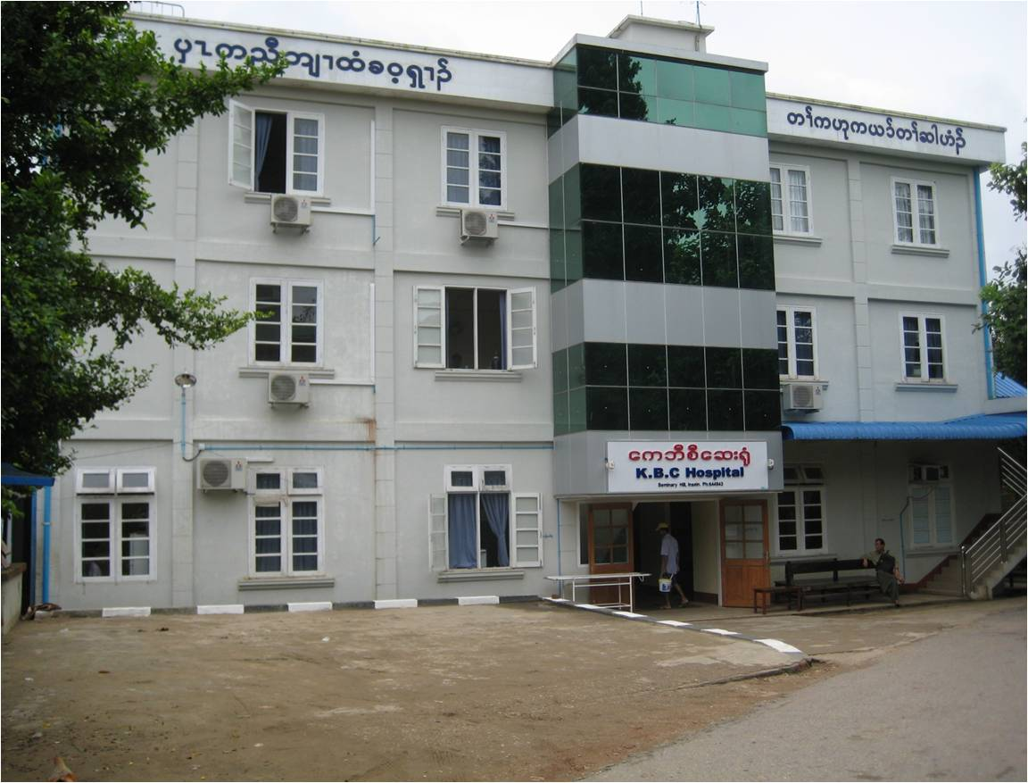In a recent report from KBC Hospital, the following appeal was made:

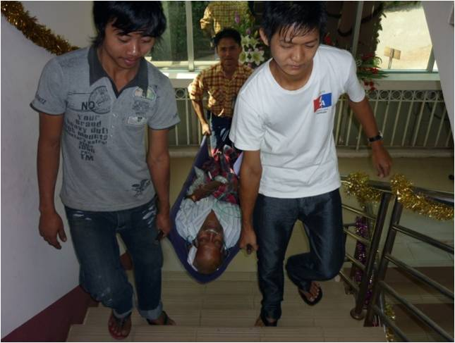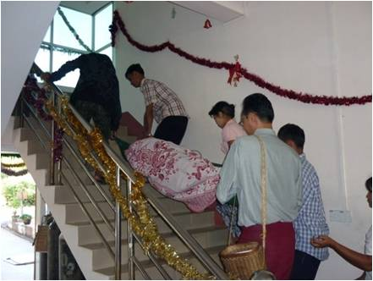“In 2010 the Government’s Ministry of Health recognized KBC Health Care Clinic as one of the private hospitals and it is now called “KBC Hospital”. As the number of patients and buildings increased the hospital has to arrange suitable facilities for customers’ convenience. Currently, we use manual labour to transport patients, to carry machines, oxygen cylinders, and other things from one floor to another. Carrying patients manually from one floor to another in not convenience patients and also has some risks. So, sometimes, we have difficulties in transferring seriously ill patients. Usually staff from KBC Hospital and patient’s relative carry patient together. This causes burden for the Hospital and also for the patient’s family. Moreover, some older people who come to the Hospital to pay visit to patients or to meet with management of the Hospital have difficulty using the stairs. Many patients and some of their family member also gave suggestion letters to us to install a lift (elevator). In the report of “Evaluation of Clients’ Satisfaction on the Services Provided by KBC Hospital”, installation of a lift is one of the recommendations from patients and their relatives. As our hospital is now growing bigger and bigger and we are essentially in need of a lift not only for transportation patients but also for emergency services.”

“Meanwhile, for transportation of patients, we have to use stretcher with hand carry. We face with many difficulties in transporting patients down stair to up stair, up stair to down stair, from operation theatre or labour room to wards and words to those rooms. Thus as a hospital we really need a lift for transportation of patients and for providing emergency services to patients. If we have a lift it will really benefit patients and we would be able to provide better health services than before.” The Lift will cost approximately $50,000. FOB has given toward this need, but we need more donations.

##### ***Praise for answer to Ventilator Need***

One sorely needed item listed in our 2011 Annual Report was a ventilator to be used in the ICU. One of our generous FOB donors promptly provided the funds and the ventilator is now in service! Thank you so much! Your donations not only touch lives in Burma, but they can save lives too!

# Report from Lwin Moe\*

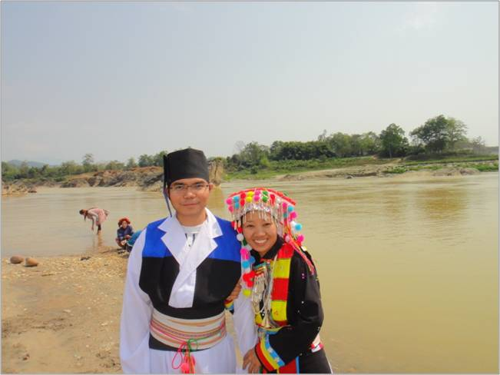I went back to Burma to get married in Myitkyina, Kachin State, on March 3. Swe Di Nar, my wife, is Lisu and a daughter of Rev. Dr. Simon Fish and Daw Lu Di from Myitkyina. Here is our picture at the confluence of the N'mai and Mali rivers near Myitkyina.

The weather in Myitkyina was like a perfect fall and perfect temperature of 70 degrees Fahrenheit. Yet, local people from villages outside of Myitkyina can't enjoy this beautiful scenery.

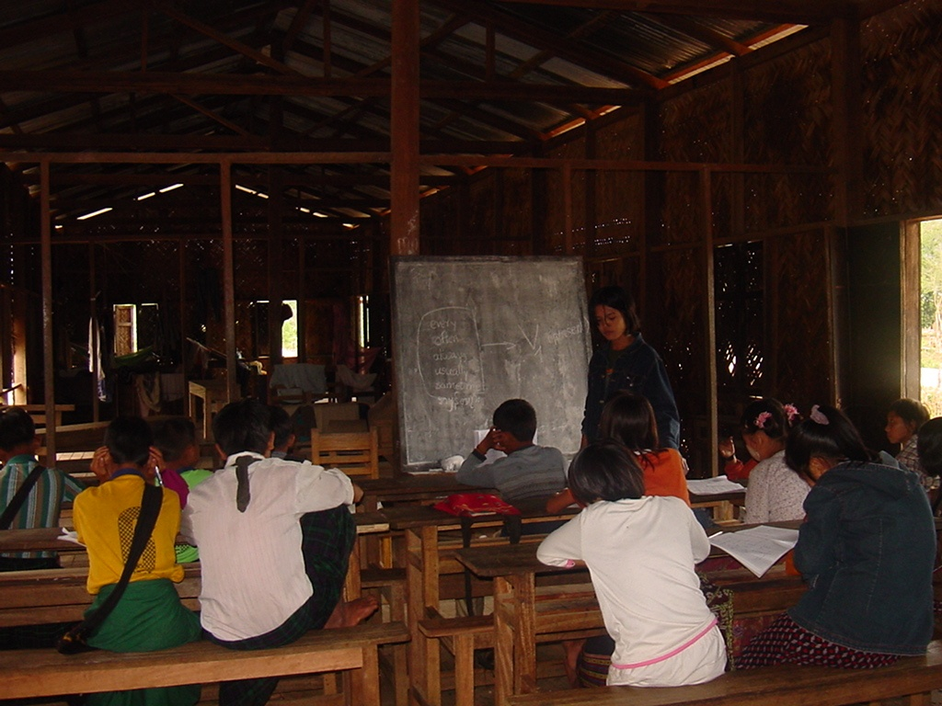We saw thousands of Internally Displaced People (IDP), living in tents in church compounds in and near Myitkyina. Fairly recently, there has been widespread conflict between government troops and the Kachin Independent Army. Life and Education in these small villages has been disrupted to the point that people are fleeing to the larger towns and cities.

I was at one of those villages a few years ago during one summer, teaching English and Math. Their school before they had to leave the villages was like in the following picture. Now, they don't have access to even this school. We also don't know where the families we visited that summer are now. It was sad to see people having to leave their home to flee the conflict and live in makeshift tents in church compounds. Please remember these people in your prayers. *\*Lwin is an Executive Committee Member*

# Chin Christian College2.jpgNews from the Chin Christian College

Friends of Burma supports many Bible Schools, Christian Colleges and Seminaries in Myanmar. We have supported Chin Christian College in scholarships and staff support. CCC is located in Hakha, the capital of Chin State. CCC is fully accredited by the Association for Theological Education in South East Asia (ATESEA). Through March, 2011 they have graduated 797 students into the service of our Lord. Currently they have 288 students enrolled.

# Agape Orphanage Project, Loikaw

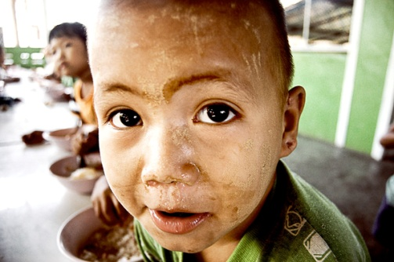Our spotlight is upon the Agape Orphanage sponsored by Loikaw Baptist Church. The orphanage began with 25 children of non-believers. As they have grown, 20 have trusted in Christ and have been baptized. They have added more children, and are assisting them in receiving a sound education. They have graduated a few who are now attending Bible College and even Seminary. (Saw Htoe Reh, Maw Mu Nay & Naw Esther). Dr Mooler Htoo thanks Friends of Burma, “By the grace of God and with the generous help from you all, the orphans are blessed and can attend school and are well fed. They are growing up both physically, mentally and spiritually day by day. They are healthy and strong and there are no expenses for their health care. We hope you will continue your support for these orphans.” Two of the new orphans are a sixth grade boy, Saw Dah Htoo, and a young girl, Naw Ei Moe Wah. Both have lost their fathers to accidents, and their mothers are not able to feed and clothe them.

Friends of Burma supports several hundred orphans throughout Myanmar, but the need is overwhelming. Please consider donating $240 per year to feed, clothe and educate a child. Myanmar is one of the poorest countries in Asia. In 2010 it ranked 132nd out of 169 states in the Human Development Index, lagging behind all of its ASEAN neighbors in indicators for poverty, health and education. An estimated quarter of the Burmese population of 50-60 million people live in poverty. Seventy per cent of the population are subsistence level farmers. Due to the extreme poverty, children are often given to the orphanages because the parent(s) can’t afford to care for them. In addition, Cyclone Nargis left several thousand children parentless.

# New Office Building.JPGNews from Pathein

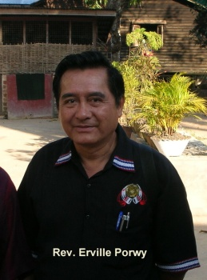Rev. Erville Porwy of the Pathein MyaungMya Sgaw Karen Baptist Association (PMSKBA) reports that their new four story office is under construction, and donations are needed for its completion. He also reports great news from the Mrokhami Baptist Mission undertaken by the PMSKBA in 1983. There are now 17 well-established Baptist churches in 18 mission fields. Together they have over 3,000 members, 50 full-time Pastors, Evangelists and Christian workers. There are three Christian Centers for Mro-Khami students and one Mission Training Center with 18 students and 7 teachers.

# 718.JPGMatthew 25 Love Hospital

Rev. Erville Porwy reports the hospital sees 75-100 patients every day with multiple surgeries performed daily. They recently delivered triplets, with mother and babies doing well. They have 12 doctors and 20 support staff.

# News from the Executive Committee

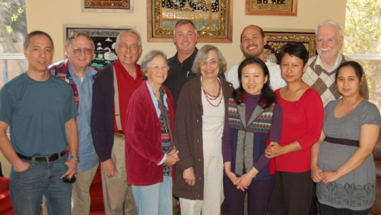Dr. Ardeth Thawnghmung, an Executive Board Member, did one year of field research on poverty in Myanmar. She was sponsored by the Fulbright Foundation and has been involved in helping build capacities for civil societal organizations.

We are pleased to announce a new Executive Board Member, Htaw Plaw Htoo. He is a naturalized American citizen and served our country in the Iraqi War. Neil and Diana Sowards were his “foster” parents while he attended college in Ft Wayne, earning a B.S. in Computer Science. He has provided much needed technical expertise in the past. We are happy to have him on board for a five year term.

The FOB Executive Committee

Annual Meeting - Feb, 2012

# MIT-Five-Story-Building.jpgMyanmar Institute of Theology

Rev. Dr. Samuel Ngun Ling reports that several degree programs have received accreditation ATESEA (Association of Theological Schools in South East Asia). Degree programs accredited are Masters of Divinity, Masters of Theology and Doctor of Ministries. He expresses deep gratitude to all faculty members, students and the Board of Trustees for their active participation in making MIT’s accreditation a great success.

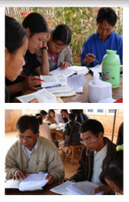They also report that the 5 story “Diamond Jubilee Building” is nearing completion. Construction has proceeded ahead of schedule, and is greatly needed as enrollment has surpassed 1,000 students.

# Inductive Bible Study

Friends of Burma is seeking supporters of a special Inductive Bible Study Program which is ongoing in Myanmar, led by Saw Daniel Ban Doo. The school was started in June 2007 as a Bible study program for the Leadership Promotion Department of Karen Baptist Convention. This is an intensive 9 month study where the students live together in a rented house and study all 66 books of the Bible in an intensive program. The teachers live in the same house, so study opportunities are almost 24/7. Students pay a minimal amount for tuition, housing, books and food. So far 27 students have graduated and are now serving in churches. This Study operates within the Karen Baptist Convention and is instrumental in training Christian Workers for rural villages. This program has a need of $3,000 for annual rents. Friends of Burma has given a matching grant of $1,500 and are seeking donors to meet that challenge.

# Recipients of Lew Murdock Scholarship best.jpgMedical Scholarships

Former Executive Committee Board member Lew Murdock has sponsored Medical Health Scholarships for several years. In 2011, 43 students were able to continue medical school training because of Lew’s generosity. There were 11 Medical School students, 8 Dental School students, 8 Nursing School students and 16 Nurse Aide’s students. These students are studying in Medical Schools in Yangon, Mandalay, Magwe and Pathein. Many more students need assistance and we encourage others to participate. Here is a collage of some of the students.

# Library Support

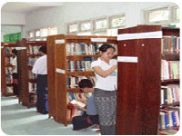Friends of Burma has founded as well as supported the education of Burmese through significant contributions toward Libraries. One expression of gratitude for this support was received from Naw Elta, Librarian at Karen Baptist Theological Seminary (KBTS). She writes, “On behalf of the Seminary, I really thank Friends of Burma who enable our library to exist as a standard library. As a Seminary, we need a lot of books in all areas to increase the knowledge of the KBTS family, as well as the surrounding seminaries and the communities around us. Because of the knowledge from the books, the knowledge gap between the rural and urban students is narrowed. The numbers of students who study at the library are so many that the supply of books is becoming limited. We appreciate your donation of the books, but we still need more, as demand is constantly increasing.” Consider the impact of your donation toward Libraries in Burma.

# Rev Say Mawler.JPGAssistance for Retired & Sick Ministers

Through your generosity, Friends of Burma is able to help retired Christian Workers in a country where there is no “Social Security” as we have in the US. One recipient, Rev. Say Mawler, Pastor of Judson Karen Fellowship Church in Yangon, had to effectively retire due to cancer. Since 2006 he endured 8 surgeries and 55 radiation treatments. He writes us, “By the grace of God, I am not dead yet, but still living, and serving God today!” He thanks us for the unexpected financial support which Friends of Burma provided him in February of this year. Please pray for him as he recovers and seeks to serve the Lord. We have received warm thank you letters from Lian Ceu Bik, Buan Thawng Lian, Pastor Duh Sang, Rev. Shisho (97 years old), Rev. Gaw Po Shwe (82 years old), Thra Tun Ni and Rev Beebay (both 71 years old) as well as many others. There are many more Pastors and Ministers who need our help.

# Eyeglasses

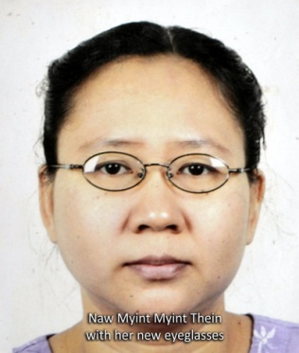Proper sight is essential for successful scholarship and study in preparation for Christian service. Friends of Burma provides for examination and prescription eyeglasses for Bible students and Ministers. As Rev. Hsa Mu Htaw, principal of KBTS writes, “Your donation for the eyeglasses is like one who opens the eyes of the blind. Students can read more, get more information from reading and do their assignments correctly.” Sadly, he reports, “There are many more students who need eyeglasses but cannot afford to buy them.” Consider how your donation for a pair of eyeglasses can further the cause of Christ by empowering a student to read and study without strain.

Naw Myint Myint Thein, one of several student recipients at Myanmar Institute of Theology writes, “Thank you so much! Now I have eyewear glass and I can read my lessons and see clearly. May the richest blessings of God shower upon you!”

# Scholarship Recipients.jpgStudent Scholarships

Pictured are Scholarship recipients from Waimaw Theological School in Kachin State. (clockwise from top left)

* Mading Zung Myaw
* Lungbang Ting Kyang
* Mangshang Luk Sawng
* Hpakawn Htoi Zan
* M. Luk Ting
* Hk. Hkawn Lum

**The center picture is of Myo graduates.**

We support students in several Bible Colleges, Christian Schools and Seminaries. We invite you to support a student for only $200 a year.

# Cyclone Nargis Update

Three and a half years after Cyclone Nargis devastated southwest Burma, many people have rebuilt their lives. However, thousands of others—especially those in the worst affected areas—are finding that their quality of life is markedly lower than pre-2008, according to a recent study.

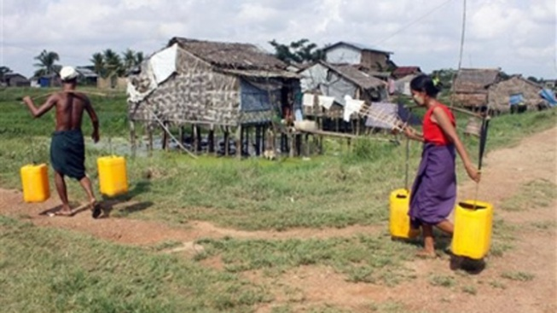The survey, released October, 2011, was carried out in the Irrawaddy Delta by a team comprising four expatriates and 15 local researchers from two community-based organizations. The study titled, “Myanmar – Surviving the Storm: Self-Protection and Survival in the Delta” was documented by Local to Global Protection, a non-governmental initiative aimed at documenting local perspectives on protection during major humanitarian crises.

The study reported that aid workers estimated as many as 200,000 people may have been killed by Cyclone Nargis—most of whom died in a period of less than twelve hours after the cyclone struck. Earlier official data records the number of dead and missing at approximately 140,000 people.

One reason for this discrepancy in numbers is that there were perhaps 50,000 unregistered migrant workers from upper Burma at the time of the cyclone (in 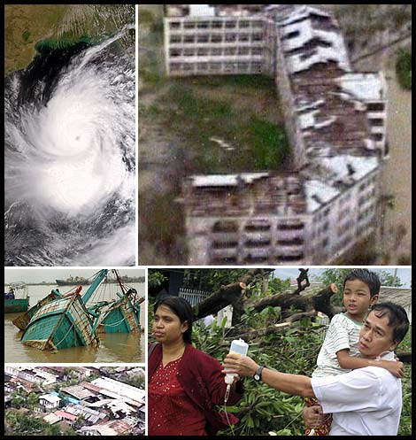Laputta Township alone), none of whom were included in official figures, said the study.

In the worst affected areas, survivors were still struggling to re-establish livelihoods long after Nargis hit, Ashley South, a Burma specialist and one of the researchers, told The Irrawaddy.

This was due to the severity of the destruction, environmental factors and also because the assistance received was not enough to meet all their needs, he said.

Altogether, some 2.5 to 3 million people were displaced by Cyclone Nargis. It flooded more than 783,000 hectares of paddy fields with saltwater, damaged irrigation systems, destroyed seeds, killed livestock, and devastated infrastructure in the Delta and beyond. Some 800,000 homes were either damaged or destroyed.

In the first days and weeks following Cyclone Nargis, informal networks and unofficial as well as official local leaders were important in helping communities survive, organize and bring assistance from larger towns to the villages. The Karen Baptist Convention and Pathein MyaungMya Sgaw Karen Baptist Association were instrumental in providing aid in this time of crisis.

# GuideStar_Exchange_seal_RGB_215X215.gifFriends of Burma is now in GuideStar

Every day, nearly 22,000 people come to GuideStar to learn more about nonprofits; in 2008, their visits added up to more than 8 million visitors. Many are donors and grantmakers seeking information on organizations to support. At Guidestar.org you can learn all about Friends of Burma through annual reports, IRS Form 990’s and financial records. Friends of Burma is unlike most Non-Profits, because all our work in the US is done by volunteers. Our total expenses are only 1% of donations received. This means when you give to Friends of Burma, 99% of your donation reaches Burma. What other organization can say that?

# Leave a Legacy of Hope

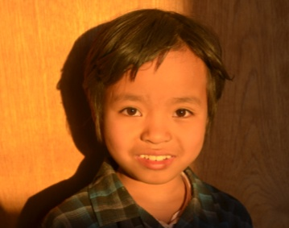Friends of Burma has partnered with American Baptist Foundation to enable support of our ministry through planned giving and creative stewardship. Ways to give:

* Outright Gifts
* Wills (Bequests)
* Charitable Gift Annuities
* Charitable Trusts
* Endowments

Contact American Baptist Foundation for additional information. Please indicate that you desire to establish a gift to support the work of Friends of Burma. You can receive more information by contacting Dr. & Mrs. Neil Sowards by email at [neildianasowards@juno.com](mailto:neildianasowards@juno.com). You may also contact the American Baptist Foundation directly at:

P.O. Box 851

Valley Forge, PA 19482-0851

(610) 768-2035

abfadmin@abc-usa.org

#### ***Please Pray about giving toward these needs:***

Compiled and edited by Jim Tompkins with the assistance of Diana Sowards.

#### **KBC Hospital**

* **A sewage water treatment plant**
* **A lift (ELEVATOR)**
* **75 KVA generator**
* **A place for patients from remote areas to stay.**
* **School fees for IDPs children at Myitkyina – $30/student. Or give to “most needed” so we can respond to new situations and needs**

#### **Needs List**

* **Support an orphan – $240/yr**
* **Scholarship for a Bible College, Seminary student – $200/yr**
* **Medicine for the poor at a small clinic – $200/yr**
* **Inductive Bible School scholarship – $200/yr**
* **Eyeglasses – $17/pair; Hearing aid – $25/pair**
* **Jubilee Annex Building at MIT – any amount**
* **Pwo Karen Building at Ahlone and at Pathein – any amount.**

#### KBC Hospital

* A sewage water treatment plant
* A lift (ELEVATOR)
* 75 KVA generator
* A place for patients from remote areas to stay.
* School fees for IDPs children at Myitkyina –
* $30/student. Or give to “most needed” so we can respond to new situations and needs