**Newsletter: Friends of Burma, Inc.**

Neil & Diana Sowards, 548 Home Ave., Ft. Wayne, IN 46807 © Phone: 260-745-3658

Email: neildianasowards@gmailcom

Website: www.friendsofburma.org

**Spring Edition, May 2023**

Dear friends, Spring is here once again, and we thank the Lord for His faithfulness and His provision. In this time of the year, everything around us become more alive and vibrant, pointing us to the creator who is in control of every season. The war in Ukraine continued and many people in Burma continued to suffer due to conflict inside the country. Many around the world are also suffering under various circumstances. We pray that these trying times will be over soon and hope will come again to those who are in the midst of the suffering season. We look around and see many things that are unsettling and worrisome, but we encourage ourselves in the Lord and carry on with the strength of our Creator. 2 Corinthians 5:7 tells us that “For we live by faith, not by sight”. We thank you for partnering with us to bring hope and healing to the people of Burma. Your generous gifts and prayers are greatly appreciated.

**One of our board members wrote why she supports Friends of Burma** My name is Naw May Pearl Cartee, and I am from Pathein, Myanmar. I was sponsored by a former missionary to Burma, to study at Judson College in Illinois. I am thankful for the scholarship from Judson College and the generous support of my sponsor and her friends as well as a wonderful Karen host family, through whom God has blessed me. I am also thankful for my education at Northern Illinois University and my awesome American host family, without whom I would not have finished my graduate study at NIU. My American host parents introduced me to Friends of Burma, and I learned about the great things that FOB has done for the people of Burma, such as supporting seminary students, providing financial assistance for clinics and hospitals to purchase needed medicines and equipment, providing for orphan children, for their daily meal and education, empowering women and men to get themselves out of poverty and have hope for the future, and many more. I am glad to be able to help my fellow country men and women. My gift may be small compared to the need in Burma, but I believe that God will bless it and use it. As I gladly receive help from others in my time of need, I also hope that I can be a channel of blessing to others, in their time of need.We would like to share with you how your prayers and generous gifts have given hope to many who are suffering in Myanmar, also known as Burma.  **Thank you letter from Agape Child Care Center** The committee members of the Agape Orphanage Project and the children thanked Lowell International Church for their generous support. Last year, by the grace of God, all the children were well, and they could attend school despite the unstable situation around Loikaw. Currently, there are 2 boys and 6 girls at the orphanage. They planned to accept 4 more children this academic year, 2023-24. They believe that God will make a way and that He’ll never forsake His children in such difficult time like this. They said, “Please remember us, the Myanmar people as well as the Ukrainians, in your prayers. We don’t know how to thank God, the Sowards and all the donors who are supporting the children to this day. The church pastors, the committee members of the project, all the church members, including the orphans always remember you all in our prayers and feel a great debt of gratitude to you all. May God bless you all as you continue to serve Him through the project”.

**Educational support**

Darren graduated from Pathein High School in 2007. During his High School years, he stayed at Gillen Hostel, a place supported by FOB that hosts outstanding students from villages. In 2007, he matriculated with two distinctions, Myanmar and Biology. After that he continued his University Education specializing in Information Technology (IT) Engineering. During his first year at the University, he lost his parents during Cyclone Nargis in 2008. With the provision from Gillen Hostel and the help of friends, he was able to finish his studies at the University. He is currently studying for a postgraduate degree at Asia University in Taiwan majoring in Social Work. FOB has provided financial assistance through Lightning for Learning Program, for his living expenses, and he is very grateful for that. Darren wrote “I kindly would like to express my sincere thanks to you for having a great concern to support my study. Your support for my study is a great contribution and help in my time of need. Your consideration and willingness to help me are highly appreciated. I also thank God for creating a way for me to know you and share our burden with each other. I pray for you to be in good health, free from obstacles and to possess a peaceful life. Continuously, I wish you, may God bless you richly”.

**Supporting IDPs**

Your generous contribution has helped many internally displaced persons (IDP) from different areas of Burma.

In Kayah State, 50 rice bags were purchased and distributed to 450 families, which is sufficient for one- week food. They are grateful for every donor and every gift.

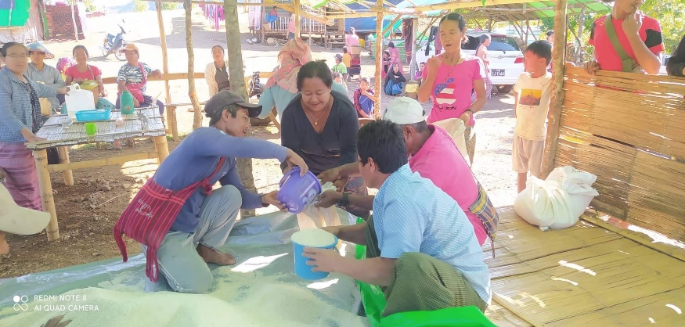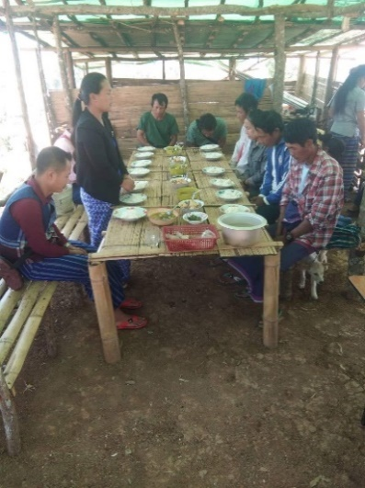

Adult praying before their meal

Children having their meal

Distributing rice

Taungoo Association which hosts people from conflict areas were also supported by your generous gifts. Many refugees were running from Thandawngyi to Taungoo.

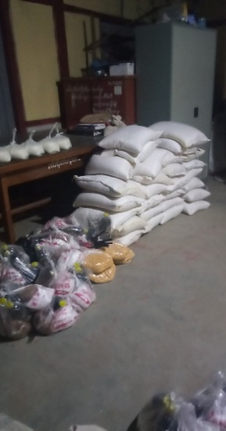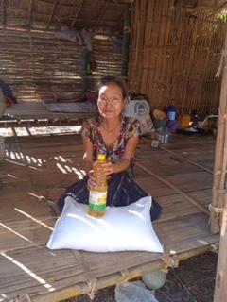

We were able to provide for Mros refugees in Hle Gu Township**.** They are from Ya Khaing State.

Your donation supported Bu Mission field in Ayeyarwaddy Division, that needed rice because they lost their daily income due to uncertain situations. We were able to purchase rice for 21 households.

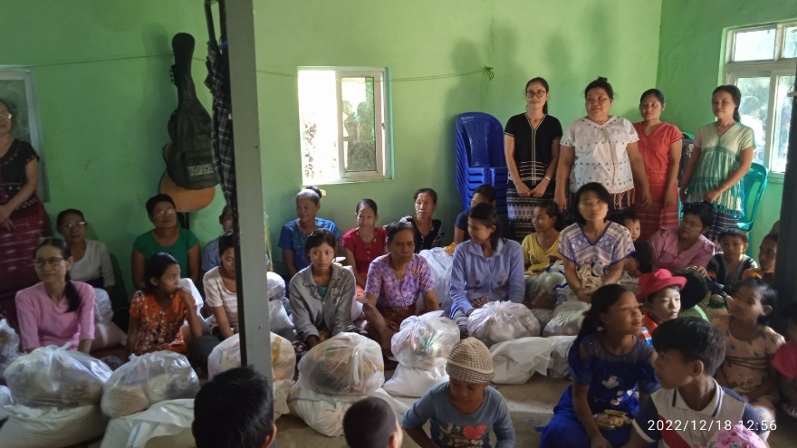

**Empowering women 1. Cool Eugenia Women Group** This group is from Delta Area which was affected by Cyclone Nargis in 2008. Currently, they are trying to build up their community for a better life. They have 19 members in the group. Based on the location, they divided the group into two. One group takes responsibility for making liquid soap and packs it into plastic bottles. They reuse the used plastic bottles and sell them to those who are around them. The second group takes responsibility for selling their products to the neighboring villages.

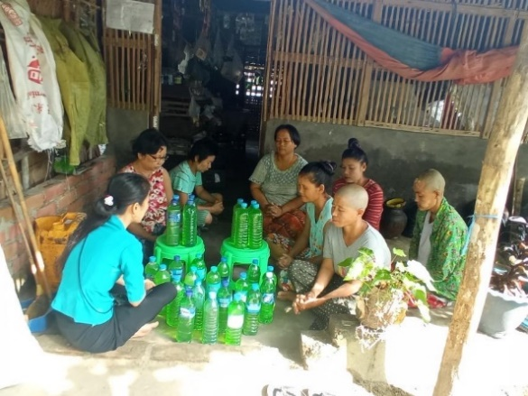 **2.Carry the Light** This group is from Eastern Bago Division, Kyaut Kyi Township. They formed the group with 10 members in 2021 and their main activity is sewing and making embroidery for Karen dresses. As the political situation in their area is unstable, the people in this area are losing their livelihood and struggling to survive.

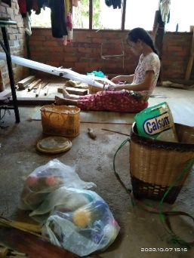 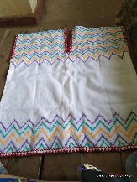

**3.Roses Group** This group is from Bago Division and was organized in 2015. They have 40 members, and they save 5000 kyats ($2.00) per month from each member. As the expenses are getting higher, most of the members take loan for the expenses for their paddy fields. Some use the loan for seasonal plantation, animal raising activities and Barber shop. As a group they can take loans with a reasonable interest rate and all these interests will be put back in their fund.

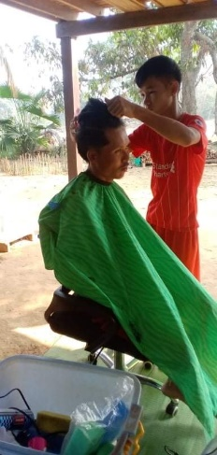

# **4. Living water Group**

This group is from Ayeyarwady Division. They have run the group activity for 5 years with 22 members and their initial capital was 300000 kyats. They save 1000 kyats monthly and provide loan and repayment activity once in 10 months. They share the loan equally based on the total amount of fund in the group. Some of them sell Burmese food, Karen clothing, and fish or dry fish. Some raised pigs and some grew betel leaves.

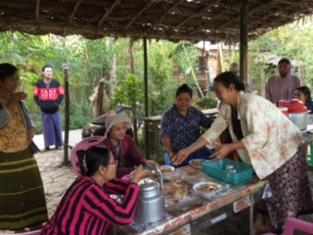 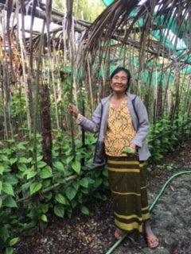

**Your generous donation has supported the healthcare ministry at Agape Clinic**  Agape Clinic is in Chin State and your support will be a great help for the community which is in dire need of caring especially for their holistic health. Agape Clinic has been serving the community effectively since February 12, 2021. Their medical team contains 9 medical doctors, 40 nurses, 4 X-ray technicians, 1 lab technician, and 14 general workers.

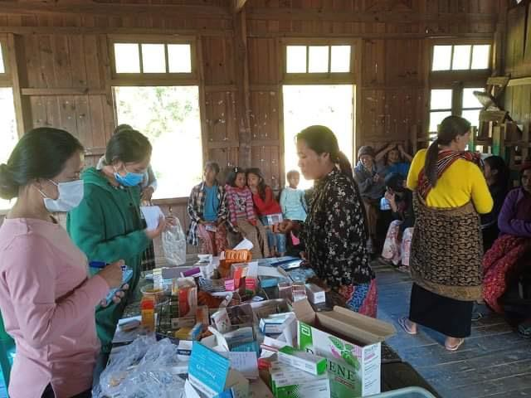 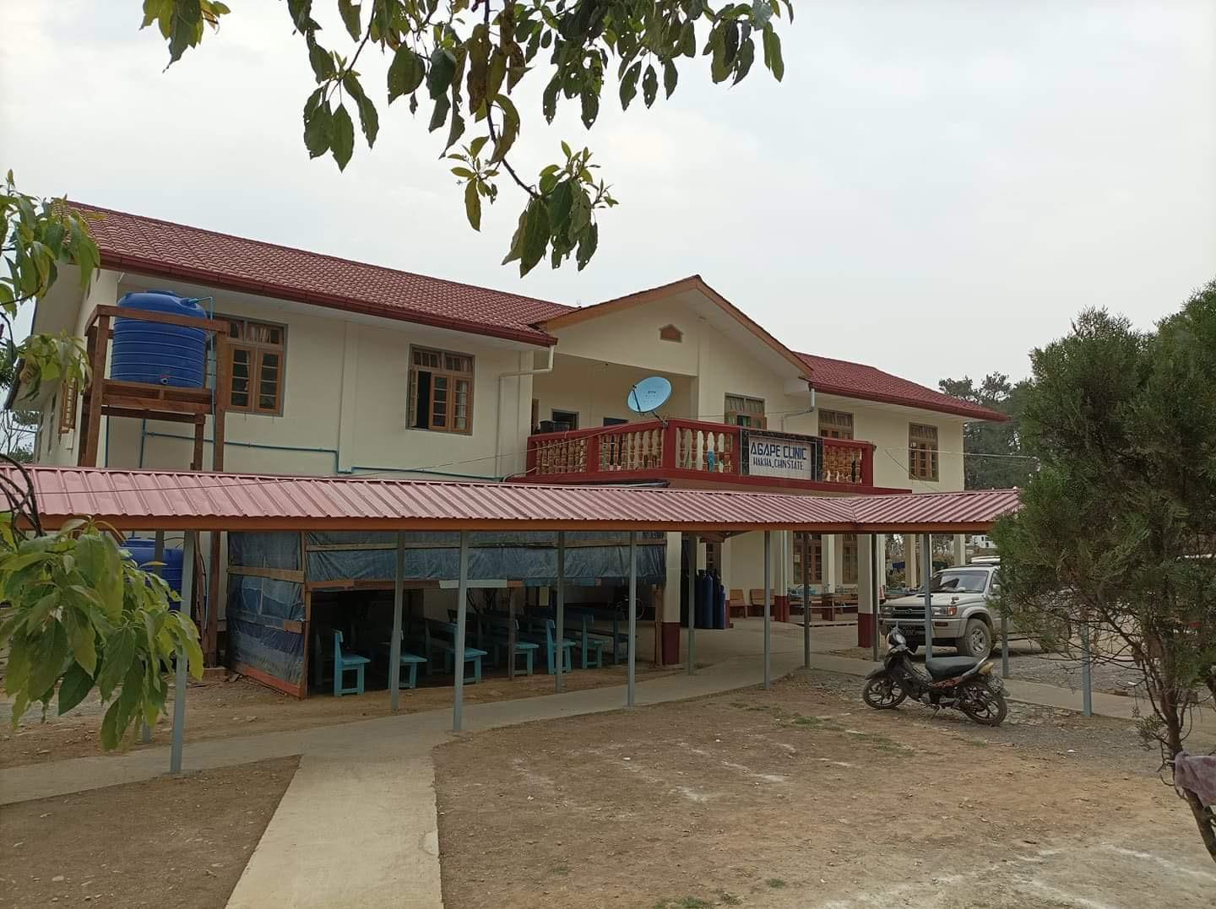 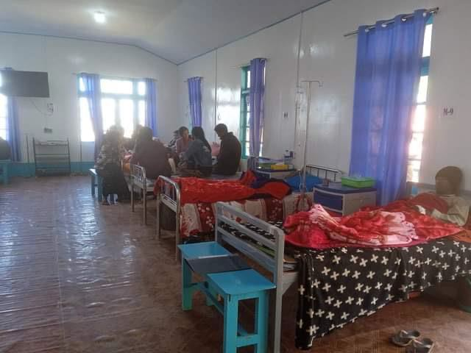

**Wish List**

1. Donations to Matthew 25 Love and KBC Hospital (any amount is welcome)
2. $17 each for prescription glasses for students at various Seminaries and Bible Schools.
3. $300 for a microcredit or Self Help group.
4. To provide food or medical care for the vulnerable families (any amount is welcome)
5. $360 for children center per child. (We welcome lesser amounts and will combine them)
6. $500 for scholarship aid to Myanmar Institute of Theology student who is working on her M.Div. This newsletter was compiled and written by Naw May P. Cartee and designed by Eh Moo Hmun. Please notify us if you wish to be on the e-mailing list and feel free to pass along the printed copy or e-mail version of this newsletter. Please visit our website (friendsofburma.org) to view all other information that could not be included in this newsletter. We do not share our donors’ names with anyone, and we do only 3 mailings a year to keep our overhead below 0.015%. Thank you all for reading and please continue to pray for Burma. Psalm 46:10-11(NIV), He says, “Be still, and know that I am God; I will be exalted among the nations, I will be exalted in the earth.”The Lord Almighty is with us; the God of Jacob is our fortress.