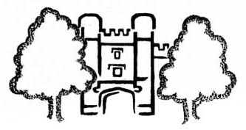 |   Registered Charity 1053923
Membership Renewal
(Annual subscription: £6 individual, £12 family)

I/We* wish to renew my individual / our family* membership. * Delete as appropriate
Name(s) and Title(s): _______________________________________________ Date ____________
Address: ____________________________________________________________________________
_____________________________________________ Postcode:____________________
Tel. No.: ____________________ E-mail address: _____________________________________________
* I/We* enclose a cheque/ cash* for £______ (Payable to ‘the Friends of Nonsuch’)
or
* I/We* have signed a Standing Order Form / ’fast payment’ form and sent it to my/our* Bank
or Building Society.
Please return this form (and payment if no Standing Order / electronic payment ) to our Registrar, Michael Dunk, ‘Glenesk’, Church Street, Ewell, Surrey, UK. KT17 2AQ, (tel. no. 020 3609 8013.) (Please do NOT send cash through the post.)
If paying by Standing Order or electronic payment, please send the Standing Order / payment form to your Bank or Building Society and send the Renewal Form to Michael Dunk..
- - - - - - - - - - - - - - - - - - - - - - - - - - - - - - - - - - - - - - - - - - - - - - - - - - - - - - - - - - - - - - - - - - - - - - - - - - - - - - - -
Standing Order Form (SO1)
To: The Manager
_________________________ Bank / Building Society
Address: _________________________________________________________________________
___________________________________________ Postcode: ___________________
Please pay to the Friends of Nonsuch, Account No.: 02207640
Sort Code: 30-98-36
Branch; High Street, Sutton SM1
the sum of ……………………....* Pounds immediately and on ……………… 1st annually until further notice. [* £6 single or £12 family subscription plus any donation desired]
My account details are as follows:
Account Name: __________________________ Signed: ______________________________
Account Number: _____________________________ Name: _______________________________
Sort Code: _____________________________ Date: _______________________________

