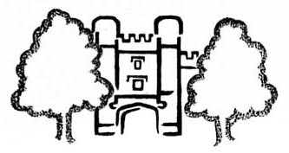 | 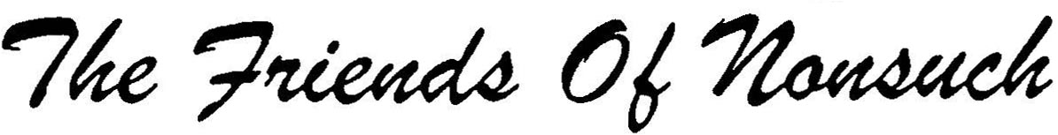  Registered Charity 1053923
Application for Membership
(Annual subscription: £6 individual, £12 family)

I/We* wish to join the Friends of Nonsuch — please enrol me/us* as members.
* Delete as appropriate
Full Name(s) and Title(s): _______________________________________________________
Full Address: ____________________________________________________________________________
_____________________________________________ Postcode:____________________
Home Tel. No.: ____________________ E-mail address: ________________________________________
Mobile Tel. No. : ___________________
I/We* enclose a cheque / cash* for £______. (Payable to ‘the Friends of Nonsuch’)
or
I/We* have arranged a Standing Order / ‘fast payment’ and sent it to my/our* Bank or Building Society.
I/We* wish to receive the FoN newsletter by email or as a printed copy delivered to my/our home.*
I/We* agree to the Friends of Nonsuch holding the above data about me/us* while I /we* are members.

Signed (by each name) : _________________________________________________ Dated: ___________
If paying by cheque, please send your Application Form, Gift Aid Declaration and Cheque to our Registrar, the Revd. Michael Dunk, ‘Glenesk’, Church Street, Ewell, Surrey, UK. KT17 2AQ, (tel. no. 020 3609 8013). (Please do NOT send cash through the post.)
If paying by Standing Order or electronic payment, please send the Standing Order or payment form to your Bank or Building Society and send the rest (Application Form and Gift Aid Declaration) to the Revd. Michael Dunk.
Please let us know if you are willing to spare a few hours to help in the Service Wing of the Mansion, either when it is open to the public or behind the scenes, or with other support work.
- - - - - - - - - - - - - - - - - - - - - - - - - - - - - - - - - - - - - - - - - - - - - - - - - - - - - - - - - - - - - - - - - - - - - - - - - - - - - - - -
Donating Subscriptions and Donations under Gift Aid
If you are a UK tax-payer, please complete this form which will allow the Friends of Nonsuch to reclaim tax you have paid and increase your gift at no extra cost to you.
Gift Aid Declaration
Full Name: _____________________________________________________________________________
Address: _______________________________________________________________________________
_________________________________________________ Postcode: ___________________
I declare that all subscriptions and donations made to the Friends of Nonsuch since April 6th 2000 and any I may make hereafter may be treated as Gift Aid donations until I notify you otherwise. I am a standard rate tax payer. My tax bill this year will be more than this donation. [Please inform the Friends of Nonsuch Registrar if this changes.]
Signed: _____________________________________ Dated: ___________________________

