[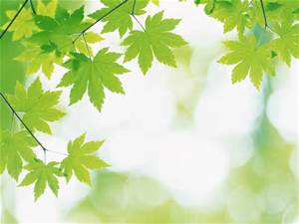](http://www.bing.com/images/search?q=leaves&view=detailv2&&id=6C1CDD58177504FC48695A529E5F1364DB648644&selectedIndex=51&ccid=pbbmqEW0&simid=608047020809193849&thid=OIP.Ma5b6e6a845b4dc3eed84d4807c3a68ebH0)