Sample raw data file definition
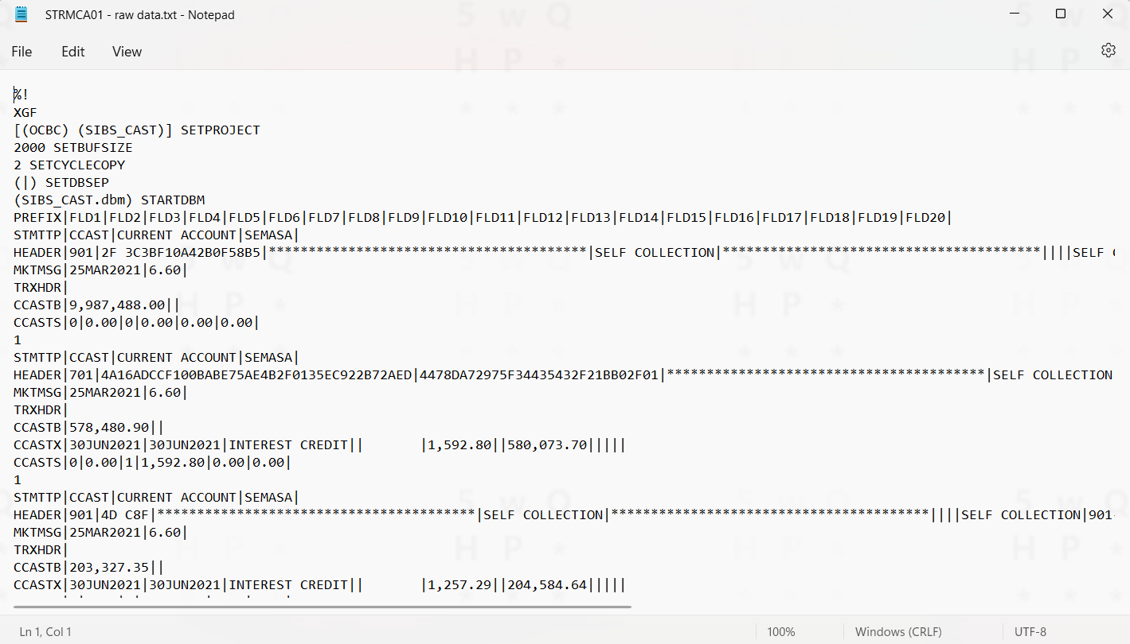
Header: Required by Xerox program to select which templates/codes to use for PDF generation
Second customer statement details
First customer statement details

Xerox Designer – Use to design the PDF output from raw data file
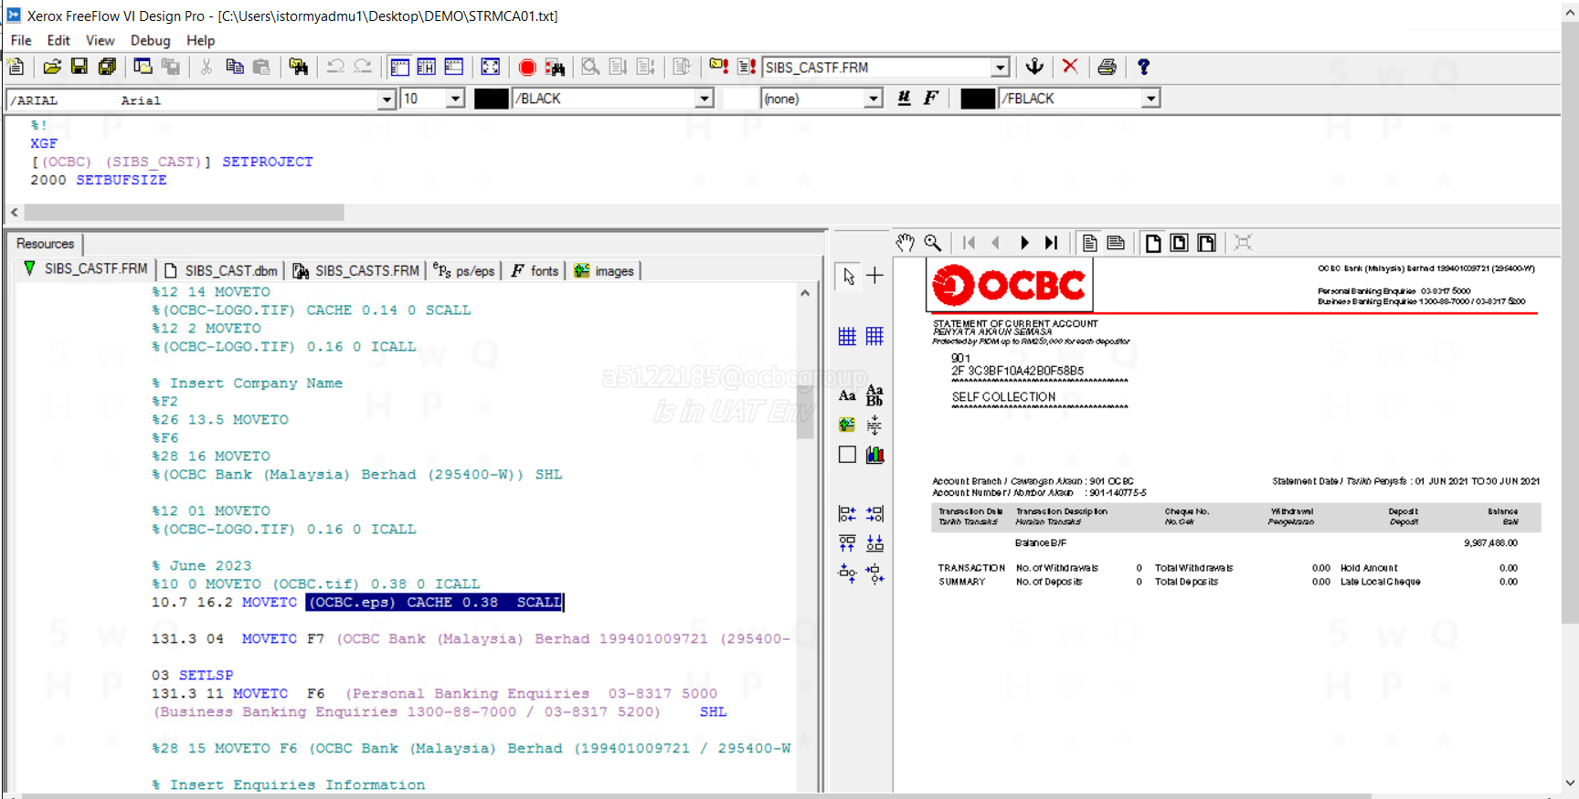
2
3
1

- Resources required to perform PDF generation for this statement.
- Codes. (use to configure position, font, table, conditional logic, etc.)
- Output preview.

