2. Assignment – Robotics

by Pascal Müller, Fabian Casares, Friedrich Müller

1. Task

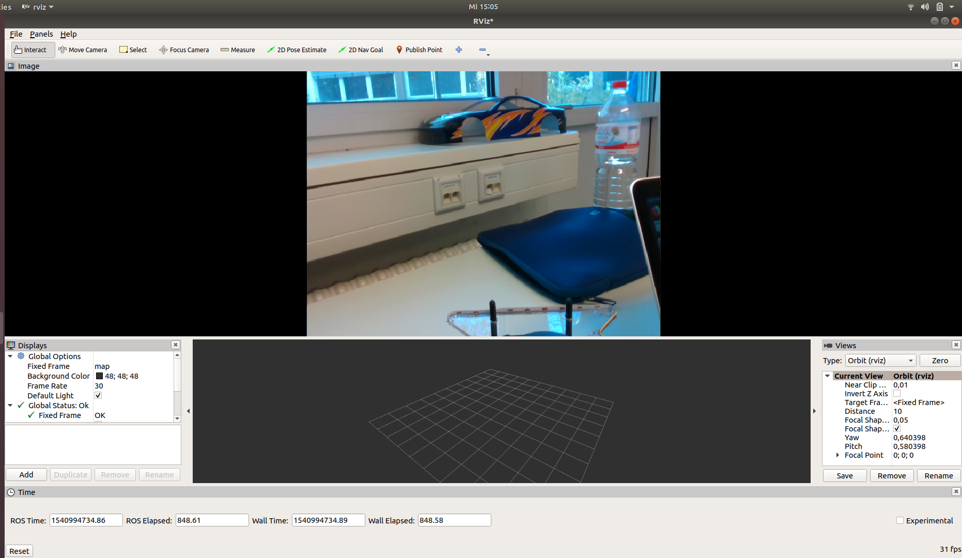
2. Task

https://github.com/frimuell/catkin_ws_user/blob/master/tasks_wise1819/ub02/publisher_subscriber.py

(See Screenshot on 2nd page)
