3. Assignment – Robotics

by Pascal Müller, Fabian Casares, Friedrich Müller

1. Drive Control and Parking Maneuver

<https://github.com/frimuell/catkin_ws_user/tree/master/tasks_wise1819/ub03>

(See video in the repo)

2. Homogenous Transformation Matrix

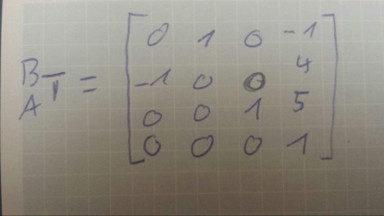

3. Rotating a Vector using Quaternion Rotation and Axis-Angle Representation as Quaternion

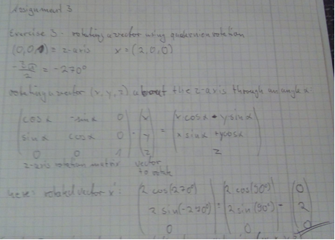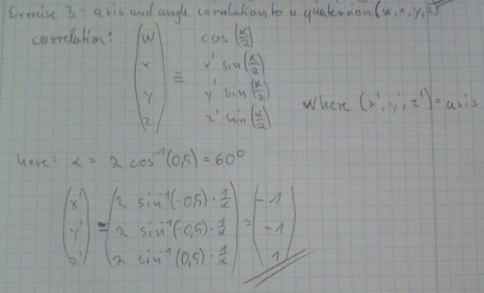

4. normal vector calculation

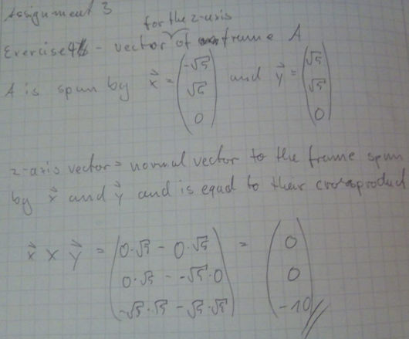

5. Driving two Circles

The radius of the circle on the track was 45 cm.

The radius of the circle on the carpet was about 10cm greater and rather difficult to measure due to the cars lack of grip on the carpet and thereby not being able to drive a proper circle.

(See videos in the repo)