Spring boot学习笔记

## 搭建第一个Spring boot项目（Maven）

### 创建Maven项目spring.boot，修改pom.xml

### 添加spring.boot启动支持

方式一：继承 **spring-boot-starter-parent**

<parent>  
 <groupId>org.springframework.boot</groupId>  
 <artifactId>spring-boot-starter-parent</artifactId>  
 <version>1.3.2.RELEASE</version>  
 <relativePath/>

</parent>

方式二：添加 **spring-boot-dependencies**

<dependencyManagement>  
 <dependencies>  
 <dependency>  
 <groupId>org.springframework.data</groupId>  
 <artifactId>spring-data-releasetrain</artifactId>  
 <version>Fowler-SR2</version>  
 <scope>import</scope>  
 <type>pom</type>  
 </dependency>  
 <dependency>  
 <groupId>org.springframework.boot</groupId>  
 <artifactId>spring-boot-dependencies</artifactId>  
 <version>1.4.0.RELEASE</version>  
 <type>pom</type>  
 <scope>import</scope>  
 </dependency>  
 </dependencies>  
</dependencyManagement>

### Spring.boot启动器列表

| **Name** | **Description** | **Pom** |
| --- | --- | --- |
| spring-boot-starter-thymeleaf | Starter for building MVC web applications using Thymeleaf views | [Pom](https://github.com/spring-projects/spring-boot/tree/master/spring-boot-starters/spring-boot-starter-thymeleaf/pom.xml) |
| spring-boot-starter-ws | Starter for using Spring Web Services. Deprecated as of 1.4 in favor of[spring-boot-starter-web-services](http://docs.spring.io/spring-boot/docs/current-SNAPSHOT/reference/htmlsingle/#spring-boot-starter-web-services) | [Pom](https://github.com/spring-projects/spring-boot/tree/master/spring-boot-starters/spring-boot-starter-ws/pom.xml) |
| spring-boot-starter-data-couchbase | Starter for using Couchbase document-oriented database and Spring Data Couchbase | [Pom](https://github.com/spring-projects/spring-boot/tree/master/spring-boot-starters/spring-boot-starter-data-couchbase/pom.xml) |
| spring-boot-starter-artemis | Starter for JMS messaging using Apache Artemis | [Pom](https://github.com/spring-projects/spring-boot/tree/master/spring-boot-starters/spring-boot-starter-artemis/pom.xml) |
| spring-boot-starter-web-services | Starter for using Spring Web Services | [Pom](https://github.com/spring-projects/spring-boot/tree/master/spring-boot-starters/spring-boot-starter-web-services/pom.xml) |
| spring-boot-starter-mail | Starter for using Java Mail and Spring Framework’s email sending support | [Pom](https://github.com/spring-projects/spring-boot/tree/master/spring-boot-starters/spring-boot-starter-mail/pom.xml) |
| spring-boot-starter-data-redis | Starter for using Redis key-value data store with Spring Data Redis and the Jedis client | [Pom](https://github.com/spring-projects/spring-boot/tree/master/spring-boot-starters/spring-boot-starter-data-redis/pom.xml) |
| spring-boot-starter-web | Starter for building web, including RESTful, applications using Spring MVC. Uses Tomcat as the default embedded container | [Pom](https://github.com/spring-projects/spring-boot/tree/master/spring-boot-starters/spring-boot-starter-web/pom.xml) |
| spring-boot-starter-data-gemfire | Starter for using GemFire distributed data store and Spring Data GemFire | [Pom](https://github.com/spring-projects/spring-boot/tree/master/spring-boot-starters/spring-boot-starter-data-gemfire/pom.xml) |
| spring-boot-starter-activemq | Starter for JMS messaging using Apache ActiveMQ | [Pom](https://github.com/spring-projects/spring-boot/tree/master/spring-boot-starters/spring-boot-starter-activemq/pom.xml) |
| spring-boot-starter-data-elasticsearch | Starter for using Elasticsearch search and analytics engine and Spring Data Elasticsearch | [Pom](https://github.com/spring-projects/spring-boot/tree/master/spring-boot-starters/spring-boot-starter-data-elasticsearch/pom.xml) |
| spring-boot-starter-integration | Starter for using Spring Integration | [Pom](https://github.com/spring-projects/spring-boot/tree/master/spring-boot-starters/spring-boot-starter-integration/pom.xml) |
| spring-boot-starter-test | Starter for testing Spring Boot applications with libraries including JUnit, Hamcrest and Mockito | [Pom](https://github.com/spring-projects/spring-boot/tree/master/spring-boot-starters/spring-boot-starter-test/pom.xml) |
| spring-boot-starter-hornetq | Starter for JMS messaging using HornetQ. Deprecated as of 1.4 in favor of[spring-boot-starter-artemis](http://docs.spring.io/spring-boot/docs/current-SNAPSHOT/reference/htmlsingle/#spring-boot-starter-artemis) | [Pom](https://github.com/spring-projects/spring-boot/tree/master/spring-boot-starters/spring-boot-starter-hornetq/pom.xml) |
| spring-boot-starter-jdbc | Starter for using JDBC with the Tomcat JDBC connection pool | [Pom](https://github.com/spring-projects/spring-boot/tree/master/spring-boot-starters/spring-boot-starter-jdbc/pom.xml) |
| spring-boot-starter-mobile | Starter for building web applications using Spring Mobile | [Pom](https://github.com/spring-projects/spring-boot/tree/master/spring-boot-starters/spring-boot-starter-mobile/pom.xml) |
| spring-boot-starter-validation | Starter for using Java Bean Validation with Hibernate Validator | [Pom](https://github.com/spring-projects/spring-boot/tree/master/spring-boot-starters/spring-boot-starter-validation/pom.xml) |
| spring-boot-starter-hateoas | Starter for building hypermedia-based RESTful web application with Spring MVC and Spring HATEOAS | [Pom](https://github.com/spring-projects/spring-boot/tree/master/spring-boot-starters/spring-boot-starter-hateoas/pom.xml) |
| spring-boot-starter-jersey | Starter for building RESTful web applications using JAX-RS and Jersey. An alternative to[spring-boot-starter-web](http://docs.spring.io/spring-boot/docs/current-SNAPSHOT/reference/htmlsingle/#spring-boot-starter-web) | [Pom](https://github.com/spring-projects/spring-boot/tree/master/spring-boot-starters/spring-boot-starter-jersey/pom.xml) |
| spring-boot-starter-data-neo4j | Starter for using Neo4j graph database and Spring Data Neo4j | [Pom](https://github.com/spring-projects/spring-boot/tree/master/spring-boot-starters/spring-boot-starter-data-neo4j/pom.xml) |
| spring-boot-starter-websocket | Starter for building WebSocket applications using Spring Framework’s WebSocket support | [Pom](https://github.com/spring-projects/spring-boot/tree/master/spring-boot-starters/spring-boot-starter-websocket/pom.xml) |
| spring-boot-starter-aop | Starter for aspect-oriented programming with Spring AOP and AspectJ | [Pom](https://github.com/spring-projects/spring-boot/tree/master/spring-boot-starters/spring-boot-starter-aop/pom.xml) |
| spring-boot-starter-amqp | Starter for using Spring AMQP and Rabbit MQ | [Pom](https://github.com/spring-projects/spring-boot/tree/master/spring-boot-starters/spring-boot-starter-amqp/pom.xml) |
| spring-boot-starter-data-cassandra | Starter for using Cassandra distributed database and Spring Data Cassandra | [Pom](https://github.com/spring-projects/spring-boot/tree/master/spring-boot-starters/spring-boot-starter-data-cassandra/pom.xml) |
| spring-boot-starter-social-facebook | Starter for using Spring Social Facebook | [Pom](https://github.com/spring-projects/spring-boot/tree/master/spring-boot-starters/spring-boot-starter-social-facebook/pom.xml) |
| spring-boot-starter-jta-atomikos | Starter for JTA transactions using Atomikos | [Pom](https://github.com/spring-projects/spring-boot/tree/master/spring-boot-starters/spring-boot-starter-jta-atomikos/pom.xml) |
| spring-boot-starter-security | Starter for using Spring Security | [Pom](https://github.com/spring-projects/spring-boot/tree/master/spring-boot-starters/spring-boot-starter-security/pom.xml) |
| spring-boot-starter-mustache | Starter for building MVC web applications using Mustache views | [Pom](https://github.com/spring-projects/spring-boot/tree/master/spring-boot-starters/spring-boot-starter-mustache/pom.xml) |
| spring-boot-starter-data-jpa | Starter for using Spring Data JPA with Hibernate | [Pom](https://github.com/spring-projects/spring-boot/tree/master/spring-boot-starters/spring-boot-starter-data-jpa/pom.xml) |
| spring-boot-starter | Core starter, including auto-configuration support, logging and YAML | [Pom](https://github.com/spring-projects/spring-boot/tree/master/spring-boot-starters/spring-boot-starter/pom.xml) |
| spring-boot-starter-velocity | Starter for building MVC web applications using Velocity views. Deprecated since 1.4 | [Pom](https://github.com/spring-projects/spring-boot/tree/master/spring-boot-starters/spring-boot-starter-velocity/pom.xml) |
| spring-boot-starter-groovy-templates | Starter for building MVC web applications using Groovy Templates views | [Pom](https://github.com/spring-projects/spring-boot/tree/master/spring-boot-starters/spring-boot-starter-groovy-templates/pom.xml) |
| spring-boot-starter-freemarker | Starter for building MVC web applications using FreeMarker views | [Pom](https://github.com/spring-projects/spring-boot/tree/master/spring-boot-starters/spring-boot-starter-freemarker/pom.xml) |
| spring-boot-starter-batch | Starter for using Spring Batch | [Pom](https://github.com/spring-projects/spring-boot/tree/master/spring-boot-starters/spring-boot-starter-batch/pom.xml) |
| spring-boot-starter-redis | Starter for using Redis key-value data store with Spring Data Redis and the Jedis client. Deprecated as of 1.4 in favor of [spring-boot-starter-data-redis](http://docs.spring.io/spring-boot/docs/current-SNAPSHOT/reference/htmlsingle/#spring-boot-starter-data-redis) | [Pom](https://github.com/spring-projects/spring-boot/tree/master/spring-boot-starters/spring-boot-starter-redis/pom.xml) |
| spring-boot-starter-social-linkedin | Stater for using Spring Social LinkedIn | [Pom](https://github.com/spring-projects/spring-boot/tree/master/spring-boot-starters/spring-boot-starter-social-linkedin/pom.xml) |
| spring-boot-starter-cache | Starter for using Spring Framework’s caching support | [Pom](https://github.com/spring-projects/spring-boot/tree/master/spring-boot-starters/spring-boot-starter-cache/pom.xml) |
| spring-boot-starter-data-solr | Starter for using the Apache Solr search platform with Spring Data Solr | [Pom](https://github.com/spring-projects/spring-boot/tree/master/spring-boot-starters/spring-boot-starter-data-solr/pom.xml) |
| spring-boot-starter-data-mongodb | Starter for using MongoDB document-oriented database and Spring Data MongoDB | [Pom](https://github.com/spring-projects/spring-boot/tree/master/spring-boot-starters/spring-boot-starter-data-mongodb/pom.xml) |
| spring-boot-starter-jooq | Starter for using jOOQ to access SQL databases. An alternative to[spring-boot-starter-data-jpa](http://docs.spring.io/spring-boot/docs/current-SNAPSHOT/reference/htmlsingle/#spring-boot-starter-data-jpa) or [spring-boot-starter-jdbc](http://docs.spring.io/spring-boot/docs/current-SNAPSHOT/reference/htmlsingle/#spring-boot-starter-jdbc) | [Pom](https://github.com/spring-projects/spring-boot/tree/master/spring-boot-starters/spring-boot-starter-jooq/pom.xml) |
| spring-boot-starter-jta-narayana | Spring Boot Narayana JTA Starter | [Pom](https://github.com/spring-projects/spring-boot/tree/master/spring-boot-starters/spring-boot-starter-jta-narayana/pom.xml) |
| spring-boot-starter-cloud-connectors | Starter for using Spring Cloud Connectors which simplifies connecting to services in cloud platforms like Cloud Foundry and Heroku | [Pom](https://github.com/spring-projects/spring-boot/tree/master/spring-boot-starters/spring-boot-starter-cloud-connectors/pom.xml) |
| spring-boot-starter-jta-bitronix | Starter for JTA transactions using Bitronix | [Pom](https://github.com/spring-projects/spring-boot/tree/master/spring-boot-starters/spring-boot-starter-jta-bitronix/pom.xml) |
| spring-boot-starter-social-twitter | Starter for using Spring Social Twitter | [Pom](https://github.com/spring-projects/spring-boot/tree/master/spring-boot-starters/spring-boot-starter-social-twitter/pom.xml) |
| spring-boot-starter-data-rest | Starter for exposing Spring Data repositories over REST using Spring Data REST | [Pom](https://github.com/spring-projects/spring-boot/tree/master/spring-boot-starters/spring-boot-starter-data-rest/pom.xml) |
| spring-boot-starter-actuator | Starter for using Spring Boot’s Actuator which provides production ready features to help you monitor and manage your application | [Pom](https://github.com/spring-projects/spring-boot/tree/master/spring-boot-starters/spring-boot-starter-actuator/pom.xml) |
| spring-boot-starter-remote-shell | Starter for using the CRaSH remote shell to monitor and manage your application over SSH | [Pom](https://github.com/spring-projects/spring-boot/tree/master/spring-boot-starters/spring-boot-starter-remote-shell/pom.xml) |

详细可参阅：<http://blog.csdn.net/chszs/article/details/50610474>

### 添加基本启动器

<dependencies>  
 <dependency>  
 <groupId>org.springframework.boot</groupId>  
 <artifactId>spring-boot-starter</artifactId>  
 </dependency>  
  
 <dependency>  
 <groupId>org.springframework.boot</groupId>  
 <artifactId>spring-boot-starter-test</artifactId>  
 <scope>test</scope>  
 </dependency>  
  
 <dependency>  
 <groupId>org.springframework.boot</groupId>  
 <artifactId>spring-boot-starter-web</artifactId>  
 </dependency>  
  
</dependencies>

* spring-boot-starter：基本启动器
* spring-boot-starter-web：支持web方式的启动器
* spring-boot-starter-test：支持单元测试启动器

注：经测试，如果添加了spring-boot-starter-web，即使没有spring-boot-starter，也是可以正常启动，不会有问题！这两者的关系应该类似与javaee与javase，前者范围更大，后者只包含了核心的功能！

### 添加启动与测试代码

* 代码结构，如图：

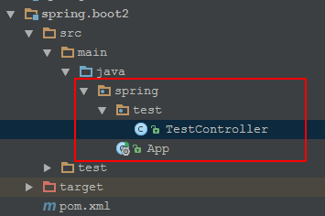

* App.java是启动类，启动类不能直接在java下，不然会报错，错误信息：**\*\* WARNING ** : Your ApplicationContext is unlikely to start due to a @ComponentScan of the default package.**

import org.springframework.boot.SpringApplication;  
import org.springframework.boot.autoconfigure.SpringBootApplication;  
  
@SpringBootApplication  
public class App {  
  
 public static void main(String[] args) {  
 SpringApplication.*run*(App.class, args);  
 }  
  
}

* TestController.java为测试Controller

import org.springframework.web.bind.annotation.RequestMapping;  
import org.springframework.web.bind.annotation.RestController;  
  
@RestController  
public class TestController {  
  
 @RequestMapping("/")  
 public String say(){  
 return "hello world...";  
 }  
  
}

### 启动第一个Spring.boot项目

* 其实，就是执行App.java中的main方法，启动日志：

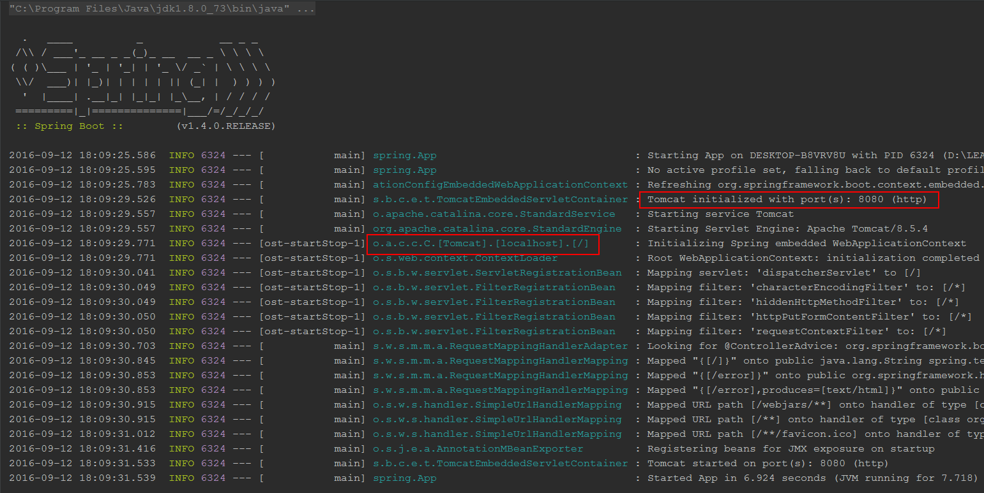

不难看出，Spring.boot内置了tomcat，实质上还是启动的tomcat！

* 访问：<http://localhost:8080/>，如图：

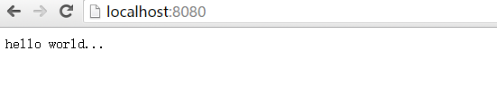

OK，第一个Spring.boot项目已经搭建完成！

## Spring.boot高级配置

### 禁用tomcat，切换jetty服务器

修改pom.xml，如图：

<dependency>  
 <groupId>org.springframework.boot</groupId>  
 <artifactId>spring-boot-starter-web</artifactId>  
 <version>${spring.boot.version}</version>  
 <exclusions>  
 <exclusion>  
 <groupId>org.springframework.boot</groupId>  
 <artifactId>spring-boot-starter-tomcat</artifactId>  
 </exclusion>  
 </exclusions>  
</dependency>  
<dependency>  
 <groupId>org.springframework.boot</groupId>  
 <artifactId>spring-boot-starter-jetty</artifactId>  
 <version>${spring.boot.version}</version>  
</dependency>

### 说说 @SpringBootApplication

*@SpringBootApplication* *// same as @Configuration @EnableAutoConfiguration @ComponentScan*

这是Spring.boot官方文档上的描述，实事也是如此！

### Spring.boot热部署

这个功能在开发时还是非常有用的，具体实现：

* pom.xml中添加配置

<dependency>  
 <groupId>org.springframework.boot</groupId>  
 <artifactId>spring-boot-devtools</artifactId>  
 <optional>true</optional>  
</dependency>

<build>  
 <plugins>  
 <plugin>  
 <groupId>org.springframework.boot</groupId>  
 <artifactId>spring-boot-maven-plugin</artifactId>  
 <configuration>  
 <fork>true</fork>  
 </configuration>  
 </plugin>  
 </plugins>  
</build>

* intellj idea 修改classpath下文件后，执行make，即会自动激活restart
* eclipse 修改classpth下文件后，执行build即可，如果设置了下去编译，那就会自动激活restart
* 静态资源不需要restart，可以使用：

spring.devtools.restart.exclude=static/**,public/**

### 切换配置

Spring.boot会根据application.properties中属性：spring.profiles.active，激活相应的配置，当 spring.profiles.active=dev时：

* 激活配置文件，如：

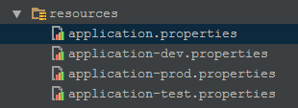

会自动加载 application-dev.properties文件

* 激活Profile配置，如：

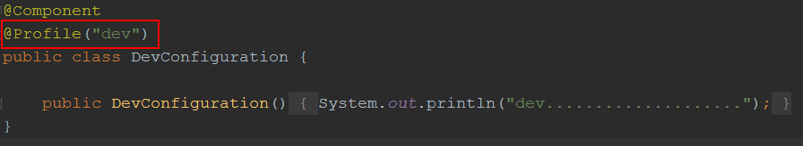

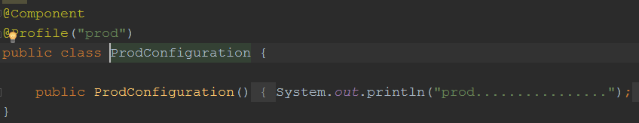

会加载@Profile(“dev”)修饰的类：**DevConfiguration.java**

### 自定义初始化

If you need to run some specific code once the SpringApplication has started, you can implement the ApplicationRunner or CommandLineRunner interfaces. Both interfaces work in the same way and offer a single run method which will be called just before SpringApplication.run(…​) completes.

ApplicationRunner or CommandLineRunner都会在容器初始化完成之前执行，对于一些特殊的操作，这个还是很有用的！

### 修改容器启动端口

可以通过设置application.properties中属性 server.port 修改端口号！

### 使用YAML配置

* 在resources目录下创建文件application.yml（此配置默认会加载），添加如下内容：

**my:  
 servers:** - dev.bar.com  
 - foo.bar.com  
 **dev:  
 url:** http://dev.bar.com  
 **name:** Developer Setup  
 **prod:  
 url:** http://foo.bar.com  
 **name:** My Cool App

* Bean中读取这些属性，代码如下：

@Configuration  
@ConfigurationProperties(prefix = "my")  
public class PropertiesBean {

// 读取list  
 private List<String> servers = new ArrayList<String>();

// 读取map  
 private Map<String, String> dev = new HashMap<String, String>();

// 读取map  
 private Map<String, String> prod = new HashMap<String, String>();

// 略去getter/setter

* 使用，像使用普通spring bean一样，注入即可，详细如下：

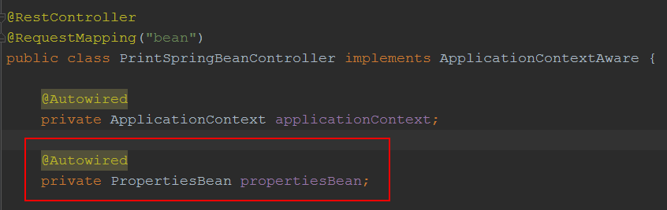

### 使用@ControllerAdvice

* 使用场景：如当抛出XXXXException时，统一响应处理！

@ControllerAdvice  
public class DefaultExceptionHandler {

// 当抛出 Exception 时，使用的响应处理器  
 @ExceptionHandler(value = Exception.class)  
 public ModelAndView defaultErrorHandler(HttpServletRequest req, Exception e) throws Exception {  
 ModelAndView mav = new ModelAndView();  
 mav.addObject("exception", e);  
 mav.addObject("url", req.getRequestURL());  
 mav.setViewName("error");  
 return mav;  
 }

// 当抛出 NullPointerException时，使用的响应处理器  
 @ExceptionHandler(value = NullPointerException.class)  
 @ResponseBody  
 public Map<String, Object> jsonErrorHandler(HttpServletRequest req, Exception e) throws Exception {  
 Map<String, Object> error = new HashMap<String, Object>();  
 error.put("Exception", e);  
 error.put("code", 0000);  
 error.put("url", req.getRequestURL().toString());  
 return error;  
 }  
  
}

### 使用freemarker作为View渲染对象

* 在pom.xml中添加start：

<dependency>  
 <groupId>org.springframework.boot</groupId>  
 <artifactId>spring-boot-starter-freemarker</artifactId>  
 <optional>true</optional>  
</dependency>

* 在application.properties中添加前/后缀（后缀测试成功，前缀不成功）：

#spring.freemarker.prefix=classpath*:/pages/  
spring.freemarker.suffix=.html

### 配置mysql数据源（默认）

* 在pom.xml中添加：

<dependency>  
 <groupId>mysql</groupId>  
 <artifactId>mysql-connector-java</artifactId>  
 <version>5.1.39</version>  
</dependency>

* 在application.properties中添加：

spring.datasource.url=jdbc:mysql://10.199.197.148:3306/log  
spring.datasource.username=root  
spring.datasource.password=123456  
spring.datasource.driver-class-name=com.mysql.jdbc.Driver

### 使用JdbcTemplate实现持久化

* 在pom.xml中添加starter：

<dependency>  
 <groupId>org.springframework.boot</groupId>  
 <artifactId>spring-boot-starter-jdbc</artifactId>  
</dependency>

* 使用：

@Repository  
public class BaseDao<T> implements IDao<T> {  
  
 @Autowired  
 private NamedParameterJdbcTemplate namedParameterJdbcTemplate;  
  
 public T findById(final Long id, String sql, Class<T> mappedClass) {  
 Map<String, Object> params = new HashMap<String, Object>() {{  
 put("id", id);  
 }};  
 return namedParameterJdbcTemplate.queryForObject(sql, params, new BeanPropertyRowMapper<T>(mappedClass));  
 }  
  
}

### 使用jpa实现持久化

* 在pom.xml中添加startter：

<dependency>  
 <groupId>org.springframework.boot</groupId>  
 <artifactId>spring-boot-starter-data-jpa</artifactId>  
</dependency>

* application.properties中添加：

spring.jpa.hibernate.ddl-auto=update

* 使用：

public interface UserRepository extends JpaRepository<User, Long> {  
  
 @Query("from User u where u.name = :name")  
 List<User> findByName(@Param("name") String name);  
  
}

### 使用mybatis实现持久化

1. **方式一：**

* 在pom.xml中添加starter：

<dependency>  
 <groupId>org.mybatis.spring.boot</groupId>  
 <artifactId>mybatis-spring-boot-starter</artifactId>  
 <version>1.1.1</version>  
</dependency>

* 使用：

@Mapper  
public interface UserMapper {  
  
 @Select("select * from user where id = #{id}")  
 User findById(@Param("id") Long id);  
  
 @Select("select * from user where name = #{name}")  
 List<User> findByName(@Param("name") String name);  
}

1. **方式二：**

* pom.xml中配置如方式一；
* application.properties中配置：

mybatis.mapper-locations=classpath:mapper/*Mapper.xml  
mybatis.type-aliases-package=com.ufo.entity

* 启动项中添加：

@MapperScan({"com.ufo.mapper"})

### 多数据源配置

* 在application.properties中添加：

spring.datasource.primary.url=jdbc:mysql://localhost:3306/test1  
spring.datasource.primary.username=root  
spring.datasource.primary.password=123456  
spring.datasource.primary.driver-class-name=com.mysql.jdbc.Driver  
  
spring.datasource.secondary.url=jdbc:mysql://localhost:3306/test2  
spring.datasource.secondary.username=root  
spring.datasource.secondary.password=123456  
spring.datasource.secondary.driver-class-name=com.mysql.jdbc.Driver

* 创建dataSource配置bean：

@Configuration  
public class DataSourceBean {  
  
 @Bean(name = "primaryDataSource")  
 @Qualifier("primaryDataSource")  
 @Primary  
 @ConfigurationProperties(prefix = "spring.datasource.primary")  
 public DataSource primaryDataSource(){  
 return DataSourceBuilder.*create*().build();  
 }  
  
 @Bean(name = "secondaryDataSource")  
 @Qualifier("secondaryDataSource")  
 @ConfigurationProperties(prefix = "spring.datasource.secondary")  
 public DataSource secondaryDataSource(){  
 return DataSourceBuilder.*create*().build();  
 }  
  
}

说明：注意标红的几个点，要相对就，不然就会报错！

* 配置jdbc模板类，创建JdbcTemplateBean：

@Configuration  
public class JdbcTemplateBean {  
  
 @Autowired  
 @Qualifier("primaryDataSource")  
 private DataSource primaryDataSource;  
  
 @Autowired  
 @Qualifier("secondaryDataSource")  
 private DataSource secondaryDataSource;  
  
  
 @Bean(name = "primaryJdbcTemplate")  
 @Qualifier("primaryJdbcTemplate")  
 public NamedParameterJdbcTemplate primaryJdbcTemplate(){  
 return new NamedParameterJdbcTemplate(primaryDataSource);  
 }  
  
 @Bean(name = "secondaryJdbcTemplate")  
 @Qualifier("secondaryJdbcTemplate")  
 public NamedParameterJdbcTemplate secondaryJdbcTemplate(){  
 return new NamedParameterJdbcTemplate(secondaryDataSource);  
 }  
  
}

* 使用：

@Service("userService2")  
public class UserService2Impl implements UserService2 {  
  
 @Resource(name = "primaryJdbcTemplate")  
 private NamedParameterJdbcTemplate primaryJdbcTemplate;  
  
 @Resource(name = "secondaryJdbcTemplate")  
 private NamedParameterJdbcTemplate secondaryJdbcTemplate;  
  
 public User findByIdPri(final long id) {  
 return findById(id, primaryJdbcTemplate);  
 }  
  
 public User findByIdSec(final long id) {  
 return findById(id, secondaryJdbcTemplate);  
 }  
  
 private User findById(final long id, NamedParameterJdbcTemplate template) {  
 Map<String, Object> params = new HashMap<String, Object>() {{  
 put("id", id);  
 }};  
 String sql = "select * from user where id = :id";  
 return template.queryForObject(sql, params, new BeanPropertyRowMapper<User>(User.class));  
 }  
  
}

* 注意点：
  + 当配置自定义的 DataSource 后，spring boot 将不会再产生默认 dataSource；
  + 当配置自定义**NamedParameterJdbcTemplate**后，spring boot将不会再产生默认的 **namedParameterJdbcTemplate**；