

café Au Lait – Ordering System

Planning and Post-Evaluation



January 1, 2017

Frinze Lapuz

**OBJECT PLANNING**

LoginPage

|  |  |  |
| --- | --- | --- |
| Object | Properties | Procedure |
| Lbl_title | Caption of Café Au Lait |  |
| Txt_Pin |  | Displays the number of current entered Pin |
| Btn_0 | Caption of 0 | Enters 0 in txt_Pin |
| Btn_1 | Caption of 1 | Enters 1 in txt_Pin |
| Btn_2 | Caption of 2 | Enters 2 in txt_Pin |
| Btn_3 | Caption of 3 | Enters 3 in txt_Pin |
| Btn_4 | Caption of 4 | Enters 4 in txt_Pin |
| Btn_5 | Caption of 5 | Enters 5 in txt_Pin |
| Btn_6 | Caption of 6 | Enters 6 in txt_Pin |
| Btn_7 | Caption of 7 | Enters 7 in txt_Pin |
| Btn_8 | Caption of 8 | Enters 8 in txt_Pin |
| Btn_9 | Caption of 9 | Enters 9 in txt_Pin |
| Btn_AC | Caption of AC | Removes last character in txt_Pin |
| Btn_Enter | Caption of Enter | Authenticates the User and if successful goes to Main Page |

MainPage

|  |  |  |
| --- | --- | --- |
| Object | Properties | Procedure |
| Lbl_title | Caption of Café Au Lait |  |
| Txt_ShowStats |  | Displays the number of coffees being currently entered |
| Btn_0 | Caption of 0 | Enters 0 in Txt_ShowStats |
| Btn_1 | Caption of 1 | Enters 1 in Txt_ShowStats |
| Btn_2 | Caption of 2 | Enters 2 in Txt_ShowStats |
| Btn_3 | Caption of 3 | Enters 3 in Txt_ShowStats |
| Btn_4 | Caption of 4 | Enters 4 in Txt_ShowStats |
| Btn_5 | Caption of 5 | Enters 5 in Txt_ShowStats |
| Btn_6 | Caption of 6 | Enters 6 in Txt_ShowStats |
| Btn_7 | Caption of 7 | Enters 7 in Txt_ShowStats |
| Btn_8 | Caption of 8 | Enters 8 in Txt_ShowStats |
| Btn_9 | Caption of 9 | Enters 9 in Txt_ShowStats |
| Btn_ClearEntry | Caption Clear Entry | Clears txt_ShowStats |
| TC_Hot | Caption Hot Coffee | Category of Hot Coffee |
| TC_Tea | Caption Tea | Category of Tea |
| TC_Cold | Caption Cold Drinks | Category of Cold Drinks |
| TC_Frozen | Caption Frozen Drinks | Category of Frozen Drinks |
| TC_Snacks | Caption Snacks | Category of Snacks |
| TC_COD | Caption Coffee of The Day | Category of Coffee Of The Day |
| FLP_Hot |  | Organizes Coffee Size of Button |
| FLP_Tea |  | Organizes Coffee Size of Button |
| FLP_Cold |  | Organizes Coffee Size of Button |
| FLP_Frozen |  | Organizes Coffee Size of Button |
| FLP_Snacks |  | Organizes Coffee Size of Button |
| FLP_COD |  | Organizes Coffee Size of Button |
| Btn (Multiple Coffee Buttons) | Size: 75 x 75  Text: Coffee_Name + Coffee_Price  Tag: Primary Key (Coffee ID) | Coffee_Click() Handler   * Creates in FLP Parent |
| LB_Num |  | Contains Number of coffee |
| LB_Name |  | Contains Name of Coffee |
| LB_Price |  | Contains The subtotal of Coffee |
| LB_PK | Visibility: Hidden | Contains Coffee ID |
| Btn_RS | Caption of Remove Selected | Removes ALL selected Items in LBs |
| Btn_Clear | Caption of Clear | Removes All items in LBs |
| Btn_DIPAy | Caption of Dine in Payment | Goes to Payment Page.  Istakeout = 0 |
| btN_TOPay | Caption Take Away Payment | Goes to Payment Page  IsTakeOut=1 |
| AdminTaskStripToolMenuItem | Caption Admin Task | Opens more Task Strip Menu |
| AddEditCoffeeTaskStripToolMenuItem | Caption Add/Edit Coffee | Open CoffeeList Form |
| AddEditEmployeeTaskStripToolMenuItem | Caption Add/Edit Employee | Open EmployeeList Form |
| SalesTaskStripToolMenuItem | Caption Check Sales | Open Sales Form |

CoffeeList

|  |  |  |
| --- | --- | --- |
| Object | Properties | Procedure |
| CoffeeDataGridView |  | Displays Database  Input Method |
| IDLabel | Default Database Details | Input Method |
| NameLabel | Default Database Details | Input Method |
| PriceLabel | Default Database Details | Input Method |
| CategoryLabel | Default Database Details | Input Method |
| IDTextBox | Default Database Details | Input Method |
| NameTextBox | Default Database Details | Input Method |
| PriceTextBox | Default Database Details | Input Method |
| CategoryComboBox | Default Database Details | Input Method |
| CoffeeBindingNavigator | Default Database Details | Navigates to:  Beginning Record  Previous Record  Next Record  Last Record  Delete Record  Save Data |

EmployeeList

|  |  |  |
| --- | --- | --- |
| Object | Properties | Procedure |
| UserDataGridView |  | Displays Database  Input Method |
| IDLabel | Default Database Details | Input Method |
| NameLabel | Default Database Details | Input Method |
| IsAdminLabel | Default Database Details | Input Method |
| IDTextBox | Default Database Details | Input Method |
| NameTextBox | Default Database Details | Input Method |
| IsAdminCheckBox | Default Database Details | Input Method |
| UserBindingNavigator | Default Database Details | Navigates to:  Beginning Record  Previous Record  Next Record  Last Record  Delete Record  Save Data |

BaristaReceipt

|  |  |  |
| --- | --- | --- |
| Object | Properties | Procedure |
| Lbl_Title | Caption of Café Au Lait |  |
| Lbl_TakeAway | Caption of TAKE AWAY  Visiblity: FALSE  TRUE when Istakeout = 1 |  |
| LB_Num |  | Contains Number of coffee |
| LB_Name |  | Contains Name of Coffee |
| Lbl_Cashier | Text: User |  |

Customer Receipt

|  |  |  |
| --- | --- | --- |
| Object | Properties | Procedure |
| Lbl_Title | Caption of Café Au Lait |  |
| LB_Num |  | Contains Number of coffee |
| LB_Name |  | Contains Name of Coffee |
| LB_Price |  | Contains Price of Coffee |
| Lbl_Tendered | Text :Tendered $ Tendered |  |
| Lbl_Total | Text : Total $Total |  |
| Lbl_change | Text : Change $Change |  |

Payment

|  |  |  |
| --- | --- | --- |
| Object | Properties | Procedure |
| Txt_ShowStats |  | Displays the number of coffees being currently entered |
| Btn_0 | Caption of 0 | Enters 0 in Txt_ShowStats |
| Btn_1 | Caption of 1 | Enters 1 in Txt_ShowStats |
| Btn_2 | Caption of 2 | Enters 2 in Txt_ShowStats |
| Btn_3 | Caption of 3 | Enters 3 in Txt_ShowStats |
| Btn_4 | Caption of 4 | Enters 4 in Txt_ShowStats |
| Btn_5 | Caption of 5 | Enters 5 in Txt_ShowStats |
| Btn_6 | Caption of 6 | Enters 6 in Txt_ShowStats |
| Btn_7 | Caption of 7 | Enters 7 in Txt_ShowStats |
| Btn_8 | Caption of 8 | Enters 8 in Txt_ShowStats |
| Btn_9 | Caption of 9 | Enters 9 in Txt_ShowStats |
| Btn_Dec | Caption . | Enters “.” In Txt_ShowStats |
| Btn_Enter | Caption of Enter | Checks Tendered with Total and Confirms Order |
| Btn_Eftpos | Caption Eftpos | Shows MessageBox of Yes/No for CashOut |
| Btn_e50 | Caption $50 | Enter 50 in Txt_ShowStats and btn_Enter |
| Btn_e20 | Caption $20 | Enter 20 in Txt_ShowStats and btn_Enter |
| Btn_e10 | Caption $10 | Enter 10 in Txt_ShowStats and btn_Enter |
| Btn_e5 | Caption $5 | Enter 5 in Txt_ShowStats and btn_Enter |
| Btn_e2 | Caption $2 | Enter 2 in Txt_ShowStats and btn_Enter |
| Btn_e1 | Caption $1 | Enter 1 in Txt_ShowStats and btn_Enter |
| Btn_exact | Caption Exact Cash | Enter total in Txt_ShowStats and btn_Enter |
| LB_Num |  | Contains Number of coffee |
| LB_Name |  | Contains Name of Coffee |
| LB_Price |  | Contains The subtotal of Coffee |
| LB_PK | Visibility: Hidden | Contains Coffee ID |
| Lbl_Total | Text: Total: “$0.00” | Display Total |
| Btn_Modify | Caption Modify Order | Goes Back To MainPage  IF IsTransactionFinished=1  Clears All Listbox and goes to mainpage |
| Lbl_Tendered | Text : Tendered |  |
| Lbl_change | Text : Change |  |
| Txt_Tendered |  | Inputs Change through numpad btn and displays here |
| Txt_Change |  | Outputs Change through here |

Sales

|  |  |  |
| --- | --- | --- |
| Object | Properties | Procedure |
| OrderCountDataGridView | Default Database Details | Displays Database |
| OrderCountDetailsPack | Default Database Details | Displays Database |
| OrderListDataGridView | Default Database Details | Displays Database |
| OrderListDetailsPack | Default Database Details | Displays Database |
| OrderProfitDataGridView | Default Database Details | Displays Database |
| OrderProfitDetailsPack | Default Database Details | Displays Database |
| OrderCountBindingNavigator | Default Database Details | Navigates to:  Beginning Record  Previous Record  Next Record  Last Record  Delete Record  Save Data |

**INTERFACE DESIGN**

Login Page Designing

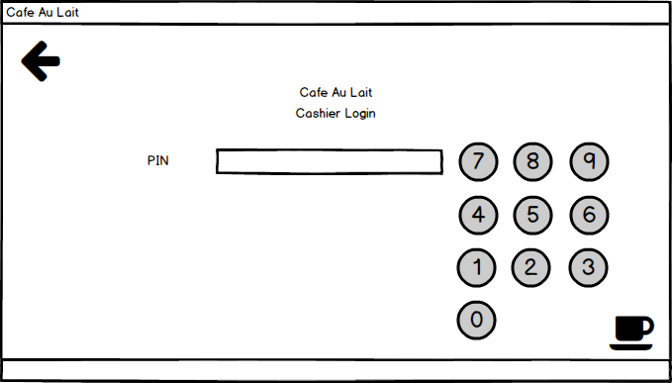

Enter Pin through Here

Main Page Designing

Sales, Add/edit coffee, employee

Implemented in Final Prog.

Condiments:Has not been added for the final project

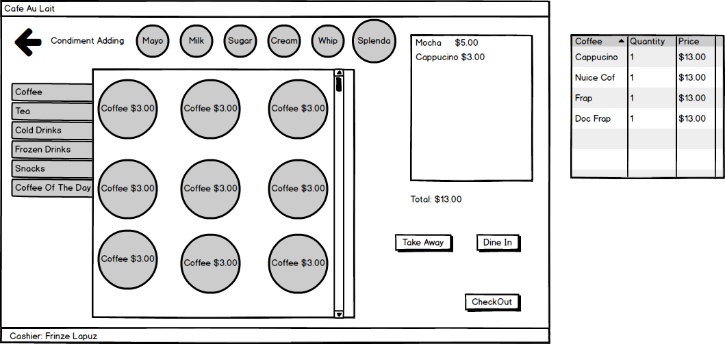

Cashier Log In

Button Automatically Gets Created

Payment

List of Purchases and Total

Automatic Categorization

Payment Page Designing

Exact Payment for Fast Transaction

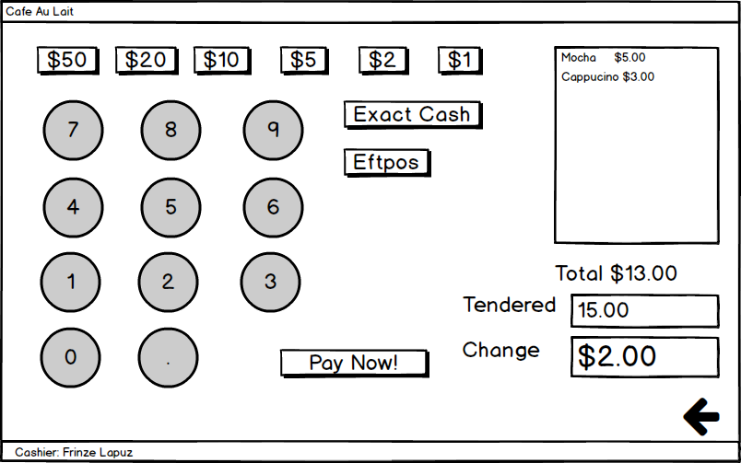

Modify Order

Enter Tendered Here

Admin Page Designing – Changed to Menu Strip in Actual Program for Simplicity

Due to Lack of Number of Content.

(May be Implemented when Admin Task becomes of high number)

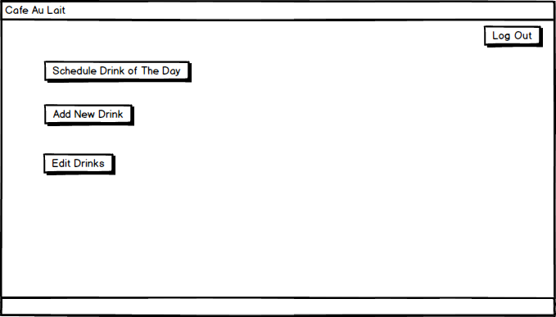

Setting A Coffee Of The Day – Not in Actual Program Due to Lack of Time to Add Feauture

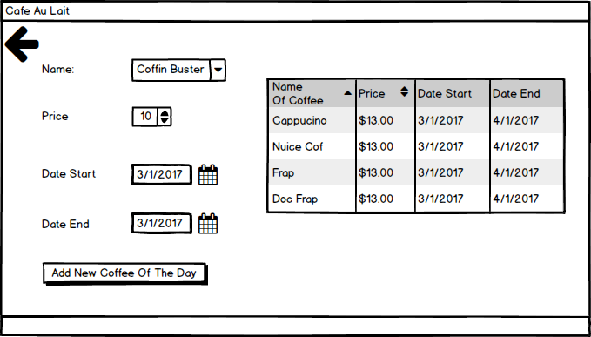

Editting Coffee Page – Editting and adding of Coffee has been made to be in the same form for the actual program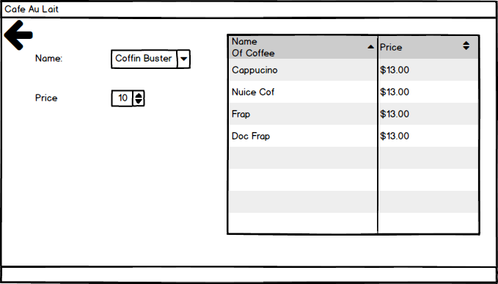

Adding New coffee Page

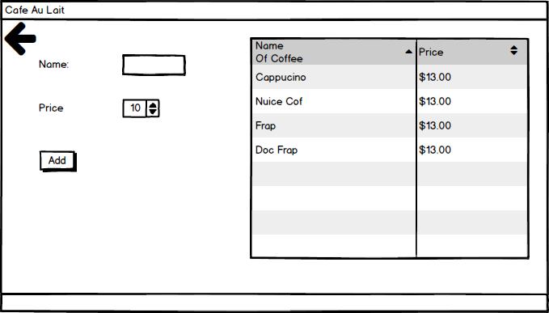

**Post-Evaluation**

The Program Made Features (Additional Features Aside From Outlined by Assessment Task) :

* User-Friendly Adding/Editing of Coffee
  + Automatically Generates Button for Cashiering
  + Adding and Editing in Program
  + No Need to Go Through Source Code To add Button
  + **No Programming Knowledge Needed to Add A New Coffee**
* User-Friendly Layout and Categories of Coffee/Buttons
  + Contains Tab Control Separating All The Categories
  + Contains Flow Layout Panel Maintaining Decent Position and Size of Button
* User-Friendly Adding/Editing of Employee
  + Adding and Editing in Program
* Logging In Feature
  + Automatically Knows when a User is an Admin or not
* User-Friendly Addition of Coffee
  + Press the button again to add Coffee
* Multi-Addition of Coffee
  + Helps in Adding Many Coffee eg. 100 Coffees at once
* Multi-Select Removal of Selection
  + Easily Removes many object by selecting everything
* Sales Checking/ Recording
  + Features amount of coffee bough in a day
  + Displays Total Sales Every Order
  + Displays Total Sales For the Whole Day / Time
* EftPos
  + Cashout System
  + Instant Pay System
* Exact Cash
  + Fast Transaction System
    - Eg. Customer Pays $50 Dollar Bill