Using Quarto for Stata dynamic documents
Let us consider an example where we study the mpg and weight variables in auto.dta. In this example, all code used to construct the desired output will be displayed as fenced block code, followed by the output it produces. This is done using the option *|echo: fenced. This option, however, doesnt seem to work well with jupyter notebooks.
We first use the sysuse command to load the dataset and then describe the data using the describe command.
```{stata}
sysuse auto, clear
describe
```
(1978 automobile data)

Contains data from C:\Program Files\Stata17/ado\base/a/auto.dta
Observations: 74 1978 automobile data
Variables: 12 13 Apr 2020 17:45
(_dta has notes)
-------------------------------------------------------------------------------
Variable Storage Display Value
name type format label Variable label
-------------------------------------------------------------------------------
make str18 %-18s Make and model
price int %8.0gc Price
mpg int %8.0g Mileage (mpg)
rep78 int %8.0g Repair record 1978
headroom float %6.1f Headroom (in.)
trunk int %8.0g Trunk space (cu. ft.)
weight int %8.0gc Weight (lbs.)
length int %8.0g Length (in.)
turn int %8.0g Turn circle (ft.)
displacement int %8.0g Displacement (cu. in.)
gear_ratio float %6.2f Gear ratio
foreign byte %8.0g origin Car origin
-------------------------------------------------------------------------------
Sorted by: foreign
Now, we want to check if mpg is always greater than 0 and less than 100. We use the assert command to perform the check. In this case, we do not want to include any output in the target HTML file, so we use the quietly attribute to modify the behavior of the dd_do Stata dynamic tag.
```{stata}
assert mpg > 0 & mpg < 100
```
If the data do not satisfy the conditions, quatro will fail with an error message, which will occur if we run the same assert command in a do-file.
Next, we want to summarize the weight variable:
```{stata}
summarize weight
```

Variable | Obs Mean Std. dev. Min Max
-------------+---------------------------------------------------------
weight | 74 3019.459 777.1936 1760 4840
We want to use the minimum and maximum values of weight in a sentence. Instead of copying and pasting the numbers from the summarize output, we can use the display Stata to show r(min) and r(max) stored results. We will also use the options *| output: asis to obtain text that follows markdown formatting.
```{stata}
*| output: asis
display "The variable weight has minimum value " %4.2f `r(min)' " and " ///
"has maximum value " %4.2f `r(max)' "."
```
The variable weight has minimum value 1760.00 and has maximum value 4840.00.
In other words, if one wants to use dynamic tags, its possible to do so by simply using display, with the corresponding locals, so Stata evaluates the expressions as normal. *| output: asis is used so the output can still be interpreted using markdown syntax.
As with dyndoc, display can also be used as a calculator. For example, if we want to include the in a sentence, instead of calculating the number and then copying and pasting it, we can use
```{stata}
*| output: asis
display "The variable weight has range " %4.2f `r(max)'-`r(min)' "."
```
The variable weight has range 3080.00.
Now, we want to graph mpg and weight using a scatterplot. There are at least two ways to do this.
First, one can simply create the scatterplot using the same procedure as before:
```{stata}
scatter mpg weight, mcolor(blue%50)
```
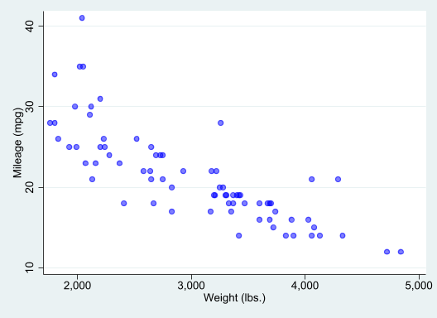
which generates a scatterplot of mpg and weight with 50% opacity color markers.
Now, we want to export the graph to a file and include an image link to the file.
```{stata}
qui:graph export fig1.png, width(1600) replace
```
This produces a graph of 1600 pixels width.
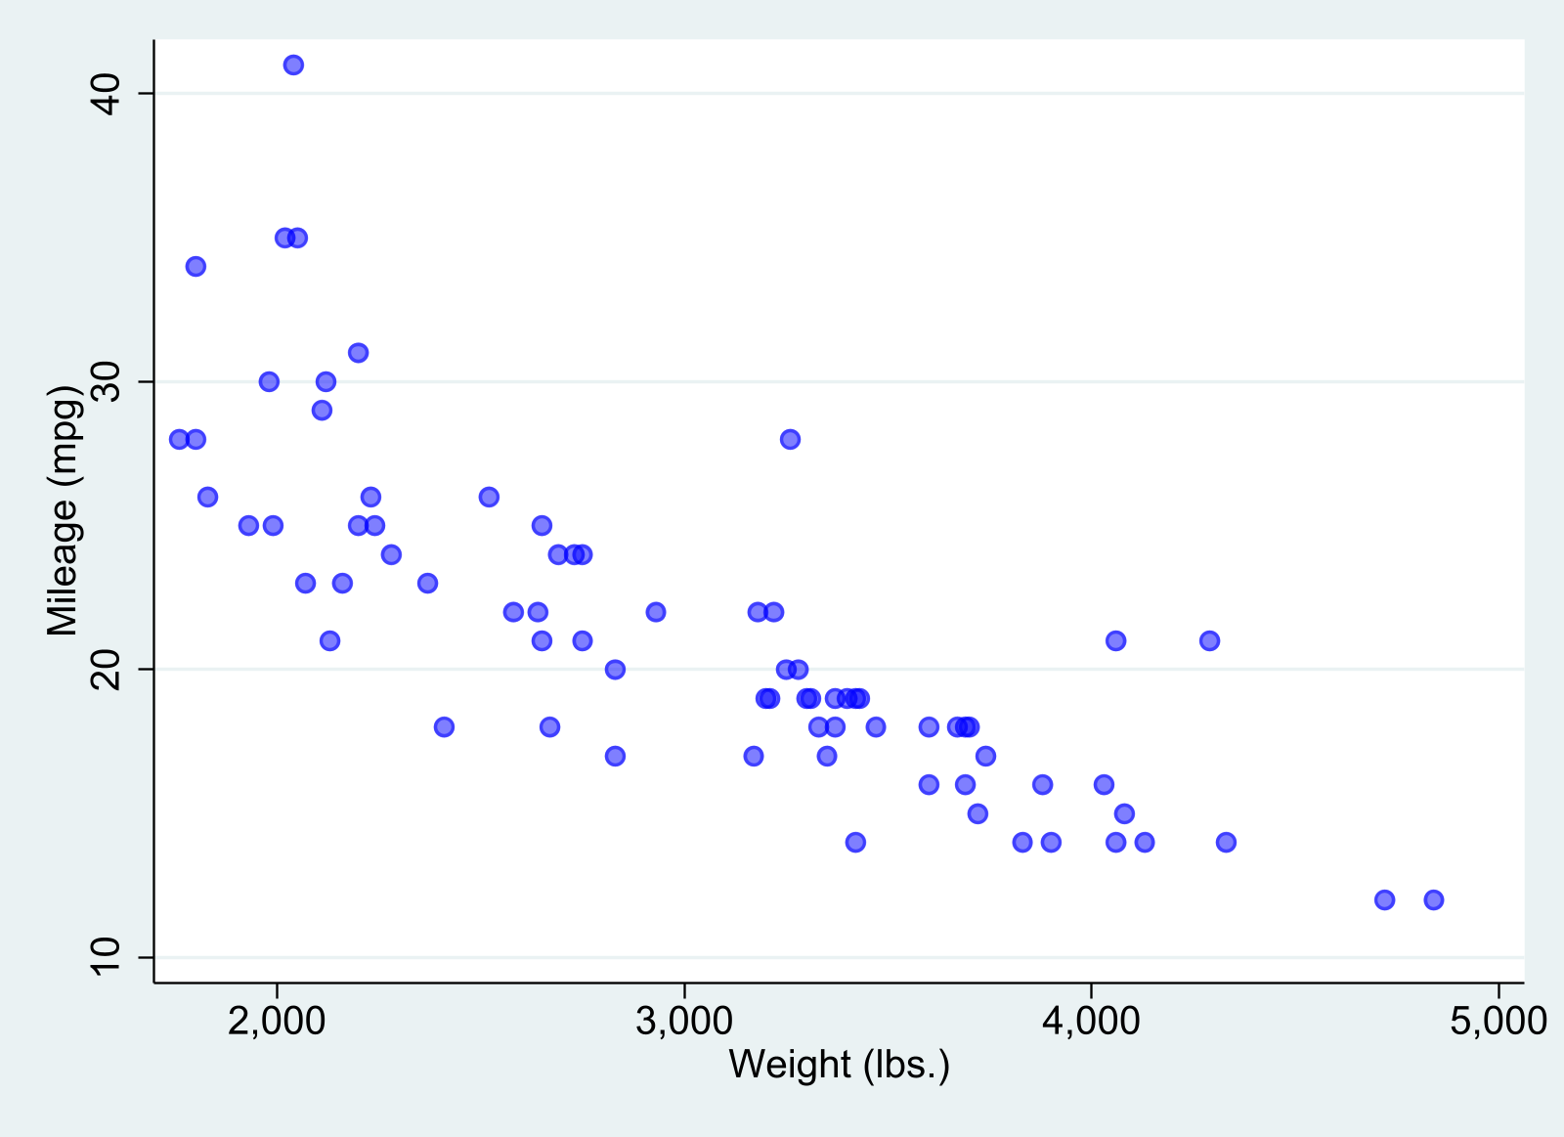
scatter
It is possible, however, to combine figure creation using quatro tags and directives. Here, however, you need to make sure all figures are named:
```{stata}
*| label: fig-cost
*| fig-cap: Price vs MPG
*| fig-subcap:
*| - Foreign Cars
*| - Domestic Cars
*| layout-ncol: 2
*| column: page

scatter price mpg if foreign==1, name(m1, replace) ylabel(0(4000)16000)
qui:graph export fig2a.png, width(1600) replace
scatter price mpg if foreign==0, name(m2, replace) ylabel(0(4000)16000)
qui:graph export fig2b.png, width(1600) replace
```
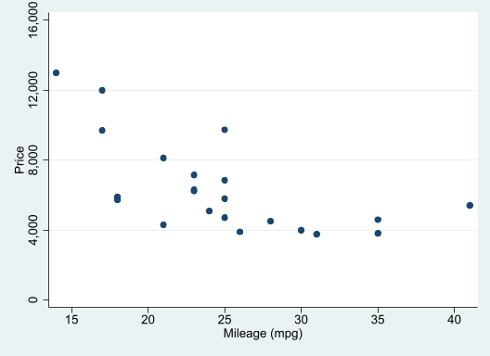  (a) Foreign Cars | 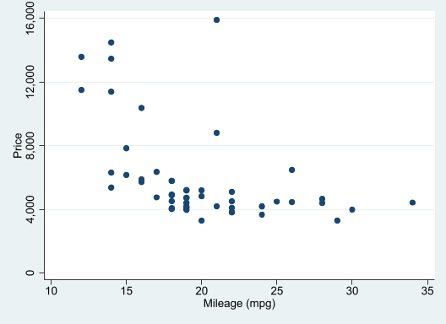  (b) Domestic Cars
Figure 1: Price vs MPG
And of course, we can now the figure tags to link it to the text:
Figure 1 provides a simple scatter between prices and MPG for foreign and domestic cars. While there seems to be a strong negative relationship between these variables among foreign cars (see Figure 1 (a)), the relationship among domestic cars is much weaker, when looking at cars with a fuel efficiency larger than 15mpg (see Figure 1 (b)).
The last approach, however, may not work with PDF format, or jupyter-notebook format, unless the figures are saved. But does seem to work with HTML and docx.
Nevertheless, one could also do the following:
::: {#fig-mpgprice layout-ncol=2 .column-page }

![foreign](fig2a.png){#fig-mpgprice-1}

![domestic](fig2b.png){#fig-mpgprice-2}

Price vs MPG
:::
to produce
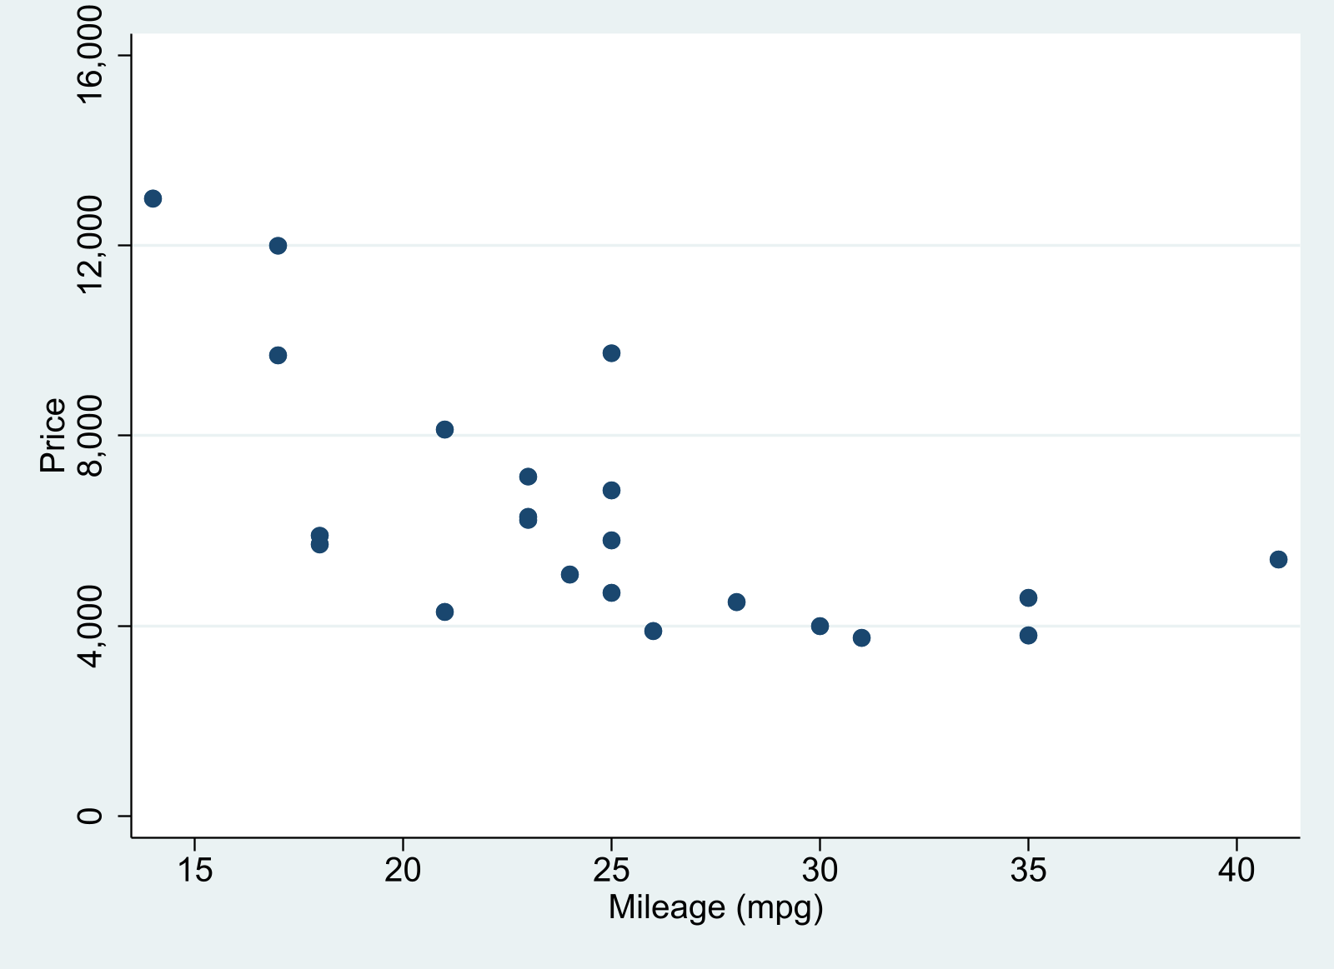  (a) foreign | 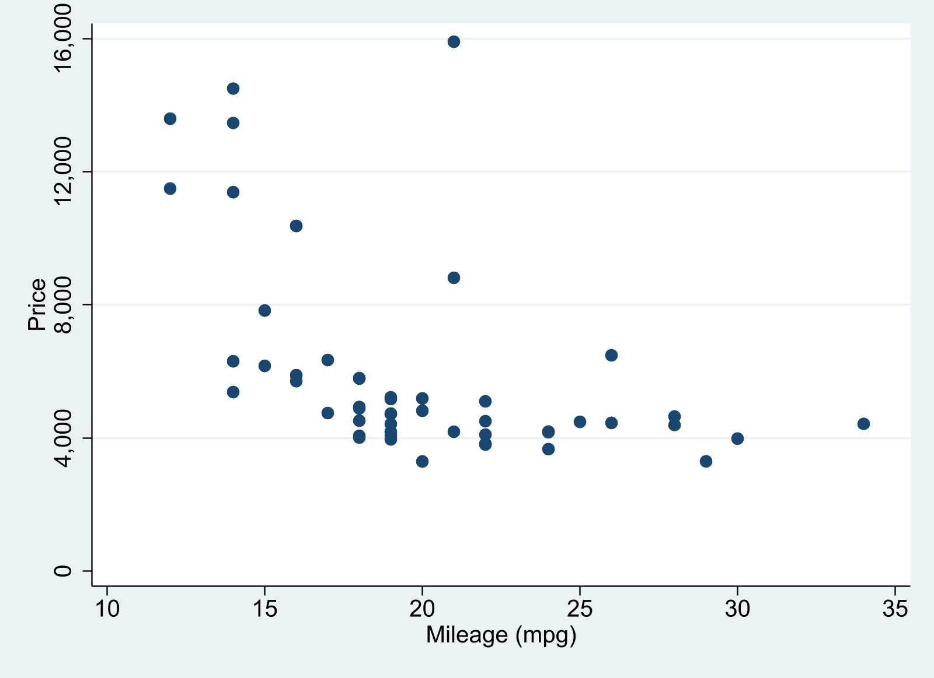  (b) domestic
Figure 2: Price vs MPG
As plot in Figure 2 provides a simple scatter between prices and MPG for foreign and domestic cars. While there seems to be a strong negative relationship between these variables among foreign cars (see Figure 2 (a)), the relationship among domestic cars is much weaker, when looking at cars with a fuel efficiency larger than 15mpg (see Figure 2 (b)).
If using VScode, to render all formats at once, you need to type quarto render filename.qmd in the terminal.
Just for fun, I also when rendering this with quatro, i used the following formats

---
format:
html: default
pdf: default
docx: default
odt: default
epub: default
jupyter: nbstata
---

