**Kathleen Coessens, Henrik Frisk and Stefan Östersjö:**

Repetition, resonance and discernment.

*Intuition leads us to go beyond the state of experience*

*toward the conditions of experience. But these conditions*

*are neither general nor abstract. They are no broader than*

*the conditioned: they are the conditions of real experience.*

(Deleuze 1966:27)

**Introduction**

Musical performance is an artistic manifestation consisting of action, or, being 'enacted' by the artist. At the same time, the artist is in a ‘discerning’, perceiving situation, a situation of ‘resonance’. However, the potential of both discernment and action is dependent upon the performer’s entire artistic background which is the result of a patient acquisition of artistic skills and knowledge, and upon the cultural tools at hand. The moment of *kairos*, the opportune time at which these processes come together joining the intuitive knowing and the individual skills of the performer to the clearest light is the focus of this second article[1]. We will in the present text look at several instances in the production and performances of a composition by the Swedish composer Henrik Frisk titled *Repetition Repeats all other Repetitions*. Particular emphasis will be put on video material from CD-recording sessions that took place with the guitarist Stefan Östersjö at the Electronic Music Studios (EMS) in Stockholm in January 2011.

*Repetition Repeats all other Repetitions* is an open form composition for 10-stringed guitar and electronics. It was premiered in Beijing in 2006 and has been performed many times since then, in three separate versions. The piece emerged out of a collaboration between the composer Henrik Frisk and the guitarist Stefan Östersjö, an artistic research project in which interaction in the widest sense was allowed to play a major part already at the outset. In the preparatory phase, and through the first incarnations of the piece, the idea of a radically open work type, the *work-in-movement,* crystallised (Eco 1989). One of the conditions that allowed for the development of this openness was the disassembly of the hierarchies attached to the roles of composer and performer and one of its consequences was that intuition was allowed to play a great role in the work.

Conceptually the piece consists of three thematically distinct motives (A, B and C in the score[2]) derived by permutations of the same tone series. One of the fundamental ideas behind the piece is that these three ‘characters’ should develop dynamically and interact with each other. Though it is only possible for the guitarist to play one of these motives at a time, Henrik’s intention was, by irregularly moving back and forth between them, and with the help of the computer part, to create the illusion that all three ’stories’ were to be told simultaneously. The guitarist would merely ’give light’ or resonate with one version of the story at a time. The way the electronic part is designed, there is a set of soundfiles and types of live-processing that correspond to the A, B and C-materials of the guitar part, respectively.[3]

Though the score is quite detailed, the way the segments are combined is up to the performer. Henceforth three different versions have been produced: in the first two the structure was settled prior to the performance, and for the third version, which is the version mainly being discussed here, the choices were made interactively in real time. In this version, the performer is allowed to interrupt the segments at whatever place, leave it and go to another segment.

**Discernment in continuity**

Each moment of performance or instance of (collaborative) artistic creation is situated in a broader web of artistic practice. A musical event indeed requires from the musician a specific background: to have acquired and elaborated the necessary cognitive and embodied patterns and trajectories that are capable of sustaining and expressing that specific artistic act of performance. However, the performance itself is enclosed in its own artistic time and place and is enacted in moments of now, reaching out towards a greater whole. In the moment of performance, the artist is absorbed in the enactment of the evolving work, from a position of self-reflective embodiment — that level of awareness may also shift and the involvement may at times be a sub-consciously governed action. Each gesture adds, changes, influences the meaning of what was before and what comes after: movements unfold, succeed and even a silence or immobility is but a tension or preparation of the embodied bound towards the next movement or sound; no movement is ever in isolation. Inner, experienced time, and spatialized, objective, analyzable time merge into an embodied time, the time of the unfolding movements and acts. The movements of the body incorporate the surrounding space, linking interiority and exteriority.

Jean-Luc Nancy reminds us how listening is always a matter of sharing (Nancy 2007:7-17). Hence, the space of the performance is also the space of the performer (and of the listener), the sound waves become part of the body, or the body part of the sounding space — resonating with each other. The artist enacts with a high perceptual and kinaesthetic sensitivity of the space, the objects, the bodies, the atmosphere, of everything that is 'in touch' with his or her body, extending the body and its unfolding gestures with the material surroundings and objects: where the artist is and what he/she does or will do, his or her spatial position, the material givenness and relatedness of body and space, merge completely in the unfolding of the musical act. A liminal space of artistic performance which challenges all ordinary quantitative time-space experiences, or chronos-topos, emerges. It is a space of resonance, an assemblage of the spaces of artistic practice, of preparation and of performance in one 'here and now'. This attention implies a fast tracking of possibilities and constraints and a fast attuning between proprioception and exteroception — between the attitudes and processes which steer up of the inner body and mind, and their reception of and interaction with the resonance of the outer world.

The musician’s tracking of these multiple perceptual inputs and outputs is a complex activity that depends on both explicit and tacit awareness and knowledge. There is a constant oscillation between conscious analytic thinking and tacit, non-conceptual knowing. This last shows itself as a ‘know-how’, a form of action led by intuition which can be defined as

*Accumulated experience that is not immediately accessible to language, but which does affect our consciousness […]. An intuitive choice is thus as conscious as a considered choice, it simply uses aspects of consciousness that are not accessible to language. It cannot say, but it can show.* (Gertrud Sandqvist, <http://www.kaapeli.fi/~roos/gertrude.htm>)

For Bergson, intuition is the flow of inner and outer experience, an undivided continuity, difficult to pin down. However, because of practical reasons, we interrupt, fraction this continuity into discernible elements or fragments:

*we start from what we take to be experience, we attempt various possible arrangements of the fragments which apparently compose it, and when at last we feel bound to acknowledge the fragility of every edifice that we have built, we end by giving up all effort to build. But there is a last enterprise that might be undertaken. It would be to seek experience at its source, or rather above that decisive turn where, taking a bias in the direction of our utility, it becomes properly human experience.’*(Bergson 1991: 184)

Intuition emerges here as an inner appreciation of the conflation of the complex information and interpretation through the senses, the body and the mind, in the now related to the background knowledge and experience. Focus and background, inner and outer experience unite in the experience of the body which is the material locus of complex interaction. What we are seeking is within that experience of multiple sensations that both afford indeterminate action and yet persist (Morris 2005:12). Returning to the introductory quote by Deleuze, in his early discussion of Bergson’s thinking and the contradictory acts of intuition he pinpoints the “decisive turn” that Bergson brings up in the quote above as a turning point. The conditions of real experience are neither general nor abstract but allow us to go beyond the turn, beyond our own experience and allow us to see it as one, “a pure memory identical to the totality of the past” (Deleuze 1966:27).

The “decisive turn” can be understood as moments of *kairos* that allow for intensive encounters between inside and outside, between perception and imagination, resistance and resonance. *Kairos* implies the convergence of 'knowing how' and 'knowing when', the faculty of both observing and realizing in any given case the available artistic means (Atwill 1998:59). Moments of *kairos* are points of heightened awareness or explicit flashes of the implicitly present flow of intuition which result into active responses to the space of resonance. But these moments do not merely present themselves to the performer from the outside nor solely from the inside: the moment of kairos is a moment of crisis, of conflict between musical powers, it is a decisive point when a new direction needs to be forced into the musical flow. The artist will have to cope with unexpected conditions which suddenly can hinder the attuning of body and space. He or she will prevent this as much as possible, by already 'sensing' or ‘weighing’ the space before, by preparing his or her body and its 'touch' with that space — relying upon intuition. The kairos of the artist concerns the faculty and reaction to cope with the unexpected, with the particular constraints of a situation and of her own act in this liminal space of performance (Coessens 2009:276).

**Repetition Repeats all other Repetitions**

##### Intuition and repetition

The embodied knowing that constitutes the framework for musical intuition is strongly brought to play in every performance of *Repetition Repeats All Other Repetitions*. A performer who has worked through the materials of the piece - the score and the computer generated sound - and who has been performing different versions of the piece in concert will create an inner field of possibilities that becomes the playground for the next performance. But even if the piece has a strong bearing on our discussion of the moment of kairos in musical performance, there are also many instances in the collaborative work of making the piece that point to the function of intuition in time-scales other than the now in performance. We will in the following section offer some background concerning the working process of the creation of the piece. This started in 2006 with the ambition of highlighting some intuitions that guided the work in three periods stretching over several years.

The preparatory work on the piece involved an extended artistic research process that included the collaborative analysis of video documentation from Stefan’s collaboration with another Swedish composer, Love Mangs, as well as writing several papers and making conference presentations of that study. During this period, the casual discussions of how the new piece might take shape were also important. We will return to below how some of those early intuitions about the piece came to guide the entire process of making the piece. But the preparatory work also involved improvisation sessions that were recorded on audio and video and later transcribed by the composer Henrik Frisk to become part of the score.

In the next phase, Henrik took all this material, borrowed Stefan’s 10-string guitar and wrote the first score to the piece. The way the score is constructed, it builds on three distinct layers and the dynamics between them:

###### Motive A

The A-motive is a transcription of the first section of the first sketch for another composition, *The Six Tones*, a quartet for two Vietnamese instruments, guitar/banjo and electronics. It makes use of a range of alternate playing techniques. The A-motive electronics make use of samples from the same Six Tones-sessions and are generally rather short.

###### Motive B

The B motive is in essence a melody with harmony and is a combination of what was initially thought to be two separate sections. The slow melodic movements are combined with repeated chords in a dynamically varied context. The B motive electronics were created making laptop improvisations on samples of the chords and some of this material consists of quite long files, up to over a minute.

###### Motive C

The C-material is almost entirely ’tapped’ on the fingerboard of the guitar using both hands in complex polyrhythmic patterns. Apart from creating a timbral texture distinct from the other two it allows for a kind of two-line polyphony difficult to perform playing the guitar with standard technique. The computer part is derived from physical modelling of a guitar with glass strings.

The first (original) version of the piece has never been performed. In the first score Henrik’s intention was to give a certain limited amount of freedom of choice in performance which Stefan, however, found to be problematic and suggested a different (and fixed instead of ‘open’) version for the premiere, which was to take place in Beijing only a few weeks later.

One problem that Stefan identified was practical: the score did not easily allow for actual use in a concert performance with all the pages and the need to turn back and forth in the material according to the real-time choices the performer should make in the course of the performance. The other problem was the greater form which did not appear to be convincing. So, before leaving for Vietnam (a stop on the trip before going to China) he had made notes in the score on how to edit the material into a different fixed version. While in Hanoi, the score was cut into small chunks and put together according to a formal outline that Stefan had drawn out. The electronic part was mapped onto these fragments following the structure of the material in the guitar part and new electronic material was created. This version was performed many times over the next two years, often in combination with the second version that we would later produce.

In this second reading of the score, the greater form is guided by the form of the modernist film classic, Viking Eggeling's 'Symphonie Diagonale'. This version was structured by Henrik and Stefan in joint sessions, working with an audio recording of the first version as one of the main materials. Based on an intuitive sense of structural affinity between the works that Stefan had, they developed a strategy for making this version of the piece by mapping the three main materials of the guitar piece to the three categories of imagery that we found in the film.[4] In the sketch in image 1 we can see one of the sheets in which Stefan and Henrik pencilled motives from the film and linked them to the A-material in the composition.

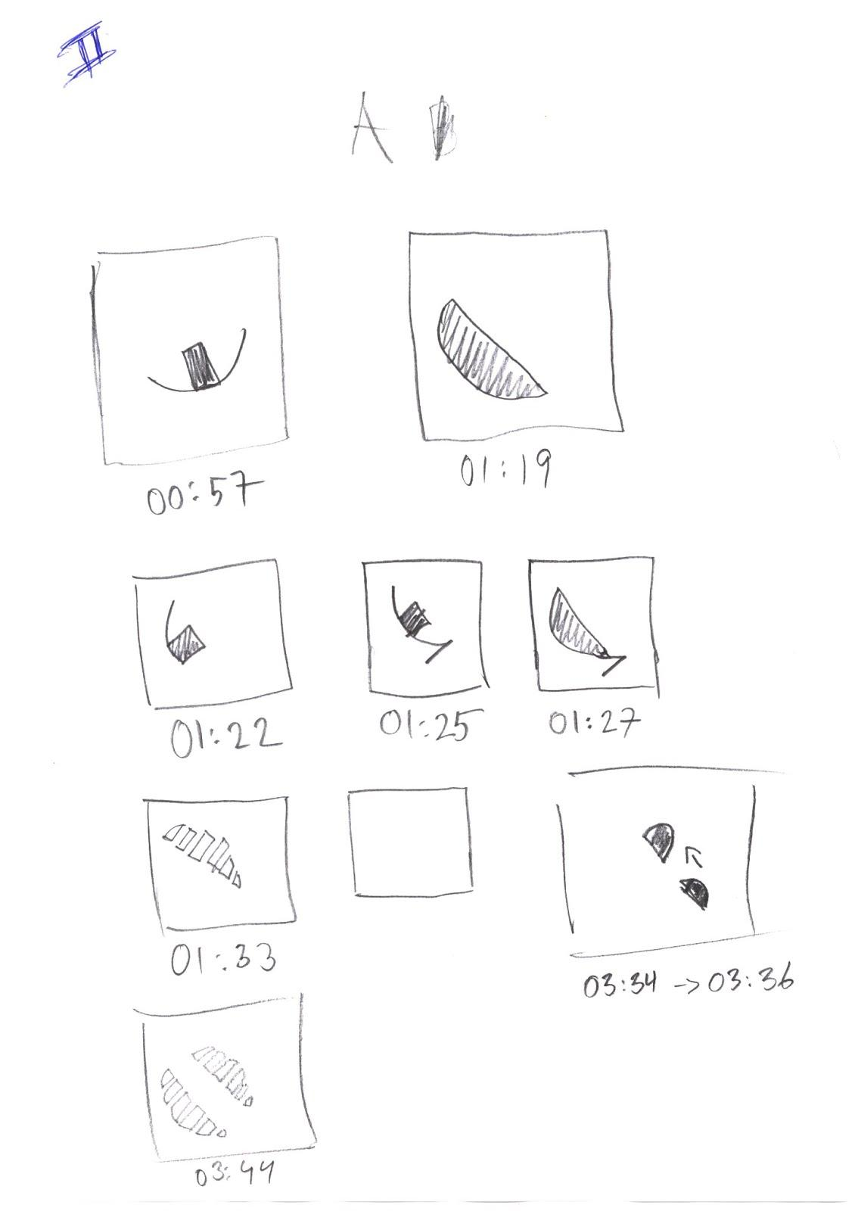

Image 1: A sketch of the graphics from the analysis of ‘*Symphonie Diagonale*’.

The third version followed. This not only expressed the composer’s original ideas for the piece, but also reflected and finally realised intuitions composer and performer both had concerning open form, not specifically related to the modernist traditions of aleatoric and mobile scores but an aim towards working modes that grew out of our practices as musicians:

[...] *our attempts at creating a dynamic score, a framework of musical notation in which different paths can be taken, is not implicitly related to the stylistic and esthetic grounds of the open work in the modernist era but instead related to its impact and operational function in machine-musician interaction today. (Frisk & Östersjö 2006:249)*

In the time of writing, the ‘dynamic score’ referred to here was a conceptual idea of a score that did not have a privileged reading mode nor a beginning or end. This early intuition continued to guide the development during the years of extensive collaborative work and eventually resulted in a piece that, expanding Umberto Eco’s classic term, could rightly be called a *work-in-movement* (1989). Though the practical realisation of the interactivity in the technical design - including the decision to create a dynamic score that can be controlled with a foot pedal by the performer during the performance - took a long time, an intuitive knowing that pointed beyond the available solutions and technical means at the time prevailed over the years.

After the premiere of the third version in October 2008, the further growth of the piece up to the CD-recording session in January 2011 was constituted mainly by the collection of more experience of performing the piece, adding to the body of accumulated knowledge from the making of the composition and the concepts that shaped its identity.

In the following text, we will analyse in detail some of the recording sessions with a focus on how embodied knowing creates a field of possibilities that constitutes the playground for musical intuition.

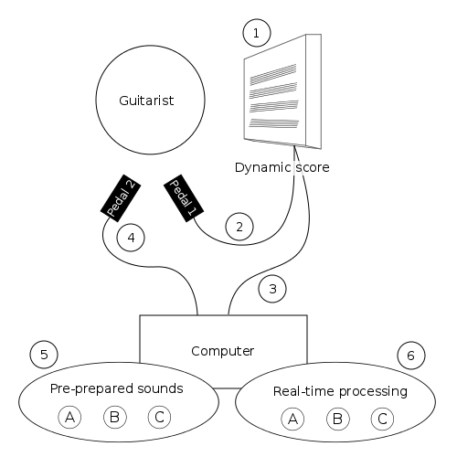

Image 2: The performer has two pedals, one that controls the page shown (2) in the score (1) and one to signal a new event trigger (4) to the computer. The computer is also informed of what page is currently showing (3). At each trigger of pedal two the computer is making a heuristic choice of material (A, B, or C) individually for the set of pre-prepared sounds (5) and for the bank of real-time processing (6) based on the score page currently showing and the preceding material.

##### The moment of kairos in performance

The situation of a performance offers a musician a spectrum of constraints and possibilities. While this spectrum is rather limited in the case of a traditional score, *Repetition Repeats All Other Repetitions* is more demanding, requiring from the performer a continuous responsibility of shaping the piece. The composer indeed offers a score that needs to be ‘re-composed’ in each performance and forces the performer to ‘re-construct’ the piece each time differently, following the decisions made in the course of the performance. Moments of kairos are inviting and disturbing situations where unexpectedness urges the artist to react and decide. *Repetition Repeats All Other Repetitions* asks from the performer a deep commitment and an openness, not only to react in unexpected situations, but to create unexpectedness by the own actions and to solve the succeeding disturbances. This piece embeds in itself the necessity of kairos as it is impossible to calculate the entire range of actions, of possibilities and occasions of intervention, decision and modification that can be undertaken in its performing.

As such, every pushing of a pedal in a performance of the piece is like opening up for a new question in the Gadamerian sense: a novel contribution in a musical hermeneutic process, launching a dialogue between the musical materials and the performer. Every pedal trigger indicates a frame opening questions and asking for a decision to be taken which will orient the course of the performance. If the pedal that changes pages in the score is pushed, a new musical material has to be chosen and shaped into the ongoing musical current. If the pedal that activates a new event in the computer is pushed, the computer will respond with either a soundfile or live-processing of the guitar part, or both. The pedal triggers function as markers of moments of kairos. In our analysis, the triggers do not necessarily have to mark the posing of a question, they can just as well mark the making of a decision. Interestingly, the openness of the score and the possibility for the performer to make choices all along the performance allows him/her not only to encounter unexpected moments of kairos, but to provoke these moments.

##### Looking ahead

The ability to move between different time-scales is one of the consistent demands in musical performance. Therefore, moments of kairos also involve choices that look further ahead and back on the development of the ongoing performance. This is inherent to being a resonant subject in the performative event. Moments of kairos and consequent decisions can always emerge. As such, in a performance of ‘Repetition’ this may also occur before the pedals are pushed. For instance, clip 2 starts with an action that seems to evoke a situation of immediate choice which already decided on beforehand of some of the actions to follow (video clip 2 and image 3):

Stefan plays the three first notes of A2 and pushes both pedals simultaneously on the second note. Not only does this activate new electronic sounds but it also takes him to a new page of the score. However, there is no sign of Stefan reading the score after the change of page. Instead he immediately continues by playing the opening of C1 which is one of the materials displayed in the next page. We believe that the page turn and the alignment of A2 and C1 that occurs was figured out before the pedals were pushed. However, the continuation after stating the two fragments seems not to have been pre-planned and Stefan reads the score intensively before setting out to play again. The sound file played back is an extensive file of C-material and Stefan plays from the middle of A4 to create a contrasting guitar material with the electronics. When the soundfile ends, and counter to how the composer originally conceived of how the electronics and acoustic part should interact, he then states the entire C1 sequence, creating a longer phrase stretching over the 48 seconds of the clip.

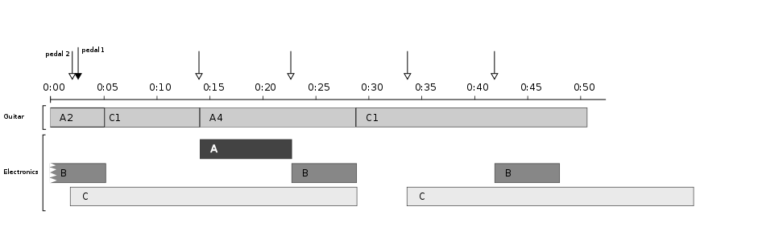

Image 3: Graphic score layout of clip 2 with pedal triggers indicated.

##### Disturbances

Decision making in the moment is not always straightforward. Rather than emerging from a sense of flow, when all parameters of an activity contribute to a heightened awareness (Csíkszentmihályi, 1990), the moment of *kairos* can indeed be a moment of crisis and doubt. Certainty is not part of the vocabulary of a performer, and even less in this piece. The artist has to be alert, to react, to contest, to interfere, and, of course, while doubt is allowed, hesitations are not; they need to remain tacit as the performance must go on. Artistic *kairos* thus requires from the musician a sincere participation and active contribution, making that little difference needed to capture both the essence of the piece and the attention of the audience.

Two examples of the progression in Clip 1 exemplify such ‘disturbances’ in the sequence of musical events. The first example of a kairos moment that disturbs, seems to invite to a change of mind allowing the performer to readjust and resonate with the sound environment (Clip 1 and Image 4):

When Stefan has played the first melodic line (starting on the last notes of the 11/16 bar of A4 and ending at an E four bars later) he stops first to look at the score on the screen (00:17) and then pushes the right pedal once (00:19) to arrive at a new score page. Meanwhile, the electronics is playing a longer soundfile. Stefan is silent for six seconds (we only wish that we could record his stream of consciousness in this moment), preparing for an event performed upon the fretboard. However, he leaves this hand position and then quickly pushes the pedal four times. This action with the pedal in fact takes him back to the same page as was the starting point. What kind of resonance with the space of musical performance is it that leads to this change of mind? Is it the development of the electronic music? Or is it something that refers to the shaping of the guitar part? With only the traces of this moment of musical thinking to refer to we can but guess. It seems obvious though that the material he turns to, a multi-stopped E that opens B3, does allow for a logical connection from the broken melodic line in the previous guitar material.

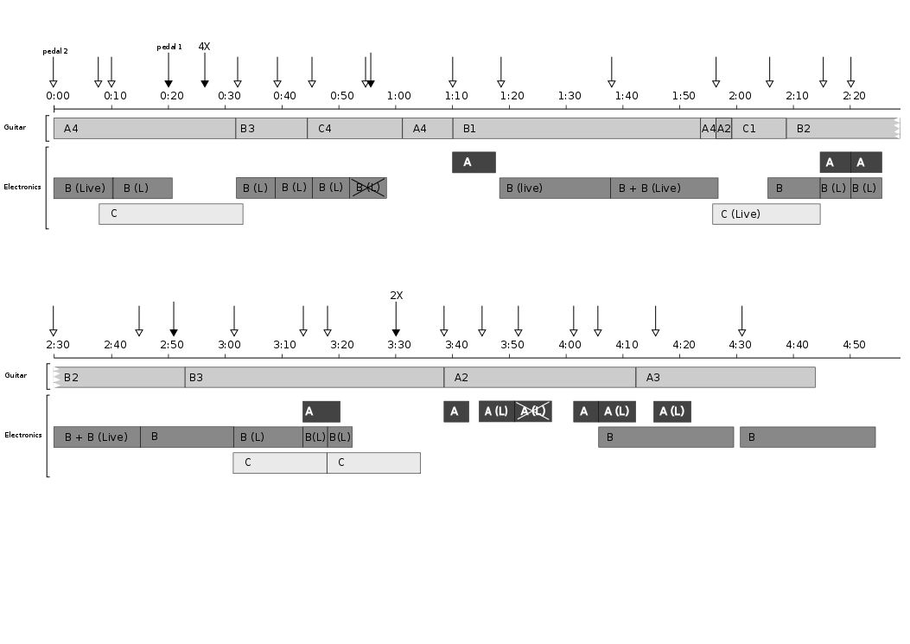

Image 4: Graphic score layout of clip 1 with pedal triggers indicated. The material that has been crossed over has been taken out in the mix.

In Clip 1 we also find a second interesting example of what we could call failed expectations. Here, the performer’s intention is disturbed by the environmental response - the interaction of the electronics. The performer has to sense again and again in the space of resonance what is appropriate and how it can be expressed in this particular situation of the performance, readjusting an unbalanced situation (Clip 1 from 1:04 on, see also Image 4):

At 1:04, after the introduction of a new material in the live electronics, Stefan plays a short two note figure and simultaneously clicks the pedal to activate the electronics. Surely, the intention was to create a new instance of electronic sound in response to the previous, cut off phrase in the electronics. The response from the computer was however unusually soft and discrete. Also, it was a very short bit of live-processing so it is followed by silence. This silence then becomes a dramatic context for Stefan’s new turn, activating again the electronics a second time at 1:10, now with a louder material also in the guitar part (the Koto pizz that opens B1). This time he has more luck with the electronics which now responds with an immediate loud attack. The failed expectations lead to a renewed attempt that weaves the two preceding phrases together into a longer more coherent section that eventually also incorporates the entire B2-B3 sections from which the crescendo on the multiple E:s (discussed above) were taken.

##### Shaping open form

While the identity of a work-in-movement is radically unstable, there are compositional elements that contribute to create a consistent identity in every performance of ‘Repetition’.

A strong factor are the electronic sound files that mirror these aspects of acoustic music in the guitar part. Some of these pre-prepared materials last for one or more minutes, others are much shorter. The score is the great paradox of the piece, highly defined in terms of timbre, rhythm and pitch as it is. However, as we have already seen from the brief account of the development of the composition, this minute expression of the composer’s ‘intentions’ has never been subject to total obedience. On the contrary: it has been cut to pieces, re-organized and partly disregarded (but also, meticulously studied and represented in great detail at other times), all in agreement with the composer.

But, in a specific performance, how is the form of the piece shaped? How much of the large-scale form is created in the moment by the performer and to what extent is the outcome determined by the composed materials? Obviously, no measurements of these proportions would be neither possible nor meaningful. However, it is crucial to consider the performer’s continuous negotiations with both the materials of the composition and the flow of events in the performance to understand musical intuition. Following Mark DeBellis, we argue that intuitive understandings emerge from an interaction between the field of possibilities available to the performer and analytical thinking. This is also the case concerning the large scale form. But how then are these processes observed and analyzed? We will in the following turn to examples from a performance version of ‘Repetition’.

In the premiere version of the piece in 2006 Stefan’s decisions of how to align the fragments - literally cutting the score to pieces and putting it back together again in a new order - were related to the physicality of playing the material on the 10-string guitar, finding new idiomatic links and sonic connections between the three materials. By these decisions, the choreography of hand movements and the physicality of the instrument became further integrated in the shaping of the form (Östersjö 2008:301-306). While the original version by the composer had followed a rather abstract trajectory - moving from a predominance of first A, then A and B towards only C-materials - this cut up version created a more complex interrelation between the materials in the acoustic part. Stefan’s decisions were indeed not based only on local considerations related to the idiomatic qualities in the materials but also on a critical reading of the design of the large-scale form of the piece.

The processes that allow for such integration of form related considerations depend on both being in the moment of the now and being informed by past and present. In a single intuition, we can contract multiple moments of time (Bergson 1991:166). However, the contraction of time can be considered as an expansion of the present because the moment of now is increased and intensified by other images and moments of duration, realising continuously syntheses of past, present and future (McNamara 1999:37; Bergson 1991:227-228). These dynamic movements of contraction and expansion are dependent upon the needs of action in an actual present. Such constantly changing and dynamic processes allow the performer to continuously make “mental leaps back and forth between the present and the past” in a complex interaction between calculated choices and intuitive responses (Frisk & Karlsson 2011: 288).

However, beneath the physicality of the instrument and the structural layers in the score, a third element, the additional voices of the electronics, makes the overall realisation even more complex, adding another layer in this play between musical forces. The interplay between the three types of material in the electronics and how the instrumental part is shaped is indeed a key element in understanding how the greater form of the piece is created. Whether the performer chooses to follow the same trajectory as the electronic part or whether the instrumental part counters this, both affect the further response from the electronics. In Clip 2 we see an example of this dialectic:

Stefan plays A2 and presses both pedals to move to C1, a point at which the electronics start playing a longer C-material. On top of it, he plays mainly A and C fragments and when the soundfile ends he moves to the first more extended scored sequence, reading the full C1 out of which a fragment was played at two seconds into this clip. At 34 seconds, the electronics again play C-material, adding to the large scale shape of the phrase. The outcome of this is a segment of 48 seconds of music which has an underlying structural basis of C-material, counterpointed with fragmented A and C material in the guitar part.

This is reflective of the design of the composition. The likelihood for C and A materials to be played back, when the performer is reading from the page in the score where A 4 and C1 are found is quite high. B-materials in the electronics are fairly unlikely to be heard. So this clip represents a typical and intended behaviour of the electronics and may be said to represent one important aspect of the way in which the electronics contribute to building larger form in the piece. But Stefan’s choice not to play C-material at the start of the first C-soundfile also contributes to the creation of this longer phrase. Starting at C1 when the file ends is instrumental for creating the longer phrase.

A somewhat different example can be seen in Clip 1 where the performer both has the intuition and intention to enter the space of resonance dominated momentarily by the electronics (Clip 1 from 1:56 on):

Stefan starts playing A2 and presses the pedal to activate the electronics but the computer responds with live processing in C. In 1:58 Stefan then pushes the pedal and starts playing C1. When Stefan presses the pedal again the computer plays B material and in 2:09 Stefan switches to B2. But from this point he chooses to follow the trajectory of the scored material, playing the entire B2 and B3 part. Again in keeping with the intended flexibility of the computer part, the electronics consist predominantly of B-material, interspersed with elements from first mainly A and then mainly C material.

In the take being mixed as a new release for the present publication, we can explore the shaping of an entire version of the piece in which the guitar part has not been edited but represents exactly the choices made by the performer at every specific moment. This recording offers an insight into both the decisions made in moments of kairos as in the overall shaping of the larger form, integrating different time dimensions. Two examples clarify this:

(1) The first two minutes are built from small fragments taken mainly from A4 and C1. The function of this section seems to be that of identifying material or rather, it could be understood as a process of listening to the material, searching for new possible identities within the composition. A characteristic which is brought out in this take is the melodic lines in A4. By breaking up and repeating bars 2-4, these melodic fragments receive a thematic function that they would not have in an uninterrupted reading of the score. Incidentally, the computer part ‘picks up’ this strategy by sampling and playing back one of these melodic contours in 1:26, when Stefan starts playing C1. By concealing part of the surrounding structure, the fragments may open up in different directions. One of those directions is towards the motoric flow of C4: the first scored section to be played in its entirety at almost 2:30 into the take. But the focus on melody takes over and the opening section eventually leads to an extended reading of the melody and chords in the B-material in the score.

(2) If we return to the section about failed expectations, the moment when Stefan chooses to start B1 with new electronics becomes decisive for the shape of the entire piece by launching a section stretching from 2:50 to 5:20 with an uninterrupted reading of sections B1 to B3. But further, when at 5:20, Stefan instead introduces A 2 and it becomes clear that the extended section of B-materials here leads over to a section focussed on A, going first backwards from A 2 to A1. This sequence is in turn read in two parts, first starting in the middle and reading to the end. After a short quote of B-material the beginning of A 1 follows. We find a remarkable moment of melodic construction at the point in bar six of A1 where Stefan stops before the two last notes and immediately moves two pages ahead to the middle of the second bar of A4 in order to return to the melodic material from the opening. Indeed, the moment when the transition away from A1 needs to be found must be yet another of the remarkable moments of kairos in the performance. This return to the material of the opening is followed by a coda made up of B4 and B5 bringing a version of the piece to a close that has dug out further melodic material from the score and at the same time also ignores most of the C materials, thus shaping a version of the piece that emerges from the space of resonance which shapes musical intuition.

**Conclusion: resonance negotiated by intuition**

In our observations of Stefan’s performances in the recording session we find a striking multidimensionality of musical discernment. In the moment of kairos, not only local decisions are taken but also directions for the greater form in the version of the piece are decided. We believe that the grounds on which these decisions are taken may be described as a space of resonance. Returning again to the initial quote from Deleuze, we ask what the conditions may be for this experience of resonance and continuity? We have indeed seen above how some of these decisions have been taken in moments when the flow of the music is disturbed or interrupted, demanding a novel initiative to move on. Failed expectations, doubt or change of mind does not have to hinder the musical flow, it may in fact fuel it and result in genuinely original output.

In the space of resonance in a particular situation, the artist has to find an equilibrium between both instantaneousness and duration, between both suspension of individual decisions and the exploration of an artistic trajectory. Resonance always implies more than the re-sounding of a particular situation, since it exceeds the space of here and now. The performer continuously integrates distance and proximity in the performance. The musician negotiates in that particular performance situation not only the best decisions concerning the performance itself, but also concerning the composition of the piece and even concerning his/her own position towards art, audience and the world — emerging in the form of intuition. Is intuition then to be understood as a background layer, an implicit active ongoing process that only becomes apparent and explicit in urgent, decisive moments of kairos, in which questions and answers can emerge both by resistance and resonance? We argue that this is an apt description of how a composition like ‘Repetition’ has been given shape over the years. Furthermore, this reminds us of the Swedish philosopher Hans Larsson’s (1892/1997: 21) Kantian notion of intuition as *comprehensio aesthetica,* or the multitemporal awareness and immediate availability of necessary experience and knowledge. Intuition has been a slowly working process in the development of a concept for a work-in-movement, but which also continues to inform the way in which each rendering of the piece has been conceived. Through this study of some moments of kairos in Stefan’s performances in the recording session we might arrive at a (now more detailed) confirmation of DeBellis’ claim that intuition is the result of an interaction between analytical thinking and perception, though perception may now be understood as a highly active process, as being in a space of resonance.

**References**

Bergson, H. (1991) *Matter and Memory,* New York: Zone Books, MIT Press.

Biggs, M. and Karlsson, H (Eds.) (2010). *The Routledge Companion to Research in the Arts*. Routledge.

Coessens, K. (2009) Musical Performance and 'kairos': exploring the time and space of artistic resonance. In International Review of the Aesthetics and Sociology of Music, vol. 40, n° 2, pp. 269-281.

Croce, B. (2004). *Aesthetics: As Science of Expression and General Linguistics*. Whitefish: Kessinger Publishing.

Csíkszentmihályi, Mihaly (1990). *Flow*: The Psychology of Optimal Experience. New York: Harper and Row.

DeBellis, M. (2009). Perceptualism, not introspectionism: the interpretation of intuition-based theories. *Music Perception, 27*(2), 121-130.

Deleuze, G. (1966). *Bergsonism.* Urzone, NY.

Eco, U. (1989). *The Open Work* (A. Cancogni, Trans.). London: Hutchinson Radius.

Frisk, H. (2008). *Improvisation, Computers, and Interaction: Rethinking Human-Computer Interaction Through Music*. PhD thesis, Malmö Faculty of Fine and Performing Arts, Lund University.

Frisk, H. & Karlsson, H (2010). *Time and Interaction: Research through Non-Visual Arts and Media*. In (Biggs and Karlsson (2010))

Frisk, H., & Östersjö, S. (2006). *Negotiating the Musical Work. An empirical study.*Paper presented at the International Computer Music Conference, New Orleans.

Larsson, H. (1892/1997). *Intuition*. Dialoger, Stockholm

McNamara, Patrick (1999), *Mind and Variability: Mental Darwinism, Memory, and*

*Self.* London, Praeger.

Nancy, J.-L. (2007). *Listening* (C. Madell, Trans.). New York: Fordham University Press.

Sandqvist, Gertrud, (1995) On Intuition, <http://www.kaapeli.fi/~roos/gertrude.htm>, accessed on 15th of January 2013.

Östersjö, S. (2008). *SHUT UP 'N' PLAY! Negotiating the Musical Work.* Lund University, Malmö.

1. See also Coessens & Östersjö (2013) in the present publication.
2. A further description of the materials, both in the score and in the electronics will follow below.
3. See Frisk (2008) for a more detailed discussion of Repetition Repeats all other Repetitions.
4. For a further discussion of the making of this version we refer to the dissertations of Östersjö and Frisk (Östersjö 2008, p. 306-314). In there, pencilled drawings mapping imagery in the film to the musical structures can be seen as well as a closer discussion of the collaborative compositional process. The video can be viewed here: http://goo.gl/z2N18