**INFO5991 Service Science Management and Engineering**

**1. Individual Profile for each member**

|  |  |  |  |
| --- | --- | --- | --- |
| Group Logo |  | | |
| Name | SID | Profile Photo | Hobbies |
| Zhiliang Wang | 460094203 | **https://lh5.googleusercontent.com/xA25oX5VHPJl3JPXoDnK4Q2m7gkSMn0Aj-3NUsA-w5t-I_Dez9mo-HEswuBg3YLmNu70LOYkpWLW2Efa4LnQ3s4J_PS2EEnGd68RJh3hJOXH-x_UTqqHgjvin0LjSxE_cd2bqh3v** | Basketball |
| Hao Guo | 460127213 |  | Computer games |
| Lida Guo | 460269052 |  | Computer games |
| Dasheng Ge | 460440743 | **https://lh6.googleusercontent.com/OBmxILiqcJa5Uy2F30cRH-U52ShgM8kY4ZTZouvm1t2rxosHyWZDqgE9KRoQTXGhdfIzCL4ibSLNFE6_mZX23Z-tt6UZFQK2oXrENV8zRevJjzr45pNi7Vw-_dbOg8RujXd1aAxZ** | Basketball and computer games |
| Qiuqi Cao | 450186109 | https://lh3.googleusercontent.com/JvGr9e_E0Oe4a7khJGkTZsdzhZt-R62FPvP9AE6xorKDvhqmHxTi1DQqGDPK80D8rXKoKGyQZc-A5iaB7bX-LPyIJl_nsbjS0a0NnuIBEyB2xAdxZgNsk4Ptlodiqq4ML1ZAU_HI | Running and swimming |
| Xiaojun Dong | 430411649 | https://lh3.googleusercontent.com/cbA2tX10fvv3lS7G0f6SGb6pBtJdxfpjLG0TK_jM9yzfm4gtgAXMmTn3TzI8LNxSXQOTaOM1iAUibg1B7LlNF2FJqplF-Ly9ikqsniL37ipKm7cNvbz7kS0diaNOKYz2NqwdSPLU | Gym & pop song |

**2. Group Profile**

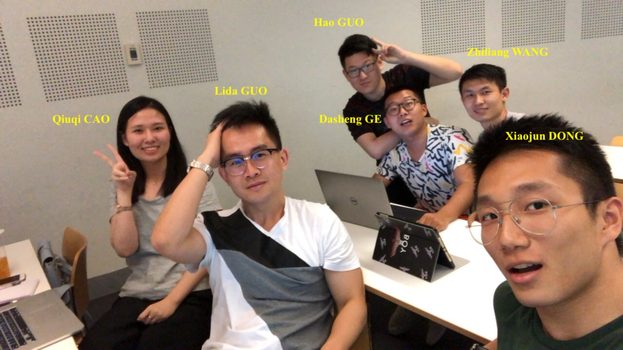**2.1 Group photo**

**2.2 Group Capability Analysis**

|  |
| --- |
|  |
|  |

|  |  |  |  |  |  |  |
| --- | --- | --- | --- | --- | --- | --- |
| Name | Zhiliang Wang | Hao Guo | Lida Guo | Dasheng Ge | Qiuqi Cao | Xiaojun Dong |
| i. Skills | Love challenges in my life;  Love talking with others; | Familiar with Java and C programming language;  Familiar with CV field ；  Visualization of big dataset; | Be familiar with Java and C programming language;  Be good at several multimedia software;  Be good at some electric engineering operation software for robotic operation; | Limited knowledge about machine learning and deep learning; | Programming skill; and processing data, data analysis; | Programming: Skilled at JAVA, C++, C#, familiar with linux;  Good at either working with others, or working independently; |
| ii. Experience | Real estate planner in Shenzhen, China;  My first master degree is about Building Material; | Worked for ERS department in Deloitte,Beijing;  Junior programmer in the project held by government | Studied in Electric Engineering and Automation of the Shanghai University;  Worked for Wind Power Department in the General Electric Co., Ltd.;  Joint the internship in Shanghai Showing Cloud Software Company Co., Ltd; | My bachelor degree is civil engineering, I did some work  experience as a structure designer and construction crew. Moreover, I have some knowledge about real-estate industry in China. | Completed my bachelor degree at The Beijing University of Chemical Technology. | Completed Bachelor of Computer Science in USYD;  Participated as a developer in a mobile application project (listed in Google Play Store) managed by the biology faculty of USYD; |
| iii. Career ambitions | I just want to find happiness during my daily work; | Be a project supervisor in one of the Fortune 500. | Understand the company’s operation progress;  To be the CEO of one company;  Create my own company; | For the future, I want to apply what I learned into solving real issues. Moreover, I want to be a data analyst in a big company. | After I graduate from the University of Sydney, I plan to find a job in China and work as a product manager in an IT company like Tencent. | Establish my own IT startups with my friends;  Work for one of the best IT companies such as Google, Apple;  Interested in integrating and applying IT technology into medical area; |
| iv. Strengths | Tough, brave, and versatile for everything; | Enough interest and enthusiastic in IT field;  Open to change ;  Enjoy solving tough questions;  Strong social skills ;  open to Suggestions | Keep interest and enthusiastic in each beginning work;  Cooperate with team leader and finish work in time; | Have a good pressure resistance and keep positive when encounter problem | Passion for studying and life; Good at problem solving. 3.Hardworking. | I have good programming and data analyze skills;  Often challenge myself by thinking or doing things in different ways;  Good at researching and utilizing resources; |
| v. Areas with room for improvement | Coding skills in developing new program and applications;  Learn how to serve customers;  Learn how to be a humorous man; | Poor writing skill;  Hard to express myself clearly;  Impatience with argument;  lack of leadership;  Novel idea | The knowledge of hard technology which can support me in some management jobs; learn to communicate with teammates efficient and effect; | Creativity: I am used to do the same thing in the same way. I think I need try something new and make something new.  Doing things carefully: be patient, try do avoid some mistakes even small defects. | When I am working at home it is hard for me to focus on my job, sometimes I will distract from focus.  Procrastination. Sometimes do my assignment near the deadline. | Lack of leadership;  Lack of management knowledge;  Sometimes I’m so impatient, a good temper can make me a better person; |

**3. Group summary**

According to the table of our group capability analysis, the top four strengths of our group are honesty, persistence, good listener and responsible. As a group, the most important thing is that each member keeps to be honest; with good persistency, each of us is able to handle tough and unfamiliar tasks; to be a good listener can help us understand each other’s ideas so that our group is able to be more productive; good responsibility can guarantee that each of us can take care of the allocated tasks, and always provide quality work. Some areas that our group is not so good at are critical thinking and creativity, we should be aware of these two aspects and make changes during this semester. The rest strengths of our group for example open-minded and optimistic are on a average level because some of our members are good at that certain area while the rest are not. By helping and collaborating with each other, our group can be even more productive. For the areas to improve, it is obvious that each of us need to be more tolerant. We also need to carefully manage our group tasks as some of us are good at certain areas such as writing.