|  |
| --- |
| Enterprise Tracking Application |
| Software Requirements Specification |
| Prepared For: Perspecta  Location: Austin, TX |
| Date: 9/7/2020  Revised: 9/17/2020 |
| Angeleen Abesamis  Remnin Ferrer  James Fritz  Yeremy Joseph  Eric Leon |

# Abstract

This document serves as the software requirements specification for the Enterprise Tracking Application that is being developed by the University of Texas at Dallas project team for Perspecta Inc. We will use this document to define what the application will do.

Table of Contents

Abstract 2

List of Figures 4

List of Tables 4

1. Introduction 5

1.1 SRS Introduction 5

1.2 SRS Purpose 5

1.3 SRS Scope 5

1.4 SRS Structure 5

2. Use Case Model for Functional Requirements 6

2.1 Graphical User Interface Use Case Models 6

2.2 Authentication Layer Use Case Models 6

2.3 Web Services Use Case Models 6

2.4 Persistence Layer Use Case Models 6

3. Use Case Model Rationale 8

4. Non-Functional Requirements 9

4.1 Usability 9

4.2 Performance 9

4.3 Portability 9

4.4 Security 9

5. Evidence of Configuration Management 10

6. References 11

# List of Figures

|  |  |  |
| --- | --- | --- |
| Figure | Description | Page |
| 2-1 | Use case 1. |  |
| 2-2 | Login page wireframe. |  |
| 2-3 | Use case 2. |  |
| 2-4 | Use case 2. |  |
| 2-5 | Use case 2. |  |
| 2-6 | Use case 2. |  |
| 2-7 | Home page wireframe. |  |
|  |  |  |

# List of Tables

|  |  |  |
| --- | --- | --- |
| Table | Description | Page |
| 2-1 | Use case 1. |  |
| 2-2 | Use case 2. |  |
| 2-3 | Use case 3. |  |
| 2-4 | Use case 4. |  |
| 2-5 | Use case 5. |  |
| 2-6 | UI Functional Requirements. |  |
|  |  |  |
|  |  |  |

# 1. Introduction

### 1.1 SRS Introduction

The introduction of the SRS should provide an overview of the entire SRS. It should contain the following subsections:

a) Definitions, acronyms, and abbreviations;

b) References;

c) Overview.

### 1.2 SRS Purpose

The purpose of the Software Requirements Specification is to provide a detailed overview of the Enterprise Tracking Application software product, its parameters and goals as per the requirements set by Perspecta Inc. This document describes the project's user interface, hardware and software requirements. It defines how Perspecta, and the team see the product and its functionality. In summary, the SRS will help the design and development throughout the software delivery lifecycle (SDLC) processes.

### 1.3 SRS Scope

This subsection should

a) Identify the software product(s) to be produced by name (e.g., Host DBMS, Report Generator, etc.);

b) Explain what the software product(s) will, and, if necessary, will not do;

c) Describe the application of the software being specified, including relevant benefits, objectives, and goals;

d) Be consistent with similar statements in higher-level specifications (e.g., the system requirements specification), if they exist.

### 1.4 SRS Structure

The SRS is structured as follows:

* Section 1, Introduction. The introduction of the Software Requirements Specification provides an overview of the entire document. It includes the introduction, purpose, scope, and structure of the document.
* Section 2, Use Case Model for Functional Requirements. This section is broken into the major components of the project. It contains the use cases for the project that will be used to identify the project functionality and the resulting functional requirements. The use cases outline the basic flow of the project functions.
* Section 3, Use Case Model Rationale. This section briefly describes the reasoning behind the structure of our use cases.
* Section 4, Non-Functional Requirements. This section contains the non-functional requirements that we will reference when choosing the architecture for the project.

# 2. Use Case Model for Functional Requirements

### 2.1 Graphical User Interface Use Case Models

Requirements table lookup acronym: UI

#### 2.1.1 Login UI

##### 2.1.1.1 Login UI Feature Introduction

The user login interface to verify access via permissions.

|  |  |
| --- | --- |
| Figure 2-1. Use case 1. | |
| Use Case ID: | UC1 |
| Use Case Name: | User Login/Logout |
| Actors: | User |
| Entry Condition(s): | User navigates to the web address of the application. |
| Basic Flow: | 1. The user enters their login id into the Login id text field. 2. The user enters their password into the Password field. 3. The user clicks the Ok button to submit their credentials for authentication and permissions. |
| Exit Condition(s): | The user provides credentials which have the appropriate permissions to access the home page for the web application. |
| Exceptions: | The user does not provide valid login credentials. The page will indicate that the login credentials are invalid. |
| Special Requirements: | The user credentials must exist in the database. |

Table 2-1. Use case 1.

##### 2.1.1.2 Wireframe

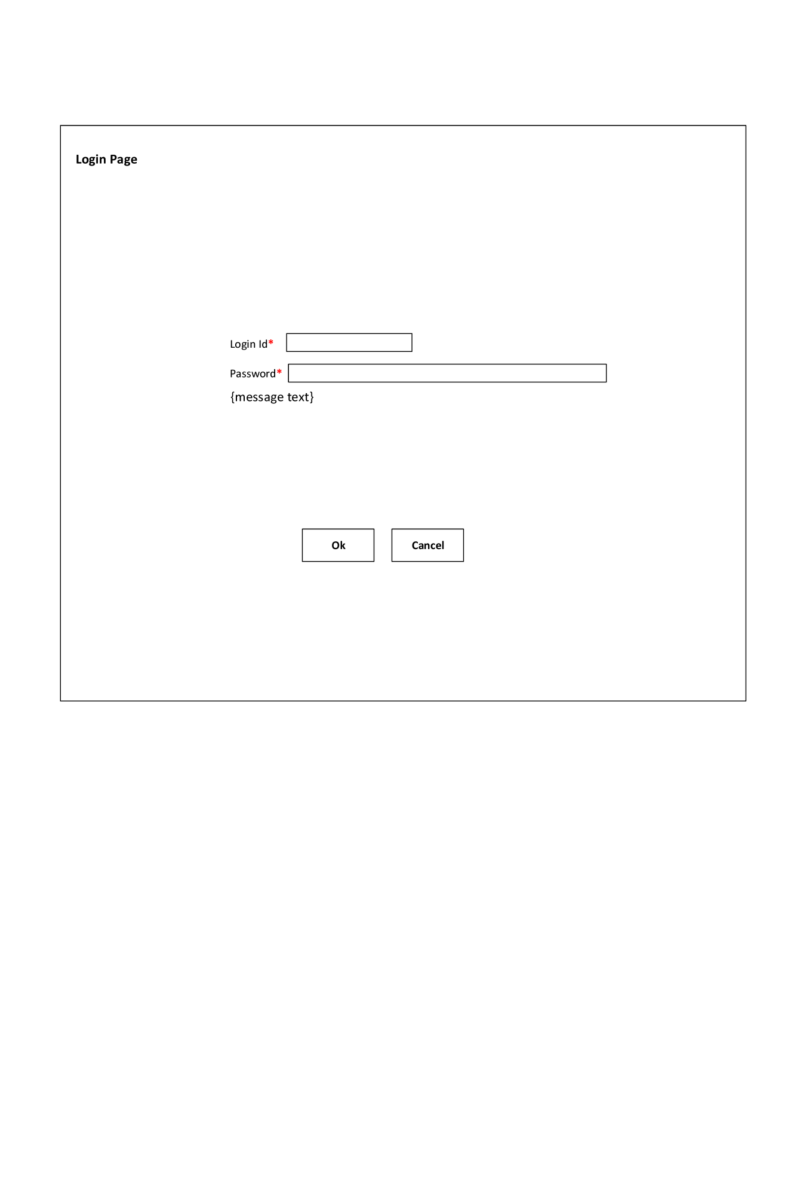

Figure 2-2. Login page wireframe.

##### 2.1.1.3 Associated Functional Requirements

**UI-FR-1**

The login user interface shall provide a text input field for the user to enter an email address as their login id.

**UI-FR-2**

The login user interface shall provide a text input field for the user to enter their password.

**UI-FR-3**

The login user interface shall provide a generic textual feedback message which will be used to notifying the user if their login attempt has failed. The message shall not provide specific information about the precise cause of the login attempt failure.

**UI-FR-4**

The login user interface shall provide a button that will allow the user to transmit their credentials for authentication.

**UI-FR-5**

The login user interface shall provide a button that will allow the user to cancel their login attempt and clear the fields.

#### 2.1.2 Home Page UI

##### 2.1.2.1 Home Page UI Feature Introduction

The home page the user will use to create, retrieve, update, and delete enterprise application integration records.

|  |  |
| --- | --- |
| Figure 2-3. Use case 2. | |
| Use Case ID: | UC2 |
| Use Case Name: | View integration records |
| Actors: | User |
| Entry Condition(s): | The user has logged in and has permission to view the records. |
| Basic Flow: | 1. The user expands either Source Applications or Destination Applications in the left side menu area. 2. The application displays the relevant information from the database within the main content area of the home page. |
| Exit Condition(s): | The user selects a different option from the left side menu or leaves the application. |
| Exceptions: | The user does not have sufficient permissions or there is no relevant information in the database. |
| Special Requirements: | The user must be logged in with valid credentials. |

Table 2-2. Use case 2.

|  |  |
| --- | --- |
| Figure 2-4. Use case 3. | |
| Use Case ID: | UC3 |
| Use Case Name: | Add integration record |
| Actors: | User |
| Entry Condition(s): | The user has logged in and has permission to add a new integration record. |
| Basic Flow: | 1. The user expands either Source Applications or Destination Applications in the left side menu area. 2. The user selects the Add option from the submenu in the left side menu area. 3. The application displays a small page where the user may enter the relevant information for the integration (TBD). 4. The user selects the Submit button to add the integration. 5. The application displays a window with a message confirming the new integration record was added. 6. The user clicks the Ok button to close the confirmation window. |
| Exit Condition(s): | The user has completed the addition process or they have canceled prior to the record being added. |
| Exceptions: | The user does not have sufficient permissions or the record exists in the database. |
| Special Requirements: | The user must be logged in with valid credentials. |

Table 2-3. Use case 3.

|  |  |
| --- | --- |
| Figure 2-5. Use case 4. | |
| Use Case ID: | UC4 |
| Use Case Name: | Edit integration record |
| Actors: | User |
| Entry Condition(s): | 1. The user has logged in and has permission to view and edit an integration record. 2. The user has displayed the existing records in the main content area. |
| Basic Flow: | 1. The user selects the area within the record they wish to edit. 2. The application allows the user to edit the record in place. 3. The user makes their edit and presses Enter to submit the change. 4. The application makes the update seamlessly. |
| Exit Condition(s): | The user has completed or cancelled the edit by pressing the Enter key or the Esc key respectively. |
| Exceptions: | The user does not have sufficient permissions. |
| Special Requirements: | The user must be logged in with valid credentials. |

Table 2-4. Use case 4.

|  |  |
| --- | --- |
| Figure 2-6. Use case 5. | |
| Use Case ID: | UC5 |
| Use Case Name: | Delete integration record |
| Actors: | User |
| Entry Condition(s): | 1. The user has logged in and has permission to view and delete an integration record. 2. The user has displayed the existing records in the main content area. |
| Basic Flow: | 1. The user selects the Delete icon within the record they wish to delete. 2. The application prompts the user to confirm they want to delete the record. 3. The user selects Ok to confirm the deletion. 4. The application deletes the record and updates the table in the application. |
| Exit Condition(s): | The user has completed or cancelled the deletion by pressing the Ok button or the Cancel button respectively. |
| Exceptions: | The user does not have sufficient permissions. |
| Special Requirements: | The user must be logged in with valid credentials. |

Table 2-5. Use case 5.

##### 2.1.2.2 Wireframe

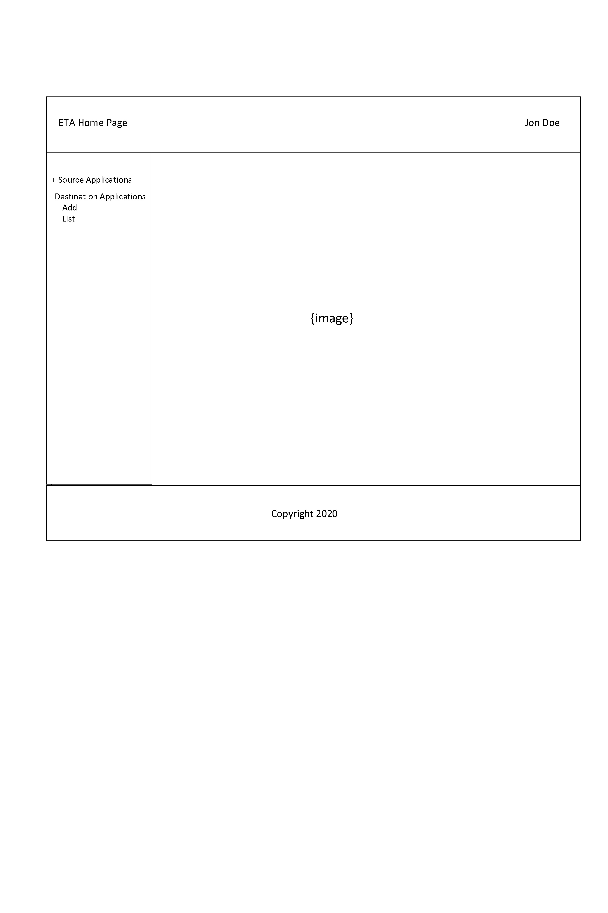

Figure 2-7. Home page wireframe.

##### 2.1.1.3 Associated Functional Requirements

**UI-FR-6**

The home page user interface shall include a header area depicting the application title and the user name.

**UI-FR-7**

The home page user interface shall include a footer area depicting the appropriate copyright information.

**UI-FR-8**

The home page user interface shall include a menu area on the left side of the main body.

**UI-FR-9**

The home page user interface left side menu shall include two expandable options, one for source applications and one for destination applications. Each of these expandable options shall have permission-based options allowing the user to add new enterprise application integrations or to list all of the current enterprise application integrations.

**UI-FR-10**

The home page user interface shall include a main content area on the right side of the main body. The main content area shall feature a default image which will be replaced by the formatted table containing the enterprise application integration records.

**UI-FR-11**

The home page user interface main content area records shall allow the user to edit any particular record in place.

**UI-FR-12**

The home page user interface main content area records shall allow the user to delete a record from within the table of results.

|  |  |  |  |  |
| --- | --- | --- | --- | --- |
| Req. ID | Type | Priority | Description | Owner |
| UI-FR-1 | Functional | Essential | Login email | JF, EL |
| UI-FR-2 | Functional | Essential | Login password | JF, EL |
| UI-FR-3 | Functional | Essential | Generic login failure message | JF, EL |
| UI-FR-4 | Functional | Essential | Login submit button | JF, EL |
| UI-FR-5 | Functional | Essential | Login cancel button | JF, EL |
| UI-FR-6 | Functional | Essential | Home page header area | JF, EL |
| UI-FR-7 | Functional | Essential | Home page footer area | JF, EL |
| UI-FR-8 | Functional | Essential | Home page menu area | JF, EL |
| UI-FR-9 | Functional | Essential | Home page menu functionality | JF, EL |
| UI-FR-10 | Functional | Essential | Home page main area | JF, EL |
| UI-FR-11 | Functional | Essential | Home page record edit | JF, EL |
| UI-FR-12 | Functional | Essential | Home page record delete | JF, EL |

Table 2-6. UI Functional Requirements.

### 2.2 Authentication Layer Use Case Models

Authentication Layer (OAuth2)

Login

Logout

Generic error message

Buttons

### 2.3 Web Services Use Case Models

Web Services Layer (Java, REST)

|  |  |
| --- | --- |
| Figure x-x. Use case x. | |
| Use Case ID: | UCX |
| Use Case Name: | Search Records |
| Actors: |  |
| Entry Condition(s): |  |
| Basic Flow: |  |
| Exit Condition(s): |  |
| Exceptions: |  |
| Special Requirements: |  |

|  |  |
| --- | --- |
| Figure x-x. Use case x. | |
| Use Case ID: | UCX |
| Use Case Name: | View Records |
| Actors: |  |
| Entry Condition(s): |  |
| Basic Flow: |  |
| Exit Condition(s): |  |
| Exceptions: |  |
| Special Requirements: |  |

|  |  |
| --- | --- |
| Figure x-x. Use case x. | |
| Use Case ID: | UCX |
| Use Case Name: | View Records (Limited) |
| Actors: |  |
| Entry Condition(s): |  |
| Basic Flow: |  |
| Exit Condition(s): |  |
| Exceptions: |  |
| Special Requirements: |  |

Search Records

View Records

Limited view records (permissions)

Add record (permissions)

Edit record (permissions)

Delete record (permissions)

### 2.4 Persistence Layer Use Case Models

Persistence Layer (MSSQL) (4)

CRUD

|  |  |
| --- | --- |
| IMG | |
| Use Case ID: | UC1 |
| Use Case Name: |  |
| Actors: |  |
| Entry Condition(s): |  |
| Basic Flow: |  |
| Exit Condition(s): |  |
| Exceptions: |  |
| Special Requirements: |  |

# 3. Use Case Model Rationale

TBD

# 4. Non-Functional Requirements

### 4.1 Usability

The site shall function as a single-page application per the client’s request. The integration data will be displayed using a sortable, table style grid.

### 4.2 Performance

The site shall respond to user input within a reasonable amount of time.

### 4.3 Portability

The application shall function in modern web browsers.

### 4.4 Security

The system shall encrypt and store user credentials in an authentication database per the client’s request.

# 5. Evidence of Configuration Management

# 6. References

END OF DOCUMENT