Table of Contents

AI Accelerator Landscape & Strategic Analysis 2026
Date: February 2, 2026
Subject: The Physics of Dominance & The Strategic Rationale for Market Consolidation

Chapter 1: The Status Quo

The Illusion of Dominance
At first glance, the AI hardware market in early 2026 appears to be a undisputed monarchy. NVIDIA’s H100 and B200 series accelerators seemingly crush all opposition in terms of Performance-per-Watt, which is the primary metric for Data Center TCO (Total Cost of Ownership).
The Status Quo: * NVIDIA: Occupies the “high ground” with vastly superior efficiency (>2.5 TFLOPS/W). * Competitors: Deterministic architectures like Groq and RISC-V grids like Tenstorrent appear to lag significantly, struggling to break the 1.0 TFLOPS/W barrier in standard precision.
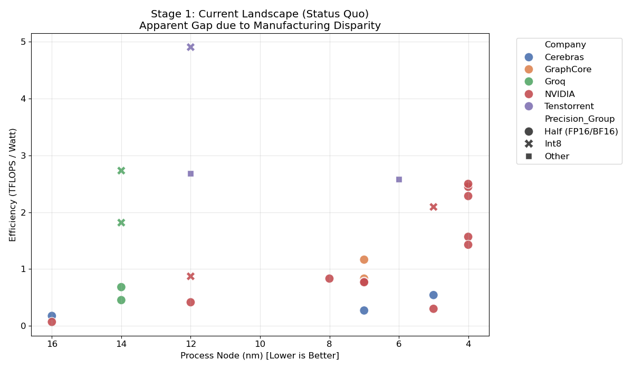 Figure 1: The Apparent Landscape. Competitors (blue/orange) are clustered in the low-efficiency zone, while NVIDIA (green) dominates the high-efficiency frontier.
To the average observer (or investor), this validates NVIDIA’s superior architecture. However, this conclusion is critically flawed because it ignores the denominator: Physics.

Chapter 2: The Physics of Critical Size

The Immutable Law of Scale
When we peel back the layer of “Product Marketing” and look at “Semiconductor Physics,” a different pattern emerges. By tracing NVIDIA’s own lineage from Pascal (16nm) to Blackwell (4nm), we find that their brilliance lies in consistently harvesting the benefits of Moore’s Law.
Our regression analysis reveals a strict power law governing AI efficiency:
$$\text{Efficiency}∝{\text{ProcessNode}}^{−2.05}$$
This means that for every 50% reduction in transistor feature size, power efficiency improves by roughly 400%.
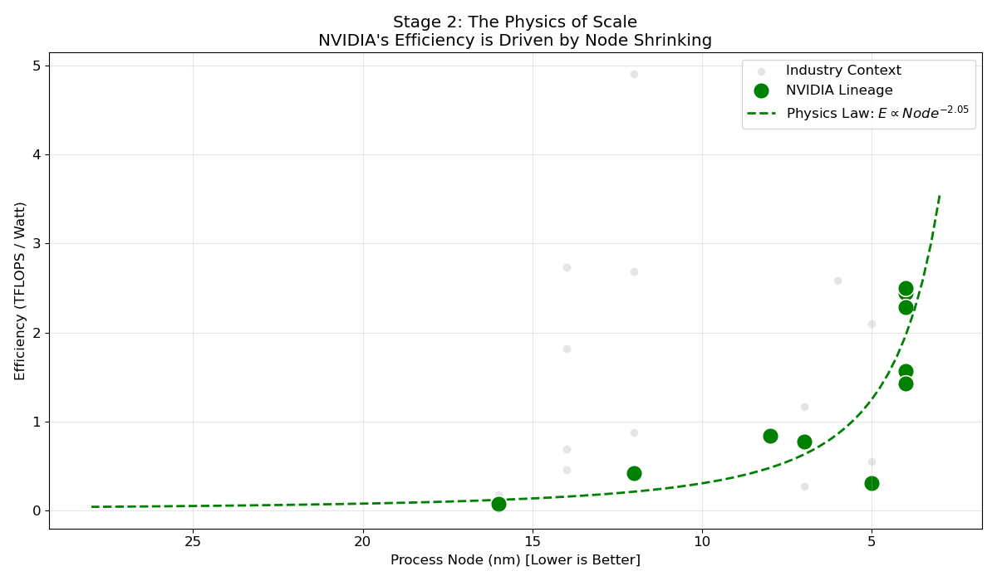 Figure 2: The Physics Law. NVIDIA’s trajectory (green dashed line) follows an inverse-square law relative to process node size. Their “dominance” is mathematically correlated with their access to TSMC’s 4nm/5nm nodes.
The implication is profound: The “Efficiency Gap” seen in Chapter 1 is not primarily Architectural; it is Manufacturing. Competitors have been fighting a 4nm enemy with 14nm weapons.

Chapter 3: The “What If” Simulation

Unmasking the Architecture
What happens if we level the playing field? Using our derived physics constant ($−2.05$), we simulated what competitor architectures would achieve if they had access to the same 4nm foundry capacity as NVIDIA.
The Counterfactual Results: 1. Groq (Tensor Streaming Processor): * Currently trapped at 14nm (~0.7 TFLOPS/W). * Simulated at 4nm: Explodes to ~8.9 TFLOPS/W. * Impact: This is 3.5x more efficient than the NVIDIA H100.
- Tenstorrent (RISC-V Grid):
  - Currently at 12nm (~2.7 TFLOPS/W in low precision).
  - Simulated at 4nm: Reaches ~25.4 TFLOPS/W.
  - Impact: An order of magnitude improvement for Edge/Inference workloads.
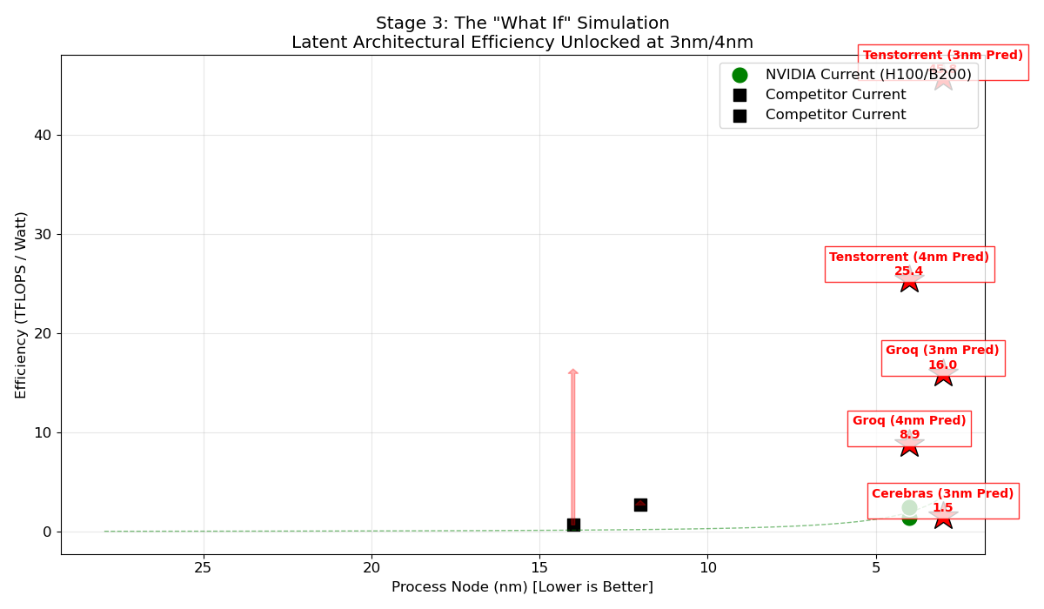 Figure 3: The Simulation. Red stars indicate the ‘Latent Potential’ of competitor architectures when normalized to 4nm. Groq (Red Star, top) leapfrogs NVIDIA’s current champion.
This reveals the terrifying truth for the incumbent: Groq’s architecture was fundamentally superior. It was only held back by a supply chain disadvantage (GlobalFoundries 14nm vs TSMC 4nm).

Chapter 4: Strategic Verdict

The Endgame: Acquisition of Groq (Jan 2026)
In January 2026, NVIDIA acquired Groq. This report provides the definitive quantitative rationale for that move.
Why it happened: NVIDIA did not buy Groq for its current revenue or market share. They bought it to prevent the Simulation from becoming Reality. * If Groq had secured 3nm capacity independently, they would have offered an inference solution with 6x lower power costs than Blackwell. * By acquiring the company, NVIDIA absorbs the threat and integrates the “Deterministic LPU” technology into its own CUDA ecosystem to solve the utilization wall.
The Survivor: Tenstorrent With Groq absorbed, Tenstorrent remains the primary alternative. Its open RISC-V nature protects it from acquisition, and its low-precision efficiency makes it the dominant player for the “Edge AI” market where NVIDIA’s high-power GPUs cannot fit.
Final Conclusion: The battle for AI hardware is defined by the Process Node. Architecture determines the slope of the curve, but the Foundry determines the position on the curve. NVIDIA’s consolidation strategy is to ensure it owns both the steepest slope and the furthest position.

