- Space Maze 2014:
  - Copyright 2104 TR Studios
- Table of Contents
- Section I: Project Overview
  - Personnel (with contact info)
    - Damian O’Leary doleary@gmu.edu
      - Production Lead, lead designer, programming assistant
    - Fritz Reese freese@gmu.edu
      - Lead programmer
    - Andrew Schilthelm aschilt2@gmu.edu
      - Lead Artist, programming assistant
    - Wes Chappell wchappel@gmu.edu
      - Level designer, Quality Assurance
  - Executive Summary
    - High Concept: This is a maze traversal game involving space exploration and combat.
    - The Hook: The fun and challenging nature of the game as well as the repeatability.
    - Setting: The game is set in various planet surfaces in space
    - Genre and Scope (number of missions): A puzzle solving exploration game. There are two missions currently.
    - Visual Style (2D, 3D Isometric, etc): The whole game is in 2D
    - Engine (and editor?): Phaser 2.0.3
  - Core Gameplay (What does the player do?)
    - Single-player: The player leads his ship through various mazes using the mouse (which the ship follows). He must defend himself from enemy ships using the mouse-click to fire the primary laser.
  - Game Feature
    - Gameplay innovations: Ray casting was used to make the mazes more challenging and mysterious. Upgrades to the ship allow the player to personalize his experience with the game.
    - Artistic techniques: 8 bit graphics creation via pixel painting.
    - Features that make this game unique: Most maze games are boring to play again once completed. Space Maze 2014 has replay value due to the difficult gameplay and the various upgrades.
  - Project Scope
    - Number of levels/missions: 2 levels
    - Number of NPCs: The number varies depending on level. Level one only has 5 enemies.
    - Number of weapons: There is one base weapon the player uses with the opportunity to upgrade the rate of fire.
    - Number of vehicles: There are two types of vehicles, the player ship and the enemy ships.
  - Target Audience: Space Maze is for the casual gamer, it’s easy to pick up and understand how to play.
  - Delivery Platforms: PC and mobile devices.
- Section II: Story, Setting, and Character
  - Story
    - There is no defined story for the game, play and have fun!
  - Environments
    - Area #1
      - General description: A desert planet devoid of life.
      - Physical characteristics: The ground is rough sand and boulders block the way to the exit.
      - Level One takes place this area.
    - Area #2
      - This is an ice planet
      - The planet surface is solid slow and sheets of ice form walls which comprise the maze.
  - Characters
    - Player Character(s)
      - Weapon set: Basic laser gun.
    - Bad Guys
      - White ships with the same basic laser gun as the player
- Section III: Combat
  - Weapons
    - Laser Gun
      - Basic fire rate of one bullet every fifth of a second
      - Can be upgraded to have faster rates of fire.
  - Powerups
    - Light Beam upgrade
      - Can increase the angle for a greater field of vision
    - Fire Rate upgrade:
      - Increases the fire rate of the players gun
- Section IV: Controls
  - PC Keyboard/Mouse Commands
    - Default keys for movement controls
      - Ship movement: player ship follows the mouse cursor or the finger if on mobile.
    - Default keys for using weapons
      - Clicking the mouse fires the weapon, or tapping your finger on a touch screen
- Section V: Interface
  - The Camera
    - Standard view: Top down view of the maze, camera follows the player.
  - Menus
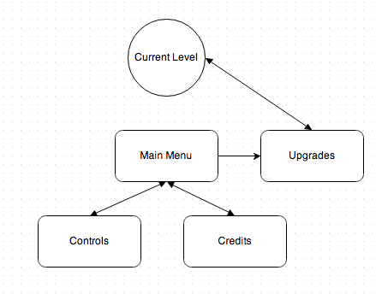
    - Main Menu
      - Continue
        - Loads the level that the current session has progressed to.
      - New Game
        - Loads and begins the first level of the game
      - Upgrades
        - Redirects you to the upgrades menu state
      - Controls
        - Displays the button controls for playing the game.
      - Credits
        - Displays the credits (names of the developers)
    - Upgrades
      - The store where the player can purchase in game upgrades for their ship.
- Section VI: Artificial Intelligence
  - NPC #1: Enemy ship
    - Statistics
      - Field of view:
        - Enemy ship can detect the player from 100 pixels away
      - Weapons:
        - Same basic gun as the player, can kill in one shot
    - Internal states & the triggers that change them
      - Enemies will roam in a random pattern. If they collide with a wall they will turn away at a random angle and resume roaming.
    - Movement
      - Moves at a constant velocity in random, linear trajectories.
    - Combat decisions
      - When the player comes within 100 pixels the enemy ship will turn and fire a laser at it.
- Section VII: Detailed Level/Mission Descriptions
  - Level #1
    - Synopsis
    - Introductory material (Cutscene? Mission briefing?)
    - Mission objectives (player goals)
    - Physical description
    - Map
    - Enemy types encountered in-level
    - Weapons/powerups available
    - Level walkthrough, including scripted sequences and non-interactive scenes. This should also include any puzzles the player must solve, as well as the solutions to those puzzles
    - Closing material (Cutscene? Debriefing? Statistics menu?)
  - Level #2
- Section IX: Scoring, Cheats, Easter Eggs, & Bonuses
  - Score (parts)
    - Score is increased for every enemy ship that the player kills. The player’s score is then decreased by the amount of time it took to complete the maze.
    - The score is displayed to the player at the end of each level and also at the bottom of the Upgrades menu screen.
- Section X: Game Modes
  - Single-player
- Section XI: Asset List
  - Art
    - Model & Texture List
      - Characters
    - Animation list
      - Characters
        - Player Ship
        - Enemy Ship

      - Weapons
        - Main Gun
      - Explosion
        - 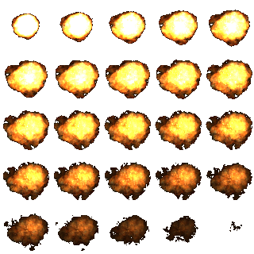
    - Interface Art List
      - Buttons (example below)
        - 
  - Sound
    - Weapon Sounds
      - Weapon #1
        - Audio engineered firing noise, resembles a “pew” sound.
  - Music
    - Ambient
      - Main menu music from “The Last of Us”
- Section XVI: References
The explosion spritesheet:
http://thundernoodle.net/notblog/2011/10/17/how-to-animate-a-sprite-using-a-sprite-sheet-in-xna/

LevelOne spritesheet:
http://rpgconspiracy.files.wordpress.com/2011/06/steampunkish-tilee.png

LevelTwo spritesheet:
http://s63.photobucket.com/user/busbuzz/media/TileD-2.png.html

Sound:
The Quarantine Zone (20 Years Later)

