Patterns of Myth, Over-promise and Hype in New Technologies: A case of Generative AI amongst Higher Education students.
Abstract
Technological innovation, such as Generative Artificial Intelligence (genAI), is often promoted with hyperbole and exaggeration. Misleading beliefs about its capabilities arise and are hard to decouple from the actual utility it can bring. This pattern paper aims to identify key traits of unrealistic beliefs, so students in Higher Education can make more informed decisions on how to approach technological innovations, such as genAI.

Introduction
“I think in many ways GPT-5 is already smarter than me and many other people,” says Sam Altman when interviewed by Die Welt [1]. Anthromorphisation, mystification and hype currently have surrounded Artificial Intelligence since the late 1950s [2]. AI is not alone in being communicated in a “hyped” fashion, that can involve “exaggerations about the significance or certainty of research findings [3]. This has been the case for a lot of topics such as but not limited to: neuroimaging, stem cell research, nanotechnology, genomics, and artifical intelligence.
Over the last few years there has been a great wave of AI applications, or more accurately software applications bundled with generative AI (GenAI) amongst other forms of AI. GenAI uses a variety of models to generate text, images, music and even video. Online platforms like ChatGPT, but also Copilot which is now embedded in the whole Microsoft Office suite, and even plain Google Search which always comes with a generated answer on top of the page. Signified with “AI” or ✨ it is usually a form of a Large Language Model that interprets requests and gives human-like answers.
The permeation of AI in our tools and systems is coupled with this belief that if we do not participate, we might miss the boat and will not be able to keep up with the renewed productivity our AI-using colleagues and competitors will enjoy.
But what we are seeing is not new. Firstly we have seen this before with the exact same term in different guises since the 1950s: AI [2]. What we are seeing is a repetition of technology industry overpromising new techniques or technologies and packaging them as a panacea for all kinds of problems or General Purpose Tools, while also decreasing emphasis on a large variety of negative consequences that this technology also brings. For example the profound physical impact these new technologies are having on our environment [4], the security issues of models with jailbreak attempts [7]. Technologies are not neutral by nature, and do not automatically point toward “progress”.
This paper puts forward a pattern that helps recognizing language and rhetoric surrounding technological innovations to deflate the hype for students in Higher Education Institutes (HEIs).

Related work
Surrounding “hype” a lot of research has already been done concerning studying hype [8], or in its problems and defining it as something other than scientific misconduct [3], also concerning the role of emotional and/or logical expectations [9] and comparing different hypes and their life cycles [10].
Myth and technology have a long history together. Collectively we adhere to the idea that with technology and change we also converge to a better reality, to progress. [11] states that believing in this myth is a religious act itself.
We project ideas of what a future society can look like with these new technologies which can be called sociotechnic imaginaries [12].
This paper seeks to find a pattern to recognize the process where mythical belief surrounding technological innovation creates myth and polarizes criticism into categories of Luddism and technophilia, while societal pressure to participate increases.

Methodology
This research will involve two types of qualitative analysis of language (and rhetoric) used in GenAI discourse and news articles as well as language used by HEI students.

Thematic analysis
Thematic analysis will be used as [13] and [14] describe it to find common themes and topics in personal interview with students. Thematic analysis is a more subjective approach to data, where language is central. It requires a coding process that uses semantic and latent codes to categorize statements and find themes and subthemes of meaning in texts.

Critical Discourse Analysis
Through critical discourse analyis (CDA) I will look at what kind of language is constructing narratives, describes relations of power and how it creates or reinforces myths [15].
CDA tries to find patterns in power dynamics and social effects in discourse. In this analysis we can take the texts further and analyze context and intertextuality to challenge social inequalities. I will focus mainly on step two: Identify obstacles to addressing the social wrong of this process which consists of three stages [16]:
- Analyse dialectical relations
- Select texts
- Analyse texts interdiscursively and linguistically

Problem
The problem with new technologies is the “hype” created around it that leads to false beliefs or “creeds”, which are hard to decouple from what the technologies actually bring to the table.

Solution
By discovering themes and power relations in language we can describe a recurring phenomenon in different technological transformations.

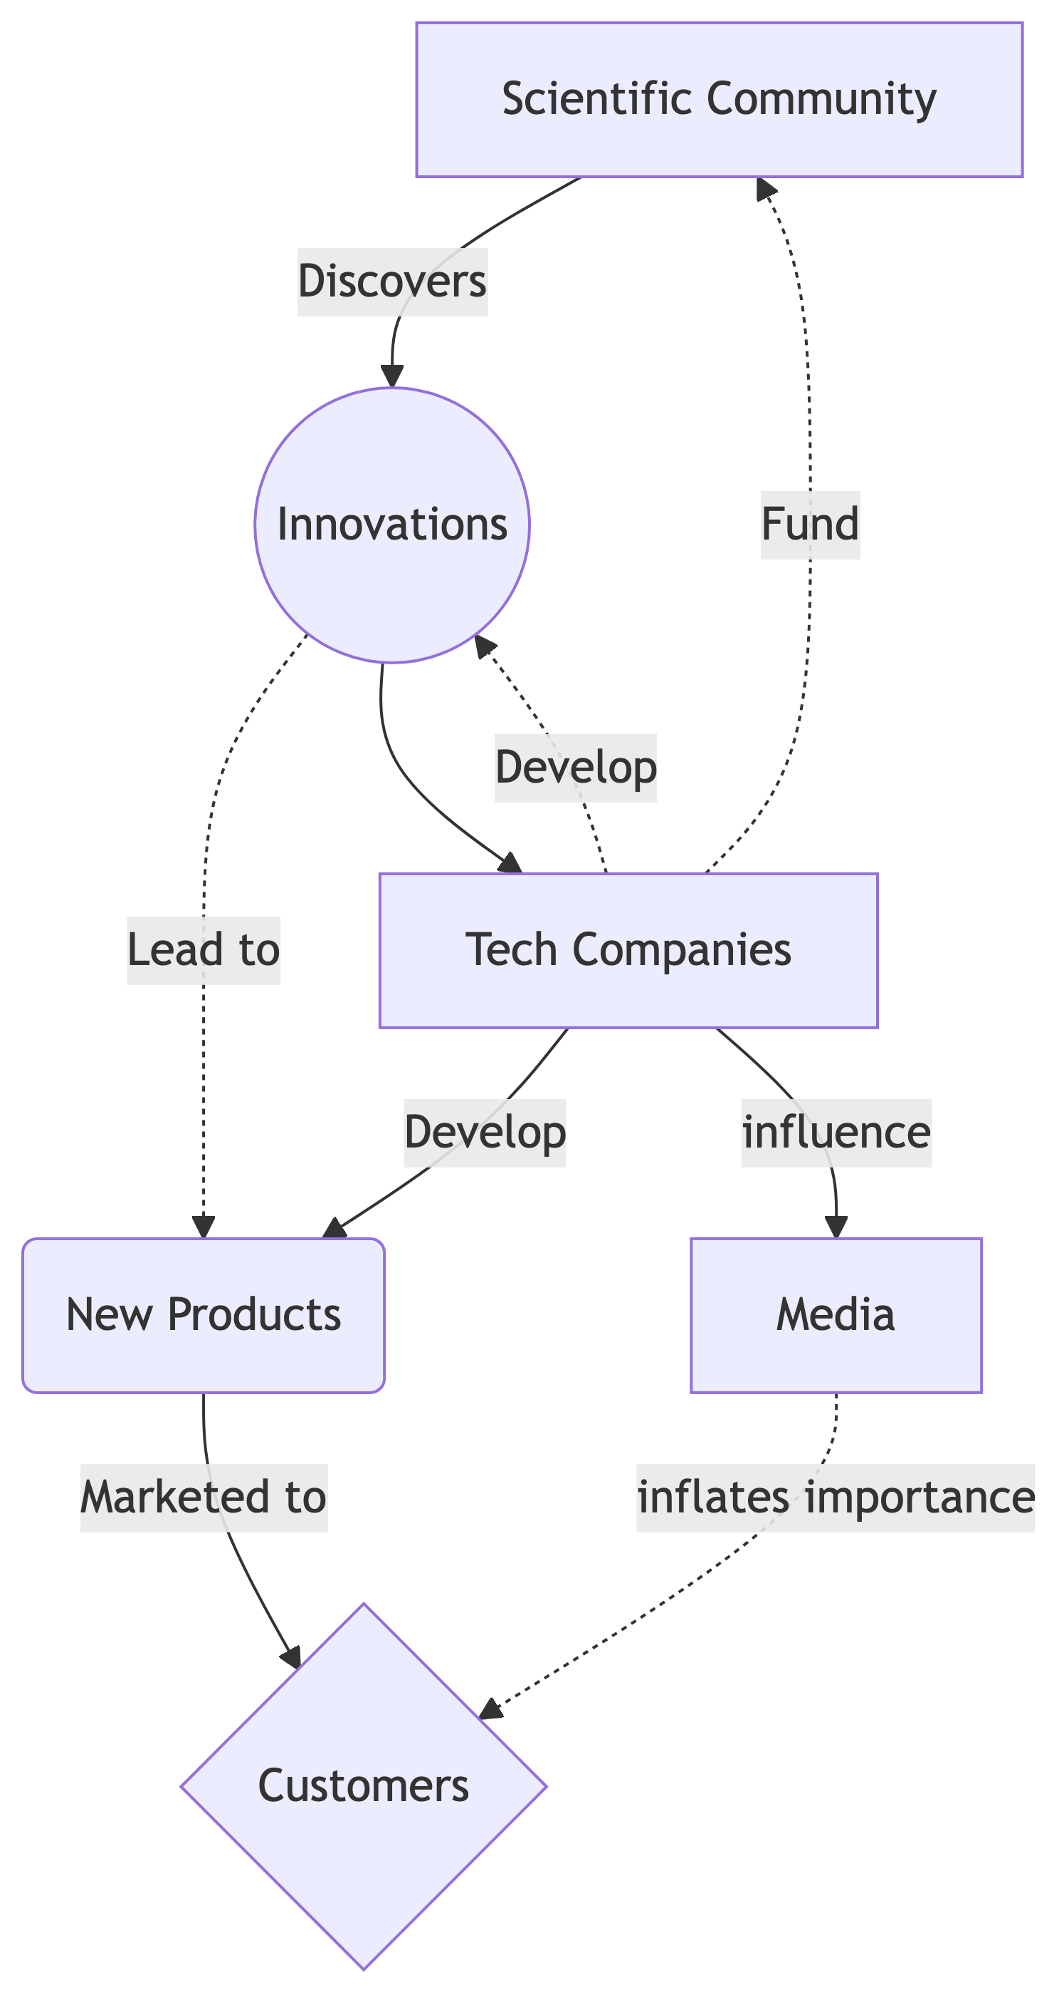

_{Source: Article Notebook}

Consequences
Being able to recognize language as hyperbolic or mythical empowers students to discern truth from propaganda.

Forces

Solutions over needs
Instead of looking at our needs we are often distracted by technology and try to find a way to fit in our workflow [17].

Pace of change and fear of missing out
Technological innovations happen quickly and people fall prey to innovation anxiety [18]. When anxious it is harder to discern truth from fiction.

Advertisement from companies
Industry leaders have a very real interest in hyping their own tool, model, progress or company as they have financial interests in attrracting more users and perhaps ruling out competition. Terms like inevitability of the technology combined with solutionism approaches to a wide-scala of problems are good examples of “myth”-smells [19].

References
1. Burgard, J.P.: OpenAI-Chef Sam Altman: ,,Ich glaube nicht, dass die KI Menschen wie Ameisen behandeln wird“ - WELT, (2025).
2. Guest, O., Suarez, M., Müller, B., van Meerkerk, E., Oude Groote Beverborg, A., de Haan, R., Reyes Elizondo, A., Blokpoel, M., Scharfenberg, N., Kleinherenbrink, A., Camerino, I., Woensdregt, M., Monett, D., Brown, J., Avraamidou, L., Alenda-Demoutiez, J., Hermans, F., van Rooij, I.: Against the Uncritical Adoption of ’AI’ Technologies in Academia, (2025). https://doi.org/10.5281/ZENODO.17065099.
3. Intemann, K.: Understanding the Problem of “Hype”: Exaggeration, Values, and Trust in Science. Canadian Journal of Philosophy. 52, 279–294 (2022). https://doi.org/10.1017/can.2020.45.
4. Crawford, K.: The atlas of AI: Power, politics, and the planetary costs of artificial intelligence. Yale University Press (2021).
5. Perez, F., Ribeiro, I.: Ignore Previous Prompt: Attack Techniques For Language Models, https://arxiv.org/abs/2211.09527, (2022). https://doi.org/10.48550/arXiv.2211.09527.
6. Li, H., Guo, D., Fan, W., Xu, M., Huang, J., Meng, F., Song, Y.: Multi-step Jailbreaking Privacy Attacks on ChatGPT, https://arxiv.org/abs/2304.05197, (2023). https://doi.org/10.48550/arXiv.2304.05197.
7. Carlini, N., Tramer, F., Wallace, E., Jagielski, M., Herbert-Voss, A., Lee, K., Roberts, A., Brown, T., Song, D., Erlingsson, U., Oprea, A., Raffel, C.: Extracting Training Data from Large Language Models, https://arxiv.org/abs/2012.07805, (2021). https://doi.org/10.48550/arXiv.2012.07805.
8. Dedehayir, O., Steinert, M.: The hype cycle model: A review and future directions. Technological Forecasting and Social Change. 108, 28–41 (2016). https://doi.org/10.1016/j.techfore.2016.04.005.
9. Shi, Y., Herniman, J.: The role of expectation in innovation evolution: Exploring hype cycles. Technovation. 119, 102459 (2023). https://doi.org/10.1016/j.technovation.2022.102459.
10. van Lente, H., Spitters, C., Peine, A.: Comparing technological hype cycles: Towards a theory. Technological Forecasting and Social Change. 80, 1615–1628 (2013). https://doi.org/10.1016/j.techfore.2012.12.004.
11. Burdett, M.S.: The religion of technology: Transhumanism and the myth of progress. Religion and Transhumanism: The Unknown Future of Human Enhancement. 131 (2014).
12. Jasanoff, S., Kim, S.-H.: Containing the Atom: Sociotechnical Imaginaries and Nuclear Power in the United States and South Korea. Minerva. 47, 119–146 (2009). https://doi.org/10.1007/s11024-009-9124-4.
13. Naeem, M., Ozuem, W., Howell, K., Ranfagni, S.: A Step-by-Step Process of Thematic Analysis to Develop a Conceptual Model in Qualitative Research. International Journal of Qualitative Methods. 22, 16094069231205789 (2023). https://doi.org/10.1177/16094069231205789.
14. Braun, V., Clarke, V.: Thematic analysis: A practical guide to understanding and doing. Thousand Oaks. (2021).
15. Blommaert, J., Bulcaen, C.: Critical Discourse Analysis. Annual Review of Anthropology. 29, 447–466 (2000).
16. Fairclough, N.: Critical discourse analysis: The critical study of language. Routledge (2013).
17. Ervin, G.L.: Can Technology Fulfill Its Promise? IALLT Journal of Language Learning Technologies. 26, 7–16 (1993). https://doi.org/10.17161/iallt.v26i2.9498.
18. Okereke, C.: Innovation Anxiety: The New Age Stressor Chibs Okereke Stress & Burnout Coach.
19. Zheng, K., Huber, L., Stark, A., Kim, N., Lameiro, F., Santo, W.L., Chowdhary, S., Kim, E., Zhang, J.: Resisting AI solutionism through workplace collective action. arXiv preprint arXiv:2508.08313. (2025).

