Achieved human agency or loss of choice in Agentic AI for students

Introduction
Young people around the globe are growing up in a different digital reality than their parents, where Artificial Intelligence (AI) is playing a big part. Regardless of whether the term of “AI natives” bares truth, there is a new group of students that spend almost 7 hours and 30 minutes online per day (Kemp 2025), on platforms where AI is embedded, e.g. in search algorithms, AI answers, or chat functions often signified with “AI” or ✨. However, this does not mean that these students have an innate skill or that they can see “behind the curtain” of these technologies just as we expected them to in the debunked “digital natives” narrative of the 2000s (Selwyn 2009).
Over the last decade the question whether Artificial Intelligence (AI) itself exhibits agency has been debated (Legaspi, He, and Toyoizumi 2019; Swanepoel 2021). This distinction between human and technological agency becomes more blurred with the emerging paradigm of Agentic AI (AAI), which is different to previous forms of AI such as Generative AI (GenAI), which we encounter in platforms lik ChatGPT, Claude or Co-pilot (Naik, Naik, and Naik 2024), because AAI can operate (semi-)autonomously and pursue complex goals with little human intervention (Acharya, Kuppan, and Divya 2025). Both GenAI and AAI largely depend on recent developments in Large Language Models (LLMs). With AAI multiple instances of these GenAI-bots run in the background interfacing each other creating seemingly autonomous and agentic systems, as a evolutionary next step from the GenAI chat-platforms widely in use among students (Silvennoinen, Aksovaara, and Alanko-Turunen 2025; Dai 2025).
This questions the notion of human agency (Anderson and Rainie 2023), as systems now also seem to (1) act with (2) intention and a certain kind of (3) reasoning, three aspects often associated with agency (Anscombe 1956; Davidson 1978). The chordal triad of Emirbayer and Mische (1998) suggests placing agency within not just a structure (Giddens 1984) but in what Mead (1932) calls the temporal dimension of sociality, using past, present and imagined futures as 3 dimensions on which agency is performed: iterational, practical-evaluative and prospective. Most of these theories are individual and describe the action of an agency up to a certain point: that of acting itself and the effect it causes. Biesta and Tedder (2007) engages with the chordal triad of agency by focussing on the notion of agency achieved in an “ecological understanding” of agency (Biesta and Tedder, n.d.); it is here that the effect of action becomes realized and experienced.
The iterational aspect is exposed in structure and collective beliefs expressed in instruments such as policies, or punitive action or attitudes of individuals. Beliefs about “inevitability of technology” and the cult of innovation (Winner 2018) pervade, while at the same time mistrust and weariness keeps AI out of universities (Guest et al. 2025).
Students navigate these punitive faculties, policies and teacher narratives as ecology in which they need to realize goals. Their agency changing from situation to situation. Are they seeing their volitions realized as achieved agency?

Knowledge Gap
Most literature focusing on AI is not (yet) mentioning agentic AI, but using GenAI, which is closely related as precursor to Agentic AI paradigm that also utilizes LLMs. So a number of the studies mentioned below are chosen from that context.
In the course of history, human development has been argued to increase where agency and freedom increase (Prados de la Escosura 2022; Sen 1999). Agency is however a bloated term that can mean a number of things in different domains, such as psychology where it focuses on individual human agency (Bandura 2001) or sociology where it focuses on the structures in which an actor operates (Giddens 1984). Agency is a term closely related to and with overlaps to terms such as autonomy and freedom. To be clear in this context, “agency” means for an actor to be free to act true to that same actor’s intentions, considering their circumstance (structure),their beliefs (iterational aspect of Emirbayer and Mische (1998)).
This in itself is impossible to measure cleanly, being dependent on so many factors. But some attempts have been made to measure how people perceive their sense of agency (Tapal, Oren, and Eitam 2017) or how Trust in Automation (TiA) influences there autonomy (Kohn et al. 2021). There are also different models that propose “measures of agency” (Grünbaum and Christensen 2020) or how concepts like autonomy and ability contribute to agency or measuring proxies for agency (Alkire 2008).
Agentic AI and AI goals in general, largely seem to focus on increasing abilities for models or replacing tedious tasks performed by humans. While research has been done about future projections of human agency in conjunction with AI in decision making (Pew Research Center, Anderson, and Rainie 2023) and in education (Mouta, Pinto-Llorente, and Torrecilla-Sánchez 2025) it does not deal with how to increase human agency for humans now. Or what the effect is of Agentic AI on agency or Sense of Agency (SoA).
The way Agentic AI or GenAI is influencing agency in students seems not to have been studied, apart from the influence it has on critical thinking (Suriano et al. 2025), and why and how they use it for studying (Dai 2025; Silvennoinen, Aksovaara, and Alanko-Turunen 2025; Suonpää, Heikkilä, and Dimkar 2024). The Human AI - Interaction framework suggested by Sundar (2020) incorporates agency, but mostly highlights interesting avenues to pursue rather than diving into topics such as: human and AI collaboration, the seeming either/or thinking of machine vs human agency; agency is seen as a “mediating variable” in the machine/human interaction (Sundar 2020).
One area of study related to increasing human agency surrounding AI is AI Literacies. Learning about AI systems explains how they perform, this demystifies and increases people’s insight in these systems (Pinski and Benlian 2024) which helps to reduce anthropomorphism (Druga and Ko 2021). Anthropomorphism is one of the things that can lead to false perceptions and misunderstanding of AI abilities(Barrow 2024). AI Literacies among students has not been studied in relation to neither human agency, their sense of agency, nor other similar approaches such as a capabilities approach.
In goal attainment and AI assisted coaching, there is a real opportunity for an AI to participate in the process this then is suggested to increase agency (Plotkina and Sri Ramalu 2024). A review collecting these kinds of studies, that are influential to agency could not be found.
Then temporal aspect of agency as suggested in the above mentioned chordal triad of agency seems not have been used at all towards agentic AI or GenAI.

Contribution to scientific discourse
The threats and opportunities for the achieved agency of adoloscents are unclear in the context of Agentic AI. First of all collecting work on how AAI and GenAI are shaping agency needs to be reviewed. Secondly I want to research the iterational dimension (Emirbayer and Mische 1998, 975) by uncovering what beliefs and habits belie the day-to-day tasks that interact with AAI. Thirdly I will investigate how students enact their intentions within their temporal-relational context of action and how their achieving of agency shapes their context. This means looking into the prospective dimension of the chordal triad (Emirbayer and Mische 1998, 984), where goals or aspirations are set and then actualized through the practical-evaluative dimension.

Research Questions
In what way is agency achieved impacted for students as a result of changing circumstances with the rise of agentic AI?

Sub-questions
- How can we categorize known effects of GenAI and Agentic AI on agency systematically?
- How are prevalent beliefs disclosed in policy and teacher narratives?
- In what way is the ecology in which action is performed changing because of AAI?
- In what ways are students performing day-to-day tasks, by either conforming or subverting rules and restrictions?

Methodology
In the following section I will elaborate on how I will conduct the research described in the above mentioned research questions.
Research Questions and how they relate to methods
 | Question | Method
RQ1 | How can we categorize known effects of GenAI and Agentic AI on agency systematically? | Systematic Literature Review
RQ2 | How are prevalent beliefs disclosed in policy and teacher narratives? | Critical Discourse Analyis
RQ3 | In what way is the ecology in which action is performed changing because of AAI? | Longitudinal study
RQ4 | In what ways are students performing day-to-day tasks, by either conforming or subverting rules and restrictions? | Mixed-Method

RQ1: Systematic Literature Review
To find out what studies related to agency a systematic literature will be conducted that searches for studies that relate to agency, such as studies that focus on empowerment (Kong, Zhu, and Yang 2025). According to the systems of Grünbaum and Christensen (2020) and Alkire (2008) when studies are performed on proxies of agency, or related concepts, they can be categorized and labeled in relation to AI or more specifically to Agentic AI if those are available. Furthermore the way agency is approached is important to delineat, whether it falls under sociology, social psychology or philosophy

RQ2: Critical Discourse Analyis
Through critical discourse analyis (CDA) I will look at what kind of language is constructing narratives, describes relations of power and how it creates or reinforces myths (Blommaert and Bulcaen 2000).
CDA tries to find patterns in power dynamics and social effects in discourse. In this analysis we can take the texts further and analyze context and intertextuality to challenge social inequalities. I will focus mainly on step two: Identify obstacles to addressing the social wrong of this process which consists of three stages (Fairclough 2013):
- Analyse dialectical relations
- Select texts
- Analyse texts interdiscursively and linguistically

RQ3: Experiment
This is where an intervention like AI Literacies will take center stage to see if this can help understand Agentic AI better to find out if a better way to deal and cope with these technologies helps students to use these more properly. The survey used for RQ2 could then again be used to see if this changes anything.

RQ4: Mixed-method
Thematic analysis will be used as Naeem et al. (2023) and Braun and Clarke (2021) describe it to find common themes and topics in personal qualitative interview with students. Thematic analysis is a more subjective approach to data, where language is central. It requires a coding process that uses semantic and latent codes to categorize statements and find themes and subthemes of meaning in texts.
After the initial analysis and recognized larger themes questions will be formulated to be able to use a more quantitative approach in the form of a survey.

Theoretical Framework
As Biesta and Tedder (2007) interacts with Emirbayer and Mische (1998) we get a

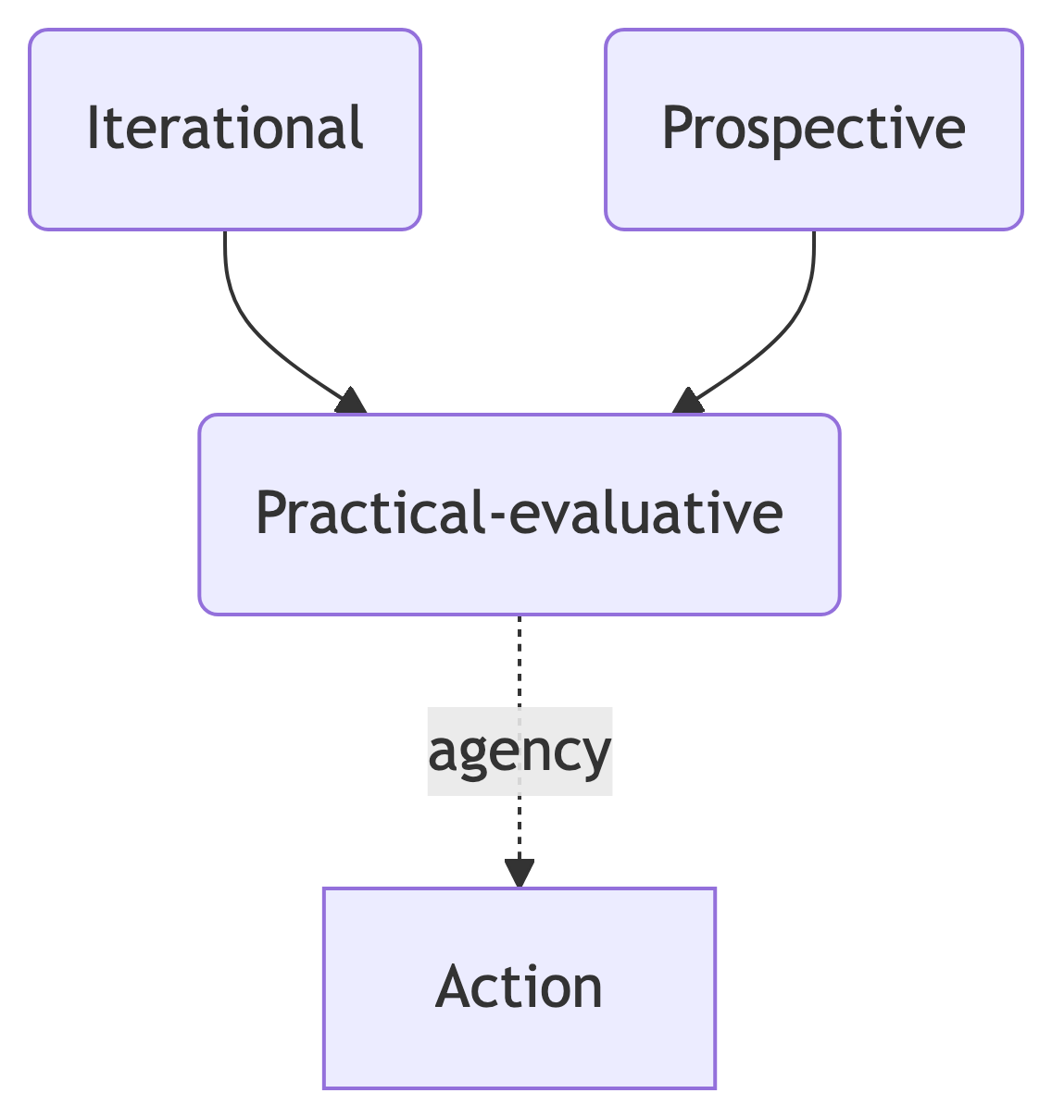

_{Source: Article Notebook}

References
Acharya, Deepak Bhaskar, Karthigeyan Kuppan, and B. Divya. 2025. “Agentic AI: Autonomous Intelligence for Complex Goals—a Comprehensive Survey.” IEEE Access : Practical Innovations, Open Solutions 13: 18912–36. https://doi.org/10.1109/ACCESS.2025.3532853.
Alkire, Sabina. 2008. “Concepts and Measures of Agency.”
Anderson, Janna, and Lee Rainie. 2023. “The Future of Human Agency.” Pew Research Center.
Anscombe, Gertrude Elizabeth Margaret. 1956. “Intention.” In Proceedings of the Aristotelian Society, 57:321–32. JSTOR.
Bandura, Albert. 2001. “Social Cognitive Theory: An Agentic Perspective.” Annual Review of Psychology 52 (1): 1–26.
Barrow, Nicholas. 2024. “Anthropomorphism and AI Hype.” AI and Ethics 4 (3): 707–11. https://doi.org/10.1007/s43681-024-00454-1.
Biesta, Gert, and Michael Tedder. 2007. “Agency and Learning in the Lifecourse: Towards an Ecological Perspective.” Studies in the Education of Adults 39 (2): 132–49. https://doi.org/10.1080/02660830.2007.11661545.
———. n.d. “How Is Agency Possible? Towards an Ecological Understanding of Agency-as-Achievement.”
Blommaert, Jan, and Chris Bulcaen. 2000. “Critical Discourse Analysis.” Annual Review of Anthropology 29: 447–66. https://www.jstor.org/stable/223428.
Braun, Virginia, and Victoria Clarke. 2021. “Thematic Analysis: A Practical Guide to Understanding and Doing.” Thousand Oaks.
Dai, Yun. 2025. “Why Students Use or Not Use Generative AI: Student Conceptions, Concerns, and Implications for Engineering Education.” Digital Engineering 4 (March): 100019. https://doi.org/10.1016/j.dte.2024.100019.
Davidson, Donald. 1978. “Intending.” In Philosophy of History and Action: Papers Presented at the First Jerusalem Philosophical Encounter December 1974, edited by Yirmiahu Yovel, 41–60. Dordrecht: Springer Netherlands. https://doi.org/10.1007/978-94-009-9365-5_5.
Druga, Stefania, and Amy J Ko. 2021. “How Do Children’s Perceptions of Machine Intelligence Change When Training and Coding Smart Programs?” In Interaction Design and Children, 49–61. Athens Greece: ACM. https://doi.org/10.1145/3459990.3460712.
Emirbayer, Mustafa, and Ann Mische. 1998. “What Is Agency?” American Journal of Sociology 103 (4): 962–1023. https://doi.org/10.1086/231294.
Fairclough, Norman. 2013. Critical Discourse Analysis: The Critical Study of Language. Routledge.
Giddens, Anthony. 1984. The Constitution of Society: Outline of the Theory of Structuration. Univ of California Press.
Grünbaum, Thor, and Mark Schram Christensen. 2020. “Measures of Agency.” Neuroscience of Consciousness 2020 (1): niaa019. https://doi.org/10.1093/nc/niaa019.
Guest, Olivia, Marcela Suarez, Barbara Müller, Edwin van Meerkerk, Arnoud Oude Groote Beverborg, Ronald de Haan, Andrea Reyes Elizondo, et al. 2025. “Against the Uncritical Adoption of ’AI’ Technologies in Academia.” Zenodo. https://doi.org/10.5281/ZENODO.17065099.
Kemp, Simon. 2025. “Digital 2025: Global Overview Report.” DataReportal – Global Digital Insights. https://datareportal.com/reports/digital-2025-global-overview-report; Data Reportal.
Kohn, Spencer C., Ewart J. de Visser, Eva Wiese, Yi-Ching Lee, and Tyler H. Shaw. 2021. “Measurement of Trust in Automation: A Narrative Review and Reference Guide.” Frontiers in Psychology 12 (October). https://doi.org/10.3389/fpsyg.2021.604977.
Kong, Siu Cheung, Jinyu Zhu, and Yin Nicole Yang. 2025. “Developing and Validating a Scale of Empowerment in Using Artificial Intelligence for Problem-Solving for Senior Secondary and University Students.” Computers and Education: Artificial Intelligence 8 (June): 100359. https://doi.org/10.1016/j.caeai.2024.100359.
Legaspi, Roberto, Zhengqi He, and Taro Toyoizumi. 2019. “Synthetic Agency: Sense of Agency in Artificial Intelligence.” Current Opinion in Behavioral Sciences, Artificial Intelligence, 29 (October): 84–90. https://doi.org/10.1016/j.cobeha.2019.04.004.
Mead, George Herbert. 1932. “The Philosophy of the Present.”
Mouta, Ana, Ana María Pinto-Llorente, and Eva María Torrecilla-Sánchez. 2025. “‘Where Is Agency Moving to?’: Exploring the Interplay Between AI Technologies in Education and Human Agency.” Digital Society 4 (2): 49. https://doi.org/10.1007/s44206-025-00203-9.
Naeem, Muhammad, Wilson Ozuem, Kerry Howell, and Silvia Ranfagni. 2023. “A Step-by-Step Process of Thematic Analysis to Develop a Conceptual Model in Qualitative Research.” International Journal of Qualitative Methods 22 (October): 16094069231205789. https://doi.org/10.1177/16094069231205789.
Naik, Ishita, Dishita Naik, and Nitin Naik. 2024. “ChatGPT Is All You Need: Untangling Its Underlying AI Models, Architecture, Training Procedure, Capabilities, Limitations And Applications.” Preprints. https://doi.org/10.36227/techrxiv.173273427.76836200/v1.
Pew Research Center, Janna Anderson, and Lee Rainie. 2023. “The Future of Human Agency,” February.
Pinski, Marc, and Alexander Benlian. 2024. “AI Literacy for Users – A Comprehensive Review and Future Research Directions of Learning Methods, Components, and Effects.” Computers in Human Behavior: Artificial Humans 2 (1): 100062. https://doi.org/10.1016/j.chbah.2024.100062.
Plotkina, Lidia, and Subramaniam Sri Ramalu. 2024. “Unearthing AI Coaching Chatbots Capabilities for Professional Coaching: A Systematic Literature Review.” Journal of Management Development 43 (6): 833–48. https://doi.org/10.1108/JMD-06-2024-0182.
Prados de la Escosura, Leandro. 2022. Human Development and the Path to Freedom: 1870 to the Present. New Approaches to Economic and Social History. Cambridge: Cambridge University Press.
Selwyn, Neil. 2009. “The Digital Native – Myth and Reality.” Aslib Proceedings 61 (4): 364–79. https://doi.org/10.1108/00012530910973776.
Sen, Amartya. 1999. Development as Freedom. Oxford University Press.
Silvennoinen, Minna, Satu Aksovaara, and Merja Alanko-Turunen. 2025. “Students’ Usage of GenAI in Universities of Applied Sciences: Experiences and Development Needs for Guidance and Support.” In 38th Bled eConference: Empowering Transformation: Shaping Digital Futures for All: Conference Proceedings, 467–82. University of Maribor Press. https://doi.org/10.18690/um.fov.4.2025.29.
Sundar, S Shyam. 2020. “Rise of Machine Agency: A Framework for Studying the Psychology of Human–AI Interaction (HAII).” Journal of Computer-Mediated Communication 25 (1): 74–88. https://doi.org/10.1093/jcmc/zmz026.
Suonpää, Maija, Jutta Heikkilä, and Ana Dimkar. 2024. “Students’ Perceptions Of Generative Ai Usage And Risks In A Finnish Higher Education Institution.” In 18th International Technology, Education and Development Conference, 3071–77. Valencia, Spain. https://doi.org/10.21125/inted.2024.0825.
Suriano, Rossella, Alessio Plebe, Alessandro Acciai, and Rosa Angela Fabio. 2025. “Student Interaction with ChatGPT Can Promote Complex Critical Thinking Skills.” Learning and Instruction 95 (February): 102011. https://doi.org/10.1016/j.learninstruc.2024.102011.
Swanepoel, Danielle. 2021. “Does Artificial Intelligence Have Agency?” In The Mind-Technology Problem, edited by Robert W. Clowes, Klaus Gärtner, and Inês Hipólito, 18:83–104. Cham: Springer International Publishing. https://doi.org/10.1007/978-3-030-72644-7_4.
Tapal, Adam, Ela Oren, and Baruch Eitam. 2017. “The Sense of Agency Scale: A Measure of Consciously Perceived Control over One’s Mind, Body, and the Immediate Environment.” Frontiers in Psychology 8 (September): 1552. https://doi.org/10.3389/fpsyg.2017.01552.
Winner, Langdon. 2018. “The Cult of Innovation: Its Myths and Rituals.” In Engineering a Better Future: Interplay Between Engineering, Social Sciences, and Innovation, edited by Eswaran Subrahmanian, Toluwalogo Odumosu, and Jeffrey Y. Tsao, 61–73. Cham: Springer International Publishing. https://doi.org/10.1007/978-3-319-91134-2_8.

