PLS stage encoder problem.
The encoder counts keep counting in certain areas because noise from the stepper is coupling into the encoder signals. Motor drive is configured for 62.5kHz and this is the noise we see. Maybe lowing the frequency will reduce the noise. Internal oscillator frequency is 32MHz
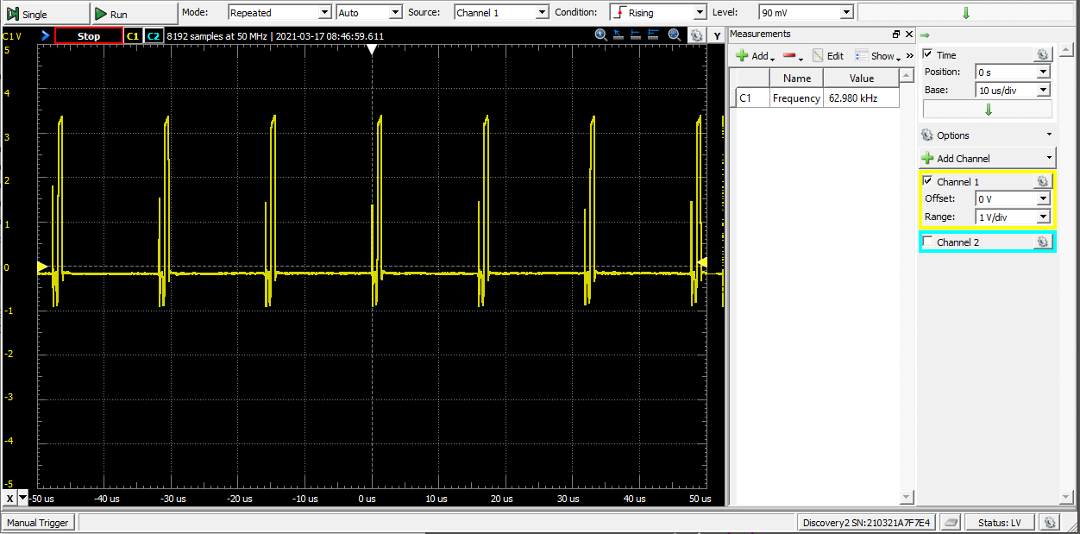
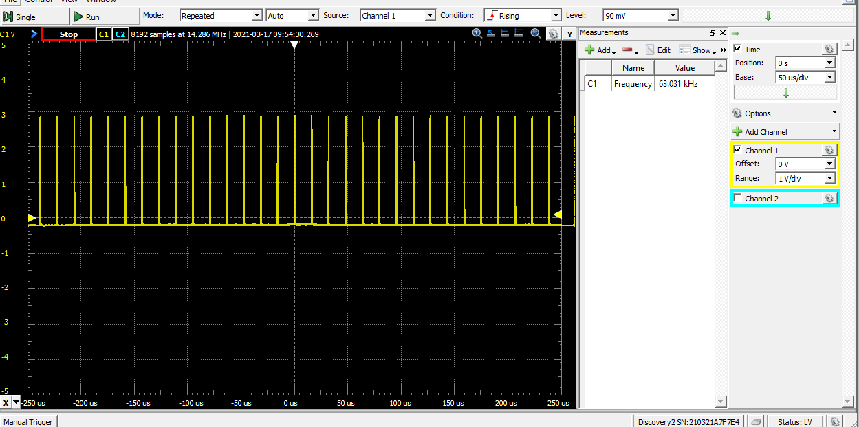
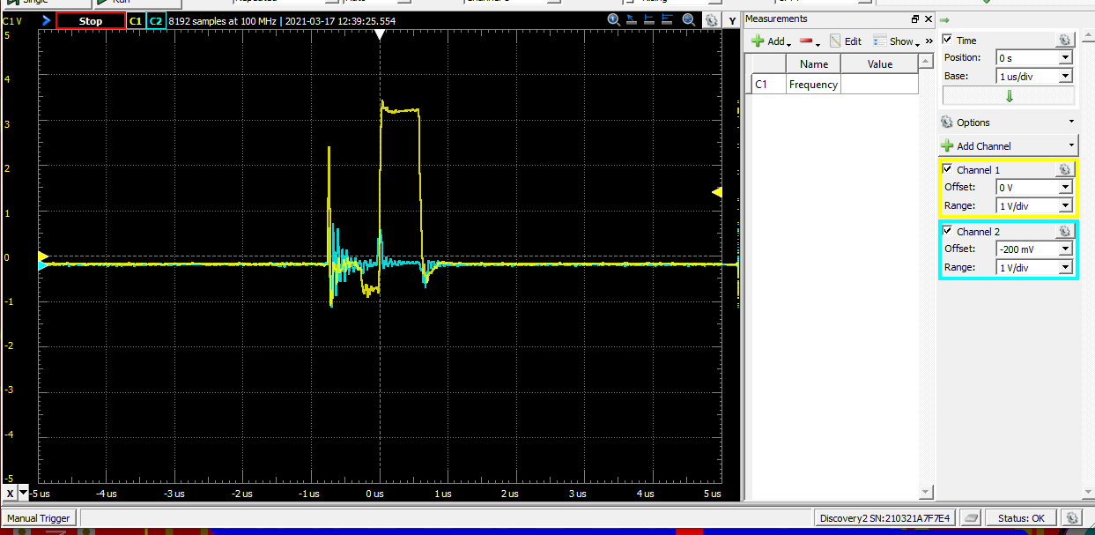
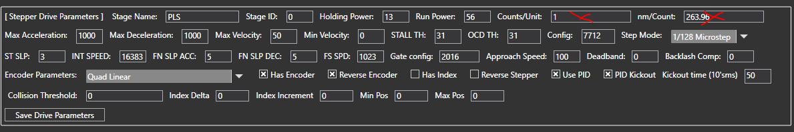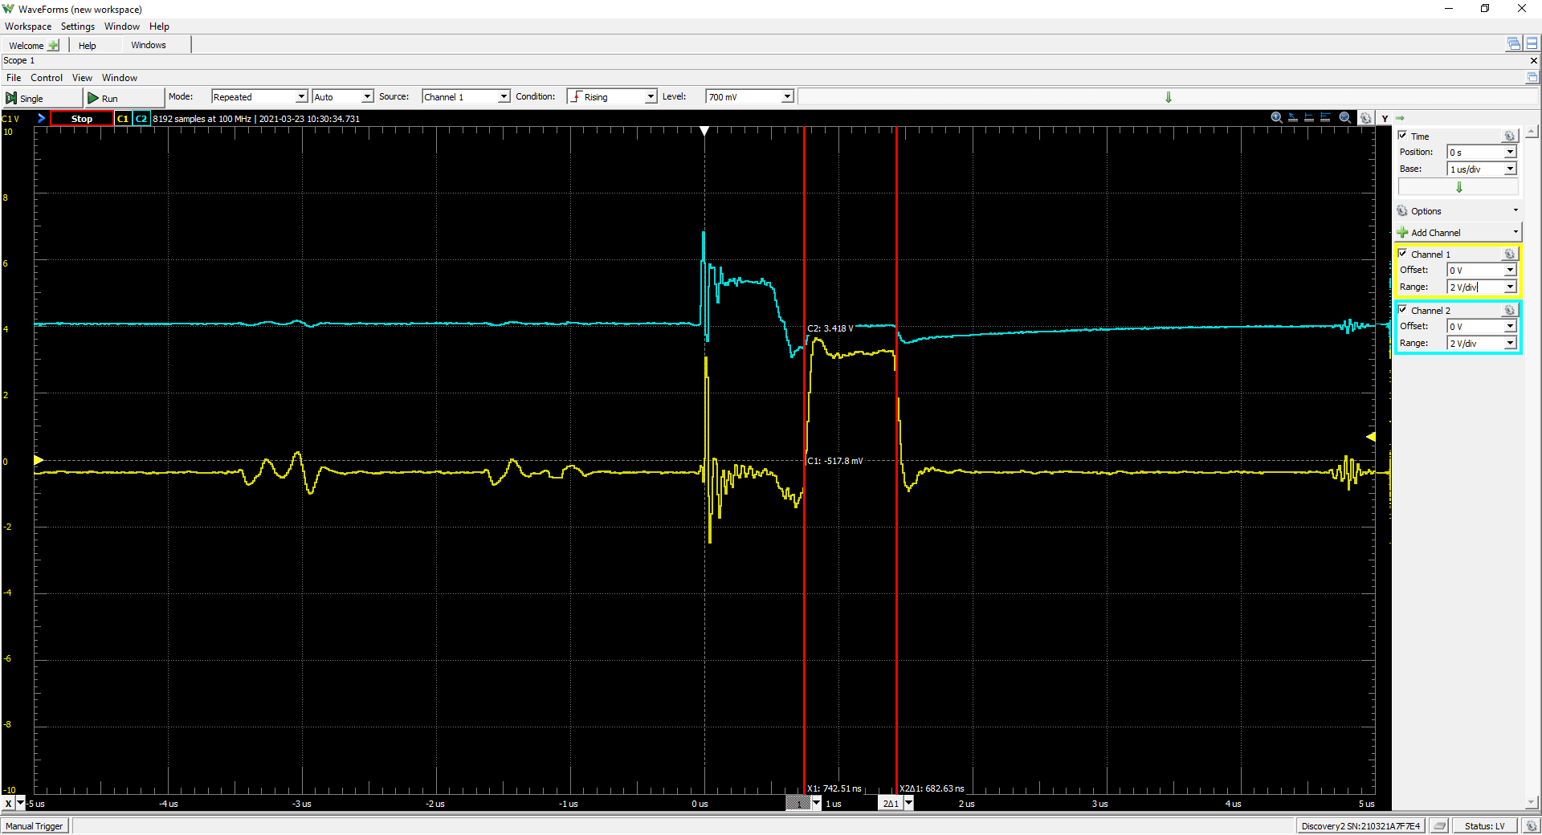
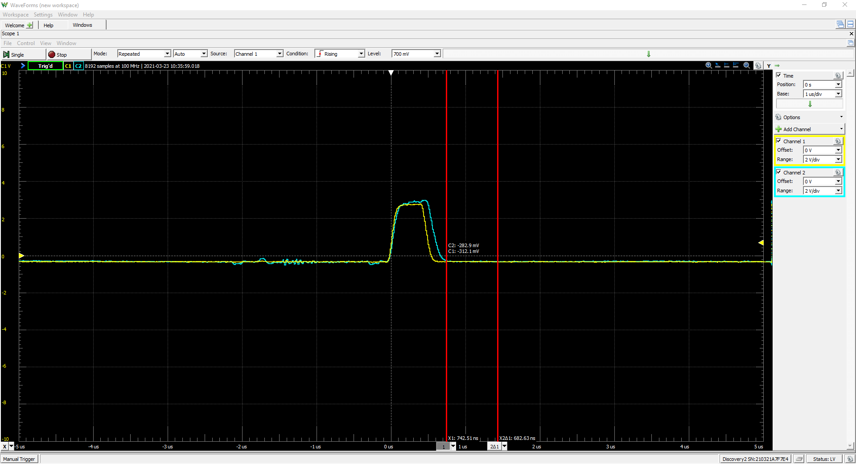
Above causes the encoder to count without stopping
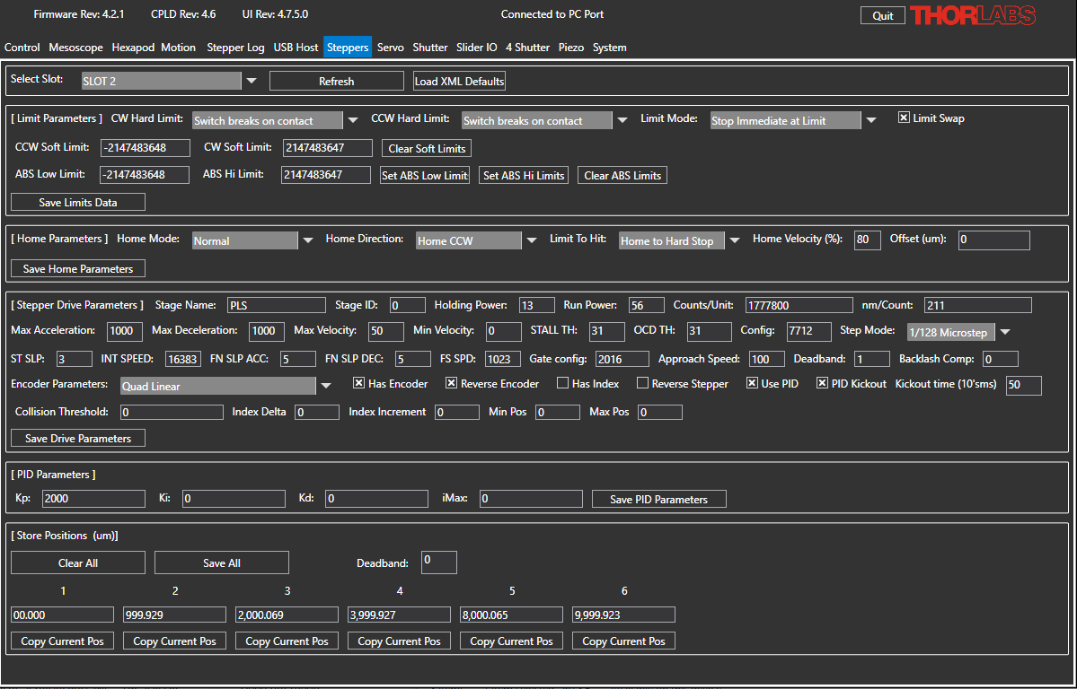

Motor:
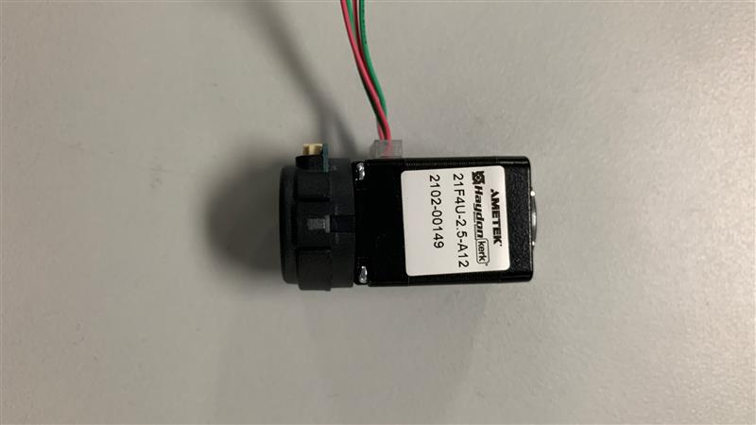
Encoder:
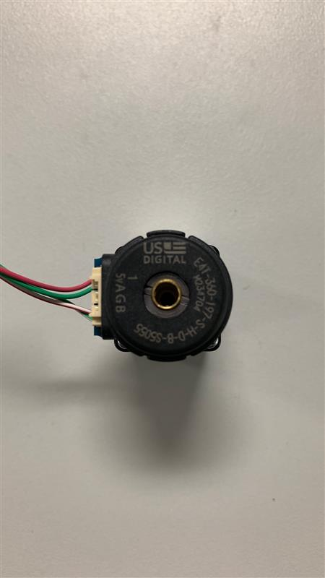

Inverted EPI:
