**Syllabus**

**Microbiology Laboratory (MCB2010L, Section 883014)**

**(Web-Enhanced Course)**

*“Nobody is born intelligent: intelligence feeds from strong effort and a desire to learn”*

*­*-Anonymous

**Term**: Fall 2015-2

**Class** **location**: Room 1663

**Class Meeting time**: Tuesday, 5:40PM – 9:00PM

**Professor**: Dr. Félix E. Rivera-Mariani

**Office**: Room 1664

**Office** **Hours**: Tuesday 3:00PM – 5:00PM or by appointment

**Email**: [friveram@mdc.edu](mailto:friveram@mdc.edu)

**Phone**: TBA

**Required Textbook (print or e-book):** Leboffe, M.J. and B. E. Pierce. 2015. Microbiology Laboratory Theory & Applications. 4th Ed. Morton Publishing Company, Inc. Englewood, CO. (ISBN 978-0-86582-830-9).

**e-book:** [**http://www.coursesmart.com/IR/7362944/9781617312502?__hdv=6.8**](http://www.coursesmart.com/IR/7362944/9781617312502?__hdv=6.8)

**Co-requisite:** Microbiology (MCB2010)

1. **Rational of the course**

To provide a hands-on learning experience of the different approaches used in the laboratory to study, enumerate, and classify microorganisms.

1. **Learning Objectives:** *By the end of this course, you should be able to:*
2. Implement correct nomenclature and writing of scientific names
3. Discriminate between the functions of the different parts of a compound microscope
4. Carry out staining protocols to study morphological properties of bacteria
5. Classify microorganisms using microscopy and staining techniques
6. Implement proper aseptic techniques to avoid and limit cross contamination
7. Carry out pure culture techniques to isolate bacteria from mixed cultures
8. Perform and interpret biochemical tests to identify bacteria
9. Design/carry out experiments to evaluate the effects of physical forces on bacterial growth
10. Design/carry out experiments to evaluate the effects of chemicals on bacterial growth
11. Carry out serial dilutions and plating techniques to enumerate bacteria
12. Carry out pipetting techniques in qualitative and quantitative experiments
13. Analyze and interpret data (i.e. series of results) gathered from lab experiments
14. Infer from immunological results to identify bacteria and determine ABO blood types
15. **Course Materials (Web-Enhanced Course)**
16. Syllabus, Professor’s credentials, Pre-Lab reading assignments, Lectures, Lab Reports, and Supplemental materials will be available at [mdc.blackboard.com](http://www.schoology.com).
17. **Required Materials (each student must have their own)**
    * Sharpie fine-tip pen
    * 10 cm ruler
    * Long sleeve Lab coat
    * Safety googles (if you use contact lenses)
    * Latex/nitrile gloves
    * Masking tape
    * Combination (no key lock) for the hall lockers
    * Download and install **Reef-PollingTM**, and bookmark <https://app.reef-education.com/#/login> into your smartphone. Instructions will be provided in class and in Blackboard Learn on how to create an account into **Reef-PollingTM**
18. **Important note about course materials**
    * ***Always*** bring your lab coat: won’t be able to allow you in lab without it
    * ***Always*** label everything with your initials, date, section, lab experiment info
    * ***Always*** have gloves available
    * ***Must*** store all belongings in the hall locker (no bags allow in lab)
    * ***Always*** have your textbook available in lab
19. **Methods of Instructions**

***Pre-Reading assignments:*** through a series of online questions to be completed in Blackboard, you will always be exposed to a new topic (e.g. terminology, protocols, interpretation of results) prior to meeting in the class. Each week, a lab section in the Lab Textbook will be assigned, and these online questions are to be completed by 5:39PM on Tuesday. These questions will also help you to **1)** read with a purpose (preparing you for class), and **2)** engage you in **spaced practice** of your learning (i.e. allowing some forgetting to settle in for learning to be effortful) because we’ll be carrying out discussions on the corresponding topics in class as well. ***These reading assignments count for a grade (see Grading Scales)****.*

***Laboratory Exercises and Experiments*** will be performed during each lab meeting, and the corresponding **lab report(s)** (available at <http://mdc.blackboard.com>) must be completed and submitted through online through Blackboard as stated in the syllabus schedule (deadlines may vary with prior notification of the professor). Results and data from a corresponding lab experiments must be collected prior to our next lab meeting. Make arrangements to collect and document the results accordingly to avoid falling behind.

***Group work*** will facilitate the discussion and peer-teaching of laboratory methods, the design and carrying out lab experiments, and interpretation of results and data obtained our laboratory exercises and experiments. You’ll find out the importance of peer-teaching in the classroom.

***Student Responses Systems*** (“clicker”), through the **Reef-PollingTM** application, will help discussion in the lab when questions, data from experiments, illustrations, and find out if were able to understand the concepts taught. Through the **Reef-PollingTM** application in your smartphone, you will be able to answer instantaneously and remotely. More importantly, this approach will allow us to discuss and exchange feedback in real-time in the lab.

***Video feedback*** will be an integral part to learn techniques in the lab. In some instances, and with the aid of your classmates, you will record yourself carrying out a technique using your smartphones. This approach will aid in interaction within the lab, and facilitate providing feedback to improve your technical skills (feedback will be provided within the actual video and by classmates).

***Monitoring your learning:*** I’ll be monitoring your learning throughout the course. With the aid of carefully designed **quizzes**, which will be **administered within the 1st 15 minutes of lab**, your responses in class, lab reports and exams, I’ll be employing mathematical (e.g. statistics) and other data analyses of your learning and proficiencies with the learning objectives of the course (see page 1). ***Don’t forget your effort****:* ***numbers*** *will tell the story about your effort as well.*

1. **Academic Integrity**

Each student is expected to maintain a high level of integrity and abide by the procedure 4035 of the Miami-Dade College Student Rights and Responsibility Handbook. Any work submitted by a student in the course for academic credit will be the student's own work. For the purpose of this course, collaboration is allowed in the following instances:in-class group work, case studies discussions, or when stated by the professor. Nevertheless, each student must submit their individual work unless stated otherwise by the instructor. Avoid at all costs copying and pasting information from your classmates’ response or from any other sources.

As part of a collaborative and encouraging classroom, you are encouraged to study together and to discuss topics and concepts covered in class with other students. You can obtain "consulting" help from students as well as provide "consulting" help to other students. However, this allowed form of cooperation should never involve one student having possession of a copy of all or part of the work done by another student or someone else, in the form digital files or hard copy documents.

In the case that copying occur, both the student who copied work from another student and the student who contributed to this behavior will both automatically receive a zero for the corresponding assignment. The penalty for violation of this Code can include failure of the course and/or notifying the corresponding University authorities for disciplinary action.

During exams (i.e. quizzes and exams), you must do your own work. Talking or discussions are not allowed during the examinations. In addition, you cannot compare papers, copy from others, or collaborate in any way. Any form of the behaviors mentioned above will result in failure of the exam and can include notifying the corresponding University authorities for disciplinary action. **Cell phones cannot leave the classroom during exams, and must be turned off during class unless needed for our in-class discussions.**

Any form of Academic Dishonesty listed in the Miami-Dade College Student Rights and Responsibility Handbook will not be accepted during in the course.

1. **Attendance**

Attendance at each class sessions parallels with your learning in the course. The Microbiology Lab course requires time and effort in order to learn and be proficient in the learning objectives stated earlier in the syllabus. In addition, **20 easy points for good attendance will provided towards your final grade**. **For each unexcused absence, unfortunately I’ll have to deduct 1 point, and 0.5 point for each unexcused tardiness.** In the event of an absence, the student will be allowed to make up work if the absence results from one of the following:

1. Official campus activities (as designated by MDC)
2. Family or personal emergencies (as designated by MDC)
3. Medical reasons (discussed with the instructor)
4. Work-related reasons (discuss with the instructor)

**-Make-up exams are allowed only** if your excuse meets any of the four requirements above.

**-**Make-up exams are **allowed only during the week of the exam** and with prior authorization.

-**Make-up for quizzes are not allowed**.

-**With three unexcused absences**, I won’t be able to keep you in the class roster.

**Laboratory Make-ups:** In case you miss a lab meeting, the student **can only make up the lab** during the week of the absence by attending another MCB2010L section. In order to be allowed to make up the lab, the student must request a written permission from the professor (Dr. Rivera-Mariani) to make-up the lab in another session. **There are no exceptions.**

**Late policy**

Unless arrangement have been made prior to the due date or have a valid absence excuse (as stated in the Attendance section of this syllabus), I won’t be able to award full grade on Lab Reports and any other assignment submitted late **(the final grade for any late assignment will be 30% less)**.

1. **Accommodations for students with disabilities**

In compliance with the Miami-Dade College and the Student Rights and Responsibility Handbook policy and equal access laws, I more than available to discuss any necessary academic accommodations that may be required for the student with disabilities. Requests for academic accommodations are to be made during the first week of the term, except for unusual circumstances, so arrangements can be made. Students are encouraged to contact the Student Services to verify their eligibility for appropriate accommodations.

1. **Inclusivity Statement**

Members (student, faculty, administrators) of the Miami-Dade College community represent a diversity of backgrounds and perspectives. In this course, and as a member of this community, I am a strong supporter of diversity and its benefits. Therefore, to maintain an adequate learning and diverse environment students in this course are strongly encouraged to:

1. share their unique beliefs, experiences, and values
2. be open to the opinions and views of others
3. honor your colleagues’ uniqueness
4. appreciate the unique opportunity we have to learn from each other
5. value each other’s opinions and communicate in a respectful manner
6. keep confidential discussions of personal and professional nature
7. take advantage of this opportunity to share ways in an inclusive environment
8. must maintain at all times a respectful environment
9. **Grading Scales:**

|  |  |
| --- | --- |
| **Item** | **Points** |
| Lab Report | 100 |
| Attendance | 20 |
| Pre-Lab Reading Assignments | 30 |
| Lab Skill Evaluations | 100 |
| Midterm Exam/Practicum | 100 |
| Final Exam/Practicum | 100 |
| **Total points** | **450** |

|  |  |  |
| --- | --- | --- |
| **Grade** | **Percentage** | **Points** |
| A | 100 – 87.0% | 392 |
| B | 86.9 – 77.0% | 347 |
| C | 76.9 – 67.0% | 302 |
| D | 66.9 – 55.0% | 248 |
| F | Below 55.0% | Below 248 |

|  |  |
| --- | --- |
| *Weekly Quizzes = bonus points* |  |

**Lab Reports (10 points each):** For each lab experiment, there is a lab report that must be completed and turned in. Deadlines for each lab report will be listed on the syllabus schedule as well as on the Blackboard Learn website <http://mdc.blackboard.com>) of the course. In some instances, the deadline may vary and the professor will inform you of any changes.

* To be able to grade and provide timely and meaningful feedback on our Lab Reports, they must…
  + be downloaded from Blackboard Learn.
  + completed only in Microsoft WordTM.
  + uploaded into their corresponding link in Blackboard Learn.
  + answered in complete sentences.
* Don’t forget that **binomial scientific** names (e.g. *Escherichia coli, E. coli*)…
  + must be ***italicized***when word processed (i.e. typed).
  + must be **underlined** when handwritten.
  + have the 1st letter of the genus (i.e. *Escherichia coli, or E. coli*) in uppercase.
* **Cross mistakes only once**, initialize, and write the correction during handwritten assignments
* Won’t be able to award full credit in lab reports if:
* a binominal name is incorrectly written (will have to deduct **1 point)**
* an answer is written in incomplete sentence (will have to deduct **0.5 point)**
* a question is left unanswered (will have to deduct **0.5 point)**
* a question is answered incorrectly (will have to deduct **0.5 point**)
* a mistake was not corrected accordingly (will have to deduct **0.5 point)**

**Pre-Lab Reading Assignments (30 total points):** With the Pre-Lab Reading assignments and guide questions, you will begin to settle new knowledge with each topic. These Pre-lab Reading Assignments will be available in Blackboard Learn (<http://mdc.blackboard.com>): their deadline will always be just before class time (5:49PM) unless otherwise stated. Keep in mind that these guide questions won’t be available when class time begins. Therefore, due the corresponding reading and complete the Pre-Lab reading way in advanced. Similar to points for attendance, these questions will be 30 easy points towards your final grade. Nevertheless, won’t be able to maintain your total 30 points when…

* less than 7 out of 10 questions are answered incorrectly: will have to deduct 0.5 points.
* none of the questions is answered: will have to deduct 0.5 points.

**Exams:** Two 100 points exams (Midterm and Final) will be administrated during regular laboratory periods. Refer to the syllabus schedule to know the dates of the exams. Each of the exams will be multiple choice questions. No scantrons are needed: questions will be answered on the printed exam provided. Won’t be able to allow calculators.

At the next lab sessions, the students will receive a Scorecard of the exam and copy of the exam: **exams must be returned to the professor and cannot be photographed**. Academic Dishonesty regulations, as stated in the MDC student handbook, will have to be strictly enforced. Any violations will lead to a zero on the exam.

**There are no make-ups for Exams unless the** absence meets the requirements of the Attendance sections of this syllabus.

**Quizzes**: During the first 15 minutes of each class section, cumulative quizzes will be administered. These quizzes will rehearse your knowledge with effortful learning and open-ended questions. They will also provide valuable information on how and what you are learning.

**Lab Skills Evaluation**

|  |  |  |
| --- | --- | --- |
|  | Lab Skill Evaluations | Points |
| I | Aseptic transfer of microbes (Exercise 1-3) | 10 |
| II | Streaking for isolation (Exercise 1-4) | 10 |
| III | Bacterial smears with Gram stain & Unknown (Exercise 3-7) | 10 |
| IV | Morphological and Physiological Unknown (Multiple Exercises) | 70 |

1. **Optional Service Learning Activity (Extra Credit)**

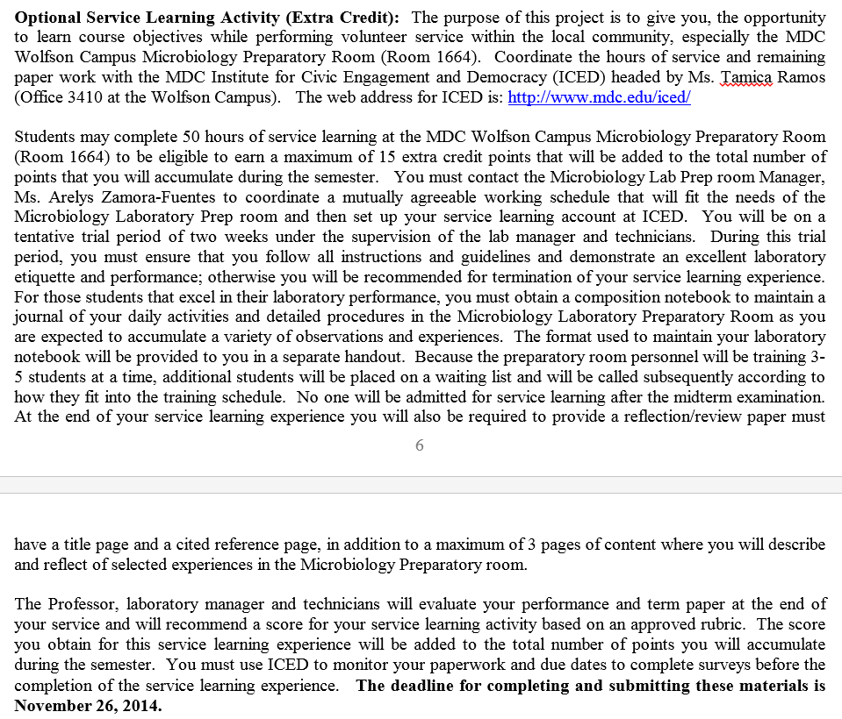

1. **Incomplete Grades and Withdrawals**

***Incomplete*** (I) grades will be posted only in consultation between the student and professor, and only when extenuating circumstances will prevent the student to complete the requirements of the course. At least one half of the course must have been completed with a C or better grades. It is important that the incomplete (I) be completed within the timeframe agreed between the student and the professor. Unfortunately, if not completed within the agreed time frame the incomplete must be submitted as an F.

***Withdrawals***: The professor is not entitled to withdraw a student from the course: it is the students’ duty to evaluate and monitor how he/she is doing in the course. Knowing your status in the course will be important in the case you determine it is necessary to withdraw from the course. The deadline to withdraw (W) from the course **November 3rd, 2015**. Keep in mind that a “W” grade will be permanent in your grade transcripts, and constitute an attempt for the course.

1. **Tentative Course Schedule (schedule may change due to unexpected events)**

(Weekly topics, due dates of Pre-Lab, Lab Reports, Projects, Exams, etc will also be posted in mdc.blackboard.com)

|  |  |  |  |  |
| --- | --- | --- | --- | --- |
| **Date** | **Week** | | **Topic** | **Due Dates for Pre-Lab Reading and**  ***Lab Reports*** |
| Jan-05 | | W1 | -Course Introduction  -Discussion of Syllabus  -Laboratory Safety Procedures  -Metric System |  |
| Jan-12 | | W2 | -Microscopy | -Pre-Lab Week 2 (3-1) |
| Jan-19 | | W3 | -Survey of Microorganisms  -Ubiquity of Microorganisms | -Pre-Lab Week3 (3-3, 3-4, 12-1, 12-3,  12-4)  -*Lab Report 1* (Metric System) |
| Jan-26 | | W4 | -Cultural Characteristics of Microorganisms  -Aseptic Techniques  -Pure Culture Techniques  -Preparation of Bacterial Smear,  -Simple Stain | -Pre Lab Week 4 (1-3, 1-4, 2-2 to 2-4,  3-5)  -*Lab Report 1* (Metric System)  -*Lab Report 2* (Diversity/Ubiquity) |
| Feb-02 | | W5 | -Differential Stains  ---Gram stain  ---Acid-Fast stain (Kinyoun Method)  **-Unknown Sample Project (beginning)** | -Pre-Lab Week 5 (3-7, 3-8) |
|  | |  |  |  |
| Feb-09 | | W6 | -Special Stains  ---Endospore Stain  ---Capsule Stains  -**Unknown Sample Project (cont)** | -Pre-Lab Week 6 (3-9, 3-10)  -*Lab Report 3* (Aseptic/Pure Cultures) |
| **Feb-16** | | **W7** | -Physiological Characteristics:  ---Oxidation and Fermentation  ---Hydrolytic and Degradation Reactions  ---Differential media  -**Unknown Sample Project (cont)** | -Pre-Lab Week 7 (5-2 to 5-9, 5-11,  5-12 to 5-18, 5-20 to 5-23)  -*Lab Report 4* (Smear/Stains)  **-*Lab Report 5* (Dichotomous Key)** |
|  | |  |  |  |
| Feb-23 | | W8 | -Physiological Characteristics (cont)  -Miniaturized multi-test systems  **-Unknown Sample Project (cont)** | -Pre-Lab Week 8 (5-29, 5-30) |
| Mar-01 | | W9 | -Cultivation of Anaerobes  -Bacterial Motility  -**Unknown Sample Project (cont)** | -Pre-Lab Week 10 (2-7, 2-8, 3-12,  5-28)  -*Lab Report 6* (Biochemical Tests)  -*Lab Report 7* (Miniat. multi-tests) |
|  | |  |  |  |
| **Mar-08** | | **W10** | **-Midterm Exam (100 Points)**  -Cultivation of Anaerobes, Bacterial Motility (cont)  **-Unknown Sample Project (cont)** |  |
|  | |  |  |  |
| Mar-15 | | W11 | -Enumeration of Bacteria  -Bacterial Growth Curve  -Cultivation of Anaerobes (cont)  -Bacterial Motility (cont)  **-Unknown Sample Project (cont)** | -Pre-Lab Week 11 (1-5, 6-1, 6-4) |
| Mar-22 | | W12 | -Bacterial Growth Curve  -Effect of Temperature  -Effect of UV  -Effect of Chemicals  **-Unknown Sample Project (cont)** | -Pre-Lab Week 12 (2-9, 2-13, 2-14,  7-3)  -*Lab Report 8* (Anaerobes)  -*Lab Report 9* (Motility) |
| Mar-29 | | W13 | -Effect of Temperature (cont)  -Effect of UV (cont)  -Effect of Chemicals (cont)  -Isolation of Staphylococci  -Isolation of Streptococci  -Bacterial Examination of Food  -Bacterial Examination of Water  **-Unknown Sample Project (cont)**  **(testing must be completed)** | -Pre-Lab Week 13 (7-8, 5-16, 5-25  to 5-27)  -*Lab Report 10* (Bact. Growth Curve) |
| Apr-05 | | W14 | -Effect of Chemicals (cont)  -Isolation of Staphylococci (cont)  -Isolation of Streptococci (cont)  -Bacterial Examination of Food (cont)  -Bacterial Examination of Water (cont)  -**-Unknown Sample Project Paper Deadline** | -Pre-Lab Week 14 (8-13)  -*Lab Report 11* (Effect of Temp/UV)  -*Lab Report 12* (Effect of Chemicals) |
| Apr-12 | | W15 | -ABO blood typing  -Immunological Identification of bacteria  **-Unknown Sample Project Paper Deadline** | -Pre-Lab Week 15 (11-4, 11-5)  -*Lab Report 13* (Bacteria in Food and  Water) |
|  | |  |  |  |
| Apr-19 | | W16 | **-Final Exam**  **-Lab Clean-up** |  |
|  | |  |  |  |