**Syllabus**

**Microbiology Laboratory (MCB2010L, Section 903395)**

**(Web-Enhanced Course)**

*“Nobody is born intelligent: intelligence feeds from strong effort and a desire to learn”*

*­*-Anonymous

**Term**: 2015-3

**Class** **location**: Room 1663

**Class Meeting time**: Thursdays, 12:00PM – 4:25PM

**Professor**: Dr. Félix E. Rivera-Mariani

**Office**: Room 1664

**Office** **Hours**: Thursdays 10:30AM – 11:30PM or by appointment

**Email**: [friveram@mdc.edu](mailto:friveram@mdc.edu); **Phone**: TBA

**Note:** Syllabus may be subject to change at the professor’s discretion**.**

**Required Textbook (print or e-book):** Leboffe, M.J. and B. E. Pierce. 2015. Microbiology Laboratory Theory & Applications. 4th Ed. Morton Publishing Company, Inc. Englewood, CO. (ISBN 978-0-86582-830-9). **e-book:** [**http://www.coursesmart.com/IR/7362944/9781617312502?__hdv=6.8**](http://www.coursesmart.com/IR/7362944/9781617312502?__hdv=6.8)

**Co-requisite:** Microbiology (MCB2010)

1. **Rational of the course**

To provide a hands-on learning experience of the different approaches used in the laboratory to study, enumerate, and classify microorganisms.

1. **Learning Objectives:** *By the end of this course, you should be able to:*
2. Implement correct nomenclature and writing of scientific names
3. Apply the metric system to different biological and microbiological scenarios
4. Discriminate between the functions of the different parts of a compound microscope
5. Formulate explanations for microbial diversity on different environments
6. Describe and differentiate microorganisms using macroscopic characteristics
7. Study and differentiate microorganisms using microscopy and staining techniques
8. Implement proper aseptic techniques to avoid and limit cross contamination
9. Carry out pure culture techniques to isolate bacteria from mixed cultures
10. Perform and interpret biochemical tests to identify bacteria
11. Design/carry out experiments to evaluate the effects of physical forces on bacterial growth
12. Design/carry out experiments to evaluate the effects of chemicals on bacterial growth
13. Carry out serial dilutions and plating techniques to enumerate bacteria
14. Carry out pipetting techniques in qualitative and quantitative experiments
15. Analyze and interpret data (i.e. series of results) gathered from lab experiments
16. Infer from immunological results the bacterial species and ABO blood types
17. **Course Materials (Web-Enhanced Course)**
18. Syllabus, Professor’s credentials, Pre-Lab reading assignments, Lectures, Lab Reports, and Supplemental materials will be available at [mdc.blackboard.com](http://www.schoology.com).
19. **Required Materials *(each student must have their own)***

|  |  |
| --- | --- |
| ***Item*** | ***Importance*** |
| 1. Sharpie fine-tip pen: | **must bring always to lab** |
| 1. Long sleeve Lab coat: | **must bring always to lab** |
| 1. Safety googles | **if you use contact lenses** |
| 1. Latex/nitrile gloves | **must bring always to lab** |
| 1. Masking tape | **must bring always to lab** |
| 1. Combination (*no key lock*) | **must bring 1st day of class** |
| 1. Reef-PollingTM app | **Download into your smartphone**  **(10$ access required)** |

1. **Always** 
   * Bring your lab coat: won’t be able to allow you in lab without it
   * Label everything with your initials, date, section, lab experiment info
   * Have gloves available
   * Store all belongings in the hall locker (**no bags or purses in the lab**)
   * Have your textbook available in lab
2. **Methods of Instructions**
3. ***Pre-Reading assignments:*** Reading assignments will prepare us for lab. In order to understand and start to familiarize with what will be performed in lab as well as with the topics and terminology, we must examine the corresponding topic in the textbook. A series of online questions to be completed in Blackboard will be posted each week for the corresponding labs. These online questions will always be due the day before the lab: **Wednesday by 12:00PM.** **These online questions count for a grade (see Grading Scales)**.
4. ***Laboratory Exercises and Experiments*** will be performed during each lab meeting, and the corresponding. For some of these laboratory exercises and experiments, **lab report(s)** will be posted on Blackboard and must be turned in before their corresponding deadline. For other lab exercises and experiments, questions will be included in the **in-class quizzes**. Questions in lab reports and in quizzes will pertain to results, data, protocols, and interpretation of exercises and experiments performed in the lab.
5. ***Group work*** will facilitate the discussion and peer-teaching of laboratory methods, the design and carrying out lab experiments, and interpretation of results and data obtained our laboratory exercises and experiments. You’ll find out the importance of peer-teaching in the classroom.
6. ***Student Responses Systems*** (“clicker”), through the **Reef-PollingTM** application, will help discussion in the lab when questions, data from experiments, and illustrations. More importantly, will allow real-time feedback on your learning and facilitate in-class discussion.
7. ***Video feedback*** will be an integral part to learn techniques in the lab. In some instances, and with the aid of your classmates, you will record yourself with smartphones carrying out a technique. This approach will aid in interaction within the lab, and facilitate providing feedback to improve your technical skills.
8. **Academic Integrity**
9. **Each student is expected to maintain a high level of integrity and abide by the procedure 4035 of the Miami-Dade College Student Rights and Responsibility Handbook.** Any work submitted by a student in the course for academic credit will be the student's own work. For the purpose of this course, collaboration is allowed in the following instances:in-class group work, case studies discussions, or when stated by the professor. Nevertheless, each student must submit their individual work unless stated otherwise by the instructor. Avoid at all costs copying and pasting information from your classmates’ response or from any other sources.

As part of a collaborative and encouraging classroom, you are encouraged to study together and to discuss topics and concepts covered in class with other students. You can obtain "consulting" help from students as well as provide "consulting" help to other students. However, this allowed form of cooperation should never involve one student having possession of a copy of all or part of the work done by another student or someone else, in the form digital files or hard copy documents.

In the case that copying occur, both the student who copied work from another student and the student who contributed to this behavior will both automatically receive a zero for the corresponding assignment. **The penalty for violation of this Code can include failure of the course and/or notifying the corresponding University authorities for disciplinary action**.

During exams (i.e. quizzes and exams), you must do your own work. Talking or discussions are not allowed during the examinations. In addition, you cannot compare papers, copy from others, or collaborate in any way. Any form of the behaviors mentioned above will result in failure of the exam and can include notifying the corresponding University authorities for disciplinary action. **Cell phones cannot leave the classroom during exams, and must be turned off during class unless needed for in-class discussions.**

***Any form of Academic Dishonesty listed in the Miami-Dade College Student Rights and Responsibility Handbook will not be accepted during in the course.***

1. **Attendance**
2. Attendance at each class sessions parallels with your learning in the course. The Microbiology Lab course requires time and effort in order to learn and be proficient in the learning objectives stated earlier in the syllabus. In addition, **20 easy points for good attendance will provided towards your final grade**. **For each unexcused absence, unfortunately I’ll have to deduct 1 point, and 0.5 point for each unexcused tardiness.** In the event of an absence, the student will be allowed to make up work if the absence results from one of the following:
   1. Official campus activities (as designated by MDC)
   2. Family or personal emergencies (as designated by MDC)
   3. Medical reasons (discussed with the instructor)
   4. Work-related reasons (discuss with the instructor)
   5. **Important Note**: **With two unexcused absences**, I won’t be able to keep you in the class roster.
3. **Make-up for exams and quizzes**
   1. **Make-up exams are allowed only** if your excuse meets any of the four requirements above, and can only me make-up during the week of the exam and with prior authorization.
   2. **Make-up for quizzes** are not allowed.
4. **Laboratory Make-ups:**
   1. In case you miss a lab meeting, the student **can only make up the lab** during the week of the absence by attending another MCB2010L section. In order to be allowed to make up the lab, the student must request a written permission from the professor (Dr. Rivera-Mariani) to make-up the lab in another session. **There are no exceptions**.
5. **Late policy**
6. Unless arrangement have been made prior to the due date or have a valid absence excuse (as stated in the Attendance section of this syllabus), I won’t be able to award full grade on Lab Reports and any other assignment submitted late **(the final grade for any late assignment will be 30% less)**.
7. **Accommodations for students with disabilities**
8. In compliance with the Miami-Dade College and the Student Rights and Responsibility Handbook policy and equal access laws, I more than available to discuss any necessary academic accommodations that may be required for the student with disabilities. Requests for academic accommodations are to be made during the first week of the term, except for unusual circumstances, so arrangements can be made. Students are encouraged to contact the Student Services to verify their eligibility for appropriate accommodations.
9. **Inclusivity Statement**
10. Members (student, faculty, administrators) of the Miami-Dade College community represent a diversity of backgrounds and perspectives. In this course, and as a member of this community, I am a strong supporter of diversity and its benefits. Therefore, to maintain an adequate learning and diverse environment students in this course are strongly encouraged to:
    1. share their unique beliefs, experiences, and values
    2. be open to the opinions and views of others
    3. honor your colleagues’ uniqueness
    4. appreciate the unique opportunity we have to learn from each other
    5. value each other’s opinions and communicate in a respectful manner
    6. keep confidential discussions of personal and professional nature
    7. take advantage of this opportunity to share ways in an inclusive environment
    8. must maintain at all times a respectful environment
11. **Grading Scales:**

|  |  |
| --- | --- |
| **Item** | **Points** |
| Quizzes | 50 |
| Lab Report | 50 |
| Attendance | 20 |
| Pre-Lab Reading Assignments | 30 |
| Lab Skill Evaluations | 100 |
| Midterm Exam/Practicum | 100 |
| Final Exam/Practicum | 100 |
| **Total points** | **450** |

|  |  |  |
| --- | --- | --- |
| **Grade** | **Percentage** | **Points** |
| A | 100 – 87.0% | 392 |
| B | 86.9 – 77.0% | 347 |
| C | 76.9 – 67.0% | 302 |
| D | 66.9 – 55.0% | 248 |
| F | Below 55.0% | Below 248 |

|  |  |
| --- | --- |
| *Reef-Polling Questions = bonus points* |  |

1. **Lab Reports (10 points each):**
   1. For some lab exercises and experiments, there is a lab report that must be completed and turned in. Deadlines for each lab report will be listed on the syllabus schedule as well as on the Blackboard website <http://mdc.blackboard.com>) of the course. In some instances, the deadline may vary and the professor will inform you of any changes.
   2. To grade and be able to provide timely and meaningful feedback, they must…
      1. be downloaded from Blackboard Learn.
      2. completed only in Microsoft WordTM.
      3. uploaded into their corresponding link in Blackboard Learn.
      4. answered in complete sentences.
   3. Don’t forget that **binomial scientific** names (e.g. *Escherichia coli, E. coli*)
      1. must be ***italicized***when word processed (i.e. typed).
      2. must be **underlined** when handwritten.
      3. have the 1st letter of the genus (i.e. *Escherichia coli, or E. coli*) in uppercase.
   4. **Cross mistakes only once**, initialize, and write the correction during handwritten assignments
   5. Won’t be able to award full credit in lab reports if:
2. a binominal name is incorrectly written (will have to deduct **1 point)**
3. an answer is written in incomplete sentence (will have to deduct **0.5 point)**
4. a question is left unanswered (will have to deduct **0.5 point)**
5. a question is answered incorrectly (will have to deduct **1 point**)
6. a mistake was not corrected accordingly (will have to deduct **0.5 point)**
7. **Pre-Lab Reading Assignments (30 total points):**
   1. Online Pre-lab Reading Assignments will be available in Blackboard (<http://mdc.blackboard.com>), and their deadline will always be the day before class time: Wednesday 12:00PM, unless otherwise stated. Keep in mind that these guide questions won’t be available after their corresponding deadline. Similar to points for attendance, these questions will be 30 easy points towards your final grade. **To maintain these 30 easy points, answer 70% of the questions correct to avoid 0.5 point of deduction from the 30 points.**

1. **Exams (100 points each):**
   1. Two 100 points exams (Midterm and Final) will be administrated during regular laboratory periods. Refer to the syllabus schedule to know the dates of the exams. Each of the exams will be multiple choice questions. No scantrons are needed: questions will be answered on the printed exam provided. Won’t be able to allow calculators.
   2. At the next lab sessions, the students will receive a Scorecard of the exam and copy of the exam: **exams must be returned to the professor and cannot be photographed**. Academic Dishonesty regulations, as stated in the MDC student handbook, will have to be strictly enforced. Any violations will lead to a zero on the exam.
   3. **There are no make-ups for Exams unless the** absence meets the requirements of the Attendance sections of this syllabus.
2. **Quizzes (5 points each)**:
   1. During the first 15 minutes of each class section, cumulative quizzes will be administered. These quizzes will rehearse your knowledge with effortful learning and open-ended questions. They will also provide valuable information on how and what you are learning.
3. **Lab Skills Evaluation**

|  |  |  |
| --- | --- | --- |
|  | Lab Skill Evaluations | Points |
| I | Aseptic transfer of microbes (Exercise 1-3) | 10 |
| II | Streaking for isolation (Exercise 1-4) | 10 |
| III | Bacterial smears with Gram stain & Unknown (Exercise 3-7) | 10 |
| IV | Morphological and Physiological Unknown (Multiple Exercises) | 70 |

1. **Optional Service Learning Activity (Extra Credit)**

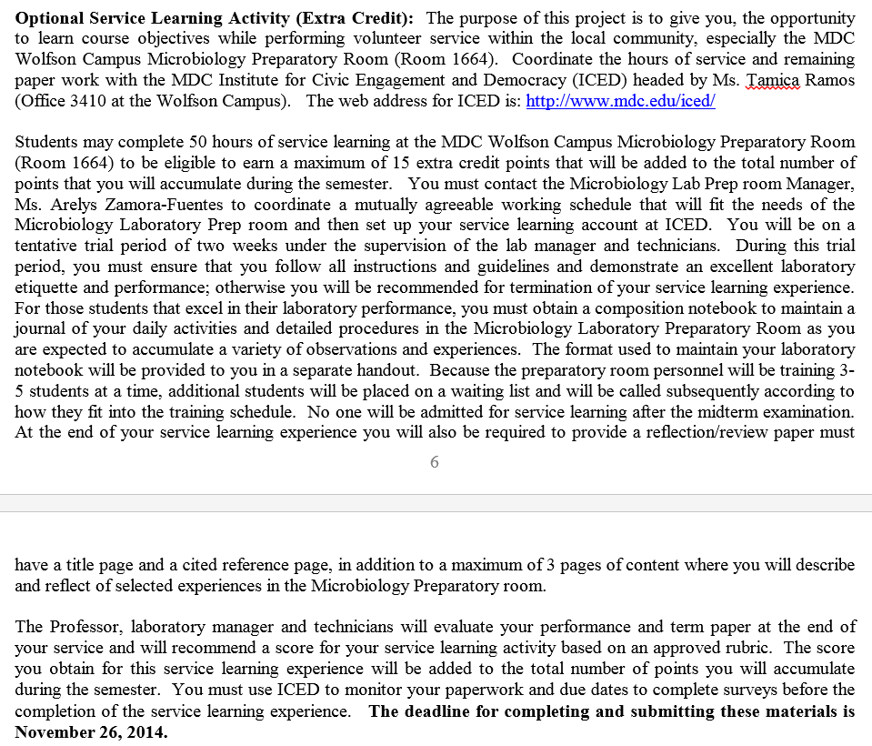

1. **Incomplete Grades and Withdrawals**
2. ***Incomplete*** (I) grades will be posted only in consultation between the student and professor, and only when extenuating circumstances will prevent the student to complete the requirements of the course. At least one half of the course must have been completed with a C or better grades. It is important that the incomplete (I) be completed within the timeframe agreed between the student and the professor. Unfortunately, if not completed within the agreed time frame the incomplete must be submitted as an F.
3. ***Withdrawals***: The professor is not entitled to withdraw a student from the course: it is the students’ duty to evaluate and monitor how he/she is doing in the course. Knowing your status in the course will be important in the case you determine it is necessary to withdraw from the course. **The deadline to withdraw (W) from the course June 28, 2016**. Keep in mind that a “W” grade will be permanent in your grade transcripts, and constitute an attempt for the course.
4. **Tentative Course Schedule (schedule may change due to unexpected events)**

(Weekly topics, due dates of Pre-Lab, Lab Reports, Projects, Exams, etc will also be posted in mdc.blackboard.com)

|  |  |  |  |  |
| --- | --- | --- | --- | --- |
| **Date** | **Week** | | **Topic** | **Due Dates for Pre-Lab Reading,**  ***Lab Reports;* Days of Quizzes** |
| May-12 | | W1 | -Course Introduction  -Discussion of Syllabus  -Metric System  -Laboratory Safety Procedures  -Microscopy  -Ubiquity and Diversity of Microorganisms | -Pre-Lab Week 1 (Syllabus,  Metric System Handout, Textbook  Pages 3 to 6; Textbook Sections  2-1, 3-1, 3-3, 3-4) |
| May-19 | | W2 | -Cultural Characteristics of Microorganisms  -Aseptic Techniques  -Pure Culture Techniques  -Bacterial Smear and Simple Stains | -Pre-Lab Week 2 (Sections 2-2, 2-3;  1-2, 1-3, 1-4; 3-4, 3-5, 3-5)  -Quiz 1 |
| **May-26** | | **W3** | -Differential Stains (Gram Stain, Acid-Fast)  -**Unknown Sample Project (beginning)** | -Pre-Lab Week3 (Sections 3-7, 3-8;  5-31)  -Quiz 2  *-Lab Report 1 (Metric System)*  *-Lab Report 2 (Microscopy)* |
| June-02 | | W4 | -Special Stains (Capsule, Endospore)  **-Unknown Sample Project** | -Pre Lab Week 4 (3-9, 3-10)  -Quiz 3  -*Lab Report 3 (Diversity/Ubiquity)* |
| June-09 | | W5 | -Physiological Characteristics  ---Oxidation and Fermentation  ---Hydrolytic and Degradation  ---Differential Media  **-Unknown Sample Project** | -Pre-Lab Week 5 (Sections 4, 4-5, 4-6,  5, 5-1 to 5-9; 5-11 to 5-18; 5-21 to  5-23)  -Quiz 4  -*Lab Report 4 (Stains)* |
|  | |  |  |  |
| June-16 | | W6 | -Physiological Characteristics (cont)  -Miniaturized multi-test systems  -Cultivation of Anaerobes  -Bacterial Motility  **-Unknown Sample Project (cont)** | -Pre-Lab Week 8 (Sections 2-7, 2-8;  5-28 to 5-30)  -Quiz 5 |
| **June-23** | | **W7** | -**Midterm Exam**  -Cultivation of Anaerobes (cond)  -Bacterial Motility  -**Unknown Sample Project (cont)** |  |
|  | |  |  |  |
| June-30 | | W8 | -Enumeration of Bacteria  -Bacterial Growth Curve  -Pipetting  **-Unknown Sample Project (cont)** | -Pre-Lab (pipetting video, Sections  1-5, 6-1, 6-4)  -Quiz 6 |
|  | |  |  |  |
| **July-7** | | **W9** | -Bacterial Growth Curve (cont)  -Effect of Physical Forces on Bacterial Growth  -Effect of Chemical on Bacterial Growth  -Antimicrobial Sensitivity Testing  **-Unknown Sample Project (complete)** | -Pre-Lab Week 11 (Sections 2-9,  2-13, 2-14, 6-6, 7-3, 8-13)  -Quiz 7  -*Lab Report 5 (Anaerobes/Motility)* |
| **July-14** | | **W10** | -Effect of Physical Forces (cont)  -Effect of Chemical Forces (cont)  -Isolation of Staphylococci and Streptococci  -Bacterial Examination of Food and Water  **-Unknown Sample Project (paper due)** | -Pre-Lab Week 12 (Sections 7-8, 5-16,  5-25 to 5-27, 7-8)  -Quiz 8 |
| July-21 | | W11 | -Isolation of Staphylococci and Strepcococci(cont)  -Bacterial Examination of Food and Water (cont)  -Hemolysis, Bile Esculin  -ABO Blood Typing |  |
| **July-28** | | **W12** | -Final Exam |  |
|  | |  |  |  |

**Note:** Syllabus may be subject to change at the professor’s discretion**.**