BotMother

A Chat-Based Forum System

Sriram Sami / Tang Yew Siang

Github source code: <https://github.com/frizensami/botmother>

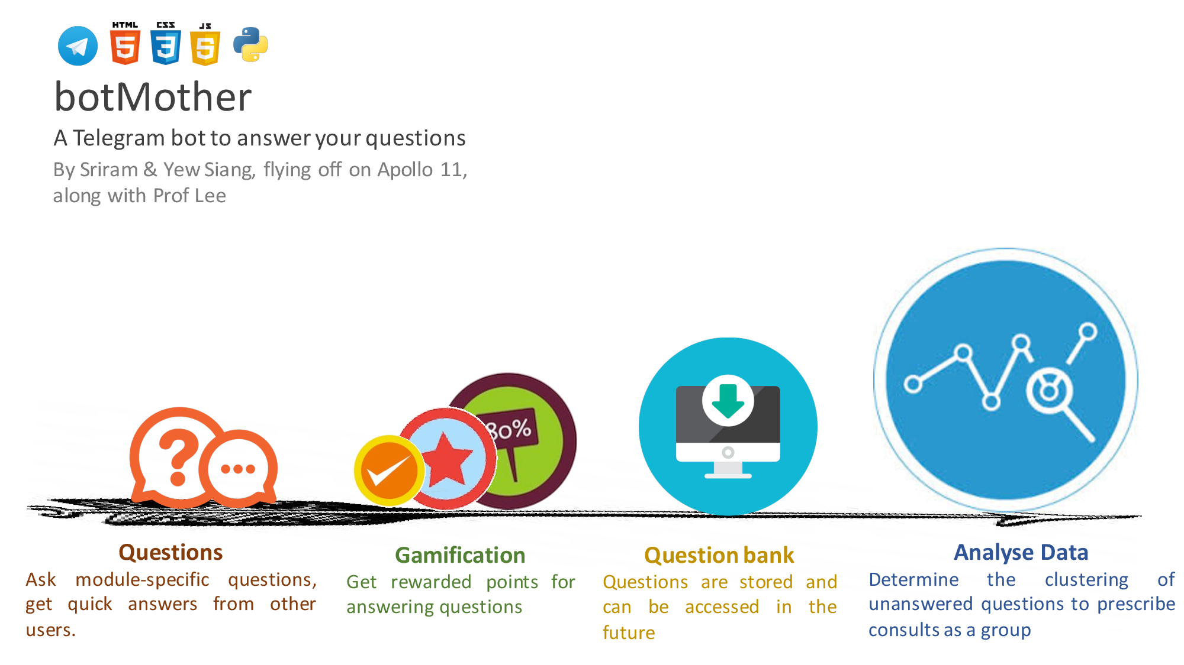Motivation

When you’re stuck with a burning question in one of your modules, or just want general advice about the module itself, your current alternatives are friends, seniors and perhaps the IVLE forums.

Many may have reached the point where either their friends and seniors don’t know the answer, or it’s inconvenient to ask them, and the IVLE forums are either too slow a medium or it’s just strange to post your question there. The question is also too module-specific for Google to help you out. Also, you’re sure that someone has asked the question and gotten an answer before, so why isn’t there a record of it somewhere so you don’t have to waste time asking the same thing again?

Aim

We hope to make the Q&A process in forums quick and engaging through messaging platforms (e.g. Telegram).

User Stories:

1. As a student who has questions and problems with a module, I want to be able to ask questions and get quality answers quickly.
2. As a student who is revising for exams, i want to be able to look at the good questions and answers of the module over the years.
3. As a student, teaching assistant or professor who wishes to help students, I want to be able to answer posed questions in a timely manner.
4. As an administrator who wants to prevent abuse of the system, I want to be able to identify abusers, warn them and ban them if they continue to cause problems.

Scope of Project:

The Telegram Bot provides a chat-like interface for students to ask questions and their peers, teaching assistants or professors to answer quickly.

A Web-based forum will share a common database with the Telegram Bot and provide the same functionality with a traditional non-chat-based interface.

Features to be completed by the mid of June:

The Telegram bot has limited features (cannot display all questions and answers, cannot comment) due to limited screen space and the potential notification spam.

1. Telegram Bot
   1. Allow users to ask, answer, vote on module-specific questions
   2. Display new questions and answers
2. Web-based forum
   1. Allow users to ask, answer, vote and comment on module-specific questions
   2. Display all questions, answers and comments
3. Mechanisms to collect datasets for analysis

Features to be completed by the mid of July:

1. Gamification system
   1. Reward users with points for good questions and answers
2. Providing recommendations with machine learning

How are we different from similar platforms?

* IVLE Forums
  + As BotMother does not require your NUSNET account, questions are not tagged to your real name if you choose so.  Also, we plan to give you fast-paced responses due to the nature of a primarily chat-based forum system, as opposed to a more static medium.
* StackOverflow/StackExchange
  + We encourage questions about homework which are frowned upon in these traditional online forums. In fact, module-specific questions are the backbone of the platform.
* Quora
  + Questions asked here can be too general

Program Flow

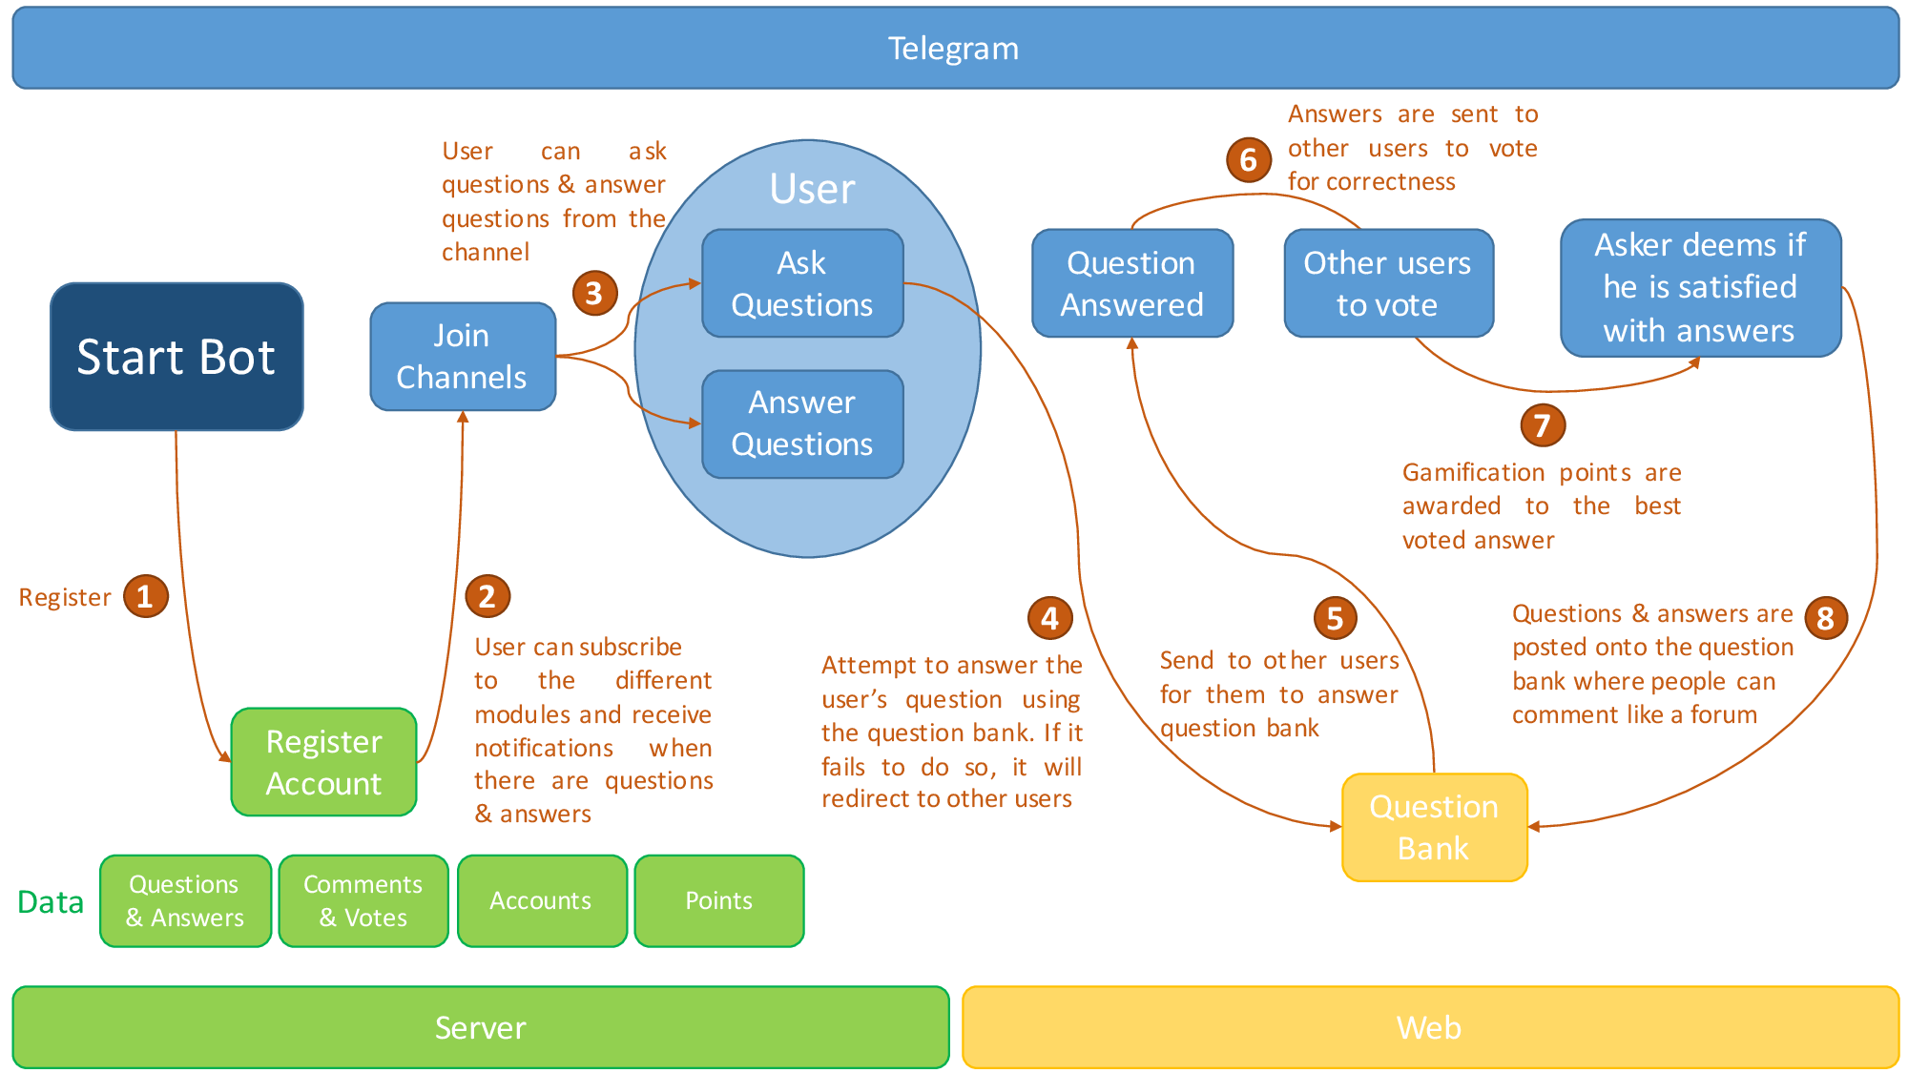

Providing Recommendations with Machine Learning

Over time, two things happen in our system:

* Reliable questions and answers are stored in the question bank
* Users who ask questions receive recommended answers from the question bank and can indicate if the recommended answer is relevant, correct and precise.

We constantly run a machine learning algorithm that looks at these three parameters: i.e.

* the question being asked,
* the question and answer being recommended as most relevant, and
* the user’s rating of the provided recommendation

and improves its model of “what is a relevant answer?” This, over time, helps the system provide increasingly more accurate recommendations.

Proposed Level of Achievement

Apollo 11