Ramrao Adik Institute of Technology
(Department of Computer Engineering)


Mini Project Report
On
RESTAURANT BILLING SYSTEM
Subject-: Open Source Technology Lab

Presented By
Roll No | Batch-Sr. No | Name
16CE2028 | A-3 01 | TANMAY VIKAS BHAGWAT
16CE1085 | A-3 04 | SACHIN RAMESH KAMATH
16CE1089 | A-3 12 | SHREYAS RAJENDRA KUDE
16CE1033 | A-3 15 | JAYESH SHRIRANG LOKHANDE

Signature of Internal Examiner
Contents of Report

Abstract
The project “Restaurant Billing System” is implemented to reduce the manual work and enhances the accuracy of work in a restaurant.
This software has been made in a user friendly interface. So that normal person can add and delete the entries of customers and handle all the transactions easily. This project is also designed with full consideration to help the users in an easy manner without any unnecessary wastage of time. This system can be implemented in big restaurant. The menu card consists of various food varieties available in the restaurant. Through the ordering form, the administrator can simply click and order the food. The billing system prepares the bill according to the ordered food.
This system entirely reduces the unnecessary time waste inside the hotel as well as it reduces unnecessary noise.
The system processes transaction and stores the resulting data. Reports will be generated from these data which help the manager to make appropriate business decisions for the restaurant. Restaurant billing system will develop to help the restaurant administrator to manage restaurant bills.

Introduction
We propose to build a software project that can efficiently handle and manage various activities of a restaurant and all these activities will be happening under the supervision of the administrator. The businesses in restaurants are now growing constantly. At the same time, the need for managing its operations and tasks arises. The best way to optimize these activities is to use a management portal . Hence the project is developed proficiently to help restaurant owners automate their business operations. This project serves the best way of maintaining customer’s order and their needs.
The project “Restaurant Billing System” is an application to automate the process of ordering and billing of a restaurant. This Graphical based application is designed considering the chain of departmental store which is located in various cities. This application also administrates its users and customers.

Implementation
Technologies used :
1. Graphical Interface toolkit: Tkinter
2. Database: SQLite 3
3. Development Tool: Jetbrains Pycharm Community Edition
4. Web browser: Google Chrome
5.Language used: Python 3
CODE
from tkinter import *
from tkinter import messagebox as ms
import sqlite3
import os

with sqlite3.connect('projectDB.db') as db:
c = db.cursor()

c.execute('CREATE TABLE IF NOT EXISTS user (username TEXT NOT NULL ,password TEXT NOT NULL);')
db.commit()
db.close()

class main:

def __init__(self,master):
self.master = master
self.username = StringVar()
self.password = StringVar()
self.widgets()

def login(self):
with sqlite3.connect('projectDB.db') as db:
c = db.cursor()

find_user = ('SELECT * FROM user WHERE username = ? and password = ?')
c.execute(find_user,[(self.username.get()),(self.password.get())])
result = c.fetchall()

if result:
#filename = 'alt2.py'
os.system("python alt2.py ")
#root.destroy()

else:
ms.showerror('Oops!','Username Not Found.')
self.username.set('')
self.password.set('')

def widgets(self):
self.frame = Frame(self.master,bg="dark slate blue")
Label(self.frame,text = 'WELCOME',font = ("Trebuchet MS",35),pady = 10, fg="goldenrod", bg="dark slate blue").grid()
Label(self.frame, text="LUXURY ROYALE", font=("Trebuchet MS", 55), bg="dark slate blue", fg="springgreen", padx=20).grid(columnspan=3)
Label(self.frame, text="Deluxe A/C Restaurant (Veg & Non-Veg)", font=("Trebuchet MS", 15), bg="dark slate blue", fg="goldenrod", pady=10).grid(columnspan=3)
Label(self.frame, text="Cashier Login", font=("Trebuchet MS", 22), bg="dark slate blue", fg="springgreen", pady=25).grid(row=3, column=1, sticky=W)
Label(self.frame, text="Cashier ID:", bg="dark slate blue", fg="goldenrod", font=("Trebuchet MS", 15), padx=-20, pady=15).grid(row=4, column=0, sticky=E)
Label(self.frame, text="Password:", bg="dark slate blue", fg="goldenrod", font=("Trebuchet MS", 15), padx=-20, pady=25).grid(row=5, column=0, sticky=E)
Entry(self.frame,textvariable = self.username,bd = 5,font = ('',15)).grid(row=4, column=1, sticky=E)
Entry(self.frame, show="*",textvariable = self.password,bd = 5,font = ('',15)).grid(row=5, column=1, sticky=E)
Button(self.frame, text="Login", font=("Trebuchet MS", 12), relief=RAISED, bg="dark slate blue", fg="goldenrod", cursor="cross", padx=30, pady=5, activebackground="springgreen",command=self.login, activeforeground="goldenrod").grid(row=6, columnspan=3)
Label(self.frame, text="", bg="dark slate blue").grid(columnspan=3)
self.frame.grid()

if __name__ == '__main__':
root = Tk()
root.title('Restaurant Payment Method')
main(root)
root.mainloop()

FUNCTIONS FOR CUISINES
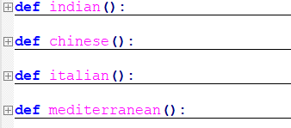

FUNCTIONS FOR VARIOUS OPERATIONS
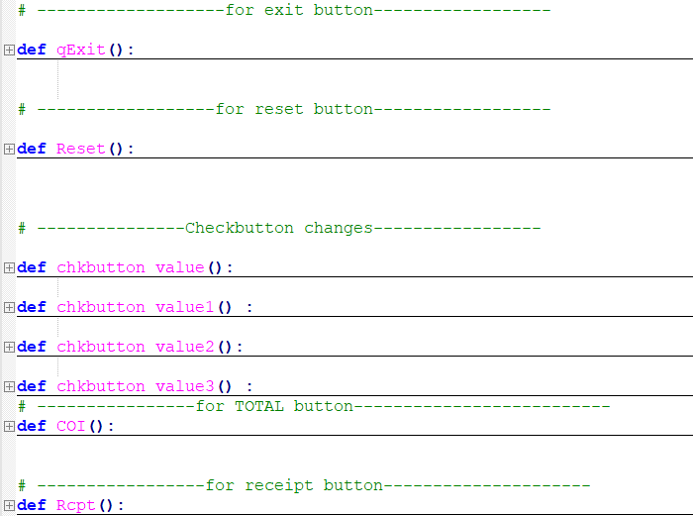

Screenshots:
Login details of cashier
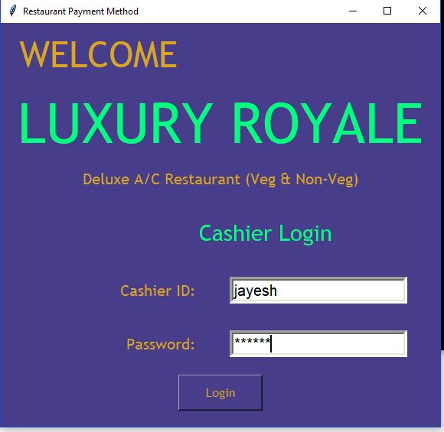
Selection of table
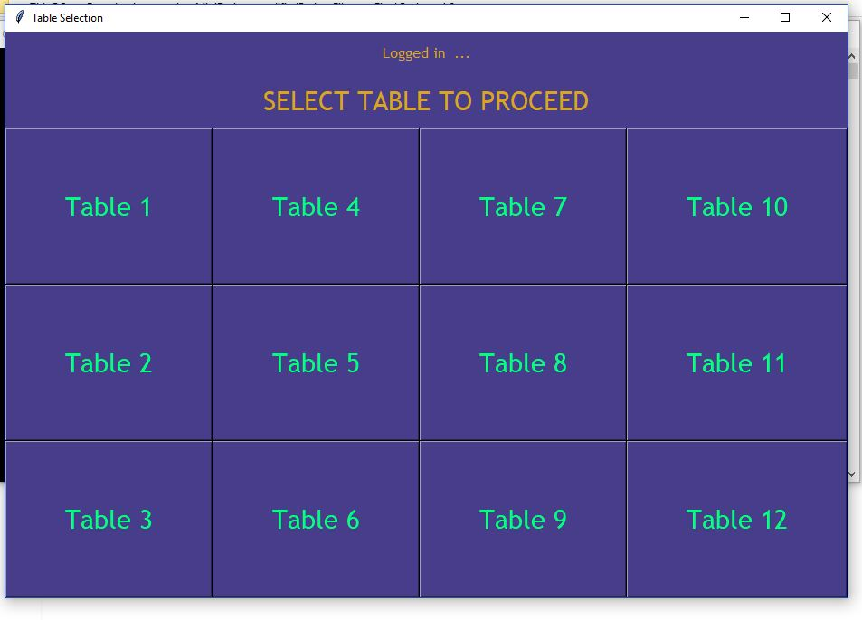
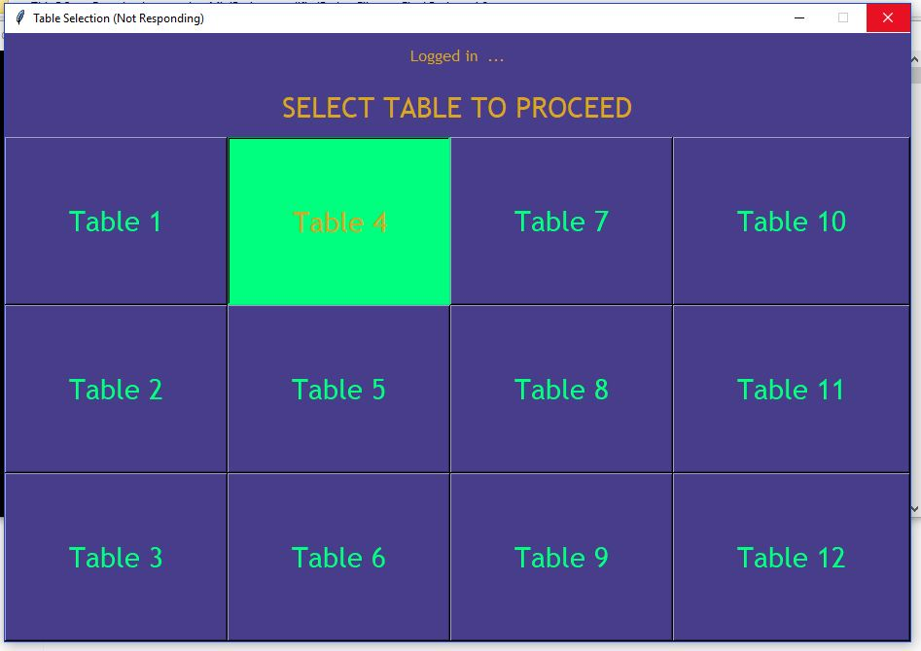
Homepage
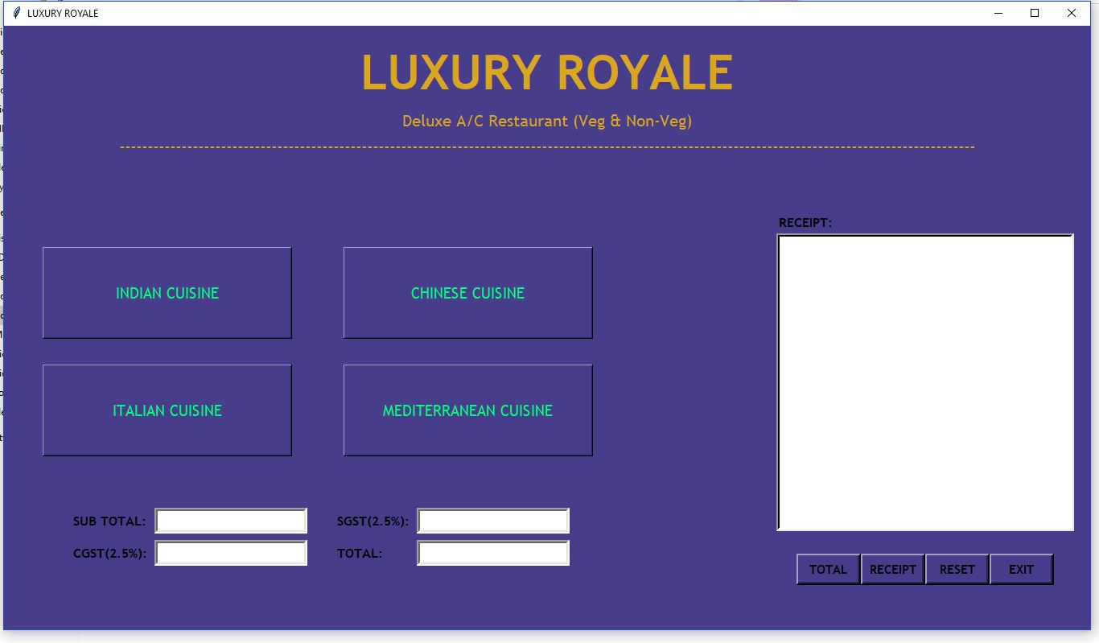

Indian Cuisine
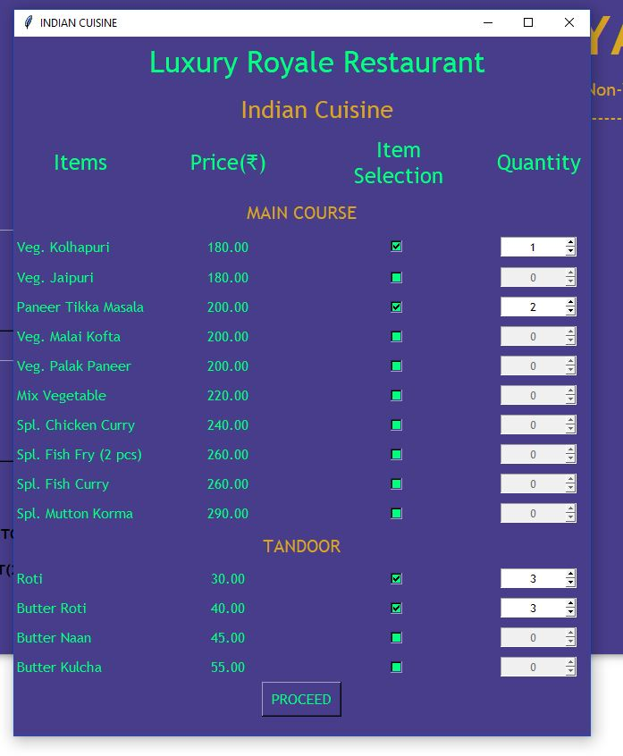
Chinese Cuisine
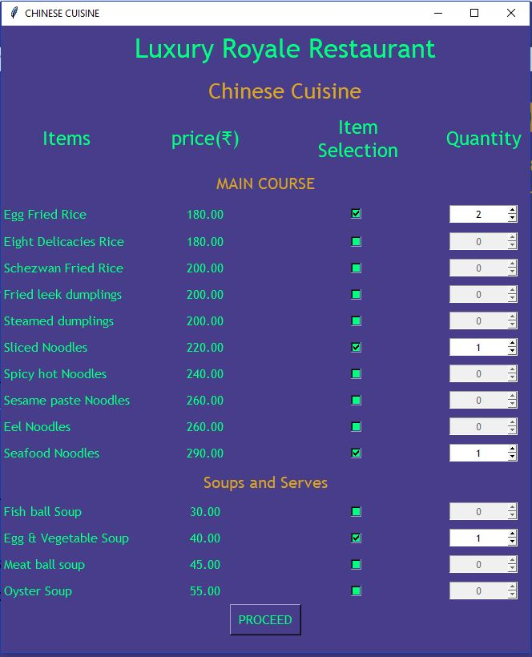
Italian Cuisine
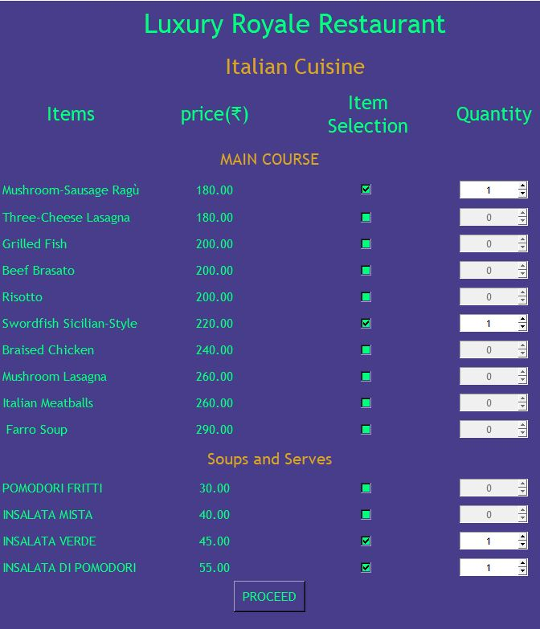

Mediterranean Cuisine
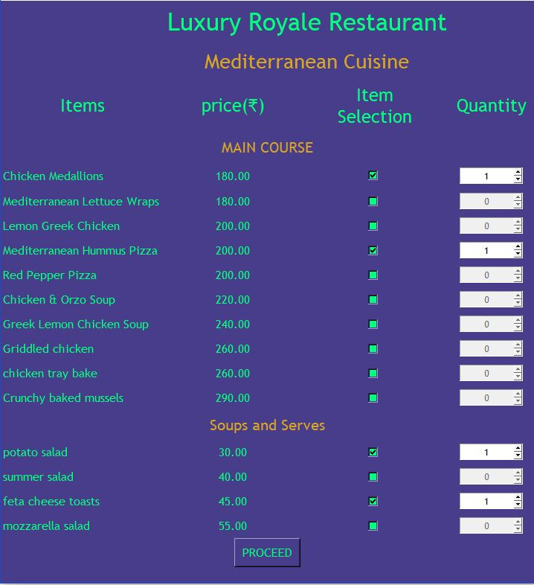

Total cost of items
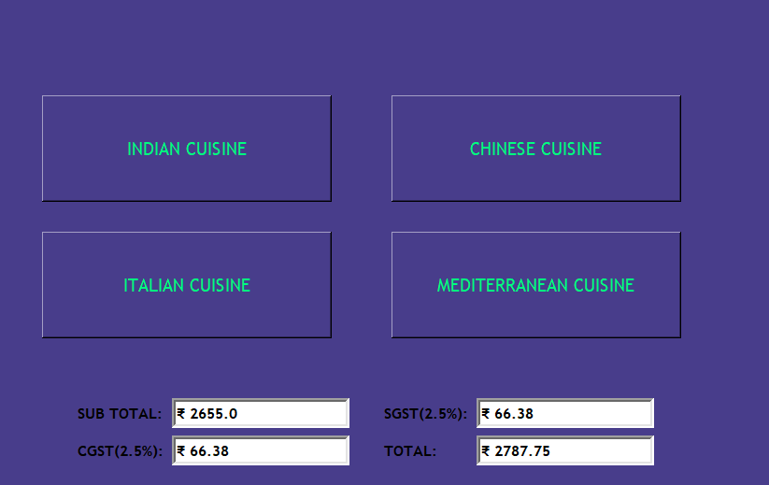
Receipt
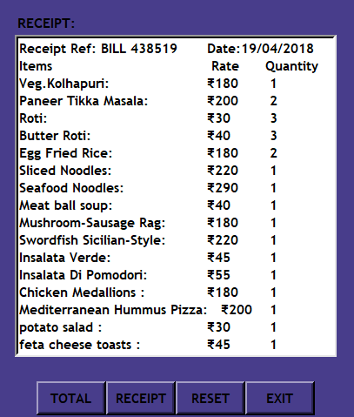
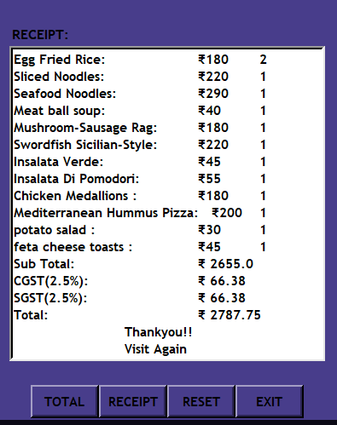

Conclusion:
Through this project, we have successfully managed to utilize sqlite3 database & Tkinter GUI module to create a fully functional Restaurant Billing System Software with Cashier Login, Table Selection, Multiple Cuisine Selection & Receipt Printing. Using various Tkinter widgets like canvas, frame, label, button, checkbutton, spinbox, we have designed a practically implementable interface for the user.

