Muğla Sıtkı Koçman University

Department of Computer Engineering

Senior Design Project I

E-Attendance Using Bluetooth Beacon Technology

Analysis & Design Report

Furkan YILMAZ

Supervisor: Doktor Öğretim Üyesi Zeynep Filiz EREN DOĞU

January 8, 2020

**Contents**

1 Introduction 3

2 Motivation 3

3 Similar Existing Applications 3

3.1 O2's 'Watch Out' Beacons Improve Crosswalk Safety 3

3.2 'Safetify' Improves the Safety of Pedestrians Listening to Music 4

4 Proposed System 4

4.1 Overview 4

4.2 Functional Requirements 5

4.3 User Interface Design 6

4.4 Entity Relationship Diagram 11

4.5 Technologies and Tools 11

5 Future Work 12

6 References 12

Project Title

# Introduction

Bluetooth beacons are hardware transmitters - a class of Bluetooth low energy (LE) devices that broadcast their identifier to nearby portable electronic devices. The technology enables smartphones, tablets and other devices to perform actions when in close proximity to a beacon. Bluetooth beacons use Bluetooth low energy proximity sensing to transmit a universally unique identifier picked up by a compatible app or operating system. The identifier and several bytes sent with it can be used to determine the device's physical location, track customers or trigger a location-based action on the device such as a check-in on social media or a push notification.

Bluetooth beacons differ from some other location-based technologies as the broadcasting device (beacon) is only a 1-way transmitter to the receiving smartphone or receiving device, and necessitates a specific app installed on the device to interact with the beacons. This ensures that only the installed app (not the Bluetooth beacon transmitter) can track users, potentially against their will, as they passively walk around the transmitters.

# Motivation

The motivation of this project is keeping track of the attendance of a class by using Bluetooth beacons. Without this technology, lecturers have to keep track of the attendance either on paper or by using student ID card system. The problem with the said solutions is that, students can sign other students name who are not present at the lecture time or use their cards to sign in. My project offers a solution to this problem.

Nowadays smartphones are pretty common. Every student has a smartphone that supports Bluetooth. The students will install The Scanner App on their phone which supports BLE. And every classroom will get a beacon device installed. These devices advertise the name of the classroom they located in with a low signal range. In order to sign in, the students will have to be present close to the beacon device. The Lecturers then, will be able to see who is in the class on their phone by using the Displayer app.

# Similar Existing Applications

## O2's 'Watch Out' Beacons Improve Crosswalk Safety

It's fairly rare for most people to leave the house without a phone in hand, which is causing a problem for crosswalk safety. Knowing that today's youth are easily distracted by chat messengers and social media, mobile network provider O2 developed 'Watch Out!' a beacon that is set up near crosswalks to alert phone users of oncoming traffic.

To make use of Watch Out, the appropriate app must be installed and a phone's Bluetooth feature must be enabled. From there, when a person approaches a dangerous location, they are sent a signal that immediately blocks all smartphone activity, helping to bring a pedestrian's full attention back to the crossing in front of them. Although the success of this app relies on installation, activation and proximity to beacons, it still has the potential to be life-saving.

## 'Safetify' Improves the Safety of Pedestrians Listening to Music

In order to improve the safety of pedestrians, a group of students from the School of Visual Arts in New York put their minds together to envision 'Safetify.'

Since a number of pedestrian deaths or injuries are linked to people wearing headphones and unwittingly putting themselves in danger, this solution poses the use of beacon technology in order to make it safer to cross streets.

The implementation of Safetify would involve installing beacons at busy intersections. When people with headphones on pass by listening to Spotify, the volume on their devices would automatically be turned down until they safely finish crossing the street. Although this is a simple way to encourage more people to become alert on the road, this concept could prove to be life-saving someday.

The applications listed above work similar to my project. However the difference is, in these application smartphone users only let the beacon locate them and push a notification to the phone. In my project after we let the beacon know the students in there, we want the students to enter their information and send it to the database through the beacon.

# Proposed System

## Overview

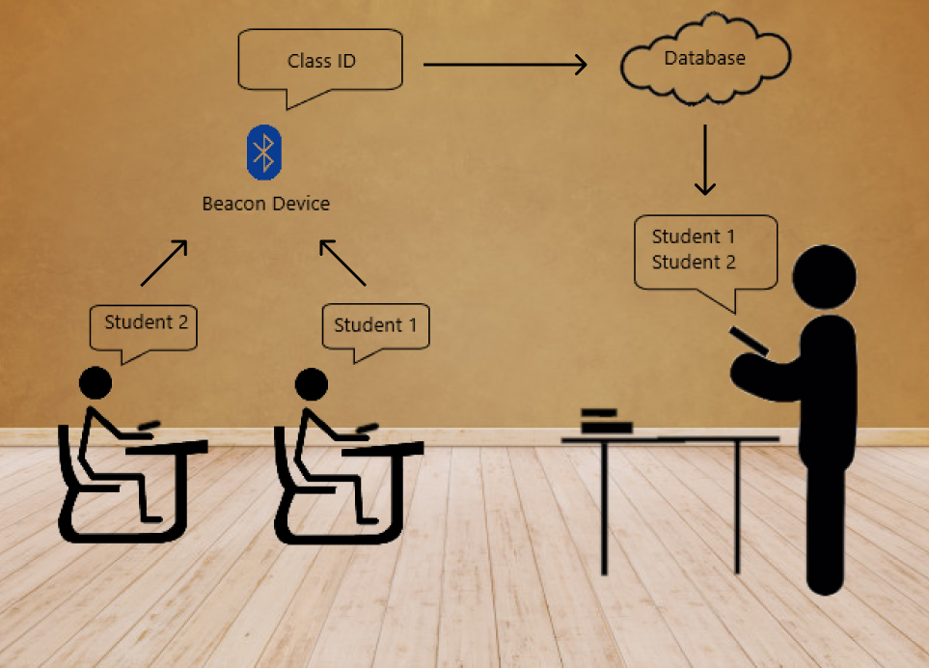

The figure above shows basic principle of the project. Once the students inside the classroom, they have to use the scanner app to find the class ID on their own smartphones. After that they need to enter their personal information. The beacon then will pass these information to database. Then the lecturer will be able to display who was present during the lesson.

## Functional Requirements

**Student:** Student is the person who uses the scanner app.

* **Sign in:** Students have to enter their name, surname and student number in order to attend.
* **Scan:** After entering their information, they have to scan the class ID they are inside.
* **Attend:** Once they scan the class ID, they must click on the ID and pass their information to the database.

**Lecturer:** Lecturer is the person who uses the displayer app

* **Sign in:** Lecturers have to enter their information.
* **Find Class:** Lecturers have to find the class they want to display.
* **Display:** After they found it, they can see who is in the class at the moment.

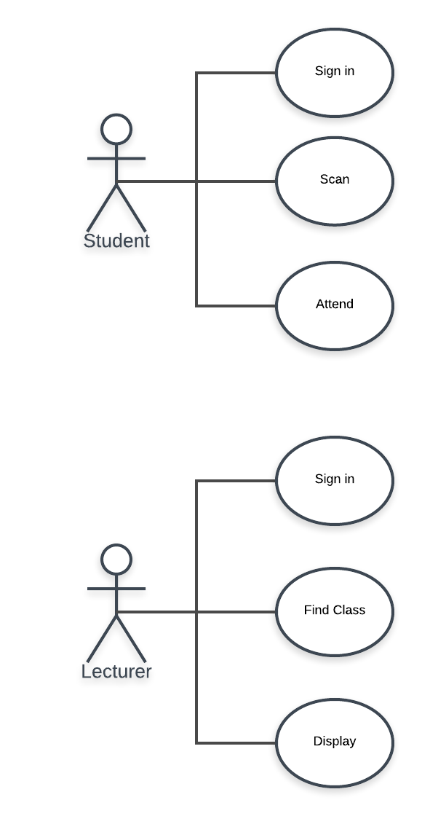

## User Interface Design

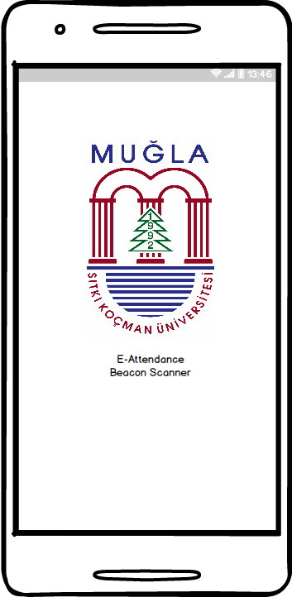

This is the first page of scanner app. Students will proceed by tapping on the university logo.

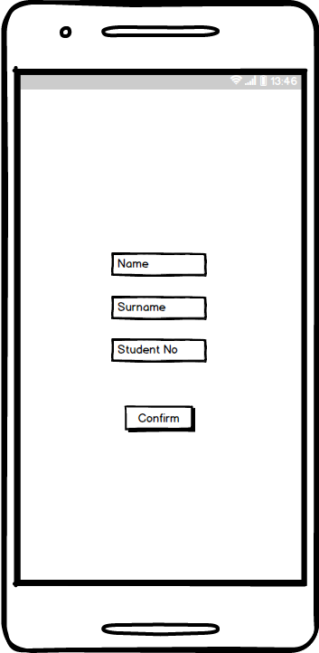

This is the second activity where the students enter their information.

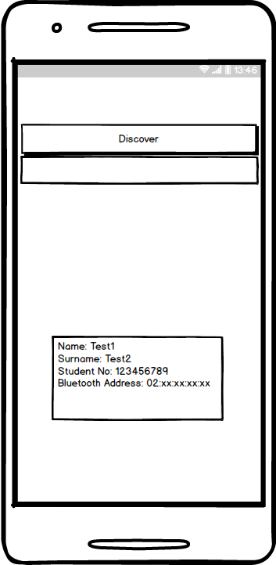

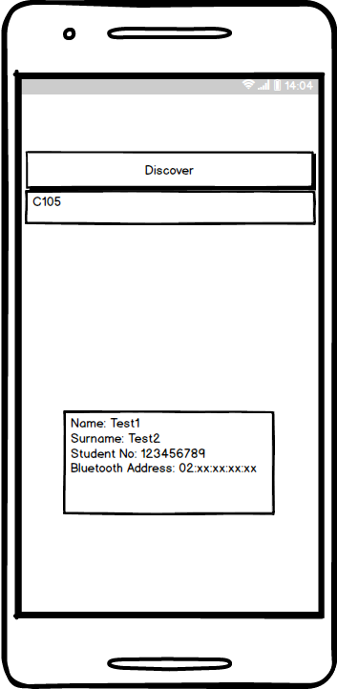After they enter their information, it and their phone’s Bluetooth address will be shown. And they will start discovering nearby beacons once they press the button.

When they start scanning, nearby beacons will start showing up.

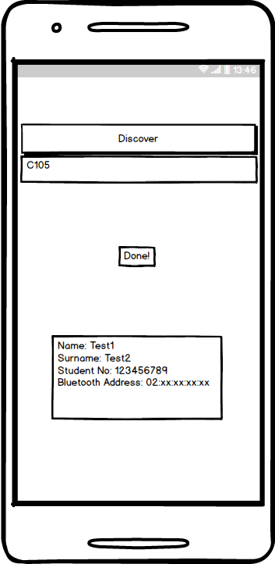

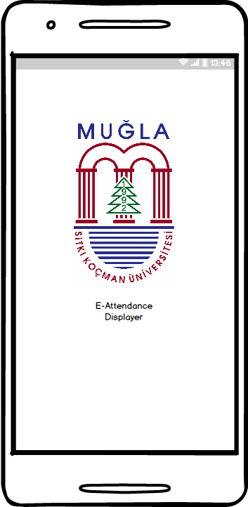And after they picked the beacon they need, they will get a message.

This is the first page of the displayer app. With this app, lecturers will be able to see who is inside the classroom.

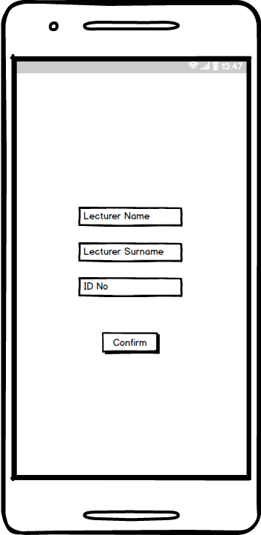

But first they need to identify themselves.

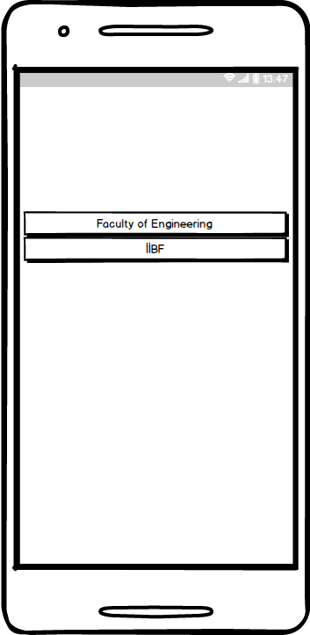

Then they will have to navigate to the class they are in. In this page they will choose which faculty they are in.

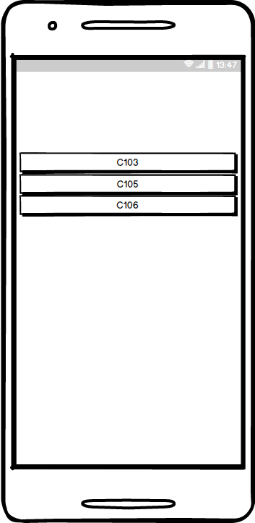

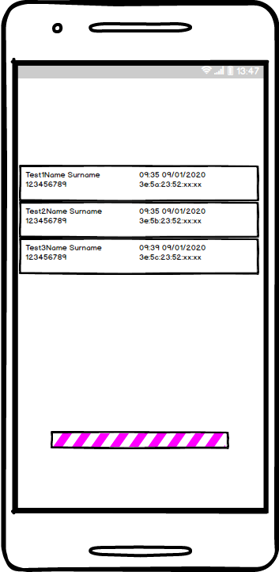And then they need to choose the classroom.

After that they can see who is attending the class. Since this project uses real-time database, the displayer app will immediately update itself and show the newest input.

Wizard of oz video: <https://youtu.be/dMcsBH9U1Lk>

## Entity Relationship Diagram

This diagram shows the properties of entities. Every student has a name, surname, student number and their phone’s Bluetooth address. Every lecturer also has a name, surname and ID number. And every beacon has a UUID (Universal Unique Identifier) number and a data it transmits.

## Technologies and Tools

* BLE Beacons: A beacon is a small Bluetooth radio transmitter, powered by batteries. Beacons are similar to a lighthouse in functionality. These small hardware devices incessantly transmit Bluetooth Low Energy (BLE) signals.
* Android Studio: Android Studio is the official integrated development environment (IDE) for Google's Android operating system, built on JetBrains' IntelliJ IDEA software and designed specifically for Android development. It is available for download on Windows, macOS and Linux based operating systems. It is a replacement for the Eclipse Android Development Tools (ADT) as the primary IDE for native Android application development.
* Balsamiq Mockup: Balsamiq Mockups is a user interface design tool for creating wireframes (also called mockups or low-fidelity prototypes). You can use it to generate digital sketches of your product ideas to facilitate discussion and understanding before any code is written.
* Firebase Real-time Database: The Firebase Realtime Database is a cloud-hosted database. Data is stored as JSON and synchronized in real-time to every connected client. When you build cross-platform apps with our iOS, Android, and JavaScript SDKs, all of your clients share one Realtime Database instance and automatically receive updates with the newest data.
* Lucidchart: Lucidchart is a web-based proprietary platform that is used to allow users to collaborate on drawing, revising and sharing charts and diagrams. Lucidchart runs on browsers that support HTML5. This means it does not require updates of third party software like flash.
* Paint 3D: Available in Windows 10 only, Paint 3D is a free program from Microsoft that includes both basic and advanced art tools. Not only can you use brushes, shapes, text, and effects to create unique 2D art but you can also build 3D objects and even remix models made by other Paint 3D users
* Java: Java is a general-purpose programming language that is class-based, object-oriented, and designed to have as few implementation dependencies as possible. It is intended to let application developers write once, run anywhere (WORA), meaning that compiled Java code can run on all platforms that support Java without the need for recompilation. Java applications are typically compiled to bytecode that can run on any Java virtual machine (JVM) regardless of the underlying computer architecture. The syntax of Java is similar to C and C++, but it has fewer low-level facilities than either of them.

# Future Work

* Security measurements will be taken
* UI improvisations will be made.
* Optimization will be made.
* Lecturers will be able to add or remove input manually.

# References

3.1 – <https://www.trendhunter.com/trends/crosswalk-safety>

3.2 - <https://www.trendhunter.com/trends/safety-of-pedestrians>

4.1 - <https://www.lifewire.com/microsoft-paint-3d-4147664>

4.2 - <https://en.0wikipedia.org/wiki/Lucidchart>

4.3 - <https://balsamiq.com/wireframes/desktop/docs/overview/>

<https://www.wikizeroo.org/index.php?q=aHR0cHM6Ly9lbi53aWtpcGVkaWEub3JnL3dpa2kvSmF2YV8ocHJvZ3JhbW1pbmdfbGFuZ3VhZ2Up>

<https://en.0wikipedia.org/wiki/Bluetooth_low_energy_beacon>