Project 6: Indicator Evaluation

Frank Kornet  
fkornet3@gatech.edu

# Abstract

Five technical analysis indicators are implemented to support ML4T’s final Strategy Evaluation project: 1) moving average convergence/divergence (MACD), 2) Bollinger Band position (BBP), 3) relative strength index (RSI), 4) money flow index (MFI), and 5) Williams %R index. On top of these technical indicators, an optimal trading strategy is developed to determine an upper bound of what can be achieved. The optimal trading strategy peeks in the future and uses future share price to decide the optimal action for each trading day.

# Introduction

This report covers sixth project for the Machine Learning for Trading (ML4T) course at Georgia Tech. The report covers the optimal trading strategy and the selected five technical indicators.

The report starts with the methodology used to develop the optimal trading strategy and the selection of five technical analysis indicators.

# Methodology

As per the project instruction’s, the report is covers JP Morgan (ticker symbol: JPM) from January 1st, 2008 to December 31st, 2009. Due to the financial crisis, this is a highly volatile period. Both the S&P 500 and JP Morgan saw a decline of fifty percent. JP Morgan ended the period with a five percent gain, while the S&P 500 still had a loss of twenty percent. Figure 1 uses the SPY exchange traded fund as a proxy, so we can compare S&P 500 against JP Morgan. The figure shows that JP Morgan had a higher volatility overall.

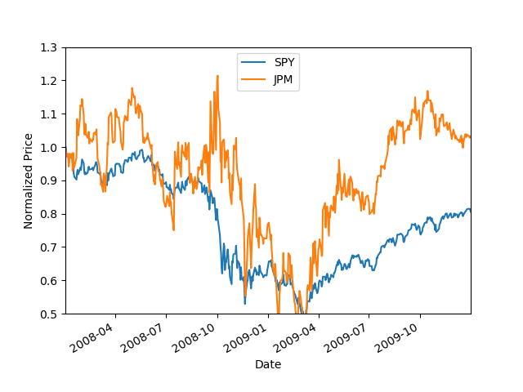

***Figure 1 – S&P 500 (ticker: SPY) vs JP Morgan (ticker: JPM)***

## Optimal Trading Strategy

According to the project instructions, we are only allowed three trading positions: own 1,000 shares in JP Morgan, short 1,000 shares in JP Morgan, or own no shares in JP Morgan. The strategy starts with an investment of 100,000 US dollars.

JP Morgan’s optimal trading strategy looks at tomorrow’s share price to determine the trading position to take each trading day. If the share price goes up or stays the same tomorrow, it will own 1,000 shares in JP Morgan. Otherwise, it will short 1,000 shares in JP Morgan. It will always take a trading position (we either own or we borrow JP Morgan shares). The optimal strategy is compared against a buy and hold strategy for JP Morgan (“Benchmark”). Both trading strategies assume zero commission and zero trading impact.

The above optimal trading strategy provides an upper bound of possible returns. Figure 2 shows the result of the buy and JPM strategy (“Benchmark”) and the optimal trading strategy (“Optimal Strategy”) outlined above. The figure shows normalized portfolio returns where one is equal to the initial investment.

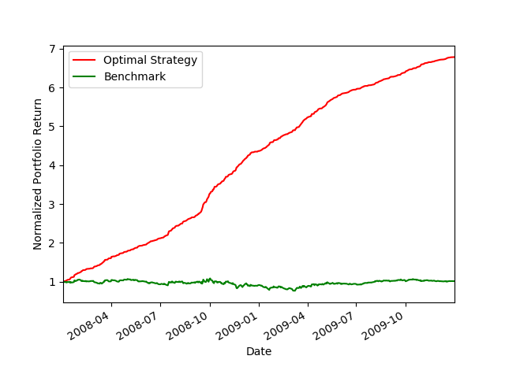

***Figure 2 – Optimal Strategy versus Benchmark***

The table below summarizes key statistics for both the benchmark and optimal trading strategy. The Sharpe ratio calculation assumes that the risk-free rate is zero percent over this period.

|  |  |  |
| --- | --- | --- |
|  | Benchmark | Optimal |
| Cumulative return | 1.23% | 578.61% |
| Daily standard deviation | 1.7% | 0.45% |
| Mean of daily return | 0.02% | 0.38% |
| Sharpe ratio | 0.0099 | 0.8393 |

***Table 1 – Optimal Strategy versus Benchmark***

## Technical Indicators

The selection of indicators is based upon the technical indicators listed in (Technical Analysis, 2020). The report identifies five types of indicators: 1) trend indicators, 2) momentum indicators, 3) volume indicators, 4) volatility indicators, and 5) other indicators.

As explained in module 02-06 Technical Analysis (video 4):

* Individual technical indicators are week
* Combinations of technical indicators perform better
* Look for contrast (stock versus market)
* Indicators work better for shorter periods than longer periods

Instead of selecting 5 technical indicators of the same type, a technical indicator from each indicator type is selected except others. Others are ignored as they appear to overlap with Bollinger Bands. The selected indicators are shown in Table 2.

For trading strategies to work, it is important to recognize which stocks have momentum. For that reason, two momentum indicators have been selected. These are leading indicators. MACD is a lagging indicator. It is hoped that the combination of lagging and leading indicators works well (to be confirmed in the final project).

The selected indicators are listed in Table 2.

|  |  |
| --- | --- |
| Indicator | Type of Indicator |
| MACD | Trend |
| RSI | Momentum |
| Williams %R | Momentum |
| MFI | Volume |
| BBP | Volatility |

***Table 2 – Selected and implemented Technical Indicators***

Momentum has been found to explain Warren Buffet’s investment success over the years (see MGT 6203 Investing Analytics lecture notes by Jonathan Clarke for more information). Based upon this, the author believes that the trading strategy needs to be tilted towards momentum to be successful.

The individual indicators are covered in the next five sections.

# Moving Average Convergence and divergence (MACD)

The MACD is a moving average technical indicator and compares the MACD line against the MACD signal line. If the MACD line is above the MACD signal line it means that the share price is rising. If it is below the MACD signal line, it means that the share price is declining. The further away the MACD line is from the MACD signal the stronger the change is (a kind of momentum).

The MACD line and MACD signal line are calculated using exponential moving averages as follows:

$$MACD line=EMA\left(fast, close\right)-EMA\left(slow, close\right)$$

$$MACD signal=EMA(9, MACD line)$$

where close is the adjusted share price close, fast is typically 12 periods and slow is typically 26 periods.

To avoid having to compare the MACD line and MACD signal line over and over again, the indicator is calculated as

$$MACD line-MACD signal line$$

This means that if the indicator is above zero, the MACD line is above the MACD signal line. If the indicator is negative, the MACD line is below the MACD signal line. And lastly, if the indicator is zero, it means that both lines are the same. This will make it easier for the final project to work with the indicator.

If the indicator is positive, it means that the share price is rising and, therefore, represents a buy opportunity. A negative value indicates that the share price is declining and represents a short opportunity. The further the distance from zero, the stronger the signal.

The indicator works best when the indicator just turns positive or negative (i.e. when share price changes direction). Once the new direction is under way, the indicator lags behind the changes taking place. By combining the lagging MACD indicator with the other selected indicators it is hoped that they balance each other out and perform better together.

The graph in Figure 3 shows the indicator against the normalized JP Morgan share price. The indicator is shown by subtracting 1.0 from the indicator. As can be seen, the indicator follows the share price. It exaggerates the trends up and down. Furthermore, it is slow to pick up changes in direction. For example, it picks up the down trend between April 2008 and July 2008 a bit too late. Something similar happens for the up-trend July 2009.

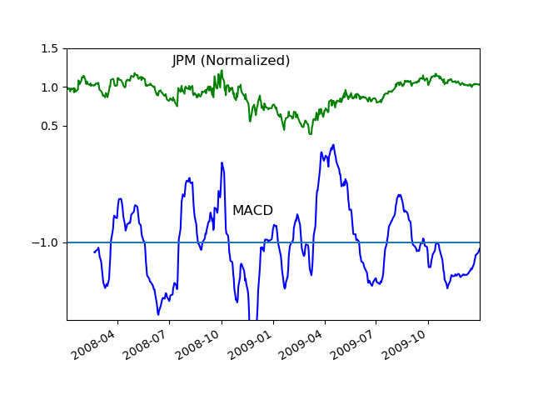

***Figure 3 – JP Morgan versus MACD***

Note: the calculation of EMA is based upon (voice32, 2020)’s implementation on GitHub. The implementation leverages the Pandas ewm() function. The rest of the code is the author’s code.

# Relative strength index (RSI)

RSI is a momentum indicator that measures the velocity and magnitude of the price change. The calculation for the indicator is based upon the vectorize me slides (Byrd, 2020). The reader is assumed to be familiar with this material, and so the calculations are not covered here.

An RSI over 70 is assumed to be overbought and hence represents a sell signal (i.e. a short opportunity) as share price for stock is expected to decline. An RSI below 30 is assumed to be oversold and is a buy signal as share price is expected to rise.

Figure 4 shows the normalized price for JP Morgan on top (similar to Figure 3) and the RSI indicator is shown at the bottom. The upper horizontal line represents 70 and the lower horizontal line represents 30 after the following transformation is applied $\frac{RSI}{100}-1$. This is done to get both lines in a single chart.

You can see that breaking through the horizontal lines typically result in the expected behavior. The breakthrough of the upper horizontal line in August 2009, however, does not correctly predict a decline. Instead the share price continues to rise.

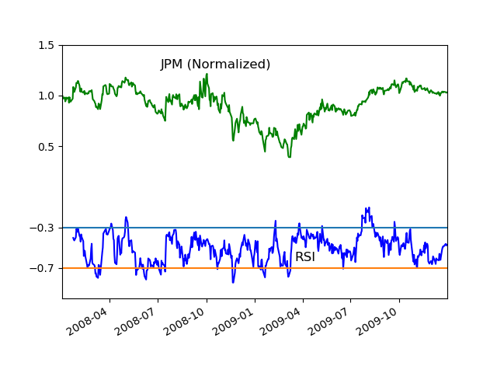

***Figure 4 – JP Morgan versus RSI***

Note that for the final project, RSI values will be normalized by dividing it through 100 to ensure the values are within zero and one.

# Williams %R

The Williams %R indicator shows the current price in relation to the current highs and lows over the last N days where N is typically 14 periods for short term trends. The indicator is calculated as follows

$$\%R=\frac{close- HH_{N}}{HH_{N}-LL_{N}}*100$$

where $HH_{N}$ is the highest high over $N$ periods and $LL_{N}$ is the lowest low over $N$ periods. If close is equal to $HH_{N}$ then %R is zero and if close is equal to $LL_{N}$ then %R is -100.

The Williams %R normally falls between -20 and -80. A value above -20 indicates an overbought situation (i.e. a short and a value below -80 indicates an undersold situation. The Williams %R has been normalized in anticipation of the final project by leaving out the multiplication by 100. So, -20 is -0.2 and -80 is -0.8.

As can be seen in Figure 5, the Williams %R results in more buy and short signals than with MACD and RSI and can, as a result, be considered a more aggressive indicator than either RSI or MACD.

Although breaking through -0.2 according to both (Technical Analysis, 2020) and (Williams %R, 2020) would imply that this is an opportunity to short the stock in anticipation of a share price decline, the graph below seems to indicate the opposite and that it is an opportunity to buy the stock in anticipation of a share price rise. The same is true for breaking through the -0.8 barrier, except that this represents a buy opportunity, but in the graph seems to reflect a short opportunity.

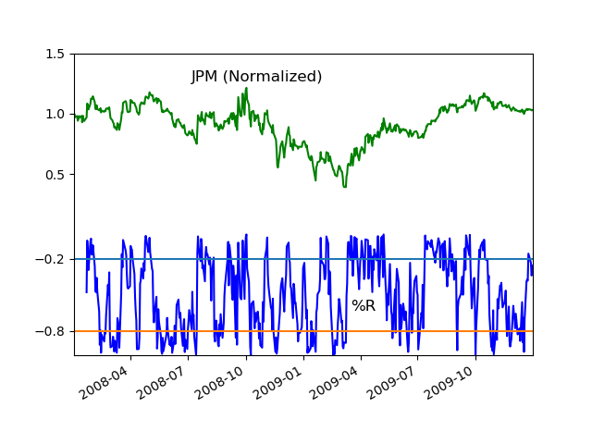

***Figure 5 – JP Morgan versus Williams %R***

The calculations have been carefully checked and the author believes that the calculations in the program are correct. Despite the anomaly with literature, the indicator seems to work well. The author suspect that the anomaly is due to the high volatility during this period.

# Money Flow Index (MFI)

The MFI is a percentage of up days money flow over the money flow of up and down days. The percentage is calculated for each trading day by looking back over the last $N$ periods (typically 14 days). The calculation uses typical price and not the close price. The typical price is defined as follows:

$typical price= \frac{high+low+close}{3}$

where $high$ is the high of each trading day, $low$ is the low of each trading day, and $close$ is the adjusted close price of each trading day. Money flow, in turn, is then calculated as

$$money flow=typical price* volume$$

where $volume$ is the trading volume at the end of each trading day.

The money flow is calculates for days when the typical price rises compared with a day before (called the $positive money flow$) and for days that the price declines with a day before (called the $negative money flow$). The final step is

$$MFI=\frac{positive money flow}{positive money flow+negative money flow}*100$$

The MFI is considered overbought when it is above 80 (i.e. a short opportunity) and undersold when it is below 20 (i.e. a buy opportunity). Figure 6 shows the MFI for JP Morgan over 2008 and 2009. The MFI index is transformed using the formula $\frac{MFI}{100}-1$ to fit it on a single graph. The horizontal line at -0.2 is equivalent to an 80 MFI and -0.8 to a 20 MFI.

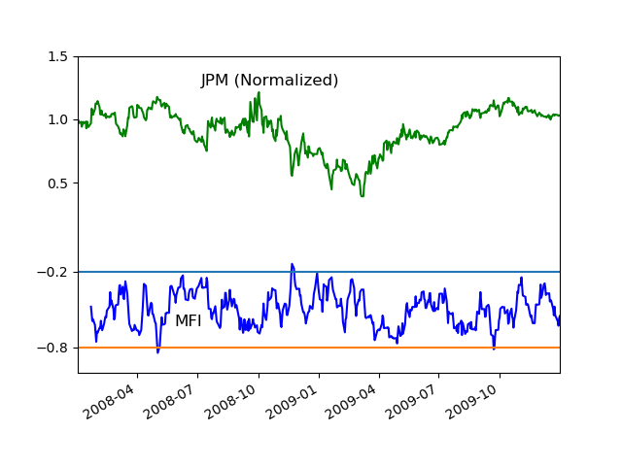

***Figure 6 – JP Morgan versus MFI***

Figure 6 has only three signals. The upper half of the MFI band is in general associated with a decline in share price and the bottom half of the MFI band is in general associated with a rise in share price.

# Bollinger Band Position (BBP)

Bollinger Bands are defined as the share price plus/minus two standard deviations over a lookback period. Assuming a normal distribution, ninety-five percent is expected to lie within plus/minus two standard deviations. By normalizing the Bollinger Bands, we get a range of zero to one where zero is the lower band and one is the upper band.

The Bollinger Bands as a technical indicator are covered in lecture 02-06 Technical Analysis (video 8). If the price breaks through the upper band from outside the band, this is considered a sell signal (i.e. a short opportunity). In similar vein, if the price breaks through the lower band from outside the band, this is considered a buy opportunity.

The calculation of BBP is based upon the material provided in vectorize me slides (Byrd, 2020). The reader is assumed to be familiar with the material and the calculations are not explained here.

Figure 7 shows BBP indicator for JP Morgan. To plot both lines on the same chart, BBP has been transformed by charting BBP – 1.0. That means that the upper horizontal become 0.0 and the lower horizontal line -1.0. Like MFI, the interpretation of BBP seems to be reversed from what literature and lecture material expects. That means that breaking through the upper line is a buy signal instead of a short signal. And, breaking through the lower horizontal line is a short signal instead of a buy signal.

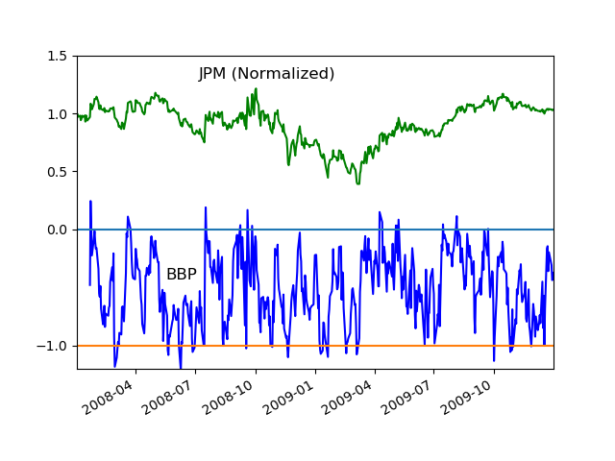

***Figure 7 – JP Morgan versus BBP***

Bollinger Bands are used in multiple ways as explained in (Technical Analysis, 2020). It states “Some traders buy when price touches the lower Bollinger Band and exit when price touches the moving average in the center of the bands. Other traders buy when price breaks above the upper Bollinger Band or sell when the price falls below the Bollinger Band.” This strongly suggests that the interpretation of BBP is unique to each stock.

In general, we see that if the indicator is in the upper half of the band, the share price typically rises. If the indicator is in the lower half of the band, the share price typically declines.

# Summary

The optimal strategy provides an upper bound for any trading strategy over 2008 and 2009 for JP Morgan. It is calculated by looking at tomorrow’s share price and determining the action that maximizes the return for tomorrow. A cumulative return of 578 percent is achieved over a two-year period.

The report covers five selected and implemented technical indicators (MACD, RSI, Williams %R, MFI, and BBP). The rationale for selecting these indicators is to get a range of indicator types that we can try in combination for the upcoming final project.

Both BBP and Williams %R show contrarian behavior compared to what literature expects (i.e. a buy signal is a short signal and a short signal is a buy signal). It is unclear why this might be the case. It may be due to limitations of the technical indicators as they only use price and volume information.

# REFERENCES

1. CS7646 ML4T, 2020. Project 6: Assess Learners. Retrieved 16 September 2020 from <http://lucylabs.gatech.edu/ml4t/fall2020/project-6/>
2. [Stock Market Indicators, voice32, 2020. Retrieved 14 October 2020 from https://github.com/voice32/stock_market_indicators/blob/master/indicators.py](https://github.com/voice32/stock_market_indicators/blob/master/indicators.py)
3. Technical Analysis, 2020. Retrieved 14 October 2020 from <http://www.mrao.cam.ac.uk/~mph/Technical_Analysis.pdf>.
4. Vectorize Me, David Byrd, 2020. Retrieved 14 October 202 from <http://lucylabs.gatech.edu/ml4t/wp-content/uploads/2020/05/CDB_vectorize_me.pptx.zip>
5. Williams %R, 2020. Retrieved 14 October 2020 from <https://school.stockcharts.com/doku.php?id=technical_indicators:williams_r>