Fx Drag as a Function of AoA and Airspeed

Wind Tunnels Test Data Used:
- Aicraft without pusher, wing --> LP3

Modifications to data
- Removing entries with non-zero control surfaces
- Removing entries with non-zero pusher motor
- Removing entries with non-zero hover motor command
- Removing entries with angle of attack higher than 15 deg --> Remove stall condition (non-linear)
- Select skew = 0 : for current log flight, skew is at 0 deg

Fit for Drag vs Fx Drag
Lift and drag are always respectively perpendicular and parallel to airspeed. They are defined as:
CL = (CL_0+CL_alpha*alpha)
and
CD = (CD_0+CL^2/(Pi*AR*e)
CD = (CD_0+(CL_0+CL_alpha*alpha)^2/(Pi*AR*e)
CD = (CD_0+(CL_0^2+2*CL_0*CL_alpha*alpha+CL_alpha^2*alpha^2)/(Pi*AR*e)
CD = CD_0+CL_0^2/(Pi*AR*e)+ (2CL_0*CL_alpha/(Pi*AR*e))*alpha+(CL_alpha^2*alpha^2)/(Pi*AR*e)
CD = K1 + K2*alpha + K3*alpha^2
where K1,K2 and K3 > 0

To see forces in the body frame, need to project drag and lift using the angle of attack:
Fx = L sin(alpha) – D cos(alpha)
By using the small angle approximation:
Fx/rho*S*V^2 = L*alpha – D
= (CL_0+CL_alpha*alpha)*alpha -D
= (CL_0*alpha+CL_alpha^2) -D
= (CL_0*alpha+CL_alpha^2)– CD_0-CL_0^2/(Pi*AR*e)- (2CL_0*CL_alpha/(Pi*AR*e))*alpha-(CL_alpha^2*alpha^2)/(Pi*AR*e)
= – CD_0-CL_0^2/(Pi*AR*e) + (CL_0-2CL_0*CL_alpha/(Pi*AR*e))*alpha + (CL_alpha^2-CL_alpha^2*alpha^2)/(Pi*AR*e))*alpha^2
Fx =( K1 + K2*alpha + K3*alpha^2 ) rho*S*V^2
Fx = ( K1 + K2*alpha + K3*alpha^2 ) V^2 (because rho and S are constant and can be captured by K1, K2 and K3)
Where K1 <0, K2 and K3 >0 (because AR >2)

Fit for all airspeeds
% Fx = (k1+k2*alpha+k3*alpha^2)*V^2
with
s_quad =

-0.038433561803693
0.003393031925358
0.139999863562600

RMS_quad =

0.307578791253760

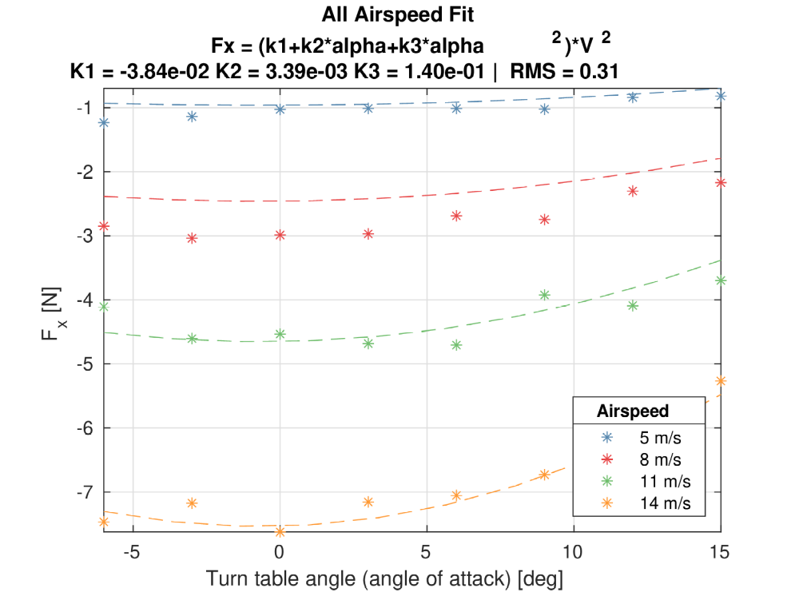
Fit is good for higher airspeed but worse at 8 m/s

Fit for lower airspeed
Airspeed < 9 m/s
s_quad_low =
-0.046135525959578
0.011078740302910
0.147716740626664
RMS_quad_low =
0.074319397173294

K1 and K3 same order of magnitude. K2 changes quite a lot.
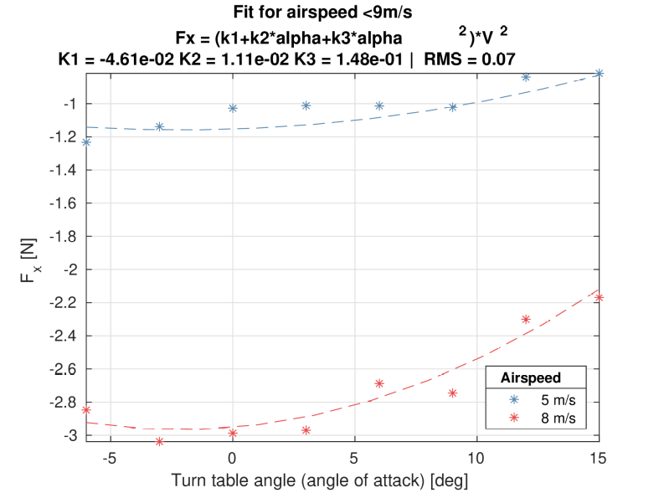

Comparison of Fits
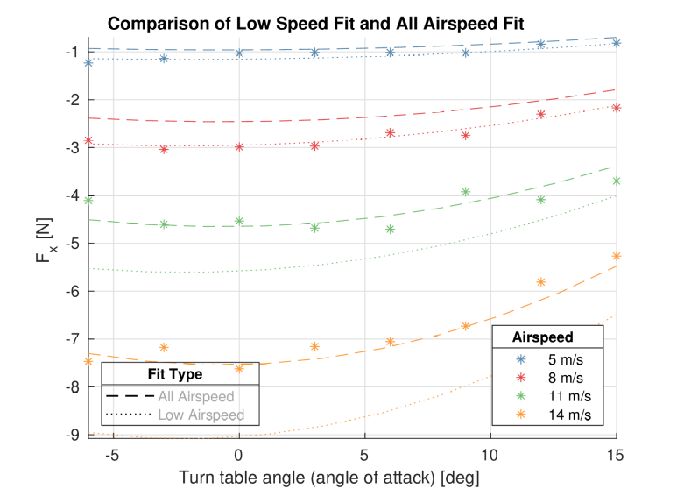

Analysis Repeated without Hover Props
Using LP4

All airspeed
s_quad =
-0.030061458379662
0.003497371379286
0.146865971330522
RMS_quad =
0.206133783957516

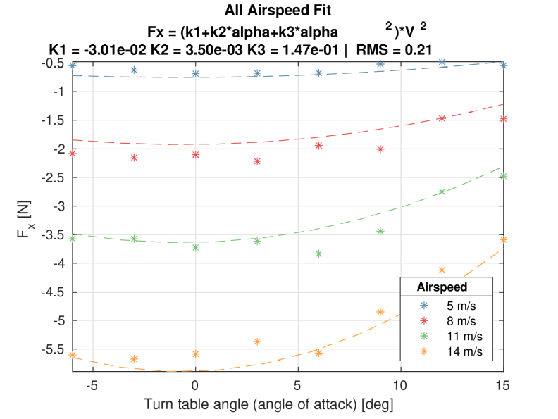
Better fit than LP4 for all airspeeds.

Low Airspeed
s_quad_low =
-0.032663240761150
0.002720617256903
0.153265498955988
RMS_quad_low =
0.146253351088681
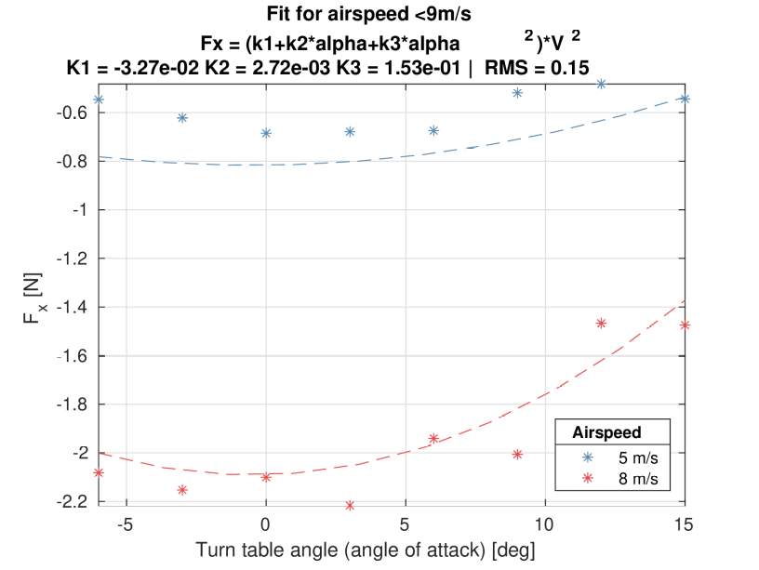

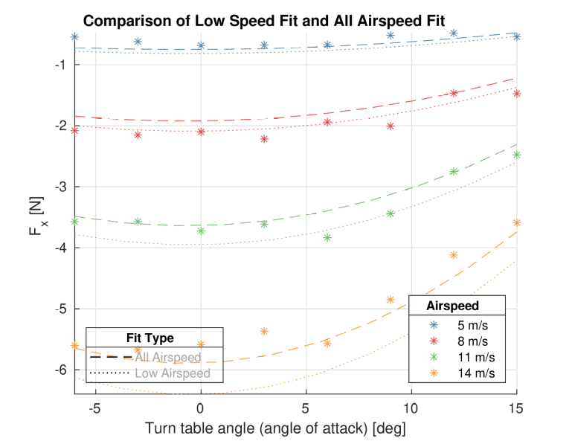

Summary
Fx = (k1+k2*alpha+k3*alpha^2)*V^2
Data Source | Fit Type | K1 | K2 | K3 | RMS
LP3 (with hover props) | All Airspeed | -3.843E-2 | 3.393E-3 | 1.400E-1 | 0.308
LP3 (with hover props) | Low Airspeed | -4.614E-2 | 1.108E-2 | 1.477E-1 | 0.074
LP4 (without hover props) | All Airspeed | -3.006E-2 | 3.497E-3 | 1.467E-1 | 0.206
LP4 (without hover props) | Low Airspeed | -3.266E-2 | 2.721E-3 | 1.533E-1 | 0.146
Both LP3 and LP4 are missing the wing

- K1 values are somewhat similar throughout the fit
- K2 values are much higher for the low speed with hover props, hinting more linear link with drag and propellers
- K3 values are similar throughtout the fit

