Wing Fx Drag as a Function of AoA, Skew and Airspeed

Wind Tunnels Test Data Used:
- Aicraft without pusher, elevator, hover props --> LP5

Modifications to data
- Removing entries with non-zero control surfaces
- Removing entries with non-zero pusher motor
- Removing entries with non-zero hover motor command
- Removing entries with angle of attack higher than 15 deg --> Remove stall condition (non-linear)

Obtaining Wing Fx Drag
% Fx = body drag + wing drag
% Wing drag = Fx-body drag
%Drag without hover props (only body drag)

drag_body_coeff = [-9.013405108486905E-3 -1.988035608425628E-2 9.850048188379294E-4 1.443975207474472E-1]; %all airspeeds without hover props with skew

Fx_body = @(alpha,skew,V) (drag_body_coeff(1) .* cos(skew)+...
drag_body_coeff(2)+...
drag_body_coeff(3) .* alpha+...
drag_body_coeff(4) .* alpha.^2).*V.^2;

Quick Analysis Drag in Quad and Forward Flight Mode
Quad Mode
In quad mode, drag is mostly constant with angle of attack
-1N at 8 m/s, -2.5N at 15 m/s
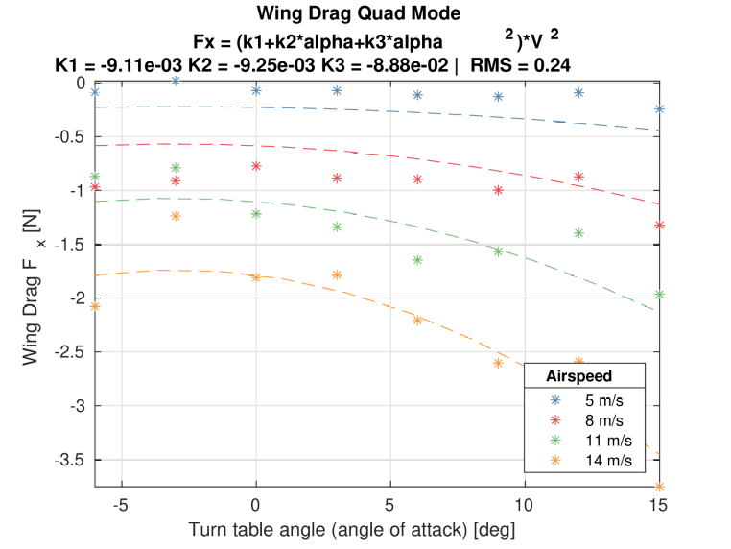

In forward flight
drag quadratic with angle of attack, becoming positive
up to 15 N
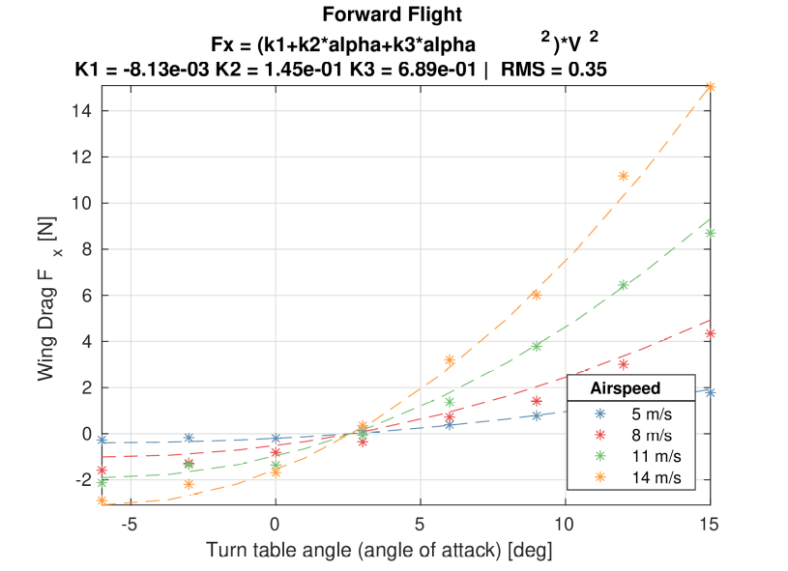

Fit for variable skew
A fit for each skew angle is performed with the equation:
(k1+k2*alpha+k3*alpha^2)*V^2

The values of the different parameters are plotted as a function of the skew:

It can be seen that k2 and k3 follow a square sinus form while k1 does not.

With this in mind, different fit functions can be generated:
% Fx0 = (k1+k2*alpha+k3*alpha^2) *(k4*sin(skew)^2+k5)*V^2
% Fx1 = (k1 + (k2*alpha+k3*alpha^2))*(sin(skew)^2+k4)*V^2
% Fx2 = (k1*(1+k5*skew)+(k2*alpha+k3*alpha^2))*(sin(skew)^2+k4)*V^2
% Fx3 = ((k1+k2*alpha+k3*alpha^2) *(sin(skew)^2+k4)*V^2
% Fx4 = ((k1+k2*alpha+k3*alpha^2) *(sin(skew)^2)+k4)*V^2
% Fx5 = ((k1+k2*alpha+k3*alpha^2) *(sin(skew)^2+k4)+k5)*V^2
% Fx6 = (k1+k5*sin(skew))+(k2*alpha+k3*alpha^2))*(sin(skew)^2+k4)*V^2

Summary
Method | Fit on Fixed Airspeed (11m/s) |  | Fit on all airspeeds
Method | RMS Error on all airspeeds | RMS Error in Quad Mode and FF | RMS Error on all airspeeds | RMS Error in Quad Mode and FF
0 | 0.85 | 0.85 | 0.59 | 0.83
1 | 0.4 | 0.4 | 0.380 | 0.446
2 | 0.4 | 0.4 | 0.380 | 0.445
3 | 0.85 | 0.85 | 0.591 | 0.835
4 | 0.46 | 0.46 | 0.404 | 0.504
5 | 0.4 | 0.4 | 0.380 | 0.449
6 | 0.39 | 0.39 | 0.375 | 0.426
Selected method is 6, with a fit on a fixed airspeed of 11m/s:

% Fx6 = (k1+k5*sin(skew))+(k2*alpha+k3*alpha^2))*(sin(skew)^2+k4)*V^2

% s_skew_6 =
%
% -0.008484928911816
% 0.153596528756635
% 0.681068034638300
% -0.035001046966954
% 0.001025145266924
%
%
% RMS_skew_6 =
%
% 0.285452936664662

