Body Fz Lift as a Function of AoA, Skew and Airspeed
Completed on 7/03/2023

Using lift_elevator.m

Wind Tunnels Test Data Used:
- Elevator Stall --> ES

Modifications to data
- Removing entries with non-zero control surfaces (except elevator)
- Removing entries with non-zero pusher motor
- Removing entries with non-zero hover motor command
- Removing entries with angle of attack higher than 15 deg --> Remove stall condition (non-linear)
- Select only skew = 90 deg

PPRZ to elevator angle fit
From data from: https://docs.google.com/spreadsheets/d/1nKS4v60zYIQFt4OwW5pYPQvWePHs4sH8KJB63gLI2ow/edit#gid=1168413276
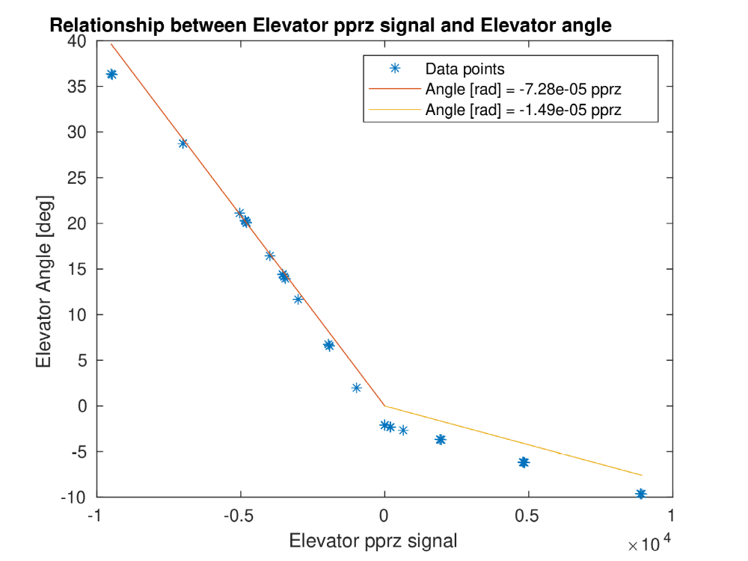

Fit Fz
Completed fit in +-15 deg angle of attack (for linear state)
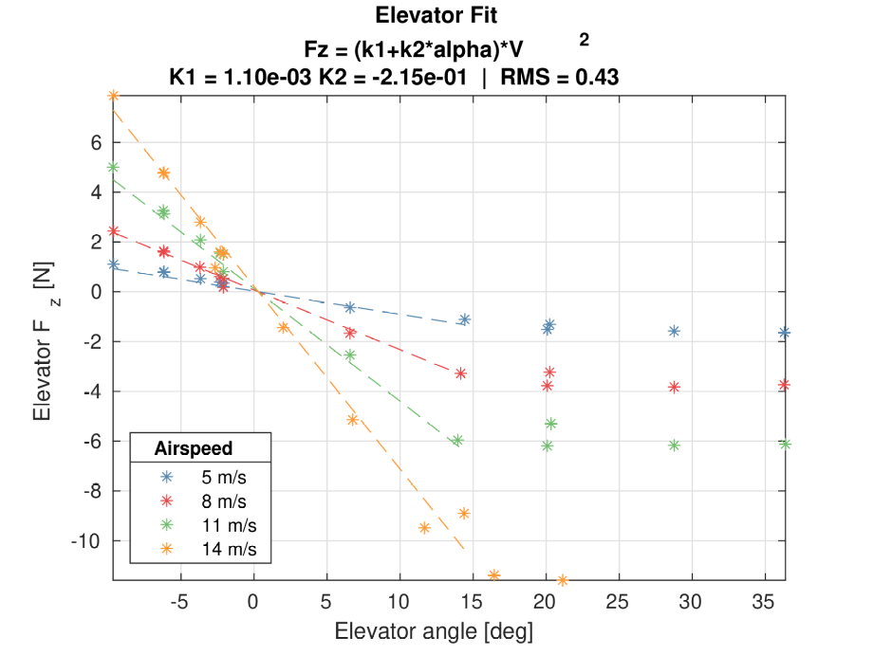

%Fz = (1.095783351807783E-3+-2.145939080916709E-1*alpha)*V^2

% s_elev =
%
% 0.001095783351808
% -0.214593908091671
%
%
% RMS_elev =
%
% 0.431208898300762

Possible recommendations:
- add alpha^2 term
- check for different hover motor usage (different angle of attack on h stab)

