Pusher Propeller Force as a Function of pprz Signal

Wind Tunnels Test Data Used:
- AE
- -
- LP1
By taking the difference between both, aim to isolate pusher force

Modifications to data
- AE
  - All entries with actuator active (except pusher prop) are removed
  - Skew = 0 deg is chosen (same as for LP1)
  - Data points relative to null (0) pusher prop command removed

Fit Pusher Thrust to RPM
Definitions:  CT = T/(rho*n^2*D^4)  J = V/(n*D) | where:  CT = coefficient of thrust  T = thrust  rho = density | n = rotationnal speed  D = diameter  J = advance ratio  V = airspeed
It is known from test data that CT proportinnal to J. Hence:
CT = a*J+b
T/(rho*n^2*D^4) = a*V/(n*D)+b
T = rho*n*D^3*a*V + b*rho*n^2*D^4
T = k1*n*V+K2*n^2
This equation is also presented in literature. This is the fit that will be used.
% Fx = k1*V*RPM+k_2*RPM^2+k_3*V

% s_all_rpm =
%
% 0.000000368865338
% -0.000045422156524
% -0.084830356821562
%
%
% RMS_all_rpm =
%
% 0.419639350722040
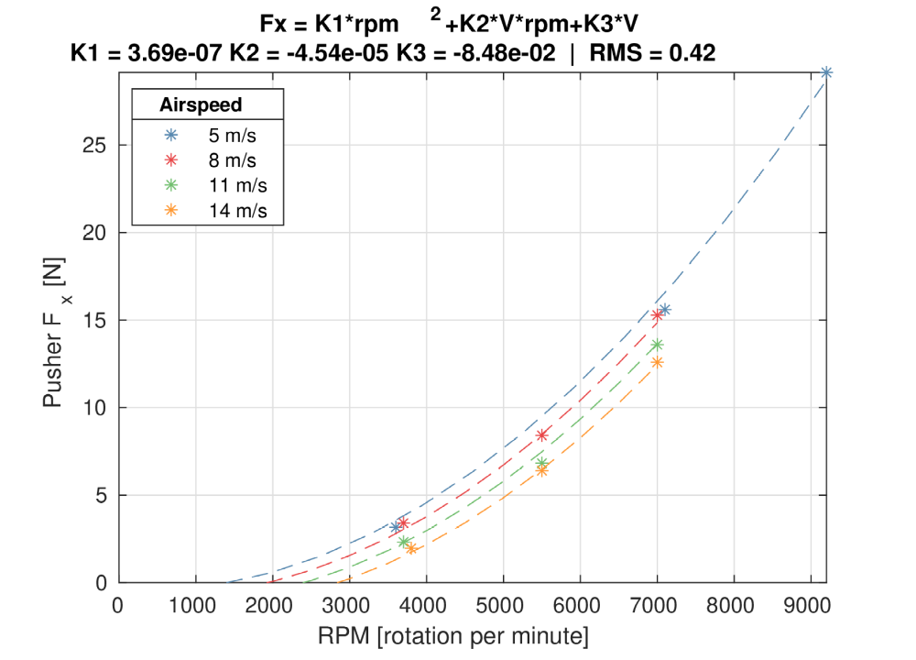

Other method
Generated using eval_Rwv3_pusher_motor_propeller.m

Using data from windtunnel, specifically for pusher prop
% Fx = k1*V*RPM+k_2*RPM^2+k_3*V

% s_all_rpm =
%
% 0.000000396222948
% -0.000052930351318
% -0.268843366027904
%
%
% RMS_all_rpm =
%
% 0.645764831243444

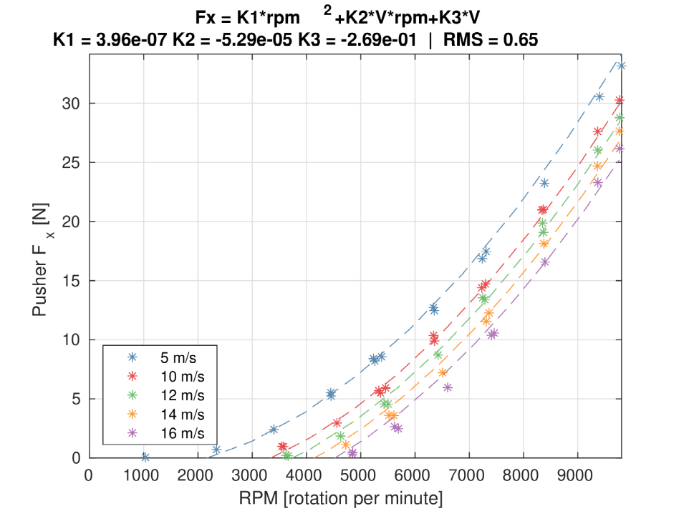

Comparison of models
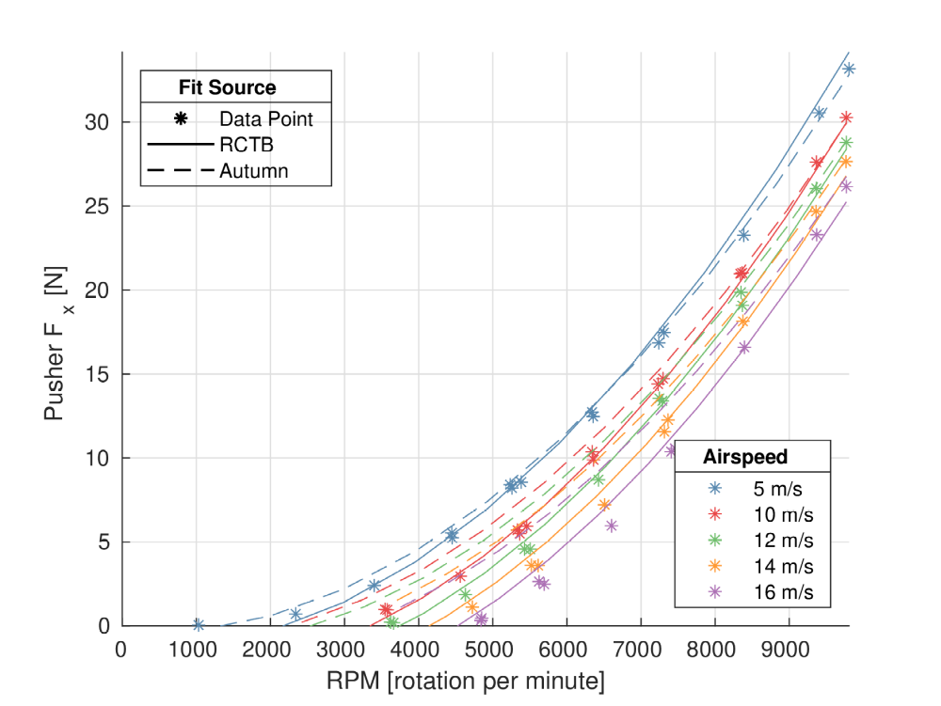
New model has a higher penalty on increasing airspeed

https://m-selig.ae.illinois.edu/props/propDB.html
Diagnosis of Airspeed Measurement Faults for Unmanned Aerial Vehicles, Hansen 2014

